INDOOR AIR QUALITY ASSESSMENT

Furnace Brook Middle School
500 Furnace Street
Marshfield, Massachusetts

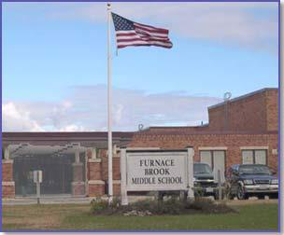

Prepared by:
Massachusetts Department of Public Health
Bureau of Environmental Health
Indoor Air Quality Program
October 2019

Background
Building: | Furnace Brook Middle School (FBMS)
Address: | 500 Furnace Street, Marshfield, Massachusetts
Assessment Coordinated Through: | Fred Russell, Director of Facilities, Town of Marshfield
Reason for Request: | Odor complaints in classroom 16 and Conference Room.
Date of Assessment: | October 15, 2019
Massachusetts Department of Public Health/Bureau of Environmental Health (MDPH/BEH) Staff Conducting Assessment: | Cory Holmes, Environmental Analyst/Inspector, IAQ Program
Building Description: | Room 16 is a general classroom located on the ground floor of the FBMS. The room contains office furniture, tile floor, painted gypsum wallboard walls and suspended ceiling tiles. It shares a common wall with general classrooms on each side and the main hallway. The Conference Room is a small room on the first floor that has been turned into office space.
Windows: | Windows are openable in both areas.

Background
Note that this building has been visited by the MDPH IAQ Program in June 2019 at the request of the BPS to investigate similar odors. The previous assessment was prompted by odor complaints, described by occupants as a “chemical, glue-type odor”. School/Town maintenance staff believed that the odor was related to roofing compounds/materials. The report from that visit can be found at: https://www.mass.gov/info-details/indoor-air-quality-reports-cities-and-towns-m.

Methods
Please refer to the IAQ Manual and appendices for methods, sampling procedures, and interpretation of results (MDPH, 2015).

Results and Discussion
The following is a summary of indoor air testing results for Total Volatile Organic Compounds (TVOCs):
- Conference Room: No measurable levels of TVOCs were detected in the breathing zone at the time of assessment; a slight reading of 2.4 ppm was measured in the utility hole above the ceiling (Picture 1).
- Room 16: No measurable levels of TVOCs were detected in the breathing zone (note that the univent was operating and bringing in fresh air at the time of testing). A slight reading of 1.4 ppm was measured near the sealed skylight above the ceiling (Picture 2).

Ventilation/Odors
A heating, ventilating and air-conditioning (HVAC) system has several functions. First it provides heating and, if equipped, cooling. Second, it is a source of fresh air. Finally, an HVAC system will dilute and remove normally-occurring indoor environmental pollutants by not only introducing fresh air, but also filtering the airstream and ejecting stale air to the outdoors via exhaust ventilation. Even if an HVAC system is operating as designed, point sources of respiratory irritants may be present and produce symptoms in sensitive individuals. The following analysis examines and identifies components of the HVAC system and likely sources of respiratory irritants found in the indoor environment.
Mechanical ventilation for classroom 16, and most general classrooms, is provided by a unit ventilator (univent) located near classroom windows (Picture 3). Univents draw air from the outdoors through a fresh air intake located on the exterior wall of the building (Picture 4) and return air through an air intake located at the base of the unit. Fresh and return air are mixed, filtered, heated or cooled and provided to rooms through an air diffuser located in the top of the unit (Figure 1). It is important to note that the univent was reportedly deactivated for several days prior to the odor complaint. It was also reported that once the univent was reactivated odors began to lessen. Not only will operating the univent dilute odors by bringing in fresh/outside air but will also pressurize the room keeping odors out (e.g., above the ceiling tiles/away from occupants).
Most classrooms with mechanical ventilation typically have exhaust or return vents installed to remove naturally occurring airborne pollutants and provide air exchange. Room 16 does not have any exhaust/return vents. The Conference Room does have an operable mechanical exhaust vent mounted in the ceiling (Picture 5). BEH/IAQ Program staff recommended installing a vent in the exhaust ductwork above the ceiling (Picture 6) to depressurize the ceiling plenum in relation to the Conference Room, which will capture odors (if present) before they reach the occupied area.

Conclusions and Recommendations
The following recommendations were made at the time of the visit and are reiterated below:
- Ensure skylight is sealed as airtight as possible using caulking or other appropriate airtight sealant. Extend this covering over the metal skylight frame (shown in Picture 2).
- Operate univent in Room 16 continuously during occupied hours and utilize openable windows to pressurize the room in relation to the ceiling plenum.
- Consider installing a vent or approximate one by drilling holes in the exhaust duct above the ceiling in the Conference Room to depressurize the ceiling plenum, which will capture odors (if present) and remove from building.
- Seal any/all open utility holes in walls and ceilings in both the Conference Room and Room 16.
- If odors persist, work with roofing contractor, HVAC specialist and/or an Industrial Hygienist to examine more permanent solutions to remove and/or eliminate source of odors.
- Refer to resource manual and other related IAQ documents located on the MDPH’s website for further building-wide evaluations and advice on maintaining public buildings. These documents are available at http://mass.gov/dph/iaq.

References
MDPH. 2015. Massachusetts Department of Public Health. Massachusetts Department of Public Health Indoor Air Quality Manual: Chapters I-III. Available at: http://www.mass.gov/eohhs/gov/departments/dph/programs/environmental-health/exposure-topics/iaq/iaq-manual/.
Picture 1
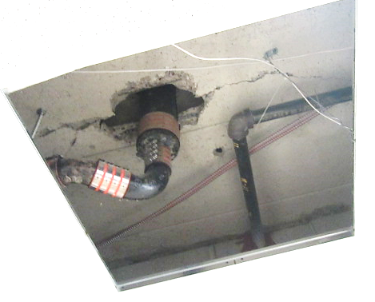
Open utility hole in Conference Room
Picture 2
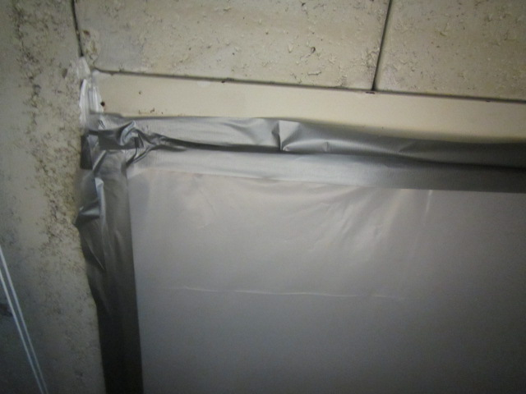
Sealed skylight above ceiling in Room 16, note metal skylight frame (arrow)
Picture 3
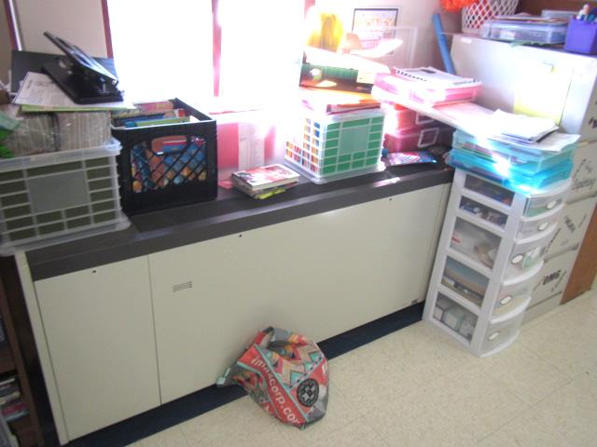
Classroom 16 univent
Picture 4
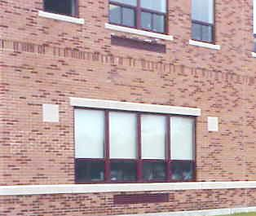
Univent fresh air intakes (arrows)
Picture 5
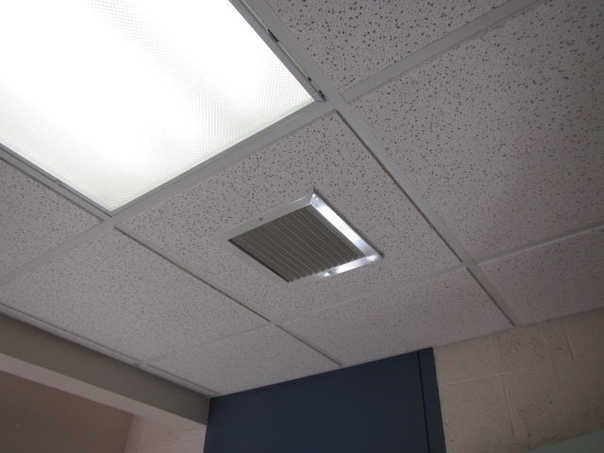
Ceiling-mounted exhaust vent in Conference Room
Picture 6
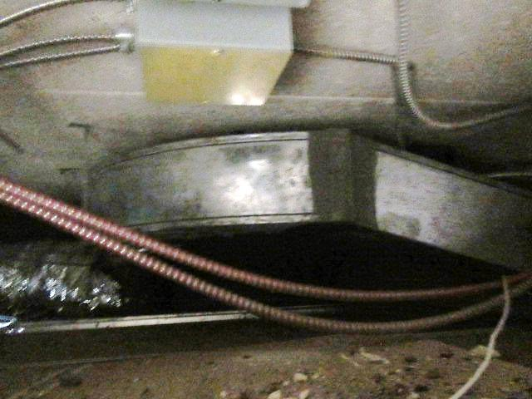
Exhaust ductwork above ceiling in Conference Room

