Distributed Resources Subcommittee (DISRS)
WebEx/Conference Call
June 23, 2023
9:00 a.m. – 12:00 p.m. EPT

Administration (9:00-9:05)
Ilyana Dropkin, PJM, will provide welcome and review Antitrust, Code of Conduct, Public Meeting/Media Participation and Participation Identification in Webex Guidelines.
Ilyana Dropkin will review meeting minutes from 5.25.23 Distributed Resources Subcommittee (DISRS).

FERC Order 2222 (9:05 – 11:50)
- Scott Baker, PJM, will review FERC Order 2222 work plan updates.
- PJM staff will review FERC directives and PJM's initial thinking on how to respond to the following topics addressed in the FERC Order: information and data, reliability criteria and dispute resolution.
- EDC have provided written comments/position papers that were posted with the meeting materials. Chris Wehr, FirstEnergy, will address any questions that stakeholders may have in regards to the posted comments/position papers.
- Open discussion for previous topics: Locational requirements.

Future Agenda Items (11:50 – 12:00)
- The facilitation team will review meeting action items and discuss future agenda items
Future Meeting Dates and Materials |  |  | Materials Due  to Secretary | Materials Published
Date | Time | Location |  | Materials Published
July 14, 2023 | 9:00 a.m. – 3:00 p.m. EPT | WebEx | July 6, 2023 | July 11, 2023
July 31, 2023 *F.O. 2222 | 1:00 p.m. – 4:00 p.m. EPT | WebEx | July 21, 2023 | July 26, 2023
August 7, 2023 | 9:00 a.m. – 3:00 p.m. EPT | WebEx | July 28, 2023 | August 2, 2023
September 8, 2023 | 9:00 a.m. – 3:00 p.m. EPT | WebEx | August 31, 2023 | September 5, 2023

Author: Ilyana Dropkin

Antitrust:
You may not discuss any topics that violate, or that might appear to violate, the antitrust laws including but not limited to agreements between or among competitors regarding prices, bid and offer practices, availability of service, product design, terms of sale, division of markets, allocation of customers or any other activity that might unreasonably restrain competition. If any of these items are discussed the chair will re-direct the conversation. If the conversation still persists, parties will be asked to leave the meeting or the meeting will be adjourned.

Code of Conduct:
As a mandatory condition of attendance at today's meeting, attendees agree to adhere to the PJM Code of Conduct as detailed in PJM Manual M-34 section 4.5, including, but not limited to, participants' responsibilities and rules regarding the dissemination of meeting discussion and materials.

Public Meetings/Media Participation:
Unless otherwise noted, PJM stakeholder meetings are open to the public and to members of the media. Members of the media are asked to announce their attendance at all PJM stakeholder meetings at the beginning of the meeting or at the point they join a meeting already in progress. Members of the Media are reminded that speakers at PJM meetings cannot be quoted without explicit permission from the speaker. PJM Members are reminded that "detailed transcriptional meeting notes" and white board notes from "brainstorming sessions" shall not be disseminated. Stakeholders are also not allowed to create audio, video or online recordings of PJM meetings. PJM may create audio, video or online recordings of stakeholder meetings for internal and training purposes, and your participation at such meetings indicates your consent to the same.
Participant Identification in Webex:
When logging into the Webex desktop client, please enter your real first and last name as well as a valid email address. Be sure to select the “call me” option.
PJM support staff continuously monitors Webex connections during stakeholder meetings. Anonymous users or those using false usernames or emails will be dropped from the teleconference.

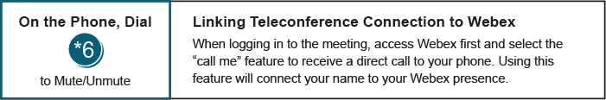

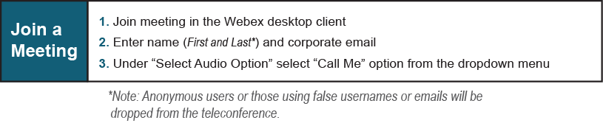

Provide feedback on the progress of this group: Facilitator Feedback Form
Visit learn.pjm.com, an easy-to-understand resource about the power industry and PJM’s role.

