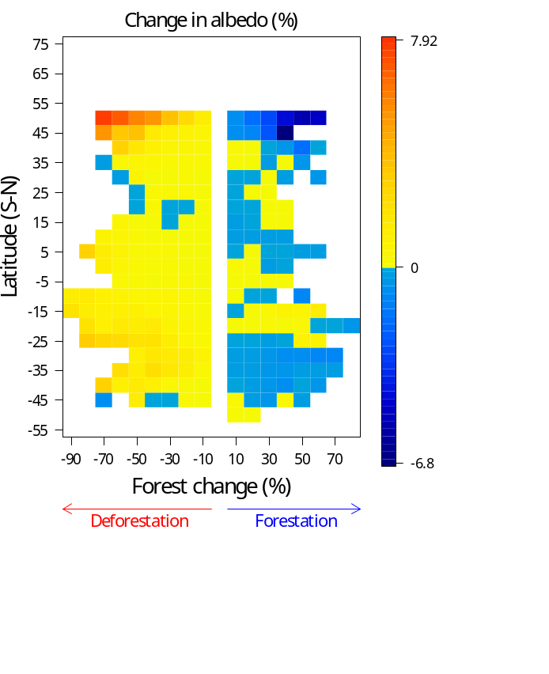

S2 Fig. Effects of forest change on albedo change considering the albedo GLASS (Global LAnd Surface Satellites) dataset. Each cell in the plots represents decadal (2011 – 2001) changes in annual means of albedo calculated for 0.05 x 0.05º cells grouped into bins of 5º latitude and 10% forest change. For this analysis, we first calculated monthly averages, and then annual averages, considering only pixels that had good-quality information for all months in a year, i.e., flags “00” and “01” (indicating uncertainty < 5 and < 10%, respectively). In some months, pixels above 55ºN had only uncertain estimates (flag “11”) and thus were not used in the analysis.

