Children's Lesson about God as Three in One - the Trinity Pyramid
 | Trinity Pyramid  Learn about our trinity or triune God: 3 in 1  the 3 job titles = one whole  Several choices depending on how much time you are allowing for this activity.  About the words "Triune and Trinity" for pupils:  "The Trinity" usually means The Father, Son Jesus and Holy Spirit combined as God.  "Triune" is from latin combination three as one - or trinity. Triune is pronounced as try-yoon.  "Triune and Trinity" are pretty much special church words hardly ever used for other purposes.
Blank version shown | KS1 can do it - but their comprehension of what it is about will vary greatly- you can use it as simply 3 names for GOD. Also applies to LKS2  (KS2)  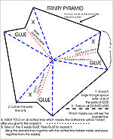  Triune God: 3 in 1 or 3 names based on the job.  We use a lot of different titles for the same person in our everyday lives and don't even think much about it. Depends on the "job" or the relationship of the other person (observer)  Have each student make a name chart identifying titles for just their mum and dad and see how many "names" you come up with. Here's a start with some possibilities. If a child comes from a one parent household and does not wish to include the absent parent, ask them to use a grandparent or other relative in that space  Father, Jesus and Spirit  * For many years, in some denominations, the "Spirit" was called "The Holy Ghost". If you use this name, you may prefer to make the totally blank pyramid. OR use the blank pyramid if you have any other special way you define the trinity such as:  Father, Son and Holy Ghost
  MUM | DAD | GOD
  Mother | Father | Father
  (christian name) | (christian name) | Son
  sister | brother | Jesus
  Aunt (christian name) | Uncle (christian name) | Spirit
  Mrs.or Ms. | Mr.
EYFS and KS1 see note above
LKS2 can do the chart
UKS2 can do the pyramid
 | Triune God

  Copy of pyramid for each student
  Glue
  Scissors
  Markers or crayons
 | Choose your pyramid and print enough for your class. Make one ahead of time to show. To colour the pyramid or not to colour?
1. Colour your pyramid if you have chosen a pyramid to colour. If you have chosen the fully coloured version go to step 2.
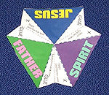 | 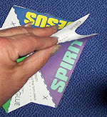
2.Cut out the shape. | 3.Fold on all dashed lines.  Press and run your fingertips along the folds to sharpen the fold.  The dotted lines should fall between the dashed lines, so just press together.
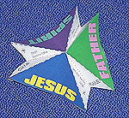 | 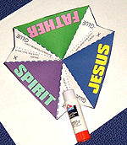
4. Make all the folds | 5. Put glue where it says "Glue" (you can glue the entire area up to the coloured spaces for best results)
6. Press the glue together from the inside of the pyramid

http://www.sundayschoolkids.com/activities-trinity-god/0-pyramid-instru.htm

