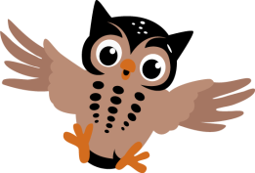

Year 4 Spellings Red

They should practise these at home, using different methods we have used in school such as rainbow letters, drawing pictures that represent the word, pyramid writing and forwards/backwards writing.
I have put a test date on each week but feel free to test or complete the spellings when you would like, this just helps with structure if you would like and the children should be used to having a spelling test each week.

Week 1  Test: 12.06.20 | Week 2  Test: 19.06.20 | Week 3  Test: 26.06.20 | Week 4  Test: 03.07.20 | Week 5  Test: 10.07.20 | Week 6  Test: 17.07.20
exactly | instantly | envious | division | fraction | question
perfectly | honestly | dangerous | vision | addition | sentence
heavily | terribly | enormous | mansion | musician | material
gently | beautifully | curious | tension | magician | quarter
hopefully | surprisingly | cautious | television | explosion | opposite
safely | separately | religious | station | confusion | ordinary

