Intro to Special Commission on State Institutions

Emily Lauer, PhD, MPH

Associate Professor, Director of CDDER

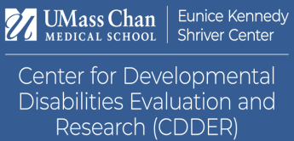

Eunice Kennedy Shriver Center
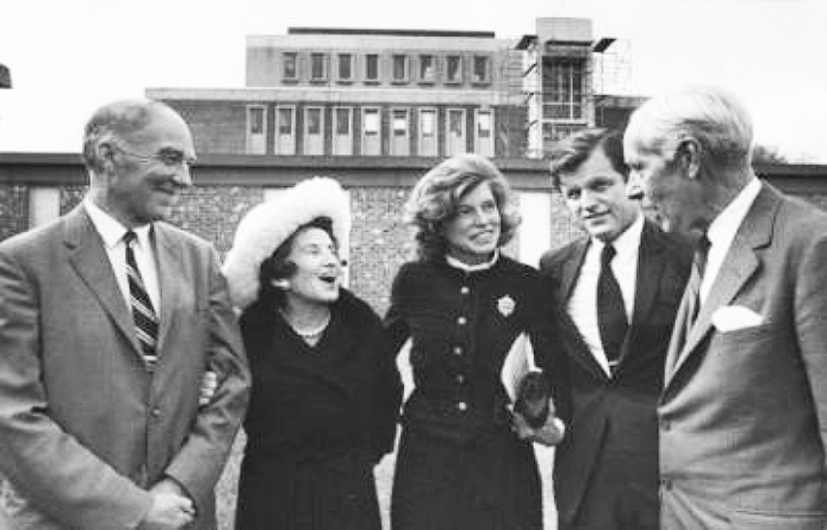
- Part of the University of Massachusetts Chan Medical School
- Dedicated to understanding and improving the challenges faced by individuals with intellectual and developmental disabilities (IDD) and/or behavioral health disorders as well as supporting their families.
- Our comprehensive experience and expertise have established the Shriver Center as an international leader, devoted to supporting the full participation of people with disabilities in community life.

Our Mission
To transform systems, policy, and practice by engaging in innovative research, education, training, and service so that people with intellectual/developmental disabilities and/or behavioral health conditions may lead self-determining lives.

Examples of relevant prior work
- Fostering Social Inclusion and Community Engagement among people with IDD
- MA Healthy People 2020 Autism Roadmap Report: Understanding Needs & Measuring Outcomes
- Experiences of Aging Caregivers in Supporting Family Members
- Evaluation of new service models with Person-Centered Evaluation
- Creation of advocacy tools for self-advocates and family members on preventive health screenings
- Teaching medical students about the lived experiences of people with disabilities – including people with disabilities
- Studying when and how people with IDD died

Areas we can support
- Support in running commission
  - Meetings
  - Updates/Reporting
- Lists of places where they were buried, information about cemeteries
- Papers
  - Where are the papers? Who has them?
    - We can do as much as we can during the time we have
  - Process of requesting papers, what happens when you try, how do other places give access to papers

Areas that may be challenging
- Legally related processes to find papers and who has what; what papers are gone
  - It may take a long time to get this information (after report is due)
- You asked to find:
    - Tell us how people were buried when they died. What were the rules? Were their families told? Did they get a gravestone with their name? Was there a funeral?
    - Find out if anybody was buried in a place they were not supposed to be buried.
  - This may be up to where the info is, who has it, how we can get it, and whether we need the help of lawyers to do so.

