Configuring a PhysioTel Digital Implant for BPR Analysis in Ponemah v5.20
The following steps explain how to enable a soft channel for a PhysioTelTM Digital implant in order for it to be used with Ponemah’s BPR analysis module to determine respiration from blood pressure.
- With the CLC connected to the system, launch Ponemah v5.20.
- Select Hardware | Hardware | Edit Configuration…
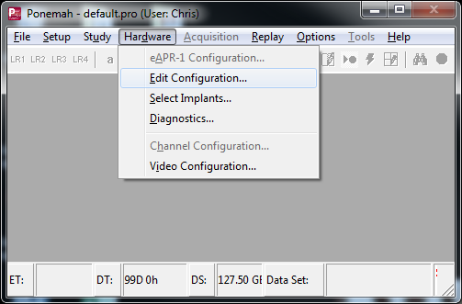

- Configure the PhysioTel Digital implants using the Configure Sources wizard.
- From the list view on the left, expand the implant of interest to display its channels.
- Select Signal Strength from the list of channels.
Note: Signal Strength will be configured for use with BPR and will no longer be able to be used to collect the Signal Strength waveform.
- Click the checkbox associated with Enabled.
- Change the Description field to RespPress.
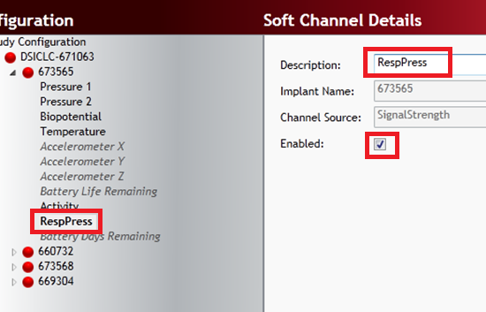
- Repeat this process for each implant that will use the BPR analysis module.
- Click Save & Exit when done.
Configure the protocol as normal.
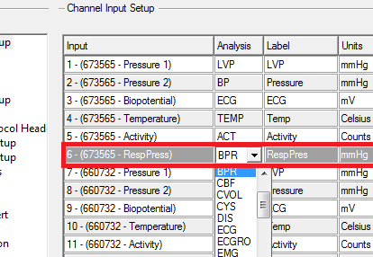
An extra channel should appear in Ponemah’s Channel Input Setup for each implant. Configure this channel to use the BPR analysis module, and configure the Labels and Units accordingly.
Note: If using Auto Configure Protocol function to automatically define protocol settings, Ponemah will setup the Respiration channel as Signal Strength using the RAW analysis module. Simply change the analysis module to BPR, then adjust the Labels and Units accordingly.

