Jukka Paloheimo  Counsel, Employment , Helsinki  Corporate Investigations & Compliance, Dispute Resolution, Employment | 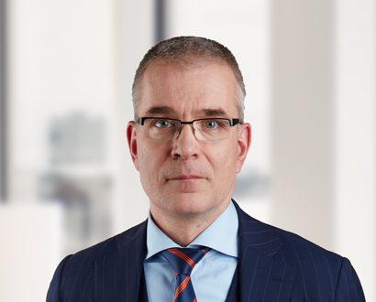
  +358 20 506 6615
  +358 40 754 2057
  jukka.paloheimo@roschier.com

Jukka Paloheimo is a Helsinki-based Counsel. He has extensive experience from assignments relating to employment and labor law with special emphasis on employment related disputes and criminal matters, including matters related to labor offences as well as occupational health and safety matters. He is a trusted advisor to major companies in these type of complex matters, with previous experience in assisting client companies in matters relating to reorganization and redundancy.
Jukka is an accredited mediator of the Finnish Bar Association. He frequently lectures on topics relating to employment law, employment disputes and occupational health and safety. He has also held webinars for international companies regarding Finnish employment law.
Prior to joining Roschier, Jukka worked as a Counsel for another major Finnish law firm.

Recognitions
Jukka is recognized as one of the leading experts in Finland in the field of employment law by Chambers Europe, The Legal 500 and Lexology Index (formerly Who’s Who Legal).
This is what clients say about Jukka:
“He is hands-on and has an excellent eye for detail and timing.”
– Chambers Europe 2024, Employment
“Jukka Paloheimo has a strategic vision on issues.”
– Chambers Europe 2024, Employment
“Jukka Paloheimo is a seasoned professional, top-class lawyer with the capability to draw the big picture in a limited timeframe with detailed law information, ripple effect scenarios and conclusions. Jukka has a great sense of humour and his in-depth knowledge is impressive, so working with him brings a very high degree of comfort and trust.”
– The Legal 500 2024, Employment
“Jukka Paloheimo is a great expert in litigation.”
– The Legal 500 2024, Employment
“His understanding of our case is great.”
– Chambers Europe 2023, Employment
“Jukka Paloheimo is an experienced litigator.”
– The Legal 500 2023, Employment

Career
Roschier (2017-)
Castrén & Snellman, Counsel (2010-2017), Senior Associate (2007-2010), Associate (2005-2007)
Law Clerk, trained at the Bench, District Court of Helsinki (2004-2005)
Peltonen, Ruokonen & Itäinen (Currently: DLA Piper Finland Oy), Associate Lawyer (2001-2005)
European Public Policy Advisors (Currently: FIPRA Finland Oy), Account Manager (1999-2000)

Memberships
Member of the Finnish Bar Association
Member of the IBA
Member of the European Employment Lawyers Association (EELA)
Member of the Finnish Lawyers’ Society
Member of the Association of Finnish Lawyers
Member of the Young Lawyers Association
Member of the Labour Law Association

Publications
“Articles about the law of evidence”, Helsinki Court of Appeals, Lappalainen (ed.), 2006

Education
University of Helsinki, LL.M. (1999)

Languages
English, Finnish, German, Swedish

