Sampsa Myllymäki  Senior Associate, Helsinki  Tax & Structuring | 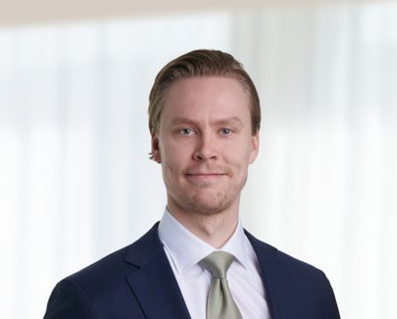
  +358 20 506 6781
  +358 50 413 2838
  sampsa.myllymaki@roschier.com

Sampsa Myllymäki is a Helsinki-based Senior Associate working with Roschier’s Tax and Structuring practice. He has experience in various domestic and international tax related matters, tax litigation processes and transfer pricing. Prior to joining Roschier in 2022, Sampsa worked for a major international accounting firm.

Work highlights
Sampsa Myllymäki’s experience includes advising:

- CVC-led consortium in the recommended cash tender offer for all shares in WithSecure Corporation;
- Fidelio Capital in the acquisition of CaPS;
- Apollo in the EUR 392 million takeover offer for all the shares in Purmo Group Oyj;
- ŌURA in the acquisition of Human Engineering Health Oy, a startup behind the metabolic health product Veri;
- Slättö in an investment by Ares Management;
- Brown-Forman in the sale of Brown-Forman Finland Oy, owner of the Finlandia vodka brand, to Coca-Cola HBC; and
- Warburg Pincus in the acquisition of Epassi Group.

Career
Roschier- (2022)
Deloitte, Consultant (2018-2020), Senior Consultant (2020-2022)

Memberships
Member of the Finnish Bar Association
Member of the International Fiscal Association (IFA)
Member of the Finnish Tax Experts’ Association (SVA)

Education
University of Turku, LL.M. (2020)

Languages
English, Finnish

