
DISCLAIMER: This document is intended solely as a technical overview of the provisions of AB 2011 (2022) and SB 6 (2022). It is not intended to serve as legal advice regarding any jurisdiction's specific policies or any proposed housing development project. Local staff should consult with their city attorney or county counsel when adopting an ordinance to implement the provisions of AB 2011 and/or SB 6 or when determining the applicability of these provisions to any proposed housing development project in their jurisdiction. Because the laws are so new, the legislative intent of major provisions is still being discussed and this memo may change significantly.

Understanding AB 2011 and SB 6
AB 2011 and SB 6 permit residential development on sites currently zoned for commercial or retail uses. Both laws go into effect on July 1, 2023. The specific standards that will apply are complicated to understand. The provisions of both laws are applicable to local jurisdictions without an implementing ordinance, although if a jurisdiction adopts one, it is exempt from CEQA. Because the laws are so new, it is not clear how much use they will see.

Policy Decisions and Recommended Actions
Potential action items related to AB 2011 and SB 6 include:
Council Action Items:
- Implementing Ordinance. Consider adopting an implementing ordinance for one or both laws
- Exempt Parcels. Decide if parcels will be exempted and if exempting, make required written findings and reallocate lost density
- Labor Requirements. Decide if and how to monitor labor requirements including reviewing reports from developers
- Relocation Assistance. Determine how to enforce relocation assistance requirements for commercial tenants and residents

Staff Action Items:
- Create development project applications
- Prepare maps of eligible parcels
- Develop procedures to enforce relocation assistance and labor monitoring procedures
- Develop project review processes that meet legally required timelines
- Define “project site” and clarify how “closest parcel” will be determined

Site Criteria & Development Standards
AB 2011 and SB 6 both allow multi-family residential projects in commercials zones, but the rules are different. There is one set of standards in SB 6 and there are two sets of standards in AB 2011, for mixed Income Housing and 100 percent affordable projects.
SB 6 projects are allowed on sites of 20 acres or less in zones that allow office, retail or parking as a principally permitted use. SB 6 does not define "principally permitted use."
AB 2011 projects are allowed in zones that allow office, retail or parking as a principally permitted use. AB 2011 defines "principally permitted use" as a use that can occupy more than 1/3 of square footage without a conditional use permit. Mixed income housing projects are only allowed on sites of 20 acres or less with at least 50 feet of frontage on public street with a right-of-way between 70 and 100 feet. There is no site size limit or street criteria that must be met for 100percent affordable housing projects.
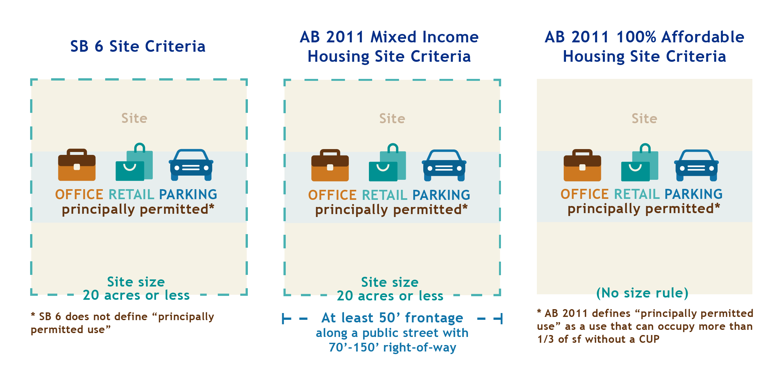

SB 6 Development Standards
To qualify for SB 6, the project must meet or exceed the default density under housing element law (20 or 30 du/acre). Generally, jurisdictions will apply the zoning standards from the closest zone that allows the housing element default density (20-30 du/acre). More specifically, the project must comply with local zoning, parking, design and other ordinances, local code requirements and procedures applicable to housing from either:
- The existing zoning for the parcel if the zoning allows residential density that exceeds default density, if not
- The standards in the closest zone that allows for housing at the default density.
The project must comply with all other objective standards for the parcel including impact fee and inclusionary housing requirements.

AB 2011 Development Standards
For AB 2011 100 percent affordable projects, the development must meet objective zoning, subdivision and design review standards for the zone that allows greater residential density between the following:
- The existing zoning designation for the parcel if it allows multifamily residential use; or
- The zoning designation for the closest parcel that allows residential use at density that is appropriate to accommodate the default density per housing element law.
Additionally, for 100 percent affordable projects, the density of the project must meet or exceed the default density under housing element law (20 or 30 du/acre).
For AB 2011 mixed income housing projects, the standards are more prescriptive. The minimum density ranges from 30-80 dwelling units per acre depending on site size, width of the adjacent street, proximity to transit and whether the site is in a metropolitan or non-metropolitan jurisdiction. Heights are also complicated to summarize, ranging from the existing permitted height to 65 feet near transit.
AB 2011 prohibits jurisdictions from applying “special” objective development standards to AB 2011 projects. (See Government Code Sections 65912.114(l); 65912.124(l).)
The rules for development standards are complicated. See the Overview Document for more details.

General Project Requirements & Review Timelines
AB 2011 and SB 6 have project requirements that are outlined below.

Table 1: Requirements and Project Criteria

 | AB 2011 Projects | SB 6 Projects
Location | Urbanized area or urban cluster (now “urban areas”) | Urbanized area or urban cluster (now “urban areas”)
Zoning and Adjoining Uses | Commercial zones (office, retail or parking);  Not on/adjacent to sites with more than 1/3 industrial use; not in proximity a freeway or oil/gas refinery |  |  | Commercial zones (office, retail or parking);  Not on/adjacent to sites with more than 1/3 industrial use
Project Type | Multi-family residential or mixed-use with at least two-thirds residential or transitional or supportive housing | Multi-family residential or mixed-use with minimum 50% residential
Labor Requirements | Prevailing wage required |  |  | Prevailing wage required;  “Skilled and trained workforce” required
Exempting Parcels | May exempt parcels with written findings and by designating “substitute” parcels | May exempt parcels with written finding and concurrently reallocate residential density
Density Bonus | Applies | Applies
Affordable Housing | Required (details in Overview document) | Only local standards*
CEQA | Exempt | Not exempt*
Approval Process | Streamlined, ministerial process (see below) | No new process*
Coastal Zone | May be used in Coastal Zone | May be used in Coastal Zone & Coastal Act applies*
*Unless applicant invokes SB 35
See additional criteria and details in Overview of AB 2011 and SB 6.

AB 2011 Review Timelines
For projects with 150 units or less, applicants must be informed of inconsistencies with all qualifying criteria within 60 days, and projects must be processed and reviewed for all applicable AB 2011 and local objective standards within 90 days. For projects with more than 150 units, applicants must be informed of inconsistencies with all qualifying criteria within 90 days, and projects must be processed and reviewed for all applicable AB 2011 and local objective standards within 180 days. If inconsistency deadline is not met, the project will be deemed compliant with qualifying criteria.
