HOW TO REGISTER YOUR CHORUS/ENSEMBLE FOR
UNISON FESTIVAL 2026 VANCOUVER

In order to register a chorus or small ensemble for Festival 2026 Vancouver, you must be designated as a Chorus Administrator for your chorus/ensemble in our Integra Planner software, and the chorus’ membership dues must be current.
For the purposes of Festival, a CHORUS is defined as a member of UNISON Choruses in good standing, with at least 12 singers. An ENSEMBLE is defined as a sub-group of a member chorus. We have two Chorus registrations rates available; 30 minute time slot for full choruses at $400 and for smaller ensembles a 15 minute time slot for $250.
The Integra Planner system is our integrated database, financial management, event planning & registration, and membership software. So, it’s important to update your chorus’ Integra record when any chorus information changes.
- Log in to Integra at using your personal email address as your username (that is, as an example lizgrave@telus.net and not treasurer@onevoicechorus.ca), scroll down to the “Membership” section and verify that your chorus(es) and ensemble(s) are listed, and that you are shown as an Administrator.
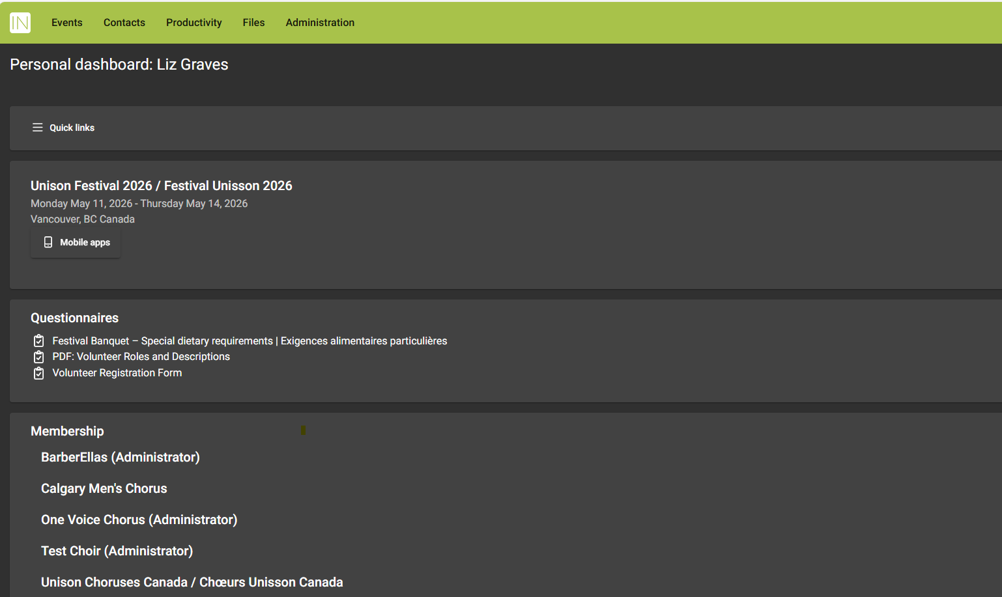
- If you are not shown as being an Administrator for your chorus, contact Liz Graves at mailto:financialadmin@unisonchoruses.ca to get it ironed out.

- When you log into Integra, your home page is your Personal Dashboard. To perform chorus administrative tasks, you need to move to your Administrator Dashboard. You can either click on the link in the top green menu bar or open the ‘Quicklinks’ menu to navigate to your Administrator Dashboard.

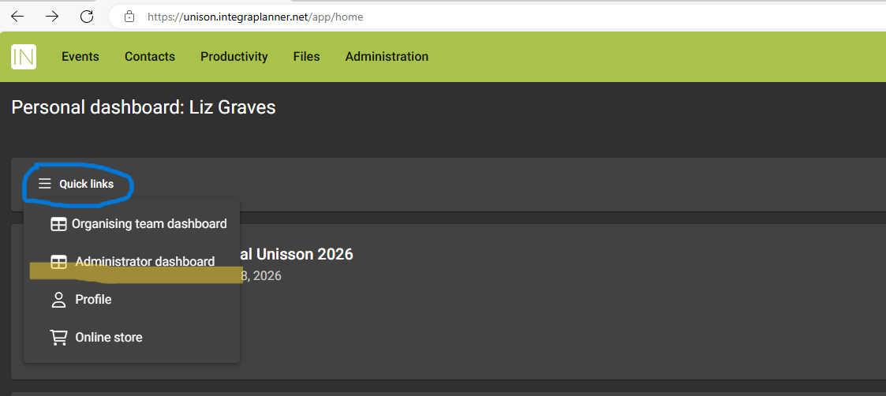
- On the Administrator Dashboard, scroll down to the section for your chorus OR ensemble and click the green ”Register” button under the Festival 2026 Vancouver heading.
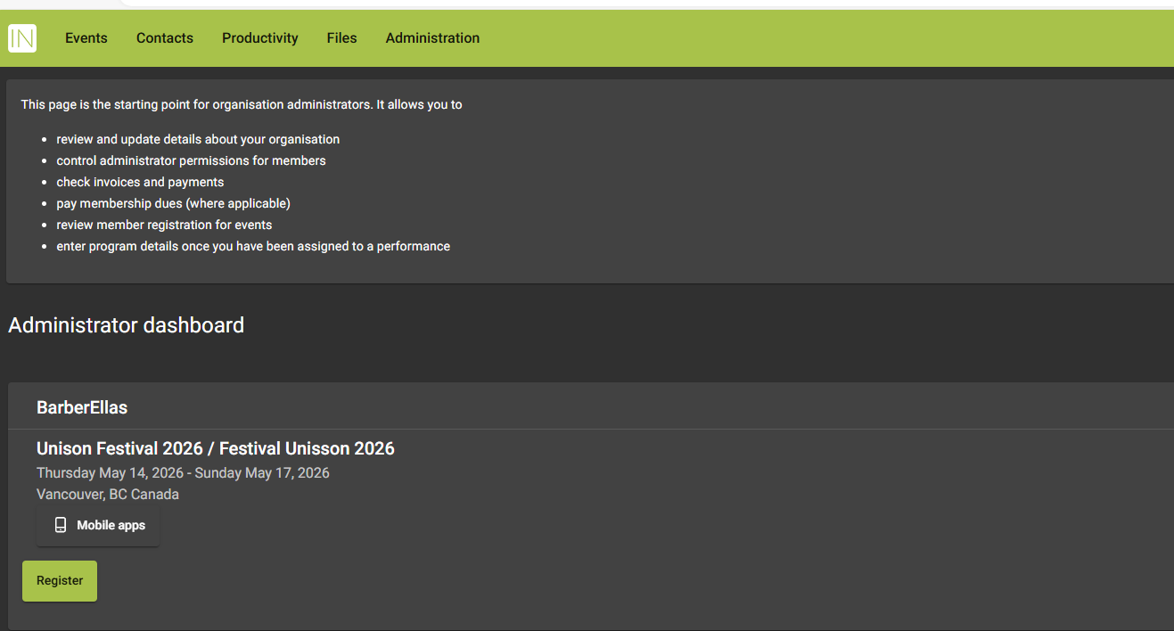

- You’ll now be prompted to review your chorus information in the database. Click on the “Organization Details” button and go through the data fields, updating any data as needed. Be sure to SAVE any changes as you go through the data.
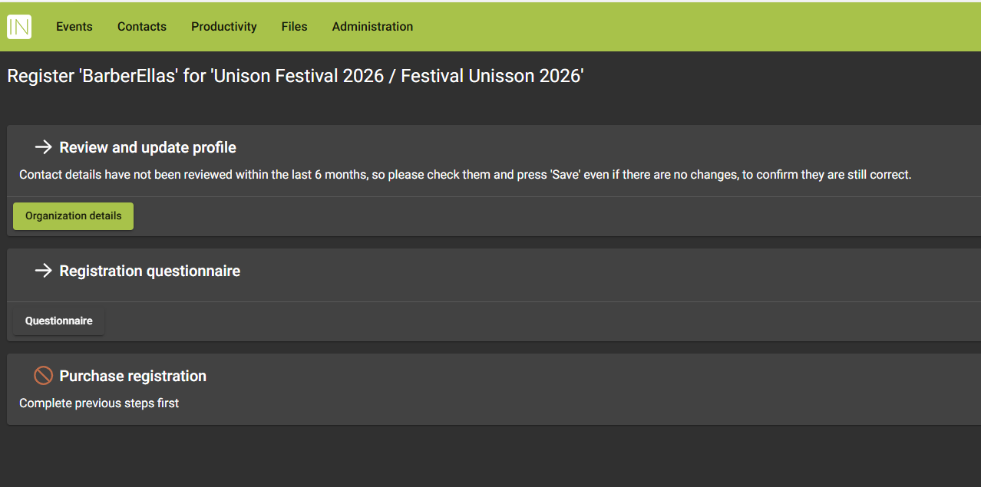
- When you’ve completed reviewing the chorus data, click the green “Save and Next” button.

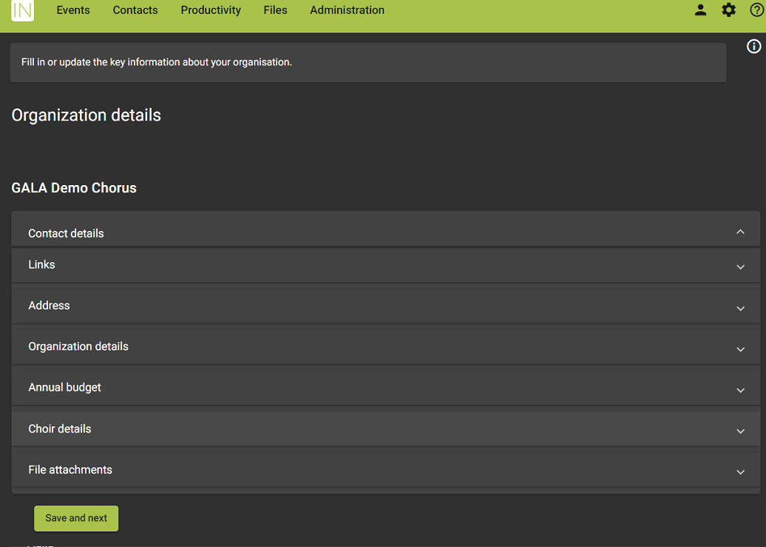
- After your chorus profile is updated, the next step in registration is to complete the Registration Questionnaire.for your chorus or ensemble. Click the green “Questionnaire” button to continue.
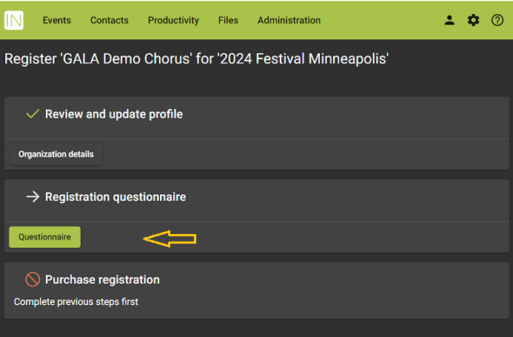
- Now you’re ready to purchase a registration for your Chorus and any ensembles (finally!). Click the green “Order” button under “Purchase registration”.
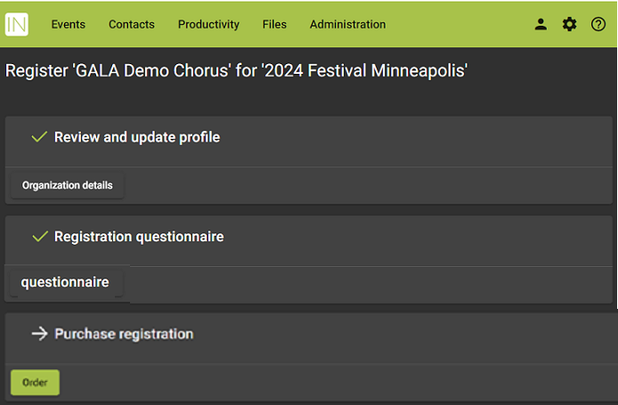

- You can now purchase your Chorus registration. Choose the item you wish from the list of available Chorus Registration items, (members 30 minute time slot $400 or members 15 minute time slot $250). Don’t worry, you will always have the ability to update your registration later if something should change. When you’re sure of your purchases, click the green “Confirm” button at the bottom of the page.
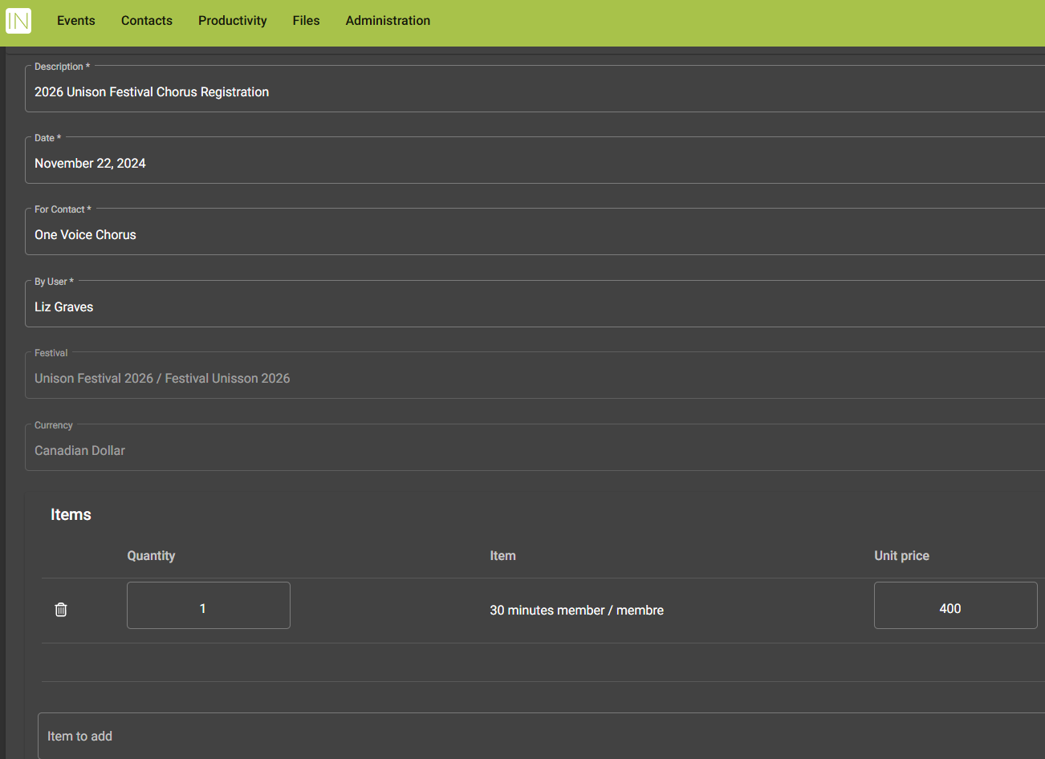

- You’ll now be directed to the Payment page. You do not have to pay immediately but know that your chorus registration is not complete until payment is received.
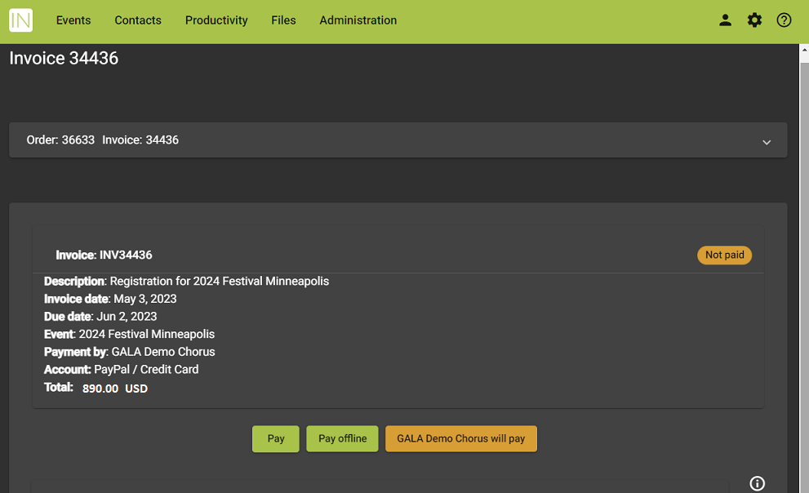

- To pay online with a credit card, select the “Pay” button and enter the credit card information as prompted. To pay by check, select the “Pay offline” button and send it to us at UNISON CHORUSES CANADA, 6, 319 13 St NW, Calgary, AB T2N1Z3. The “Chorus will pay” button is only applicable to individual delegate purchases, not to chorus registrations.
- If you have questions or hit any obstacles, contact Liz Graves at mailto:financialadmin@unisonchoruses.ca.

THANK YOU. We can’t wait to see you all May 15th to 18th, 2026!



