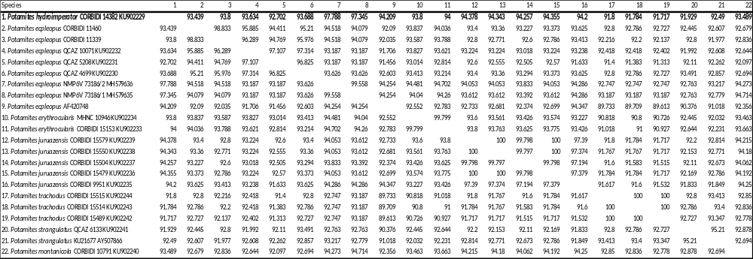
Supp. file 2. Uncorrected genetic distances (p-distances) between Potamites hydroimperator sp. nov. and other congeners. Values based on the 16S alignment. Values for the new species are in bold. https://doi.org/10.5852/ejt.2021.760.1445.4737

