Microsoft Word vs. Google Docs
A comprehensive, evidence-backed demonstration document
Positioning thesis
Word provides the real-time collaboration people expect from modern cloud editors while adding deeper professional document production, formal review, rich desktop features, enterprise security, automation, accessibility, and file-format control.
Prepared for | Executive / Sales / IT decision-makers
Prepared by | Microsoft Word capability team
Date | 2026-07-03
Document purpose | Prove “all they have plus more” with Word features embedded in this .docx
Status | Draft for review – use Track Changes and comments for sign-off

Table of Contents

Tip: In Word, right-click

the Table of Contents and choose “Update Field” to refresh page numbers.

1. Executive summary
Microsoft Word should be positioned as the premium document platform: it matches the cloud collaboration benefits commonly associated with Google Docs, then extends beyond them with mature legal-grade review, long-document production, advanced layout, enterprise-grade protection, automation, accessibility, and integration across Microsoft 365.

3. Capability matrix: Word has all the expected basics plus professional depth
Capability | Google Docs expectation | Microsoft Word answer | Word advantage
Real-time coauthoring | Multiple users edit in a browser | Coauthoring in Word desktop/web when stored in OneDrive/SharePoint | Collaboration with desktop-grade layout and review controls
Comments & mentions | Comments, suggestions, action items | Threaded comments, @mentions, tasks, resolved threads | Integrated with Outlook/Teams/Microsoft 365 identity
Change review | Suggesting mode | Track Changes: insertions, deletions, formatting, reviewer identity, accept/reject, lock tracking | More formal review workflow for legal, editorial, regulated documents
Version history | Restore prior versions | Version history through OneDrive/SharePoint; local file versioning options | Cloud + enterprise repositories + records processes
Long documents | Headings, outline, basic TOC | TOC, captions, cross-references, indexes, bibliography, fields, master-document practices | Better for reports, contracts, manuals, theses
Formatting/design | Basic styles/tables/images | Advanced styles, themes, columns, section breaks, page setup, watermarks, object placement | Higher-fidelity professional output
Mail merge | Requires add-ons/workarounds | Native mail merge with Excel/Outlook data | Production-ready personalized letters, labels, envelopes, email merges
Automation | Apps Script/add-ons | VBA macros, Office Scripts ecosystem, COM/add-ins, Power Automate, content controls | Broader enterprise automation surface
Security/compliance | Drive permissions/admin controls | Purview labels, encryption, DLP, retention/eDiscovery integration, IRM, protected view | Deeper Microsoft 365 governance stack
AI assistance | Gemini/Smart Compose depending on plan | Copilot in Word plus Editor, summaries, drafting, rewrite, M365 grounding where licensed | AI integrated with M365 data and compliance controls
Offline capability | Offline mode after setup | Full desktop application plus offline files synced later | Most capable no-internet document editor
Compatibility | Imports/exports DOCX | Native DOCX fidelity and Office ecosystem standard | Best authoritative format for businesses

4. Visual proof: capability depth
The chart below is an illustrative scoring model for sales discussion. It is not a benchmark; it visualizes where Word typically differentiates when business documents require control, polish, and governance.
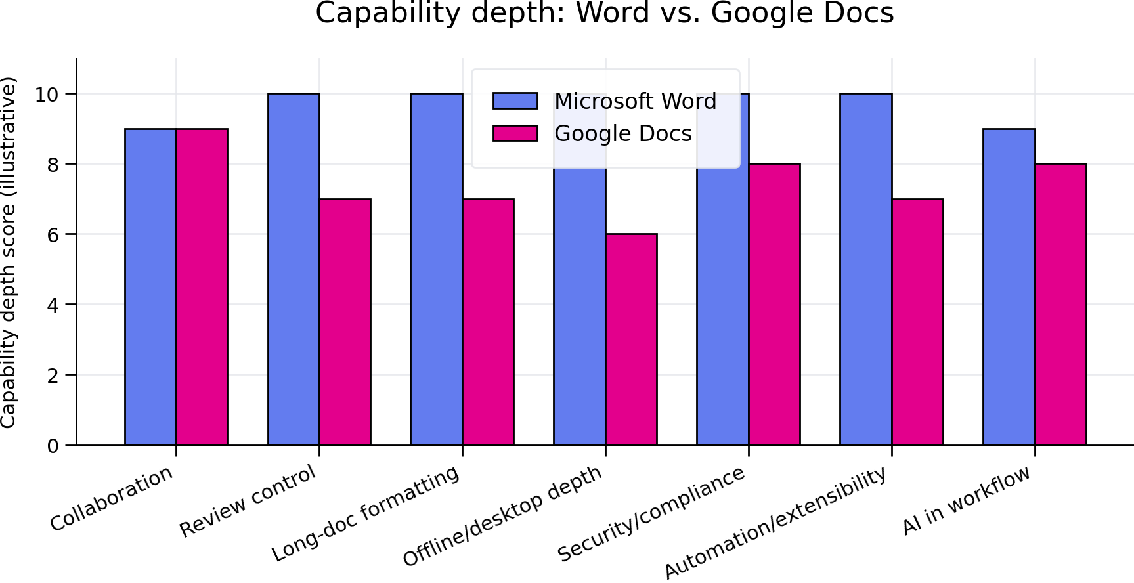

5. Built-in Word feature demonstration in this file
- Title page with styled metadata table
- Automatic Table of Contents field
- Headers and footers with page numbering fields
- Bookmarks and internal hyperlinks
- External hyperlinks to sources
- Styled comparison tables
- Callout boxes with shading
- Embedded chart image
- Landscape section for wide matrix
- Custom paragraph styles
- Footnote-style source appendix
- Checklist, glossary, numbered procedures
- Signature block
- Document properties/core metadata
- Watermark-like confidentiality statement in header
Jump back to Executive Summary or continue to the group-by-group argument below.

6. Wide stakeholder view: why each buyer persona cares
Persona | Need | Google Docs covers | Word adds | Proof point to demo | Sales line
Legal | Auditable review | Suggestions/comments | Track Changes, compare/combine, lock tracking, permissions | Turn on Track Changes; accept/reject edits | “A browser editor is not a contract lifecycle tool.”
Marketing | Pixel-aware polish | Basic layout | Advanced styles, sections, columns, image wrapping, PDF export | Show branded template and exported PDF | “Collaborate fast, publish beautifully.”
HR | Personalized outbound docs | Manual copies/add-ons | Mail merge with Excel/Outlook | Merge offer letters or policy notices | “One approved template, thousands of outputs.”
IT/Security | Data protection | Drive controls | Purview labels, encryption, DLP, eDiscovery, retention | Apply a sensitivity label | “Productivity without bypassing governance.”
Executives | Speed + trust | Live collaboration | Coauthoring plus formal sign-off and version control | Show comments, tasks, final PDF | “Fewer drafts, fewer risks.”

7. Collaboration: match the cloud-first expectation
- Coauthor in real time from Word for the web or desktop when files are in OneDrive/SharePoint.
- Use comments, replies, @mentions, and explicit permissions.
- Keep one authoritative file rather than emailing attachments.
Demo suggestion
Open this section in Word, turn on Track Changes, add a comment with an @mention, then export to PDF to show the complete workflow.

8. Review and governance: where Word separates itself
- Track Changes is more granular and formal than lightweight suggesting workflows.
- Accept/reject workflows support accountable editing.
- Compare and combine support external redlines and offline reviewers.
Demo suggestion
Open this section in Word, turn on Track Changes, add a comment with an @mention, then export to PDF to show the complete workflow.

9. Professional document production
- Advanced styles, numbering, captions, references, indexes, and sectioning support long-form documents.
- Native DOCX fidelity avoids conversion drift when the final system of record is Office.
- Word’s desktop app remains strong when internet access is poor or unavailable.
Demo suggestion
Open this section in Word, turn on Track Changes, add a comment with an @mention, then export to PDF to show the complete workflow.

10. Security, compliance, and enterprise control
- Sensitivity labels classify and protect documents.
- Encryption and usage rights can travel with the file.
- Microsoft 365 audit, retention, eDiscovery, and DLP workflows support regulated organizations.
Demo suggestion
Open this section in Word, turn on Track Changes, add a comment with an @mention, then export to PDF to show the complete workflow.

11. Automation and extensibility
- Mail merge, templates, content controls, fields, macros, add-ins, and Power Automate can industrialize document work.
- Teams can create reusable branded templates with locked-down areas and editable fields.
- IT can govern add-ins and templates centrally.
Demo suggestion
Open this section in Word, turn on Track Changes, add a comment with an @mention, then export to PDF to show the complete workflow.

12. Live demo checklist
- ☐ Open in Word desktop and show full-fidelity layout
- ☐ Update the Table of Contents
- ☐ Add a comment and @mention a reviewer
- ☐ Turn on Track Changes and make an edit
- ☐ Accept/reject a change
- ☐ Show Version History from a OneDrive/SharePoint-stored copy
- ☐ Apply a sensitivity label if available
- ☐ Export to PDF
- ☐ Run Accessibility Checker
- ☐ Use Editor or Copilot if licensed

13. Objection handling
“Google Docs is easier for collaboration.”
Agree on ease, then show Word coauthoring plus Track Changes, comments, and version history in the same file.
“Docs is browser-native.”
Word has web access and a full desktop app; users can choose lightweight browser editing or high-powered desktop editing.
“Our users like autosave.”
Autosave is available for cloud-stored Word documents, and version history supports recovery.
“We only need simple documents.”
For simple docs, both work. The reason to standardize on Word is that the same tool handles simple drafts and high-stakes deliverables.

Appendix A – Source links
- Microsoft Support – Track Changes in Word: Word supports Track Changes views, accepting/rejecting changes, author colors, and locking tracking. https://support.microsoft.com/en-us/word/training/track-changes-in-word
- Microsoft Word Blog – secure collaboration in Word: Word collaboration uses OneDrive/SharePoint with coauthoring, comments, track changes, version history, secure sharing, and access levels. https://word.cloud.microsoft/create/en/blog/document-collaboration-in-word/
- Microsoft Learn – sensitivity labels: Microsoft Purview sensitivity labels can classify and protect content with encryption, markings, and access restrictions in Office apps. https://learn.microsoft.com/en-us/purview/sensitivity-labels
- Microsoft Learn – Copilot data protection architecture: Microsoft 365 Copilot honors Microsoft 365 access controls, sensitivity labels, and encryption. https://learn.microsoft.com/en-us/microsoft-365/copilot/microsoft-365-copilot-architecture-data-protection-auditing
- Google Workspace – Google Docs product page: Google Docs provides real-time collaboration, comments, suggestions, @mentions, Smart Compose, spelling/grammar suggestions, translation, Sheets/Meet integrations, add-ons, version history, offline access, security, and encryption. https://www.googleapps.com/docs/about/?hl=en

Appendix B – Approval / sign-off
Role | Name / Signature | Date
Business Owner
IT / Security
Legal / Compliance

1. Executive summary
Microsoft Word should be positioned as the premium document platform: it matches the cloud collaboration benefits commonly associated with Google Docs, then extends beyond them with mature legal-grade review, long-document production, advanced layout, enterprise-grade protection, automation, accessibility, and integration across Microsoft 365.
- Parity: real-time coauthoring, comments, @mentions, sharing links, version history, autosave, templates, spelling/grammar help, and web access.
- Word advantage: Track Changes controls, compare/combine, mail merge, advanced styles, captions/cross-references, indexes, custom fields, content controls, macros/add-ins, protected documents, sensitivity labels, and richer desktop publishing features.
- Enterprise advantage: integration with SharePoint, OneDrive, Teams, Purview, Copilot, Outlook, Excel, PowerPoint, Power Automate, and Microsoft security/compliance workflows.
Bottom line
Google Docs is excellent for lightweight browser-first collaboration. Word is built for the full lifecycle: brainstorming, drafting, formal review, publication, records retention, compliance, and reuse.

2. Evidence base and source notes
Source | What it supports | Link
Microsoft Support – Track Changes in Word | Word supports Track Changes views, accepting/rejecting changes, author colors, and locking tracking. | Open source
Microsoft Word Blog – secure collaboration in Word | Word collaboration uses OneDrive/SharePoint with coauthoring, comments, track changes, version history, secure sharing, and access levels. | Open source
Microsoft Learn – sensitivity labels | Microsoft Purview sensitivity labels can classify and protect content with encryption, markings, and access restrictions in Office apps. | Open source
Microsoft Learn – Copilot data protection architecture | Microsoft 365 Copilot honors Microsoft 365 access controls, sensitivity labels, and encryption. | Open source
Google Workspace – Google Docs product page | Google Docs provides real-time collaboration, comments, suggestions, @mentions, Smart Compose, spelling/grammar suggestions, translation, Sheets/Meet integrations, add-ons, version history, offline access, security, and encryption. | Open source

3. Capability matrix: Word has all the expected basics plus professional depth
Capability | Google Docs expectation | Microsoft Word answer | Word advantage
Real-time coauthoring | Multiple users edit in a browser | Coauthoring in Word desktop/web when stored in OneDrive/SharePoint | Collaboration with desktop-grade layout and review controls
Comments & mentions | Comments, suggestions, action items | Threaded comments, @mentions, tasks, resolved threads | Integrated with Outlook/Teams/Microsoft 365 identity
Change review | Suggesting mode | Track Changes: insertions, deletions, formatting, reviewer identity, accept/reject, lock tracking | More formal review workflow for legal, editorial, regulated documents
Version history | Restore prior versions | Version history through OneDrive/SharePoint; local file versioning options | Cloud + enterprise repositories + records processes
Long documents | Headings, outline, basic TOC | TOC, captions, cross-references, indexes, bibliography, fields, master-document practices | Better for reports, contracts, manuals, theses
Formatting/design | Basic styles/tables/images | Advanced styles, themes, columns, section breaks, page setup, watermarks, object placement | Higher-fidelity professional output
Mail merge | Requires add-ons/workarounds | Native mail merge with Excel/Outlook data | Production-ready personalized letters, labels, envelopes, email merges
Automation | Apps Script/add-ons | VBA macros, Office Scripts ecosystem, COM/add-ins, Power Automate, content controls | Broader enterprise automation surface
Security/compliance | Drive permissions/admin controls | Purview labels, encryption, DLP, retention/eDiscovery integration, IRM, protected view | Deeper Microsoft 365 governance stack
AI assistance | Gemini/Smart Compose depending on plan | Copilot in Word plus Editor, summaries, drafting, rewrite, M365 grounding where licensed | AI integrated with M365 data and compliance controls
Offline capability | Offline mode after setup | Full desktop application plus offline files synced later | Most capable no-internet document editor

