Please find my memo indicating changes made to address editor and reviewer comments. I am grateful to the editorial team and reviewer for the opportunity to revise and resubmit the manuscript, as well as for the thoughtful and enlightening feedback they have provided. I am very happy with ways the paper has improved and hope that you all feel the same way.

The memo is organized by reviewer comment:

1. Each suggested change is provided first verbatim and in “quotes”
2. My response is *indented and italicized*
3. Where appropriate, I have replicated old and new figures/tables and also pasted the new verbatim text from the manuscript/appendix highlighted in gray.

I hope this eases the process of re-reviewing the paper by minimizing back and forth between the memo and the revised manuscript. Thank you all, again.

**Editorial Team review**

Editorial team:“Thus, we invite you to revise your manuscript and resubmit it as a Research Note for further review. Note that the word limit for Research Notes is 8,000 words.”

*The paper has been revised to be a Research Note. The word count (including title, abstract, footnotes, captions, and citations) is now: 8,546 words*

“Spotlight your main findings early in the manuscript, following the advice of Reviewer 1.”

*The main findings are now spotlighted in the fourth paragraph of the introduction, which has been shortened. The new paragraph on the findings, also reproduced below in response to Reviewer 1’s comment, are below:*

[Begin paper excerpt]

Cross-domain military contests are neither new nor a cause for alarm. Rather than introduce a new theory, this paper contributes to the existing theoretical debate between the deterrence and spiral models of conflict with four main findings about domains that provide empirical support for existing optimistic theories of cross-domain deterrence. First, cross-domain conflict is prevalent. Some degree of cross-domain military action occurs in 58% of crises over the past century, with 23% of crises involving completely dissimilar military actions by belligerents. Second, cross-domain conflict is not novel: the rate of “cross-domainness” has remained more-or-less constant over the past century despite the accumulation of new military domains during this time period. The number of domains available does not itself seem to have triggered a greater reliance on cross-domain operations. Third, crises in which belligerents engage in cross-domain military conflict are no more escalatory than crises where conflict remains within a given domain. Indeed, cross-domain conflicts in crises actually appear slightly less violent than conflicts within domains. Finally, cross-domain conflict in crises does not endure appreciably longer than crises in which states respond with like-means. Taken together, these findings seem to support optimistic interpretations of the effects of cross-domain conflict and to mitigate against pessimistic fears. While data on the more salient new domains like cyber remains limited at this time and these domains may be distinct when it comes to likely casualties and the types of actors that engage, insights about cross-domain interactions in more traditional military domains should help to inform theories of conflict as they are being developed and applied to more novel domains.

[End paper excerpt]

Editorial team:“Cut most of the theory (section 2) and implications (section 5) sections, focusing on the data and how it tests the two competing explanations.”

*Section 2 has been shortened and no longer includes a discussion of:*

* *other theories of conflict escalation*
* *origin of security dilemma debate*
* *conventional-nuclear interaction*
* *new cyber and space domains*

*Instead, section 2 is now focused on just defining domains and policymaker concern about cross-domain conflict. It is reproduced below in full:*

[Begin paper excerpt]

A growing number of studies seek to address the effect on escalation of how conflicts are fought. Despite manifest interest, however, there is little agreement about how to conceptualize and categorize the means by which nations fight. One approach to differentiating the means of conflict is in terms of the domains in which conflicts take place. There are many ways of thinking about domains, as they can be distinguished from one another by technology, tactics, geography, or purpose (Lindsay and Gartzke 2019). Some have questioned the utility of conceptualizing these domains as distinct, especially as new domains like space and cyber increasingly play the role of supplementing rather than supplanting operations in more traditional domains (Libicki 2012).

Rather than engage in ontological debates about the best way to typologize conflict behavior, domains here represent a useful starting point for thinking about differences in the ways that nations choose to fight, and how these differences affect observable attributes of conflict, such as duration or intensity. Practitioners think about domains as distinct with distinctive (and known) advantages and disadvantages (Lindsay and Gartzke 2019). As already noted, the term “domain” is used here loosely to refer to land, air, sea, WMD, space, and cyber. Domains differ from one another in the constraints (and opportunities) they offer concerning power projection, movement, coordination, casualty risk, and cost – all factors that produce unique cross-domain dynamics regarding conflict intensity and duration (Lindsay and Gartzke 2020, 9–10).

If the problem of the security dilemma is to decide whether a particular response to an adversary’s behavior will deter or escalate, the problem as applied to the conduct of an actual conflict is whether the military means one chooses determines the likelihood of escalation. Evaluations of the importance of actions in domains has recently shifted to theorizing about interactions across domains (Lindsay and Gartzke 2019). There is suspicion that cross-domain interactions are more prevalent now because there are more (and newer) domains in which states operate. Researchers and policymakers have expressed concerns that new tools of warfare may embolden revisionist forces in world affairs (Hicks and Friend 2019), although skepticism about the novelty and efficacy of these “new” forms of warfare has also cast some doubt on those concerns (Gannon et al. 2021).

Empirical evidence, however, remains limited due in large part to the very novelty and putative heterogeneity of these emerging domains (Mawdsley 2016). Even where recent empirical research has made headway in identifying the ownership and use of new modes of warfare, the efforts are contained to a single capability or domain (Allen and Martinez Machain 2018).

[End paper excerpt]

*Section 5 (implications) has been shortened and no longer includes a discussion of:*

* *Cyber-kinetic interaction and implications for new domains*
* *Policy implications for A2AD in East Asia and Russian gray zone conflict*
* *Avenues for future research (sequence of actions, disaggregating military units, disaggregating military actions, non-military actions, domains as a dependent variable)*

*Instead, section 5 is now just focused on the empirical finding about the consistency of cross-domain interactions over time as well as the test of the deterrence vs spiral explanations of cross-domain conflict. It is reproduced in full below:*

[Begin paper excerpt]

Emerging interest in understanding cross-domain conflict is well-deserved, given the frequency with which these interactions occur. But this research need not be spurred by, not limited to, the study of new domains made possible because of emerging technologies. Crises have always been cross-domain. As far back as World War II, President Roosevelt advocated high altitude precision bombing precisely because it represented a cross-domain military strategy, as “Hitler built a fortress around Europe, but he forgot to put a roof on it.” (footnote: quoted in Grant (2007).) Indeed, contrary to the convictions of many observers, the evidence provided here seems to show that cross-domainness is both common and has not risen appreciably over the past century.

Competing theories of deterrence and spiral models of conflict have rarely accounted for the strategic interaction of the military domains used by opposing sides. The common assumption held by pessimists is that cross-domain interactions risk a dangerous spiral because of potential miscommunication over proportionality, stake, and resolve. In contrast, the evidence provided here suggests that cross-domain interactions contain elements of the stability-instability paradox, where one side’s willingness to shift conflict new domain — a potential indicator of a willingness to escalate — creates conditions that lessen observed crisis escalation. Attempts to use full-spectrum combined arms forces may increase a state’s probability of victory, but those doing so should consider preparing for a bloodier war if their opponents are not already using, or are unlikely to respond with, their own full-spectrum combined arms forces.

[End paper excerpt]

Editorial team: “Clarify the presentation and discussion of the data, following the detailed advice of both reviewers.”

*The presentation and discussion of the data has been clarified, including figures and tables redone in alignment with suggestions, the continuous nature of the independent variable re-written, and clarification of missing data on domains actor possess included. Those are described in detail after each of the corresponding reviewer suggestions.*

Editorial team: “Note also that International Studies Quarterly is committed to ensuring that scholars receive appropriate intellectual acknowledgement regardless of race, gender, class, professional standing, or other categorical attributes. Please pay particular attention to this issue when revising your citations for overlooked authors and literatures. You can easily check the gender-balance of your references by using the GBAT tool found here: https://jlsumner.shinyapps.io/syllabustool/. Using this tool, your references are approximately 21.36% woman-authored. Given the persistent gender citation gap in international relations and the increasing number of female students and faculty in the discipline, we aim for approximately 30% female citations to ensure appropriate scholarly recognition.”

*Significant revisions were made to the citations in this manuscript. Cutting down section 2 and section 5 resulted in numerous all-male citations being removed, as their arguments are no longer part of the manuscript. Redundant “list” citations were also modified.*

*More important than removing all-male citations, numerous citations to woman-authored pieces were added to the manuscript. As a result of these two changes, the GBLAT tool now indicates that the references are approximately 29.09% woman-authored.*

*Of the 14 new citations, 4 are mixed co-authored and the remaining 10 are woman-authored:*

1. *Allen, Susan Hannah, and Carla Martinez Machain. 2018. “Choosing Air Strikes.” Journal of Global Security Studies 3 (2): 150–62.* [*https://doi.org/10.1093/jogss/ogy005*](https://doi.org/10.1093/jogss/ogy005)*.*
2. *Carson, Austin, and Keren Yarhi-Milo. 2017. “Covert Communication: The Intelligibility and Credibility of Signaling in Secret.” Security Studies 26 (1): 124–56.* [*https://doi.org/10.1080/09636412.2017.1243921*](https://doi.org/10.1080/09636412.2017.1243921)*.*
3. *Chung, Neo Christopher, BłaŻej Miasojedow, Michał Startek, and Anna Gambin. 2019. “Jaccard/Tanimoto Similarity Test and Estimation Methods for Biological Presence-Absence Data.” BMC Bioinformatics 20 (15): 644.* [*https://doi.org/10.1186/s12859-019-3118-5*](https://doi.org/10.1186/s12859-019-3118-5)*.*
4. *Grant, Rebecca. 2007. “Return of the Bomber: The Future of Long-Range Strike.” AIR FORCE ASSOCIATION ARLINGTON VA.*
5. *Lupton, Danielle L. 2020. “The Reputational Costs and Ethical Implications of Coercive Limited Air Strikes: The Fallacy of the Middle-Ground Approach.” Ethics & International Affairs 34 (2): 217–28.* [*https://doi.org/10.1017/S0892679420000209*](https://doi.org/10.1017/S0892679420000209)*.*
6. *Macdonald, Julia, and Jacquelyn Schneider. 2019. “Battlefield Responses to New Technologies: Views from the Ground on Unmanned Aircraft.” Security Studies 0 (0): 1–34.* [*https://doi.org/10.1080/09636412.2019.1551565*](https://doi.org/10.1080/09636412.2019.1551565)*.*
7. *Mastro, Oriana Skylar. 2011. “Signaling and Military Provocation in Chinese National Security Strategy: A Closer Look at the Impeccable Incident.” Journal of Strategic Studies 34 (2): 219–44.* [*https://doi.org/10.1080/01402390.2011.559025*](https://doi.org/10.1080/01402390.2011.559025)*.*
8. *Mawdsley, Jocelyn. 2016. “Comparing Militaries: The Challenges of Datasets and Process-Tracing.” In The Routledge Companion to Military Research Methods, edited by Alison J. Williams, Neil Jenkings, Rachel Woodward, and Matthew F. Rech, 115–25.*
9. *Mehta, Rupal N. 2019. “Extended Deterrence and Assurance in an Emerging Technology Environment.” Journal of Strategic Studies 0 (0): 1–25.* [*https://doi.org/10.1080/01402390.2019.1621173*](https://doi.org/10.1080/01402390.2019.1621173)*.*
10. *Pettyjohn, Stacie L., and Becca Wasser. 2019. “Competing in the Gray Zone: Russian Tactics and Western Responses.” Santa Monica, CA: RAND Corporation.*
11. *Rasler, Karen A., and William R. Thompson. 2006. “Contested Territory, Strategic Rivalries, and Conflict Escalation.” International Studies Quarterly 50 (1): 145–67.* [*https://doi.org/10.1111/j.1468-2478.2006.00396.x*](https://doi.org/10.1111/j.1468-2478.2006.00396.x)*.*
12. *Talmadge, Caitlin. 2017. “Would China Go Nuclear? Assessing the Risk of Chinese Nuclear Escalation in a Conventional War with the United States.” International Security 41 (4): 50–92.* [*https://doi.org/10.1162/ISEC_a_00274*](https://doi.org/10.1162/ISEC_a_00274)*.*
13. *Tan, Michelle. 2017. “The Multi-Domain Battle.” Defense News.* [*https://www.defensenews.com/digital-show-dailies/ausa/2016/10/03/the-multi-domain-battle/*](https://www.defensenews.com/digital-show-dailies/ausa/2016/10/03/the-multi-domain-battle/)*.*
14. *Vasquez, John A., and Marie T. Henehan. 2001. “Territorial Disputes and the Probability of War, 1816-1992.” Journal of Peace Research 38 (2): 123–38.*

**Reviewer 1**

Reviewer 1: “First, the paper lacks “punch.” I should note that this paper is polished and clearly written, but I emerge unenthused by the framing (albeit excited about the new data). Perhaps the author could incorporate policymaker quotes or something along those lines to liven it up a bit? I leave it up to the editors to decide whether this is necessary. This point might be related to the fact that the paper does not propose a new theory but rather relies on competing conceptions of the effectiveness of cross-domain warfare. The author proposes new data to speak to the ongoing debate between pessimists and optimists on cross-domain conflict. I have no problem with this approach. Indeed, I think it suitable to the introduction of a new dataset. However, I think this approach contributes to an underwhelming argument section.”

*The first half of the introduction has been re-written to add more “punch”. One policymaker quote has been added to the first paragraph to be illustrative of the concern about new domains of warfare:*

[Begin paper excerpt]

Increased technological sophistication has given rise to new modes of conflict as states acquire a growing number of "levers" or options through which to confront one another. During the advent of each new domain of conflict, practitioners scramble to update military strategy and technology to keep up with the now irreparably transformed landscape of war. General David Perkins, Senior Commander of Training and Doctrine Command, noted that the Cold War featured "ground forces fighting ground forces, air forces fighting air forces. Cyber didn’t even exist when I was a lieutenant. What’s happening now is those lines are blurring between those domains...So what we’re seeing is the ability to take an activity in one domain and produce an effect or dominate another domain." (footnote: quoted in Tan 2017.) There is little consensus about whether to sound the alarm about dangerously escalatory cross-domain interactions (Pettyjohn and Wasser 2019) or to caution against excess concern (Borghard and Schneider 2019). There also remains considerable ambiguity about whether recent cases of cross-domain conflict are emblematic of the future of warfare, or whether they are at most variations on a more durable set of themes (Gannon et al 2021). As so often occurs, the question is "how new is new"?

While recent events have motivated a growing interest in understanding the settings in which states take military action and the consequences those choices have for international stability, the larger context of cross- or multi-domain conflict has not been studied systematically. In part, this is due to limited empirical data concerning the conduct of conflict. While scholars have developed numerous detailed datasets of participants, duration, and outcomes to understand conflict, empirically-oriented research concerning where contests take place, within which domain, has only recently received attention (Lindsay and Gartzke 2019). Researchers typically frame their inquiries around particular emerging technologies (Sechser, Narang, and Talmadge 2019) or operations within individual domains, unable to address more formative questions about how domains interact (Allen 2017; Lupton 2020).(footnote: For work that does look at cross-domain interaction, see Martinez-Machain (2015), Macdonald and Schneider (2019), and Post (2019).)

This paper takes an inductive, data-driven approach to identify spatial and temporal patterns in the military domains in which states operate during conflict as well as the relationship between cross-domain interactions and the intensity and duration of international crises. Rather than come up with a new typology of military domains, this study adopts a commonly agreed upon understanding shared by practitioners and scholars that contains the traditional domains of land, air, and sea as well as the recent domains of space, cyber, and weapons of mass destruction (WMD).(Footnote: While WMD is rarely a distinct military branch and has geographic overlap with the other domains, they do represent a distinct domain in how actors think about them in the international context. My concern here is less to get domains "right" and more to expose the diversity of options for conflict setting.) In doing so, the study develops and introduces a novel dataset of the military domains in which 1,282 crisis actors operated during 425 international crises from 1918 to 2015. These data expand on the familiar and well-regarded International Crisis Behavior dataset (Brecher and Wilkenfeld 2000).

[End paper excerpt]

*Another policymaker quote has been added to the first paragraph of the conclusion to illustrate the concept that cross-domain conflict is not new. That paragraph is reproduced below:*

[Begin paper excerpt]

Emerging interest in understanding cross-domain conflict is well-deserved, given the frequency with which these interactions occur. But this research need not be spurred by, not limited to, the study of new domains made possible because of emerging technologies. Crises have always been cross-domain. As far back as World War II, President Roosevelt advocated high altitude precision bombing precisely because it represented a cross-domain military strategy, as “Hitler built a fortress around Europe, but he forgot to put a roof on it.” (footnote: quoted in Grant (2007).) Indeed, contrary to the convictions of many observers, the evidence provided here seems to show that cross-domainness is both common and has not risen appreciably over the past century.

[End paper excerpt]

Reviewer 1: “The author simply needs to make their contribution clearer. S/he is making an important argument (that cross-domainness in neither new nor dangerous) but dances around the debate, almost as if hoping not to offend anyone. As one possible suggestion, the author could make it more explicit before section 3.1 that s/he is going to test two sets of competing theories. It is not 100% clear that this is the case throughout the early sections.”

*The second half of the introduction has been re-written to eliminate two paragraphs that danced around the importance of defining military domains and to make clear that the paper is about testing two competing theories and which theory it finds support for (the optimism theory). The re-written latter half of the introduction is re-produced below. Note that it picks up right where my response to the previous comment left off, so the complete revised introduction is composed of the previous excerpt followed by this one:*

[Begin paper excerpt]

Cross-domain military contests are neither new nor a cause for alarm. Rather than introduce a new theory, this paper contributes to the existing theoretical debate between the deterrence and spiral models of conflict with four main findings about domains that provide empirical support for existing optimistic theories of cross-domain deterrence. First, cross-domain conflict is prevalent. Some degree of cross-domain military action occurs in 58% of crises over the past century, with 23% of crises involving completely dissimilar military actions by belligerents. Second, cross-domain conflict is not novel: the rate of “cross-domainness” has remained more-or-less constant over the past century despite the accumulation of new military domains during this time period. The number of domains available does not itself seem to have triggered a greater reliance on cross-domain operations. Third, crises in which belligerents engage in cross-domain military conflict are no more escalatory than crises where conflict remains within a given domain. Indeed, cross-domain conflicts in crises actually appear slightly less violent than conflicts within domains. Finally, cross-domain conflict in crises does not endure appreciably longer than crises in which states respond with like-means. Taken together, these findings seem to support optimistic interpretations of the effects of cross-domain conflict and to mitigate against pessimistic fears. While data on the more salient new domains like cyber remains limited at this time and these domains may be distinct when it comes to likely casualties and the types of actors that engage, insights about cross-domain interactions in more traditional military domains should help to inform theories of conflict as they are being developed and applied to more novel domains.

This paper is organized into five sections. Section 2 outlines existing thinking concerning the domains in which states fight. Section 3 then details the existing theoretical debate between cross-domain pessimists and optimists, as applied to the intensity and duration of international crises. Section 4 provides an empirical test of these contrasting theories by introducing a novel dataset of the military domains in which states operated during international crises since 1918. Section 5 concludes with the implications of these findings for theories of conflict.

[End paper excerpt]

Reviewer 1: “Figures 1 & 3 could be simplified into tables to take up less space.”

*Figure 1 has been replaced with tables. Below, see old Figure 1 (left) and new Table 2 (right). Figure 3 is addressed in the next comment.*

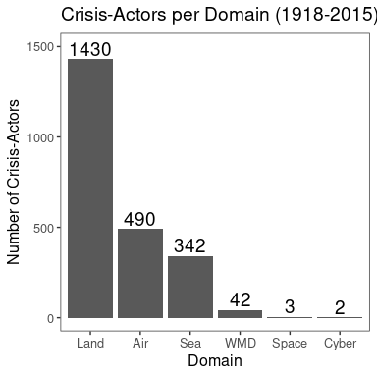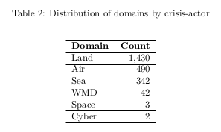

Reviewer 1: “For Figure 3, I’m unsure why there are two bars for 0.25 and 0.75. You could also label the bars.”

*Figure 3 has been redone by converting it from a histogram to a bar plot. The histogram was unclear since each unique value was not labeled, hence the appearance of multiple bars for 0.25 and 0.75. The new figure now labels each value, conveying that the “second bar” for 0.25 is actually the cases with a cross-domainness score of 0.33. This should better convey the continuous nature of the measure than a table would by providing a sense of the “distance” between the scores. The old figure (left) and new figure (right) are shown here:*

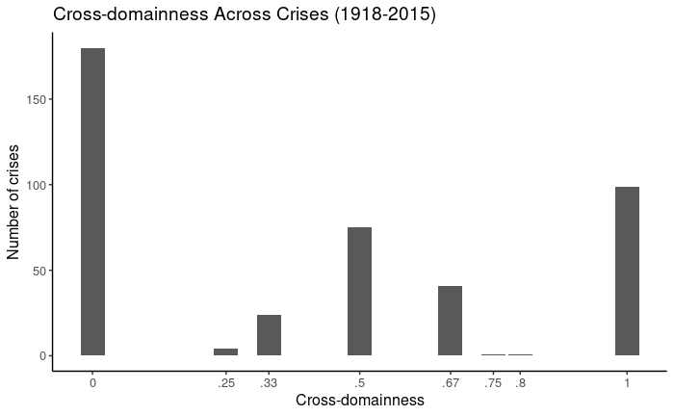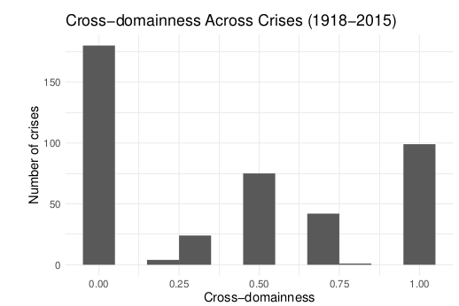

Reviewer 1: “Figure 2 just needs to be more aesthetically pleasing with clear labels, smaller/different font, etc.”

*Figure 2 has been redone as a simplified Venn diagram focusing on the land, air, and sea domains since they are by far the most common. The appendix includes a cleaned up version of the original plot with smaller text, clearer labels, cleaner dots, and a descriptive title. Below, see old Figure 2 (left) and new Figure 2 (right):*

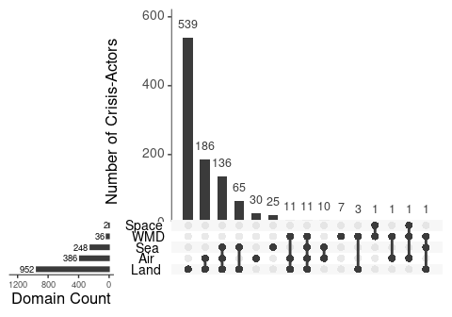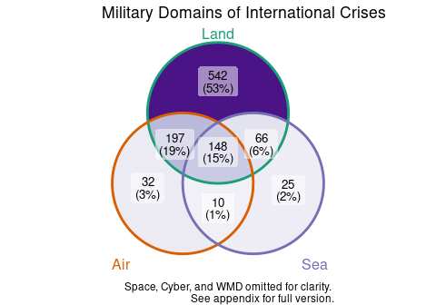

Reviewer 1: “I would cut figure 5 completely or move it to the appendix. Given that the author does not code the ICB dataset, no figures of the dataset are necessary. You can easily describe them verbally in the text or just put everything into the appendix.”

*Figure 5 has been removed from the manuscript. Instead, summary statistics for the two dependent variables are provided in Table 1 in the appendix. Below see old Figure 5 (above) and new appendix table A1 (below):*

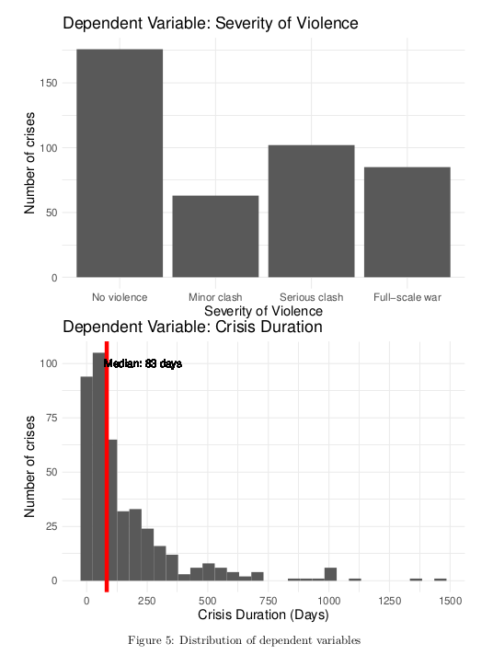

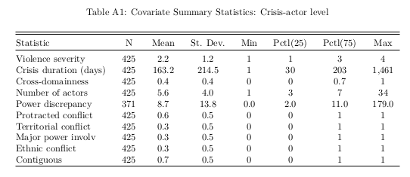

Reviewer 1: “When analyzing the data in Table 3, is the independent variable binary (cross-domain or no) or ordered (cross-domain at different levels)? I assume the latter based on the coding but it was unclear from the author’s discussion. Personally, I’d like to see both the binary and the ordinal measures estimated in these models. With the binary, the author could get predicted probabilities, looking at the probability of violence at each stage. This might help the author interpret the substantive effects. I use margins, margins(dydx), and marginsplot in Stata to this effect.”

*The independent variable (cross-domainness) is a continuous measure bounded between 0 and 1 where higher values represent higher cross-domainness. The first paragraph of Section 4.1.3 “Measuring cross-domainness” has been rewritten to clarify that. The revision to Figure 3 (converting the histogram to a bar plot) should also help. The new paragraph describing the measurement of the independent variable (cross-domainness) is reproduced here in full:*

(Begin paper excerpt)

4.1.3 “Measuring cross-domainness” The third and final step involves identifying the dissimilarity of the domains in which each side of each crisis-dyad took actions. "Cross-domainness" is a continuous variable between 0 and 1, inclusive. For each crisis, if the two sides took actions in identical domains, "cross-domainess" equals 0. As the distinctiveness of the domains in which each side acted increases, the value of "cross-domainness" increases, with crises where the two sides took actions in entirely distinct domains equaling 1.

[end paper excerpt]

*To the reviewer’s point about a binary measure to generate predicted probabilities, the question is whether all the values of cross-domainness between 0 and 1 (non-inclusive) should be treated as 0’s or as 1’s:*

*I looked into existing research using similar measures in non-political science fields and found inconsistent suggestions. I could either consider any amount of dissimilarity as cross-domain (converting all values > 0 to 1) or consider any amount of similarity as same-domain (converting all values < 1 to 0). In other words, I would have to decide if a crisis in which one side used land + air and the other used land + sea was coded as a 0 because they both used land or coded as a 1 because air and sea were each used by only one side.*

*The optimism and pessimism theories don’t provide a clear theoretical prior about which of those two coding decisions to take, and the results are unlikely to be the same for both coding decisions. Absent a theoretical prior, I am hesitant to run both models and then decide ex-post which makes more sense as a generalized interpretation of “cross-domain”.*

Reviewer 1: “Finally, I’d like to see more descriptive statistics as they relate to the actors using the various military options. Do most of the cross-domain situations involve great powers? Mostly, I’d like to know whether cross-domain military conflict is just a thing of powerful states.”

*The summary statistics section of the appendix now includes 2 tables showing cross-domainness as it relates to great powers. The new text in the appendix, as well as the 2 new tables, are reproduced in full below:*

[Begin appendix excerpt]

Different states could be expected to take military actions in the various domains at different frequencies. Table A2 shows that, consistent with expectations, superpowers use a wider variety of domains than small and middle powers. At the crisis-level, Table A3 shows that there is no significant difference in the amount of cross-domainness conditional on the number of great powers involved. This could occur if great power opponents in a crisis use the same domains as one another at the same rates as crises involving two non-great powers. The codings for great power status used here come from the original ICB coding and are defined in the original codebook (Brecher and Wilkenfeld 2000).

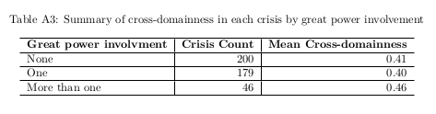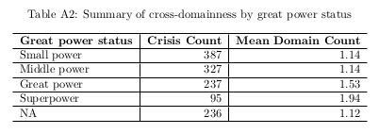[End appendix excerpt]

**Reviewer 2**

Reviewer 2: “As it stands, the paper seems like it would make more sense as a data paper that focuses more on exploring the data. In what follows I will make several broad recommendations that I believe will help the author in revising this manuscript.”

*The paper has been revised to be a research note focused on the empirical contribution and new data. Those revisions are described above in the comments to the editorial team.*

Reviewer 2: “Mainly, I think that the largest problem with this manuscript is that while it discusses on page 15 that 0s (cases in which different countries did not use a particular domain) mean different things for countries that chose not to use that domain as opposed to those that were not able to use the domain, this is not further addressed in the analysis or in the theory. The author compares the similarity of domains that were used by both sides, but does not further address what it means when one side did not have a domain as an option and the other did. I bring this point up because the author is dealing with the use of domains as a signal of resolve and willingness to escalate. If the author were focusing on the effect that the use of different domains has on outcomes, I could see how it would matter less whether a state had the ability to use one type of domain versus another. Yet, when we think of the use of domains as a signal, then choosing not to expand to a new domain can also be a signal in and of itself (for example, it can be a signal of restraint that keeps the crisis from escalating). In addition, countries that are much more powerful in one domain rather than another may focus on the one domain not because they are avoiding escalation, but because they know where their comparative advantage is. Thus, I think that without considering these points, the inferences that can be drawn from the similarity of domains in which the actors engaged is somewhat limited. If this were a paper that was more focused on introducing the data itself, this problem would be avoided.”

*The reviewer is correct that absent data on whether an actor could have taken military action in a particular domain, the theoretical analysis is somewhat limited. I spent a few months trying to collect that data from both a newly released dataset on post-1970 military capabilities (rDMC at* [*https://www.militarycapabilities.com/*](https://www.militarycapabilities.com/)*) as well as gathering original data on pre-1970 military capabilities from the Stateman’s Yearbook. In doing so, I realized that still would not fully resolve the problem at the country or crisis-dyad level since regardless of what domains each side possessed, the lowest possible cross-domainness score is always 0 (land vs land can occur regardless of all the other options) and the highest possible cross-domainness score is always 1 (land vs non-land can always occur regardless of all the other options).*

*Incorporating the reviewer’s insight would require a new measure for crises where 1) the overall combination of domains used by actor A could not have been used by actor B and 2) cases where an actor abstained from using a domain it did possess. The latter, as the reviewer notes, requires a significantly more developed theory since it requires thinking through what it means to “use” domains given research on general vs immediate deterrence (are US nuclear weapons or aircraft carriers ever really coded as a “not used”?).*

*To partially address this important concern, I have made the following changes to the manuscript:*

*1. The paper is now focused on introducing the data itself. Section 2 and the implications section have been significantly condensed and the theory section has been re-written to make clear that it is a test of existing theories of deterrence and spiral models of conflict.*

*2. The point about actors shifting (or consciously not shifting) to a domain where they have comparative advantage has been incorporated into the manuscript, with a caveat that empirically evaluating this claim requires data about the domains in which actors could have taken military action and that data is not available here.*

[Begin paper excerpt]

While presenting your enemy with multiple dilemmas --- responding to your adversaries "rock" with "paper" --- may help you win a contest, it could also produce an incentive for your opponent to do the same --- respond again with "scissors" --- thus encouraging escalation (Talmadge 2017). It has been argued that responding in-kind --- playing rock against rock --- should be de-escalatory because it represents a symbolic gesture to opt against one's most efficient response (paper), as doing do would require the opposing side to engage in a new, even more efficient response (scissors). If an actor has a comparative advantage in a domain in which their opponent is not taking action, opting not to reap the benefits of conflict in that domain represents a refusal to escalate.(footnote: An empirical test of this argument requires data on the domains in which an actor could take military action. Although that data is not introduced in this paper, it is noted as an important area for further inquiry.) By responding in-kind, states can agree to call it a draw in a way that represents an explicit or tacit compromise (Carson 2016). Conversely, engaging in a new military domain may unintentionally create an "escalatory updraft" if the opponent misinterprets what should be a tit-for-tat response that ends aggression with one that instead escalates it (O’Neill 1991, p 104). Taking action in a new domain may help one side secure victory by representing a reduction in cost, but the very logic of escalation dominance that generates that outcome also means interacting in the new domain constitutes a (relative) increase in cost for one's opponent, with adverse consequences for the likelihood of a peaceful settlement (Mehta 2019). Cheap and easy can be attractive, but it sends mixed messages. An opponent may be cowed by superior capabilities across domains, but they may also be encouraged by implicit evidence of an opponent's unwillingness to pay the high(er) price of sticking it out, within a given domain.

[End paper excerpt]

*3. I plan on continuing the data collection on domains in which states could have taken action during this time period, in the hopes that a future manuscript can develop the theory of signaling described here. Existing research (Post 2019) on signaling provides a useful starting point for thinking about domains in this respect, and applying that to the ICB data at the domain-level with distinct categorical values for (1) not owned, (2) owned + not used, and (3) owned + used.*

Reviewer 2: “One area that I think is left unexplored by the author is the increased effectiveness that comes from engaging in cross-domain warfare. This point is mentioned briefly on page 21, but not really discussed at length. Given that this is something that would not really be affected by the “different zeroes” problem mentioned on page 15, I think that it would be worth exploring further. If cross-domain warfare makes victory more likely, then perhaps what is being signaled by the use of new domains is one state’s greater capabilities (which “on paper” may not be as credible of a signal).”

*This is an exciting question that initially motivated the project. The difficulty is that cross-domain is a crisis-level variable that is difficult to apply to an actor-level dependent variable like victory/outcome. For cross-domainness to be an actor-level variable, the sequence of events in a crisis would have to be known. For example, if actor A first deployed land troops and then actor B responded with an aerial bombing, we could say that actor B took “cross-domain” action because their reaction was in a different domain than the initial action. But if all we know is that in a crisis, one side deployed troops and the other engaged in aerial bombing, it is not clear which actor took the crisis “out of domain”.*

*This issue is being addressed in a future edition of the data that does code the sequence of actions in each crisis. With the sequence coded, researchers can then code when an actor responds to an action “out of domain” as well as what action that was a response to. Unfortunately, that coding has been ongoing for over 6 years given the difficulties of coding event data at the sentence level. The author hopes that version of the broader data will be released soon, and wants this paper to be an initial demonstration of the value of domain-level data that is needed to justify continued effort into the broader project.*

*As an initial test, the appendix now includes a table of descriptive statistics about the number of domains an actor uses and the crisis outcome. That table and the accompanying text are reproduced below in full:*

[Begin appendix excerpt]

The number of domains in which states take actions could also be an indication of their resolve, as devoting resources to more domains may indicate a greater willingness to incur costs. This could positively correlate with an actor’s probability of victory since actors who devote more resources to a conflict may be more likely to emerge victorious. Table A4 provides descriptive statistics that indicate there may be a weak positive relationship between the number of domains in which an actor takes military action and the likelihood of a positive outcome. A more sophisticated analysis would look at “relative domain count” – accounting for the number of domains their opponent used – to test theories evaluating the balance of capabilities as opposed to the balance of resolve (Powell 2015).

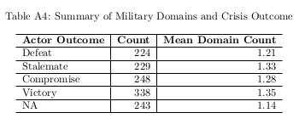

[End appendix excerpt]

Reviewer 2: “Finally, I believe that by addressing the cyber domain when only two of the crisis actors in the sample use it, the paper may be extending itself too much. I understand that we can draw inferences about the cyber domain from other cross-domain uses of force, but I still think that the difference in adding air power to a ground-only campaign is different from adding land-based forces to a cyber operation. Though cyber operations are indeed aggressive and can result in people being killed, I think they are still perceived differently than more traditional uses of military force. As an example, there have recently been various cbyer attacks from foreign actors against U.S. actors. Though there has certainly been a strong public response to them, it is very different from what it would have been if these had been naval attacks against U.S. vessels, for example (even if they were attacks that did not result in any casualties).”

*References to the cyber domain have been omitted from the theory section (cross-domain escalation) and from the implications section given the reviewer’s point about the uniqueness of cyber.*

*The introduction has also been modified to mention some of the ways in which the cyber domain is unique. It now reads as follows:*

[Begin paper excerpt]

Taken together, these findings seem to support optimistic interpretations of the effects of cross-domain conflict and to mitigate against pessimistic fears. While data on the more salient new domains like cyber remains limited at this time and these domains may be distinct when it comes to likely casualties and the types of actors that engage, insights about cross-domain interactions in more traditional military domains should help to inform theories of conflict as they are being developed and applied to more novel domains.

[End paper excerpt]

Reviewer 2: “As a minor point, when the author notes (under the pessimistic theory) that cross-domain conflict makes it harder to compare proportionality, an illustrative example would be useful to clarify this point.”

*An illustrative example from the Cuban Missile Crisis, originally provided by Schelling, has been provided in his discussion of the importance of “connectedness” between a response and the domain of aggression. The second half of the first paragraph of the pessimistic subsection has been re-written to this effect and is reproduced below:*

[Begin paper excerpt]

Crises in which actors interact in dissimilar military domains may be more violent and/or last longer because cross-domain interactions complicate interpretations of proportionality and the scope of disputed stakes, thus contributing to misperceptions of capability or resolve (Morrow 2019). If a belligerent taking action with 100 ground troops is met with a defender deploying 1000 ground troops, the belligerent could reasonably interpret the defender's action as a "raise" indicating the defender places a high value on the issue(s) in dispute. But if the defender responds to a deployment of 100 troops with 10 aircraft, it is less clear whether that is a raise, or instead is an effort to achieve something different, such as saving face. Schelling (1966, p. 87) describes the risk of a hypothetical example where the US responds to Soviet missiles in Cuba by quarantining Vladivostok. Because there is "a tendency to keep things in the same currency, to respond in the same language", cross-domain conflict makes it difficult for actors to ascertain their opponents resolve (Schelling 1966, p. 147). Cross-domain conflict presents actors with an "apples-to-oranges" comparison, making it more difficult potentially to assess relative resolve or an opponent's value for the issue(s) at stake. This injection of (additional) ambiguity could make a negotiated settlement more difficult by clouding evaluations of the bargaining range.

[End paper excerpt]