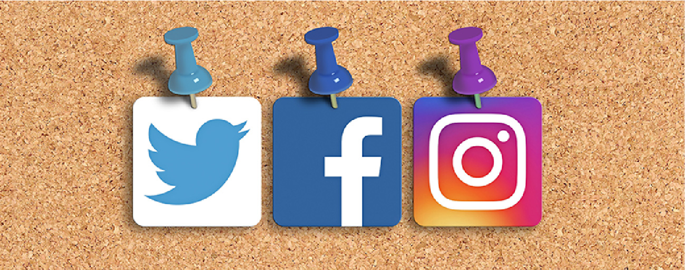

Figure 1.1 Do You Use Facebook? Economics is greatly impacted by how well information travels through society. Today, social media giants Twitter, Facebook, and Instagram are major forces on the information super highway. (Credit: modification of "Social Media Mixed Icons - Banner" by Blogtrepreneur/Flickr, CC BY 2.0)

Chapter Objectives

In this chapter, you will learn about:

* What Is Economics, and Why Is It Important?
* Microeconomics and Macroeconomics
* How Economists Use Theories and Models to Understand Economic Issues
* How Economies Can Be Organized: An Overview of Economic Systems

## Introduction

Bring It Home

Information Overload in the Information Age

To post or not to post? Every day we are faced with a myriad of decisions, from what to have for breakfast, to which show to stream, to the more complex—“Should I double major and add possibly another semester of study to my education?” Our response to these choices depends on the information we have available at any given moment. Economists call this “imperfect” because we rarely have all the data we need to make perfect decisions. Despite the lack of perfect information, we still make hundreds of decisions a day.

Streams, sponsors, and social media are altering the process by which we make choices, how we spend our time, which movies we see, which products we buy, and more. Whether they read the reviews or just check the ratings, it's unlikely for Americans to make many significant decisions without these information streams.

As you will see in this course, what happens in economics is affected by how well and how fast information disseminates through a society, such as how quickly information travels through Facebook. “Economists love nothing better than when deep and liquid markets operate under conditions of perfect information,” says Jessica Irvine, National Economics Editor for News Corp Australia.

This leads us to the topic of this chapter, an introduction to the world of making decisions, processing information, and understanding behavior in markets —the world of economics. Each chapter in this book will start with a discussion about current (or sometimes past) events and revisit it at chapter’s end—to “bring home” the concepts in play.

What is economics and why should you spend your time learning it? After all, there are other disciplines you could be studying, and other ways you could be spending your time. As the Bring it Home feature just mentioned, making choices is at the heart of what economists study, and your decision to take this course is as much as economic decision as anything else.

Economics is probably not what you think. It is not primarily about money or finance. It is not primarily about business. It is not mathematics. What is it then? It is both a subject area and a way of viewing the world.