## Self-Check Questions

[1](http://openstax.org/books/principles-microeconomics-3e/pages/chapter-10#fs-idm64669072-solution).

Suppose that, due to a successful advertising campaign, a monopolistic competitor experiences an increase in demand for its product. How will that affect the price it charges and the quantity it supplies?

[2](http://openstax.org/books/principles-microeconomics-3e/pages/chapter-10#fs-idm141628400-solution).

Continuing with the scenario in question 1, in the long run, the positive economic profits that the monopolistic competitor earns will attract a response either from existing firms in the industry or firms outside. As those firms capture the original firm’s profit, what will happen to the original firm’s profit-maximizing price and output levels?

[3](http://openstax.org/books/principles-microeconomics-3e/pages/chapter-10#fs-idm16606608-solution).

Consider the curve in the figure below, which shows the market demand, marginal cost, and marginal revenue curve for firms in an oligopolistic industry. In this example, we assume firms have zero fixed costs.

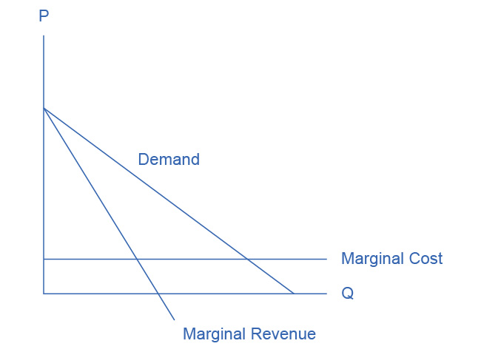

Figure 10.6

1. Suppose the firms collude to form a cartel. What price will the cartel charge? What quantity will the cartel supply? How much profit will the cartel earn?
2. Suppose now that the cartel breaks up and the oligopolistic firms compete as vigorously as possible by cutting the price and increasing sales. What will be the industry quantity and price? What will be the collective profits of all firms in the industry?
3. Compare the equilibrium price, quantity, and profit for the cartel and cutthroat competition outcomes.

[4](http://openstax.org/books/principles-microeconomics-3e/pages/chapter-10#fs-idp37882656-solution).

Sometimes oligopolies in the same industry are very different in size. Suppose we have a duopoly where one firm (Firm A) is large and the other firm (Firm B) is small, as the prisoner’s dilemma box in Table 10.4 shows.

|  |  |  |
| --- | --- | --- |
|  | Firm B colludes with Firm A | Firm B cheats by selling more output |
| Firm A colludes with Firm B | A gets $1,000, B gets $100 | A gets $800, B gets $200 |
| Firm A cheats by selling more output | A gets $1,050, B gets $50 | A gets $500, B gets $20 |

Table 10.4

Assuming that both firms know the payoffs, what is the likely outcome in this case?