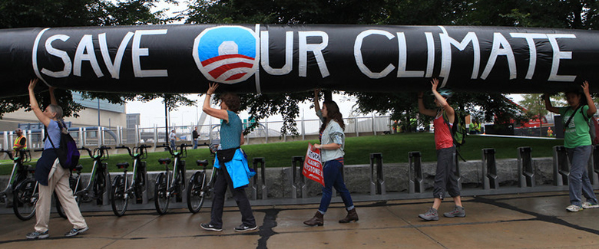

Figure 12.1 Environmental Debate Across the country, countless people have protested, even risking arrest, against the Keystone XL Pipeline. (Credit: modification of "People Risk Arrest at State Department Office in Boston Protesting Keystone XL Pipeline" by NoKXL/Flickr, CC BY 2.0)

Chapter Objectives

In this chapter, you will learn about:

* The Economics of Pollution
* Command-and-Control Regulation
* Market-Oriented Environmental Tools
* The Benefits and Costs of U.S. Environmental Laws
* International Environmental Issues
* The Tradeoff between Economic Output and Environmental Protection

## Introduction to Environmental Protection and Negative Externalities

Bring It Home

Keystone XL

You might have heard about Keystone XL in the news. It was a pipeline system designed to bring oil from Canada to the refineries near the Gulf of Mexico, as well as to boost crude oil production in the United States. While a private company, TransCanada, planned to build and own the pipeline, U.S. government approval was required because of its size and location. There were four phases in plans to build the pipeline, and the first two of these had been in operation.

Sounds like a great idea, right? A pipeline that would move much needed crude oil to the Gulf refineries would increase oil production for manufacturing needs, reduce price pressure at the gas pump, and increase overall economic growth. Supporters argued that the pipeline would be one of the safest pipelines built yet, and would reduce America’s dependence on politically vulnerable Middle Eastern oil imports.

Not so fast, said its critics. The Keystone XL would be constructed over an enormous aquifer (one of the largest in the world) in the Midwest, and through an environmentally fragile area in Nebraska, causing great concern among environmentalists about possible destruction to the natural surroundings. They argued that leaks could taint valuable water sources and pipeline construction could disrupt and even harm indigenous species. Environmentalist groups fought government approval of the proposed pipeline construction, and in November 2015, the Obama administration refused to grant the cross-border permit necessary to build the Keystone XL pipeline. In 2017, the Trump administration sought to grant the necessary cross-border permit, and legal challenges emerged. In 2021, President Biden, on his first day in office, canceled the cross-border permit, effectively ending (for now) the Keystone XL pipeline.

Environmental concerns matter when discussing issues related to economic growth. However, how much should economists factor in these issues when deciding policy? In the case of the pipeline, how do we know how much damage it would cause when we do not know how to put a value on the environment? Would the pipeline's benefits outweigh the opportunity cost? The issue of how to balance economic progress with unintended effects on our planet is the subject of this chapter.

In 1969, the Cuyahoga River in Ohio was so polluted that it spontaneously burst into flame. Air pollution was so bad at that time that Chattanooga, Tennessee was a city where, as an article from *Sports Illustrated* put it: “the death rate from tuberculosis was double that of the rest of Tennessee and triple that of the rest of the United States, a city in which the filth in the air was so bad it melted nylon stockings off women’s legs, in which executives kept supplies of clean white shirts in their offices so they could change when a shirt became too gray to be presentable, in which headlights were turned on at high noon because the sun was eclipsed by the gunk in the sky.”

The problem of pollution arises for every economy in the world, whether high-income or low-income, and whether market-oriented or command-oriented. Every country needs to strike some balance between production and environmental quality. This chapter begins by discussing how firms may fail to take certain social costs, like pollution, into their planning if they do not need to pay these costs. Traditionally, policies for environmental protection have focused on governmental limits on how much of each pollutant could be emitted. While this approach has had some success, economists have suggested a range of more flexible, market-oriented policies that reduce pollution at a lower cost. We will consider both approaches, but first let’s see how economists frame and analyze these issues.