## 15.1 Drawing the Poverty Line

### Learning Objectives

By the end of this section, you will be able to:

* Explain economic inequality and how the poverty line is determined
* Analyze the U.S. poverty rate over time, noting its prevalence among different groups of citizens

Comparisons of high and low incomes raise two different issues: economic inequality and poverty. Poverty is measured by the number of people who fall below a certain level of income—called the poverty line—that defines the income one needs for a basic standard of living. Income inequality compares the share of the total income (or wealth) in society that different groups receive. For example, one of numerous ways to look at income inequality is to compare the share of income that the top 10% receive to the share of income that the bottom 10% receive.

In the United States, the official definition of the poverty line traces back to a single person: Mollie Orshansky. In 1963, Orshansky, who was working for the Social Security Administration, published an article called “Children of the Poor” in a highly useful and dry-as-dust publication called the *Social Security Bulletin*. Orshansky’s idea was to define a poverty line based on the cost of a healthy diet.

Her previous job had been at the U.S. Department of Agriculture, where she had worked in an agency called the Bureau of Home Economics and Human Nutrition. One task of this bureau had been to calculate how much it would cost to feed a nutritionally adequate diet to a family. Orshansky found that the average family spent one-third of its income on food. She then proposed that the poverty line be the amount one requires to buy a nutritionally adequate diet, given the size of the family, multiplied by three.

The current U.S. poverty line is essentially the same as the Orshansky poverty line, although the government adjusts the dollar amounts to represent the same buying power over time. The U.S. poverty line in 2021 ranged from $12,880 for a single individual to $26,500 for a household of four people.

Figure 15.2 shows the U.S. poverty rate over time; that is, the percentage of the population below the poverty line in any given year. The poverty rate declined through the 1960s, rose in the early 1980s and early 1990s, but seems to have been slightly lower since the mid-1990s. However, in no year in the last six decades has the poverty rate been less than 10.5% of the U.S. population—that is, at best almost one American in nine is below the poverty line. In recent years, the poverty rate peaked at 15.1% in 2010, before dropping to 10.5% in 2019. Table 15.1 compares poverty rates for different groups in 2011. As you will see when we delve further into these numbers, poverty rates are relatively low for White people, for the elderly, for the well-educated, and for male-headed households. Poverty rates for females, Hispanic people, and African Americans are much higher than for White people. While Hispanic people and African Americans have a higher percentage of individuals living in poverty than others, most people in the United States living below the poverty line are White people.

Link It Up

Visit this [website](http://openstax.org/l/povertyprogram) for more information on U.S. poverty.

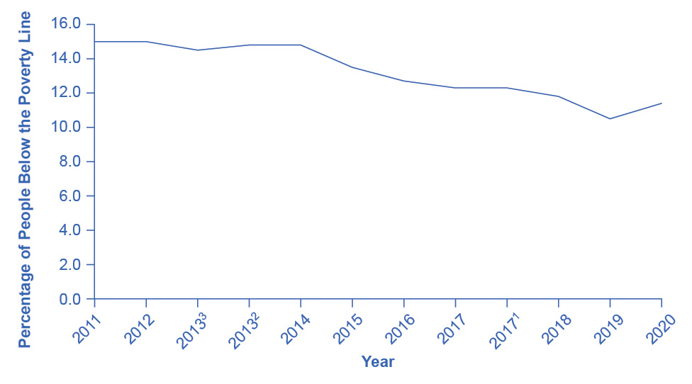

Figure 15.2 The U.S. Poverty Rate since 1960 The poverty rate fell dramatically during the 1960s, rose in the early 1980s and early 1990s, and, after declining in the 1990s through mid-2000s, rose to 15.1% in 2020, which is close to the 1960 levels. Between 2010 and 2019, the poverty rate declined to 10.5%, before rising to 11.4% in 2020 due to the onset of the COVID-19 pandemic in 2020. (Source: U.S. Census Bureau)

|  |  |
| --- | --- |
| Group | Poverty Rate |
| Females | 12.6% |
| Males | 10.2% |
|  |  |
| White (Non-Hispanic) | 8.2% |
| Black | 19.5% |
| Hispanic | 17.0% |
|  |  |
| Under age 18 | 16.1% |
| Ages 18–64 | 10.4% |
| Ages 65+ | 9.0% |

Table 15.1 Poverty Rates by Group, 2020

The concept of a poverty line raises many tricky questions. In a vast country like the United States, should there be a national poverty line? After all, according to the Federal Register, the median household income for a family of four was $109,113 in New Jersey and $59,701 in Mississippi in 2017, and prices of some basic goods like housing are quite different between states. The poverty line is based on cash income, which means it does not account for government programs that provide non-cash assistance such as Medicaid (health care for low-income individuals and families) and food aid. Also, low-income families can qualify for federal housing assistance. (We will discuss these and other government aid programs in detail later in this chapter.)

Should the government adjust the poverty line to account for the value of such programs? Many economists and policymakers wonder whether we should rethink the concept of what poverty means in the twenty-first century. The following Clear It Up feature explains the poverty lines set by the World Bank for low-income countries around the world.

Clear It Up

How do economists measure poverty in low-income countries?

The World Bank sets two poverty lines for low-income countries around the world. One poverty line is set at an income of $1.90/day per person. The other is at $3.20/day. By comparison, the U.S. 2015 poverty line of $20,090 annually for a family of three works out to $18.35 per person per day.

Clearly, many people around the world are far poorer than Americans, as Table 15.2 shows. China and India both have more than a billion people; Nigeria is the most populous country in Africa; and Egypt is the most populous country in the Middle East. In all four of those countries, in the mid-2000s, a substantial share of the population subsisted on less than $2/day. About half the world lives on less than $2.50 a day, and 80 percent of the world lives on less than $10 per day. (Of course, the cost of food, clothing, and shelter in those countries can be very different from those costs in the United States, so the $2 and $2.50 figures may mean greater purchasing power than they would in the United States.)

|  |  |  |  |
| --- | --- | --- | --- |
| Country | Year | Percentage of Population with Income Less Than $1.90/Day/Person | Percentage of Population with Income Less Than $3.20/Day/Person |
| Brazil | 2019 | 4.6% | 9.1% |
| China | 2017 | 0.5% | 5.4% |
| Egypt | 2017 | 3.8% | 28.9% |
| India | 2011 | 22.5% | 61.7% |
| Mexico | 2018 | 1.7% | 6.5% |
| Nigeria | 2018 | 39.1% | 71.0% |

Table 15.2 Poverty Lines for Low-Income Countries, mid-2000s (Source: https://datatopics.worldbank.org/world-development-indicators/themes/poverty-and-inequality.html)

Any poverty line will be somewhat arbitrary, and it is useful to have a poverty line whose basic definition does not change much over time. If Congress voted every few years to redefine poverty, then it would be difficult to compare rates over time. After all, would a lower poverty rate change the definition, or is it the case that people were actually better off? Government statisticians at the U.S. Census Bureau have ongoing research programs to address questions like these.