## 15.2 The Poverty Trap

### Learning Objectives

By the end of this section, you will be able to:

* Explain the poverty trap, noting how government programs impact it
* Identify potential issues in government programs that seek to reduce poverty
* Calculate a budget constraint line that represents the poverty trap

Can you give people too much help, or the wrong kind of help? When people are provided with food, shelter, healthcare, income, and other necessities, assistance may reduce their incentive to work, particularly if their work is likely to offer low wages and reduce government assistance. Consider a program to fight poverty that works in this reasonable-sounding manner: the government provides assistance to the those who need it, but as the recipients earn income to support themselves, the government reduces the level of assistance it provides. With such a program, every time a person earns $100, they lose $100 in government support. As a result, the person experiences no net gain for working. Economists call this problem the poverty trap.

Consider the situation a single-parent family faces. Figure 15.3 illustrates a single mother (earning $8 an hour) with two children. First, consider the labor-leisure budget constraint that this family faces in a situation without government assistance. On the horizontal axis is hours of leisure (or time spent with family responsibilities) increasing in quantity from left to right. Also on the horizontal axis is the number of hours at paid work, going from zero hours on the right to the maximum of 2,500 hours on the left. On the vertical axis is the amount of income per year rising from low to higher amounts of income. The budget constraint line shows that at zero hours of leisure and 2,500 hours of work, the maximum amount of income is $20,000 ($8 × 2,500 hours). At the other extreme of the budget constraint line, an individual would work zero hours, earn zero income, but enjoy 2,500 hours of leisure. At point A on the budget constraint line, by working 40 hours a week, 50 weeks a year, the utility-maximizing choice is to work a total of 2,000 hours per year and earn $16,000.

Now suppose that a government antipoverty program guarantees every family with a single mother and two children $18,000 in income. This is represented on the graph by a horizontal line at $18,000. With this program, each time the mother earns $1,000, the government will deduct $1,000 of its support. Table 15.3 shows what will happen at each combination of work and government support.

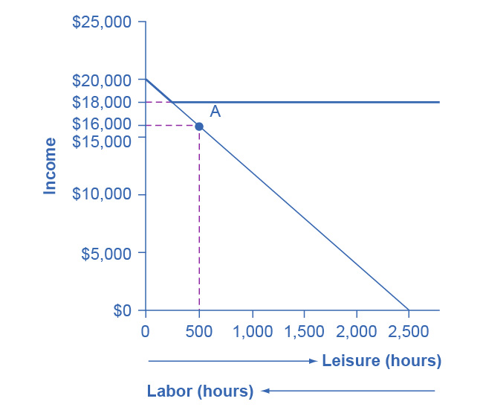

Figure 15.3 The Poverty Trap in Action The original choice is 500 hours of leisure, 2,000 hours of work at point A, and income of $16,000. With a guaranteed income of $18,000, this family would receive $18,000 whether it provides zero hours of work or 2,000 hours of work. Only if the family provides, say, 2,300 hours of work does its income rise above the guaranteed level of $18,000—and even then, the marginal gain to income from working many hours is small.

|  |  |  |  |
| --- | --- | --- | --- |
| Amount Worked (hours) | Total Earnings | Government Support | Total Income |
| 0 | 0 | $18,000 | $18,000 |
| 500 | $4,000 | $14,000 | $18,000 |
| 1,000 | $8,000 | $10,000 | $18,000 |
| 1,500 | $12,000 | $6,000 | $18,000 |
| 2,000 | $16,000 | $2,000 | $18,000 |
| 2,500 | $20,000 | 0 | $20,000 |

Table 15.3 Total Income at Various Combinations of Work and Support

The new budget line, with the antipoverty program in place, is the horizontal and heavy line that is flat at $18,000. If the mother does not work at all, she receives $18,000, all from the government. If she works full time, giving up 40 hours per week with her children, she still ends up with $18,000 at the end of the year. Only if she works 2,300 hours in the year—which is an average of 44 hours per week for 50 weeks a year—does household income rise to $18,400. Even in this case, all of her year’s work means that household income rises by only $400 over the income she would receive if she did not work at all. She would need to work 50 hours a week to reach $20,800.

The poverty trap is even stronger than this simplified example shows, because a working mother will have extra expenses like clothing, transportation, and child care that a nonworking mother will not face, making the economic gains from working even smaller. Moreover, those who do not work fail to build up job experience and contacts, which makes working in the future even less likely.

To reduce the poverty trap the government could design an antipoverty program so that, instead of reducing government payments by $1 for every $1 earned, the government would reduce payments by some smaller amount instead. Imposing requirements for work as a condition of receiving benefits and setting a time limit on benefits can also reduce the harshness of the poverty trap.

Figure 15.4 illustrates a government program that guarantees $18,000 in income, even for those who do not work at all, but then reduces this amount by 50 cents for each $1 earned. The new, higher budget line in Figure 15.4 shows that, with this program, additional hours of work will bring some economic gain. Because of the reduction in government income when an individual works, an individual earning $8.00 will really net only $4.00 per hour. The vertical intercept of this higher budget constraint line is at $28,000 ($18,000 + 2,500 hours × $4.00 = $28,000). The horizontal intercept is at the point on the graph where $18,000 and 2500 hours of leisure is set. Table 15.4 shows the total income differences with various choices of labor and leisure.

However, this type of program raises other issues. First, even if it does not eliminate the incentive to work by reducing government payments by $1 for every $1 earned, enacting such a program may still reduce the incentive to work. At least some people who would be working 2,000 hours each year without this program might decide to work fewer hours but still end up with more income—that is, their choice on the new budget line would be like S, above and to the right of the original choice P. Of course, others may choose a point like R, which involves the same amount of work as P, or even a point to the left of R that involves more work.

The second major issue is that when the government phases out its support payments more slowly, the antipoverty program costs more money. Still, it may be preferable in the long run to spend more money on a program that retains a greater incentive to work, rather than spending less money on a program that nearly eliminates any gains from working.

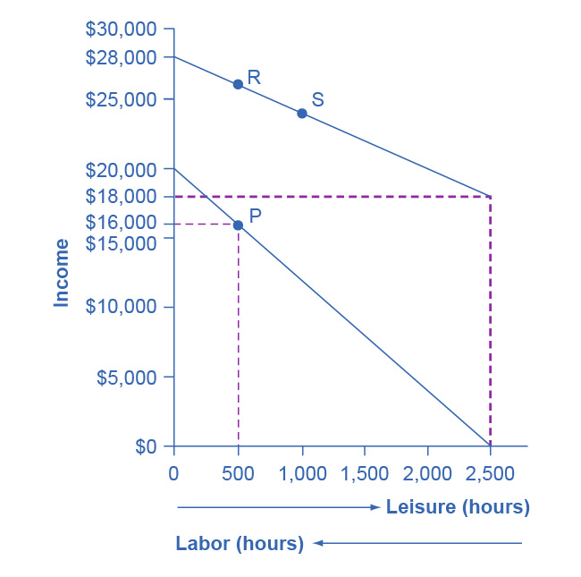

Figure 15.4 Loosening the Poverty Trap: Reducing Government Assistance by 50 Cents for Every $1 Earned On the original labor-leisure opportunity set, the lower, downward-sloping budget set, the preferred choice P is 500 hours of leisure and $16,000 of income. Then, the government created an antipoverty program that guarantees $18,000 in income even to those who work zero hours, shown by the hoizontal dashed line. In addition, every $1 earned means phasing out 50 cents of benefits at $18,000. This program leads to the higher budget set, which the diagram shows. The hope is that this program will provide incentives to work the same or more hours, despite receiving income assistance. However, it is possible that the recipients will choose a point on the new budget set like S, with less work, more leisure, and greater income, or a point like R, with the same work and greater income.

|  |  |  |  |
| --- | --- | --- | --- |
| Amount Worked (hours) | Total Earnings | Government Support | Total Income |
| 0 | 0 | $18,000 | $18,000 |
| 500 | $4,000 | $16,000 | $20,000 |
| 1,000 | $8,000 | $14,000 | $22,000 |
| 1,500 | $12,000 | $12,000 | $24,000 |
| 2,000 | $16,000 | $10,000 | $26,000 |
| 2,500 | $20,000 | $8,000 | $28,000 |

Table 15.4 The Labor-Leisure Tradeoff with Assistance Reduced by 50 Cents for Every Dollar Earned

The next module will consider a variety of government support programs focused specifically on people experiencing poverty, including welfare, SNAP (Supplemental Nutrition Assistance Program), Medicaid, and the earned income tax credit (EITC). Although these programs vary from state to state, it is generally a true statement that in many states from the 1960s into the 1980s, if poor people worked, their level of income barely rose—or did not rise at all—after factoring in the reduction in government support payments. The following Work It Out feature shows how this happens.