## 19.3 Intra-industry Trade between Similar Economies

### Learning Objectives

By the end of this section, you will be able to:

* Identify at least two advantages of intra-industry trading
* Explain the relationship between economies of scale and intra-industry trade

Absolute and comparative advantages explain a great deal about global trading patterns. For example, they help to explain the patterns that we noted at the start of this chapter, like why you may be eating fresh fruit from Chile or Mexico, or why lower productivity regions like Africa and Latin America are able to sell a substantial proportion of their exports to higher productivity regions like the European Union and North America. Comparative advantage, however, at least at first glance, does not seem especially well-suited to explain other common patterns of international trade.

### The Prevalence of Intra-Industry Trade between Similar Economies

The theory of comparative advantage suggests that trade should happen between economies with large differences in opportunity costs of production. Roughly half of all U.S. trade involves shipping goods between the fairly similar high-income economies of Japan, Canada, and the United States. Furthermore, the trade has an important geographic component—the biggest trading partners of the United States are Canada and Mexico (see Table 19.13).

|  |  |  |
| --- | --- | --- |
| Country | U.S. Exports Go to ... | U.S. Imports Come from ... |
| China | 8.6% | 17.7% |
| Canada | 17.6% | 12.6% |
| Japan | 4.3% | 4.3% |
| Mexico | 15.8% | 13.6% |
| South Korea | 3.8% | 3.3% |

Table 19.13 Top Trading Partners (November 2021) (Source: https://www.census.gov/foreign-trade/statistics/highlights/toppartners.html)

Moreover, the theory of comparative advantage suggests that each economy should specialize to a degree in certain products, and then exchange those products. A high proportion of trade, however, is intra-industry trade—that is, trade of goods within the same industry from one country to another. For example, the United States produces and exports autos and imports autos. Table 19.14 shows some of the largest categories of U.S. exports and imports. In all of these categories, the United States is both a substantial exporter and a substantial importer of goods from the same industry. In 2021, according to the U.S. Census Bureau, the United States exported $131 billion worth of autos, and imported $317 billion worth of autos. About 60% of U.S. trade and 60% of European trade is intra-industry trade.

|  |  |  |
| --- | --- | --- |
| Some U.S. Exports | Quantity of Exports ($ billions) | Quantity of Imports ($ billions) |
| Autos | $131 | $317 |
| Food and beverages | $147 | $167 |
| Capital goods | $474 | $695 |
| Consumer goods | $201 | $699 |
| Industrial supplies | $578 | $589 |
| Other transportation | $63 | $113 |

Table 19.14 Some Intra-Industry U.S. Exports and Imports in 2021 (Source: https://www.census.gov/foreign-trade/data/index.html)

Why do similar high-income economies engage in intra-industry trade? What can be the economic benefit of having workers of fairly similar skills making cars, computers, machinery and other products which are then shipped across the oceans to and from the United States, the European Union, and Japan? There are two reasons: (1) The division of labor leads to learning, innovation, and unique skills; and (2) economies of scale.

### Gains from Specialization and Learning

Consider the category of machinery, where the U.S. economy has considerable intra-industry trade. Machinery comes in many varieties, so the United States may be exporting machinery for manufacturing with wood, but importing machinery for photographic processing. The underlying reason why a country like the United States, Japan, or Germany produces one kind of machinery rather than another is usually not related to U.S., German, or Japanese firms and workers having generally higher or lower skills. It is just that, in working on very specific and particular products, firms in certain countries develop unique and different skills.

Specialization in the world economy can be very finely split. In fact, recent years have seen a trend in international trade, which economists call splitting up the value chain. The value chain describes how a good is produced in stages. As indicated in the beginning of the chapter, producing the iPhone involves designing and engineering the phone in the United States, supplying parts from Korea, assembling the parts in China, and advertising and marketing in the United States. Thanks in large part to improvements in communication technology, sharing information, and transportation, it has become easier to split up the value chain. Instead of production in a single large factory, different firms operating in various places and even different countries can divide the value chain. Because firms split up the value chain, international trade often does not involve nations trading whole finished products like automobiles or refrigerators. Instead, it involves shipping more specialized goods like, say, automobile dashboards or the shelving that fits inside refrigerators. Intra-industry trade between similar countries produces economic gains because it allows workers and firms to learn and innovate on particular products—and often to focus on very particular parts of the value chain.

Link It Up

Visit this [website](http://openstax.org/l/iphoneassembly) for some interesting information about the assembly of the iPhone.

### Economies of Scale, Competition, Variety

A second broad reason that intra-industry trade between similar nations produces economic gains involves economies of scale. The concept of economies of scale, as we introduced in [Production, Costs and Industry Structure](http://openstax.org/books/principles-microeconomics-3e/pages/7-introduction-to-production-costs-and-industry-structure), means that as the scale of output goes up, average costs of production decline—at least up to a point. Figure 19.5 illustrates economies of scale for a plant producing toaster ovens. The horizontal axis of the figure shows the quantity of production by a certain firm or at a certain manufacturing plant. The vertical axis measures the average cost of production. Production plant S produces a small level of output at 30 units and has an average cost of production of $30 per toaster oven. Plant M produces at a medium level of output at 50 units, and has an average cost of production of $20 per toaster oven. Plant L produces 150 units of output with an average cost of production of only $10 per toaster oven. Although plant V can produce 200 units of output, it still has the same unit cost as Plant L.

In this example, a small or medium plant, like S or M, will not be able to compete in the market with a large or a very large plant like L or V, because the firm that operates L or V will be able to produce and sell its output at a lower price. In this example, economies of scale operate up to point L, but beyond point L to V, the additional scale of production does not continue to reduce average costs of production.

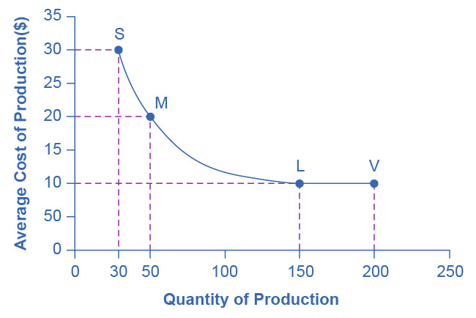

Figure 19.5 Economies of Scale Production Plant S, has an average cost of production of $30 per toaster oven. Production plant M has an average cost of production of $20 per toaster oven. Production plant L has an average cost of production of only $10 per toaster oven. Production plant V still has an average cost of production of $10 per toaster oven. Thus, production plant M can produce toaster ovens more cheaply than plant S because of economies of scale, and plants L or V can produce more cheaply than S or M because of economies of scale. However, the economies of scale end at an output level of 150. Plant V, despite being larger, cannot produce more cheaply on average than plant L.

The concept of economies of scale becomes especially relevant to international trade when it enables one or two large producers to supply the entire country. For example, a single large automobile factory could probably supply all the cars consumers purchase in a smaller economy like the United Kingdom or Belgium in a given year. However, if a country has only one or two large factories producing cars, and no international trade, then consumers in that country would have relatively little choice between kinds of cars (other than the color of the paint and other nonessential options). Little or no competition will exist between different car manufacturers.

International trade provides a way to combine the lower average production costs that come from economies of scale and still have competition and variety for consumers. Large automobile factories in different countries can make and sell their products around the world. If General Motors, Ford, and Chrysler were the only players in the U.S. automobile market, the level of competition and consumer choice would be considerably lower than when U.S. carmakers must face competition from Toyota, Honda, Suzuki, Fiat, Mitsubishi, Nissan, Volkswagen, Kia, Hyundai, BMW, Subaru, and others. Greater competition brings with it innovation and responsiveness to what consumers want. America’s car producers make far better cars now than they did several decades ago, and much of the reason is competitive pressure, especially from East Asian and European carmakers.

### Dynamic Comparative Advantage

The sources of gains from intra-industry trade between similar economies—namely, the learning that comes from a high degree of specialization and splitting up the value chain and from economies of scale—do not contradict the earlier theory of comparative advantage. Instead, they help to broaden the concept.

In intra-industry trade, climate or geography do not determine the level of worker productivity. Even the general level of education or skill does not determine it. Instead, how firms engage in specific learning about specialized products, including taking advantage of economies of scale determine the level of worker productivity. In this vision, comparative advantage can be dynamic—that is, it can evolve and change over time as one develops new skills and as manufacturers split the value chain in new ways. This line of thinking also suggests that countries are not destined to have the same comparative advantage forever, but must instead be flexible in response to ongoing changes in comparative advantage.