## Problems

55.

Assume two countries, Thailand (T) and Japan (J), have one good: cameras. The demand (d) and supply (s) for cameras in Thailand and Japan is described by the following functions:

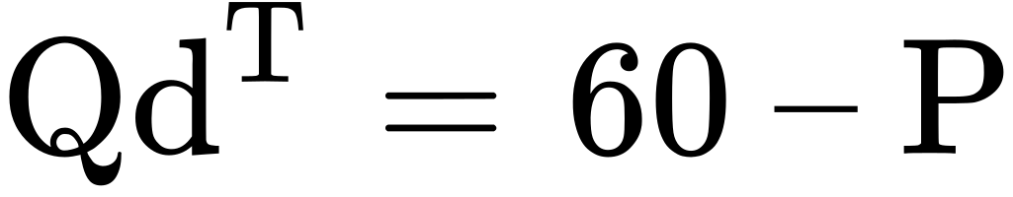

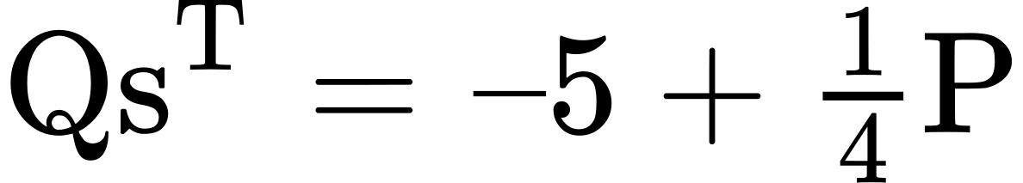

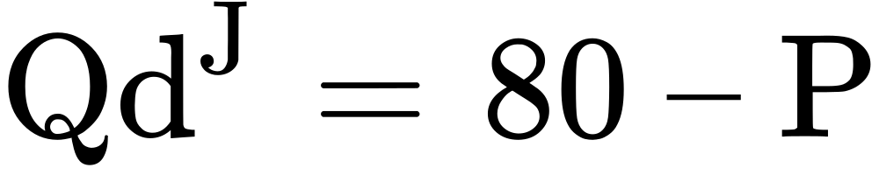

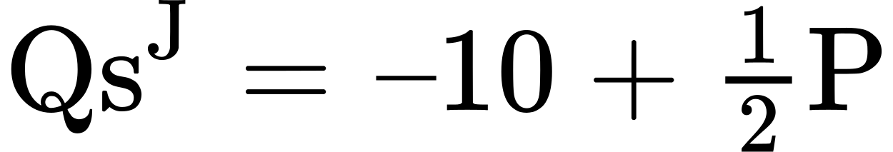

P is the price measured in a common currency used in both countries, such as the Thai Baht.

1. Compute the equilibrium price (P) and quantities (Q) in each country without trade.
2. Now assume that free trade occurs. The free-trade price goes to 56.36 Baht. Who exports and imports cameras and in what quantities?

56.

You have just been put in charge of trade policy for Malawi. Coffee is a recent crop that is growing well and the Malawian export market is developing. As such, Malawi coffee is an infant industry. Malawi coffee producers come to you and ask for tariff protection from cheap Tanzanian coffee. What sorts of policies will you enact? Explain.

57.

The country of Pepperland exports steel to the Land of Submarines. Information for the quantity demanded (Qd) and quantity supplied (Qs) in each country, in a world without trade, are given in Table 20.6 and Table 20.7.

|  |  |  |
| --- | --- | --- |
| Price ($) | Qd | Qs |
| 60 | 230 | 180 |
| 70 | 200 | 200 |
| 80 | 170 | 220 |
| 90 | 150 | 240 |
| 100 | 140 | 250 |

Table 20.6 Pepperland

|  |  |  |
| --- | --- | --- |
| Price ($) | Qd | Qs |
| 60 | 430 | 310 |
| 70 | 420 | 330 |
| 80 | 410 | 360 |
| 90 | 400 | 400 |
| 100 | 390 | 440 |

Table 20.7 Land of Submarines

1. What would be the equilibrium price and quantity in each country in a world without trade? How can you tell?
2. What would be the equilibrium price and quantity in each country if trade is allowed to occur? How can you tell?
3. Sketch two supply and demand diagrams, one for each country, in the situation before trade.
4. On those diagrams, show the equilibrium price and the levels of exports and imports in the world after trade.
5. If the Land of Submarines imposes an anti-dumping import quota of 30, explain in general terms whether it will benefit or injure consumers and producers in each country.
6. Does your general answer change if the Land of Submarines imposes an import quota of 70?