## 5.1 Price Elasticity of Demand and Price Elasticity of Supply

### Learning Objectives

By the end of this section, you will be able to:

* Calculate the price elasticity of demand
* Calculate the price elasticity of supply

Both the demand and supply curve show the relationship between price and the number of units demanded or supplied. Price elasticity is the ratio between the percentage change in the quantity demanded (Qd) or supplied (Qs) and the corresponding percent change in price. The price elasticity of demand is the percentage change in the quantity *demanded* of a good or service divided by the percentage change in the price. The price elasticity of supply is the percentage change in quantity *supplied* divided by the percentage change in price.

We can usefully divide elasticities into three broad categories: elastic, inelastic, and unitary. Because price and quantity demanded move in opposite directions, price elasticity of demand is always a negative number. Therefore, price elasticity of demand is usually reported as its absolute value, without a negative sign. The summary in Table 5.1 is assuming absolute values for price elasticity of demand. An elastic demand or elastic supply is one in which the elasticity is greater than one, indicating a high responsiveness to changes in price. Elasticities that are less than one indicate low responsiveness to price changes and correspond to inelastic demand or inelastic supply. Unitary elasticities indicate proportional responsiveness of either demand or supply, as Table 5.1 summarizes.

|  |  |  |
| --- | --- | --- |
| If . . . | Then . . . | And It Is Called . . . |
| $\text{\% change in quantity}>\text{\% change in price}$ | $\frac{\text{\% change in quantity}}{\text{\% change in price}}>1$ | Elastic |
| $\text{\% change in quantity}=\text{\% change in price}$ | $\frac{\text{\% change in quantity}}{\text{\% change in price}}=1$ | Unitary |
| $\text{\% change in quantity}<\text{\% change in price}$ | $\frac{\text{\% change in quantity}}{\text{\% change in price}}<1$ | Inelastic |

Table 5.1 Elastic, Inelastic, and Unitary: Three Cases of Elasticity

Link It Up

Before we delve into the details of elasticity, enjoy this [article](http://openstax.org/l/Super_Bowl) on elasticity and ticket prices at the Super Bowl.

To calculate elasticity along a demand or supply curve economists use the average percent change in both quantity and price. This is called the Midpoint Method for Elasticity, and is represented in the following equations:

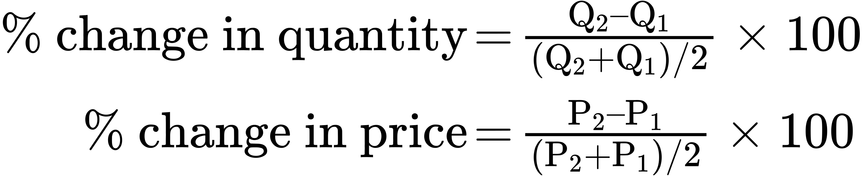

The advantage of the Midpoint Method is that one obtains the same elasticity between two price points whether there is a price increase or decrease. This is because the formula uses the same base (average quantity and average price) for both cases.

### Calculating Price Elasticity of Demand

Let’s calculate the elasticity between points A and B and between points G and H as Figure 5.2 shows.

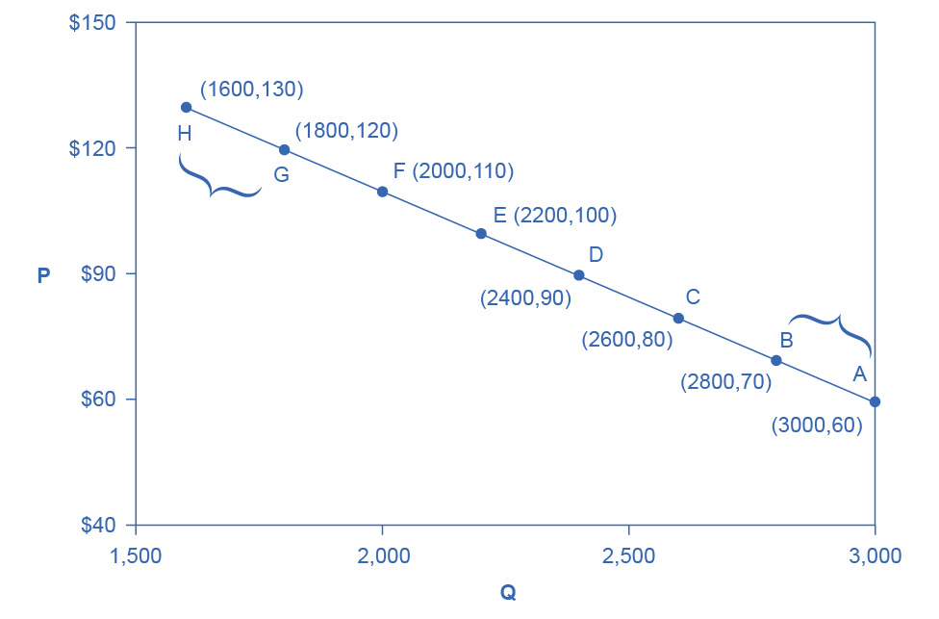

Figure 5.2 Calculating the Price Elasticity of Demand We calculate the price elasticity of demand as the percentage change in quantity divided by the percentage change in price.

First, apply the formula to calculate the elasticity as price decreases from $70 at point B to $60 at point A:

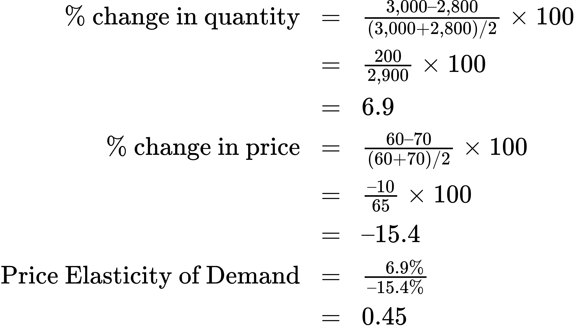

Therefore, the elasticity of demand between these two points is $\frac{ 6.9\%}{–15.4\%}$ which is 0.45, an amount smaller than one, showing that the demand is inelastic in this interval. Price elasticities of demand are *always* negative since price and quantity demanded always move in opposite directions (on the demand curve). By convention, we always talk about elasticities as positive numbers. Mathematically, we take the absolute value of the result. We will ignore this detail from now on, while remembering to interpret elasticities as positive numbers.

This means that, along the demand curve between point B and A, if the price changes by 1%, the quantity demanded will change by 0.45%. A change in the price will result in a smaller percentage change in the quantity demanded. For example, a 10% *increase* in the price will result in only a 4.5% *decrease* in quantity demanded. A 10% *decrease* in the price will result in only a 4.5% *increase* in the quantity demanded. Price elasticities of demand are negative numbers indicating that the demand curve is downward sloping, but we read them as absolute values. The following Work It Out feature will walk you through calculating the price elasticity of demand.

Work It Out

Finding the Price Elasticity of Demand

Calculate the price elasticity of demand using the data in Figure 5.2 for an increase in price from G to H. Has the elasticity increased or decreased?

Step 1. We know that:



Step 2. From the Midpoint Formula we know that:

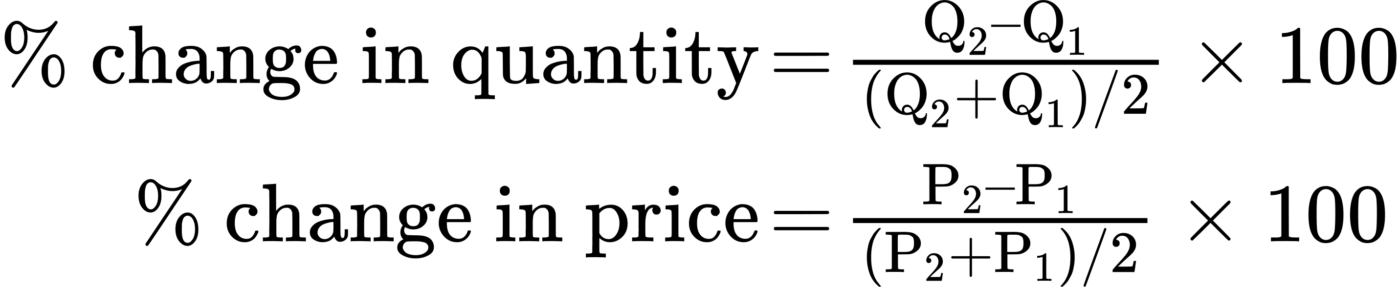

Step 3. So we can use the values provided in the figure in each equation:

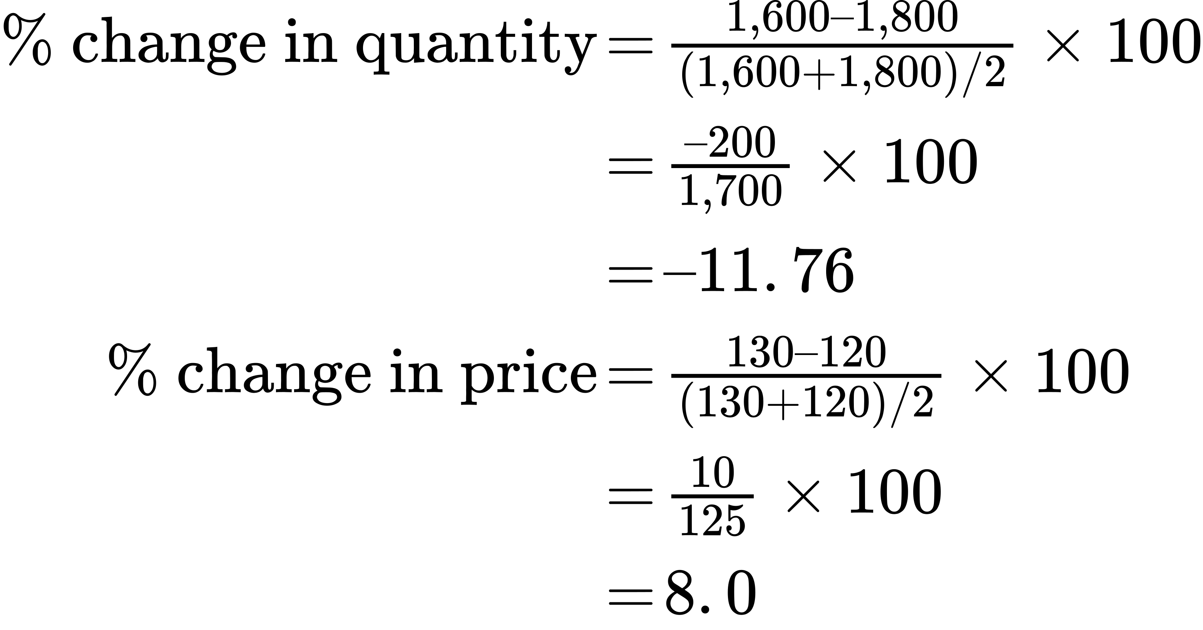

Step 4. Then, we can use those values to determine the price elasticity of demand:

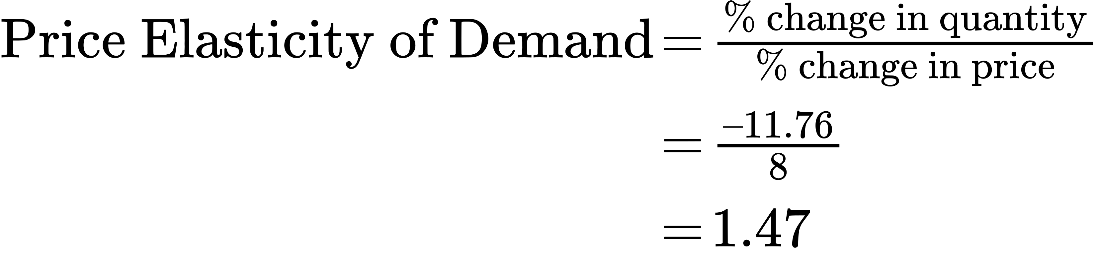

Therefore, the elasticity of demand from G to is H 1.47. The magnitude of the elasticity has increased (in absolute value) as we moved up along the demand curve from points A to B. Recall that the elasticity between these two points was 0.45. Demand was inelastic between points A and B and elastic between points G and H. This shows us that price elasticity of demand changes at different points along a straight-line demand curve.

### Calculating the Price Elasticity of Supply

Assume that an apartment rents for $650 per month and at that price the landlord rents 10,000 units as Figure 5.3 shows. When the price increases to $700 per month, the landlord supplies 13,000 units into the market. By what percentage does apartment supply increase? What is the price sensitivity?

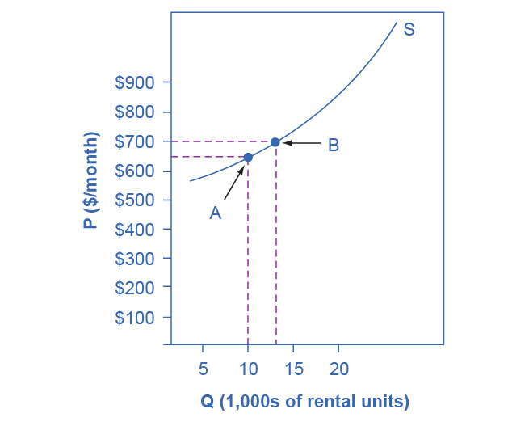

Figure 5.3 Price Elasticity of Supply We calculate the price elasticity of supply as the percentage change in quantity divided by the percentage change in price.

Using the Midpoint Method,

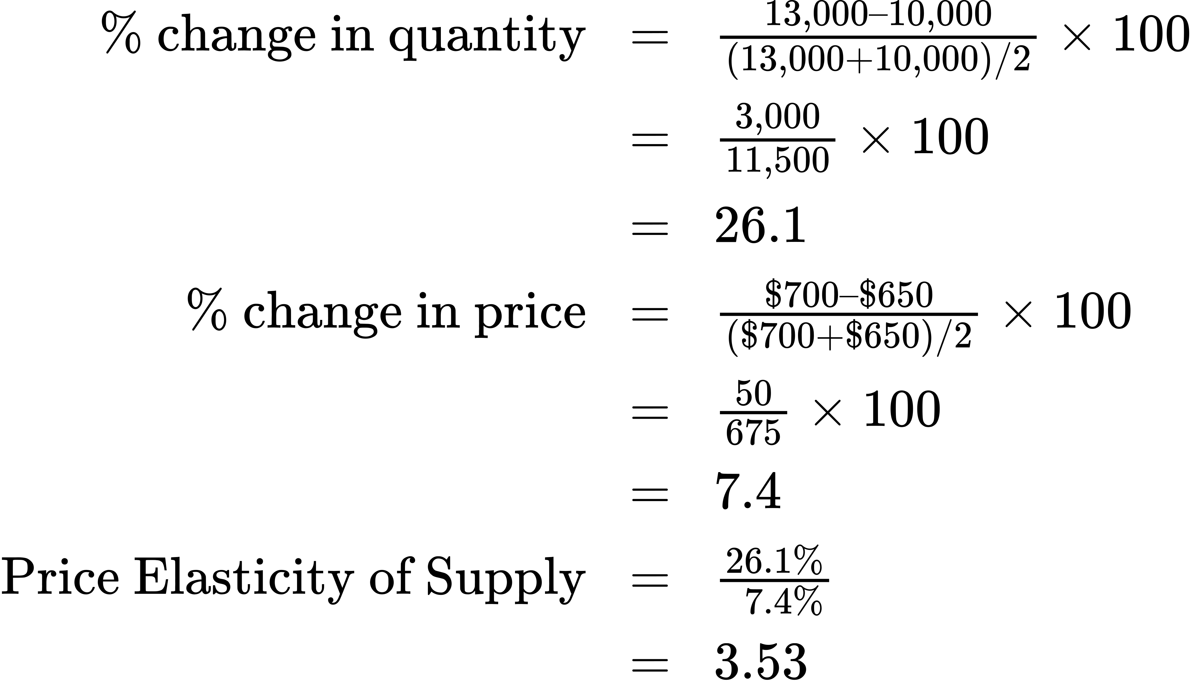

Again, as with the elasticity of demand, the elasticity of supply is not followed by any units. Elasticity is a ratio of one percentage change to another percentage change—nothing more—and we read it as an absolute value. In this case, a 1% rise in price causes an increase in quantity supplied of 3.5%. The greater than one elasticity of supply means that the percentage change in quantity supplied will be greater than a one percent price change. If you're starting to wonder if the concept of slope fits into this calculation, read the following Clear It Up box.

Clear It Up

Is the elasticity the slope?

It is a common mistake to confuse the slope of either the supply or demand curve with its elasticity. The slope is the rate of change in units along the curve, or the rise/run (change in y over the change in x). For example, in Figure 5.2, at each point shown on the demand curve, price drops by $10 and the number of units demanded increases by 200 compared to the point to its left. The slope is –10/200 along the entire demand curve and does not change. The price elasticity, however, changes along the curve. Elasticity between points A and B was 0.45 and increased to 1.47 between points G and H. Elasticity is the *percentage* change, which is a different calculation from the slope and has a different meaning.

When we are at the upper end of a demand curve, where price is high and the quantity demanded is low, a small change in the quantity demanded, even in, say, one unit, is pretty big in percentage terms. A change in price of, say, a dollar, is going to be much less important in percentage terms than it would have been at the bottom of the demand curve. Likewise, at the bottom of the demand curve, that one unit change when the quantity demanded is high will be small as a percentage.

Thus, at one end of the demand curve, where we have a large percentage change in quantity demanded over a small percentage change in price, the elasticity value would be high, or demand would be relatively elastic. Even with the same change in the price and the same change in the quantity demanded, at the other end of the demand curve the quantity is much higher, and the price is much lower, so the percentage change in quantity demanded is smaller and the percentage change in price is much higher. That means at the bottom of the curve we'd have a small numerator over a large denominator, so the elasticity measure would be much lower, or inelastic.

As we move along the demand curve, the values for quantity and price go up or down, depending on which way we are moving, so the percentages for, say, a $1 difference in price or a one unit difference in quantity, will change as well, which means the ratios of those percentages and hence the elasticity will change.