## 7.1 Explicit and Implicit Costs, and Accounting and Economic Profit

### Learning Objectives

By the end of this section, you will be able to:

* Explain the difference between explicit costs and implicit costs
* Understand the relationship between cost and revenue

Each business, regardless of size or complexity, tries to earn a profit:

$\text{Profit}=\text{Total Revenue – Total Cost}$

Total revenue is the income the firm generates from selling its products. We calculate it by multiplying the price of the product times the quantity of output sold:

$\text{Total Revenue}=\text{Price × Quantity}$

We will see in the following chapters that revenue is a function of the demand for the firm’s products.

Total cost is what the firm pays for producing and selling its products. Recall that production involves the firm converting inputs to outputs. Each of those inputs has a cost to the firm. The sum of all those costs is total cost. We will learn in this chapter that short run costs are different from long run costs.

We can distinguish between two types of cost: explicit and implicit. Explicit costs are out-of-pocket costs, that is, actual payments. Wages that a firm pays its employees or rent that a firm pays for its office are explicit costs. Implicit costs are more subtle, but just as important. They represent the opportunity cost of using resources that the firm already owns. Often for small businesses, they are resources that the owners contribute. For example, working in the business while not earning a formal salary, or using the ground floor of a home as a retail store are both implicit costs. Implicit costs also include the depreciation of goods, materials, and equipment that are necessary for a company to operate. (See the Work It Out feature for an extended example.)

These two definitions of cost are important for distinguishing between two conceptions of profit, accounting profit, and economic profit. Accounting profit is a cash concept. It means total revenue minus explicit costs—the difference between dollars brought in and dollars paid out. Economic profit is total revenue minus total cost, including both explicit and implicit costs. The difference is important because even though a business pays income taxes based on its accounting profit, whether or not it is economically successful depends on its economic profit.

Work It Out

Calculating Implicit Costs

Consider the following example. Eryn currently works for a corporate law firm. She is considering opening her own legal practice, where she expects to earn $200,000 per year once she establishes herself. To run her own firm, she would need an office and a law clerk. She has found the perfect office, which rents for $50,000 per year. She could hire a law clerk for $35,000 per year. If these figures are accurate, would Eryn’s legal practice be profitable?

Step 1. First you have to calculate the costs. You can take what you know about explicit costs and total them:

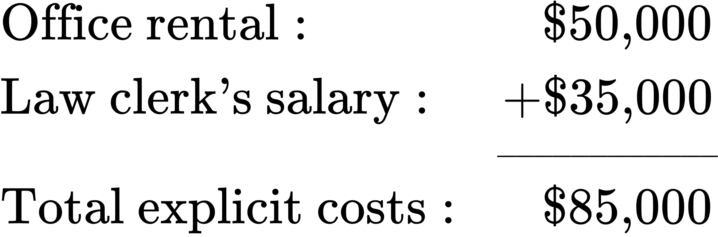

Step 2. Subtracting the explicit costs from the revenue gives you the accounting profit.

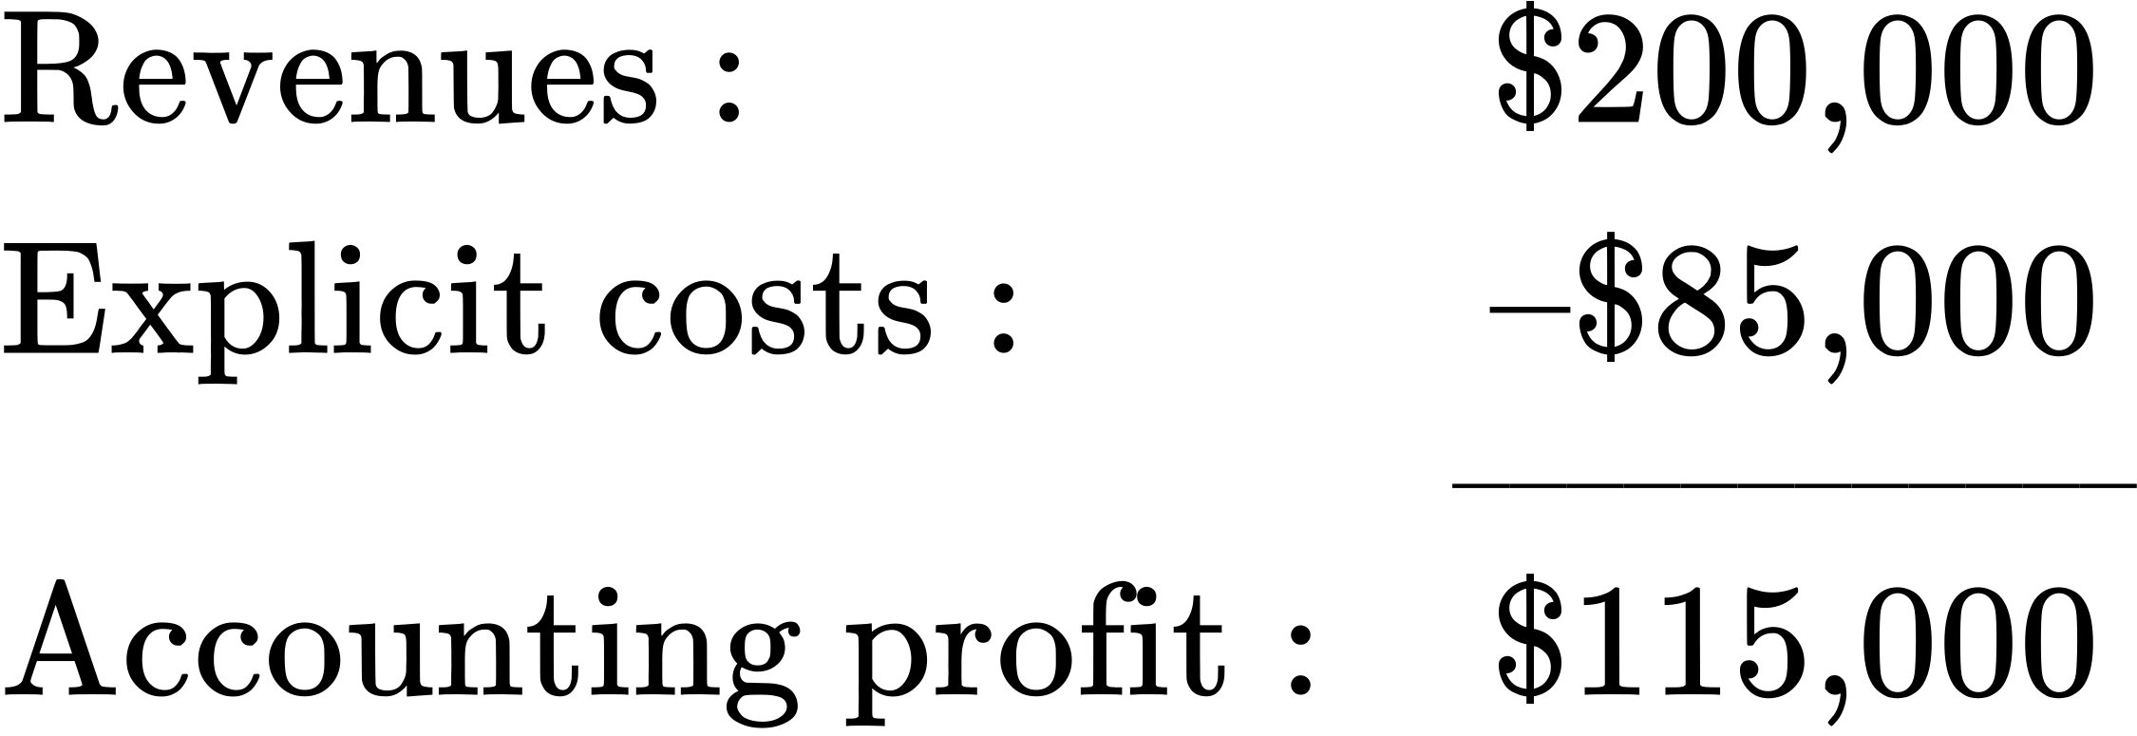

However, these calculations consider only the explicit costs. To open her own practice, Eryn would have to quit her current job, where she is earning an annual salary of $125,000. This would be an implicit cost of opening her own firm.

Step 3. You need to subtract both the explicit and implicit costs to determine the true economic profit:

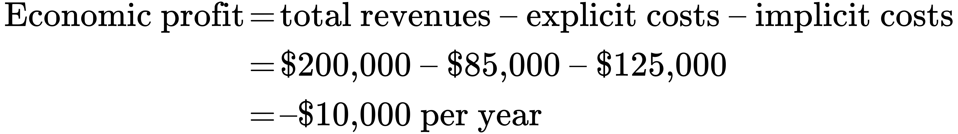

Eryn would be losing $10,000 per year. That does not mean she would not want to open her own business, but it does mean she would be earning $10,000 less than if she worked for the corporate firm.

Implicit costs can include other things as well. Maybe Eryn values her leisure time, and starting her own firm would require her to put in more hours than at the corporate firm. In this case, the lost leisure would also be an implicit cost that would subtract from economic profits.

Now that we have an idea about the different types of costs, let’s look at cost structures. A firm’s cost structure in the long run may be different from that in the short run. We turn to that distinction in the next few sections.