## 7.3 Costs in the Short Run

### Learning Objectives

By the end of this section, you will be able to:

* Understand the relationship between production and costs
* Understand that every factor of production has a corresponding factor price
* Analyze short-run costs in terms of total cost, fixed cost, variable cost, marginal cost, and average cost
* Calculate average profit
* Evaluate patterns of costs to determine potential profit

We’ve explained that a firm’s total costs depend on the quantities of inputs the firm uses to produce its output and the cost of those inputs to the firm. The firm’s production function tells us how much output the firm will produce with given amounts of inputs. However, if we think about that backwards, it tells us how many inputs the firm needs to produce a given quantity of output, which is the first thing we need to determine total cost. Let’s move to the second factor we need to determine.

For every factor of production (or input), there is an associated factor payment. Factor payments are what the firm pays for the use of the factors of production. From the firm’s perspective, factor payments are costs. From the owner of each factor’s perspective, factor payments are income. Factor payments include:

* Raw materials prices for raw materials
* Rent for land or buildings
* Wages and salaries for labor
* Interest and dividends for the use of financial capital (loans and equity investments)
* Profit for entrepreneurship. Profit is the residual, what’s left over from revenues after the firm pays all the other costs. While it may seem odd to treat profit as a “cost”, it is what entrepreneurs earn for taking the risk of starting a business. You can see this correspondence between factors of production and factor payments in the inside loop of the circular flow diagram in [Figure 1.7](http://openstax.org/books/principles-microeconomics-3e/pages/1-3-how-economists-use-theories-and-models-to-understand-economic-issues#CNX_Econ_C01_002).

We now have all the information necessary to determine a firm’s costs.

A cost function is a mathematical expression or equation that shows the cost of producing different levels of output.

|  |  |  |  |  |
| --- | --- | --- | --- | --- |
| Q | 1 | 2 | 3 | 4 |
| Cost | $32.50 | $44 | $52 | $90 |

Table 7.3 Cost Function for Producing Widgets

What we observe is that the cost increases as the firm produces higher quantities of output. This is pretty intuitive, since producing more output requires greater quantities of inputs, which cost more dollars to acquire.

What is the origin of these cost figures? They come from the production function and the factor payments. The discussion of costs in the short run above, Costs in the Short Run, was based on the following production function, which is similar to Table 7.3 except for "widgets" instead of trees.

|  |  |  |  |  |  |  |  |  |  |  |
| --- | --- | --- | --- | --- | --- | --- | --- | --- | --- | --- |
| **Workers (L)** | 1 | 2 | 3 | 3.25 | 4.4 | 5.2 | 6 | 7 | 8 | 9 |
| **Widgets (Q)** | 0.2 | 0.4 | 0.8 | 1 | 2 | 3 | 3.5 | 3.8 | 3.95 | 4 |

Table 7.4

We can use the information from the production function to determine production costs. What we need to know is how many workers are required to produce any quantity of output. If we flip the order of the rows, we “invert” the production function so it shows $L=f\left(Q\right)$.

|  |  |  |  |  |  |  |  |  |  |  |
| --- | --- | --- | --- | --- | --- | --- | --- | --- | --- | --- |
| **Widgets (Q)** | 0.2 | 0.4 | 0.8 | 1 | 2 | 3 | 3.5 | 3.8 | 3.95 | 4 |
| **Workers (L)** | 1 | 2 | 3 | 3.25 | 4.4 | 5.2 | 6 | 7 | 8 | 9 |

Table 7.5

Now focus on the whole number quantities of output. We’ll eliminate the fractions from the table:

|  |  |  |  |  |  |  |  |  |  |  |
| --- | --- | --- | --- | --- | --- | --- | --- | --- | --- | --- |
| **Widgets (Q)** |  |  |  | 1 | 2 | 3 |  |  |  | 4 |
| **Workers (L)** |  |  |  | 3.25 | 4.4 | 5.2 |  |  |  | 9 |

Table 7.6

Suppose widget workers receive $10 per hour. Multiplying the Workers row by $10 (and eliminating the blanks) gives us the cost of producing different levels of output.

|  |  |  |  |  |
| --- | --- | --- | --- | --- |
| **Widgets (Q)** | 1.00 | 2.00 | 3.00 | 4.00 |
| **Workers (L)** | 3.25 | 4.4 | 5.2 | 9 |
| **× Wage Rate per hour** | $10 | $10 | $10 | $10 |
| **= Cost** | $32.50 | $44.00 | $52.00 | $90.00 |

Table 7.7

This is same cost function with which we began! (shown in Table 7.3)

Now that we have the basic idea of the cost origins and how they are related to production, let’s drill down into the details.

### Average and Marginal Costs

The cost of producing a firm’s output depends on how much labor and physical capital the firm uses. A list of the costs involved in producing cars will look very different from the costs involved in producing computer software or haircuts or fast-food meals.

We can measure costs in a variety of ways. Each way provides its own insight into costs. Sometimes firms need to look at their cost per unit of output, not just their total cost. There are two ways to measure per unit costs. The most intuitive way is average cost. Average cost is the cost on average of producing a given quantity. We define average cost as total cost divided by the quantity of output produced. $AC=TC/Q$ If producing two widgets costs a total of $44, the average cost per widget is $\$44/2=\$22$ per widget. The other way of measuring cost per unit is marginal cost. If average cost is the cost of the average unit of output produced, marginal cost is the cost of each individual unit produced. More formally, marginal cost is the cost of producing one more unit of output. Mathematically, marginal cost is the change in total cost divided by the change in output: $MC=ΔTC/ΔQ$. If the cost of the first widget is $32.50 and the cost of two widgets is $44, the marginal cost of the second widget is $\$44−\$32.50=\$11.50.$ We can see the Widget Cost table redrawn below with average and marginal cost added.

|  |  |  |  |  |
| --- | --- | --- | --- | --- |
| Q | 1 | 2 | 3 | 4 |
| Total Cost | $32.50 | $44.00 | $52.00 | $90.00 |
| Average Cost | $32.50 | $22.00 | $17.33 | $22.50 |
| Marginal Cost | $32.50 | $11.50 | $8.00 | $38.00 |

Table 7.8 Extended Cost Function for Producing Widgets

Note that the marginal cost of the first unit of output is always the same as total cost.

### Fixed and Variable Costs

We can decompose costs into fixed and variable costs. Fixed costs are the costs of the fixed inputs (e.g., capital). Because fixed inputs do not change in the short run, fixed costs are expenditures that do not change regardless of the level of production. Whether you produce a great deal or a little, the fixed costs are the same. One example is the rent on a factory or a retail space. Once you sign the lease, the rent is the same regardless of how much you produce, at least until the lease expires. Fixed costs can take many other forms: for example, the cost of machinery or equipment to produce the product, research and development costs to develop new products, even an expense like advertising to popularize a brand name. The amount of fixed costs varies according to the specific line of business: for instance, manufacturing computer chips requires an expensive factory, but a local moving and hauling business can get by with almost no fixed costs at all if it rents trucks by the day when needed.

Variable costs are the costs of the variable inputs (e.g., labor). The only way to increase or decrease output is by increasing or decreasing the variable inputs. Therefore, variable costs increase or decrease with output. We treat labor as a variable cost, since producing a greater quantity of a good or service typically requires more workers or more work hours. Variable costs would also include raw materials.

Total costs are the sum of fixed plus variable costs. Let's look at another example. Consider the barber shop called “The Clip Joint” in Figure 7.7. The data for output and costs are in Table 7.9. The fixed costs of operating the barber shop, including the space and equipment, are $160 per day. The variable costs are the costs of hiring barbers, which in our example is $80 per barber each day. The first two columns of the table show the quantity of haircuts the barbershop can produce as it hires additional barbers. The third column shows the fixed costs, which do not change regardless of the level of production. The fourth column shows the variable costs at each level of output. We calculate these by taking the amount of labor hired and multiplying by the wage. For example, two barbers cost: 2 × $80 = $160. Adding together the fixed costs in the third column and the variable costs in the fourth column produces the total costs in the fifth column. For example, with two barbers the total cost is: $160 + $160 = $320.

|  |  |  |  |  |
| --- | --- | --- | --- | --- |
| Labor | Quantity | Fixed Cost | Variable Cost | Total Cost |
| 1 | 16 | $160 | $80 | $240 |
| 2 | 40 | $160 | $160 | $320 |
| 3 | 60 | $160 | $240 | $400 |
| 4 | 72 | $160 | $320 | $480 |
| 5 | 80 | $160 | $400 | $560 |
| 6 | 84 | $160 | $480 | $640 |
| 7 | 82 | $160 | $560 | $720 |

Table 7.9 Output and Total Costs

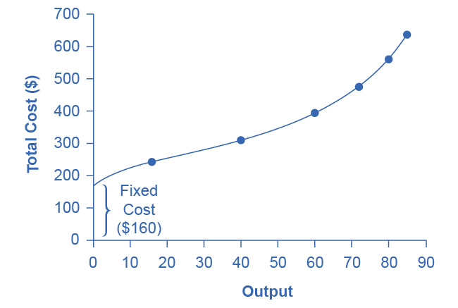

Figure 7.7 How Output Affects Total Costs At zero production, the fixed costs of $160 are still present. As production increases, variable costs are added to fixed costs, and the total cost is the sum of the two.

At zero production, the fixed costs of $160 are still present. As production increases, we add variable costs to fixed costs, and the total cost is the sum of the two. Figure 7.7 graphically shows the relationship between the quantity of output produced and the cost of producing that output. We always show the fixed costs as the vertical intercept of the total cost curve; that is, they are the costs incurred when output is zero so there are no variable costs.

You can see from the graph that once production starts, total costs and variable costs rise. While variable costs may initially increase at a decreasing rate, at some point they begin increasing at an increasing rate. This is caused by diminishing marginal productivity which we discussed earlier in the [Production in the Short Run](http://openstax.org/books/principles-microeconomics-3e/pages/7-2-production-in-the-short-run) section of this chapter, which is easiest to see with an example. As the number of barbers increases from zero to one in the table, output increases from 0 to 16 for a marginal gain (or marginal product) of 16. As the number rises from one to two barbers, output increases from 16 to 40, a marginal gain of 24. From that point on, though, the marginal product diminishes as we add each additional barber. For example, as the number of barbers rises from two to three, the marginal product is only 20; and as the number rises from three to four, the marginal product is only 12.

To understand the reason behind this pattern, consider that a one-man barber shop is a very busy operation. The single barber needs to do everything: say hello to people entering, answer the phone, cut hair, sweep, and run the cash register. A second barber reduces the level of disruption from jumping back and forth between these tasks, and allows a greater division of labor and specialization. The result can be increasing marginal productivity. However, as the shop adds other barbers, the advantage of each additional barber is less, since the specialization of labor can only go so far. The addition of a sixth or seventh or eighth barber just to greet people at the door will have less impact than the second one did. This is the pattern of diminishing marginal productivity. As a result, the total costs of production will begin to rise more rapidly as output increases. At some point, you may even see negative returns as the additional barbers begin bumping elbows and getting in each other’s way. In this case, the addition of still more barbers would actually cause output to decrease, as the last row of Table 7.9 shows.

This pattern of diminishing marginal productivity is common in production. As another example, consider the problem of irrigating a crop on a farmer’s field. The plot of land is the fixed factor of production, while the water that the farmer can add to the land is the key variable cost. As the farmer adds water to the land, output increases. However, adding increasingly more water brings smaller increases in output, until at some point the water floods the field and actually reduces output. Diminishing marginal productivity occurs because, with fixed inputs (land in this example), each additional unit of input (e.g., water) contributes less to overall production.

### Average Total Cost, Average Variable Cost, Marginal Cost

The breakdown of total costs into fixed and variable costs can provide a basis for other insights as well. The first five columns of Table 7.10 duplicate the previous table, but the last three columns show average total costs, average variable costs, and marginal costs. These new measures analyze costs on a per-unit (rather than a total) basis and are reflected in the curves in Figure 7.8.

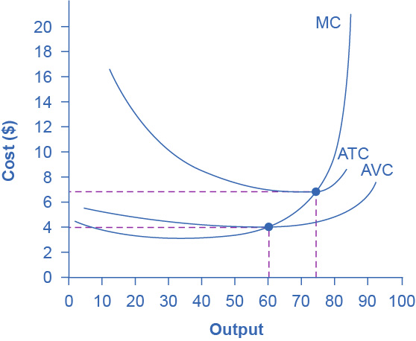

Figure 7.8 Cost Curves at the Clip Joint We can also present the information on total costs, fixed cost, and variable cost on a per-unit basis. We calculate average total cost (ATC) by dividing total cost by the total quantity produced. The average total cost curve is typically U-shaped. We calculate average variable cost (AVC) by dividing variable cost by the quantity produced. The average variable cost curve lies below the average total cost curve and is also typically U-shaped. We calculate marginal cost (MC) by taking the change in total cost between two levels of output and dividing by the change in output. The marginal cost curve is upward-sloping.

|  |  |  |  |  |  |  |  |
| --- | --- | --- | --- | --- | --- | --- | --- |
| Labor | Quantity | Fixed Cost | Variable Cost | Total Cost | Marginal Cost | Average Total Cost | Average Variable Cost |
| 1 | 16 | $160 | $80 | $240 | $15.00 | $15.00 | $5.00 |
| 2 | 40 | $160 | $160 | $320 | $3.33 | $8.00 | $4.00 |
| 3 | 60 | $160 | $240 | $400 | $4.00 | $6.67 | $4.00 |
| 4 | 72 | $160 | $320 | $480 | $6.67 | $6.67 | $4.44 |
| 5 | 80 | $160 | $400 | $560 | $10.00 | $7.00 | $5.00 |
| 6 | 84 | $160 | $480 | $640 | $20.00 | $7.62 | $5.71 |

Table 7.10 Different Types of Costs

Average total cost (sometimes referred to simply as average cost) is total cost divided by the quantity of output. Since the total cost of producing 40 haircuts is $320, the average total cost for producing each of 40 haircuts is $320/40, or $8 per haircut. Average cost curves are typically U-shaped, as Figure 7.8 shows. Average total cost starts off relatively high, because at low levels of output total costs are dominated by the fixed cost. Mathematically, the denominator is so small that average total cost is large. Average total cost then declines, as the fixed costs are spread over an increasing quantity of output. In the average cost calculation, the rise in the numerator of total costs is relatively small compared to the rise in the denominator of quantity produced. However, as output expands still further, the average cost begins to rise. At the right side of the average cost curve, total costs begin rising more rapidly as diminishing returns come into effect.

We obtain average variable cost when we divide variable cost by quantity of output. For example, the variable cost of producing 80 haircuts is $400, so the average variable cost is $400/80, or $5 per haircut. Note that at any level of output, the average variable cost curve will always lie below the curve for average total cost, as Figure 7.8 shows. The reason is that average total cost includes average variable cost and average fixed cost. Thus, for Q = 80 haircuts, the average total cost is $8 per haircut, while the average variable cost is $5 per haircut. However, as output grows, fixed costs become relatively less important (since they do not rise with output), so average variable cost sneaks closer to average cost.

Average total and variable costs measure the average costs of producing some quantity of output. Marginal cost is somewhat different. Marginal cost is the additional cost of producing one more unit of output. It is not the cost per unit of *all* units produced, but only the next one (or next few). We calculate marginal cost by taking the change in total cost and dividing it by the change in quantity. For example, as quantity produced increases from 40 to 60 haircuts, total costs rise by 400 – 320, or 80. Thus, the marginal cost for each of those marginal 20 units will be 80/20, or $4 per haircut. The marginal cost curve is generally upward-sloping, because diminishing marginal returns implies that additional units are more costly to produce. We can see small range of increasing marginal returns in the figure as a dip in the marginal cost curve before it starts rising. There is a point at which marginal and average costs meet, as the following Clear it Up feature discusses.

Clear It Up

Where do marginal and average costs meet?

The marginal cost line intersects the average cost line exactly at the bottom of the average cost curve—which occurs at a quantity of 72 and cost of $6.60 in Figure 7.8. The reason why the intersection occurs at this point is built into the economic meaning of marginal and average costs. If the marginal cost of production is below the average cost for producing previous units, as it is for the points to the left of where MC crosses ATC, then producing one more additional unit will reduce average costs overall—and the ATC curve will be downward-sloping in this zone. Conversely, if the marginal cost of production for producing an additional unit is above the average cost for producing the earlier units, as it is for points to the right of where MC crosses ATC, then producing a marginal unit will increase average costs overall—and the ATC curve must be upward-sloping in this zone. The point of transition, between where MC is pulling ATC down and where it is pulling it up, must occur at the minimum point of the ATC curve.

This idea of the marginal cost “pulling down” the average cost or “pulling up” the average cost may sound abstract, but think about it in terms of your own grades. If the score on the most recent quiz you take is lower than your average score on previous quizzes, then the marginal quiz pulls down your average. If your score on the most recent quiz is higher than the average on previous quizzes, the marginal quiz pulls up your average. In this same way, low marginal costs of production first pull down average costs and then higher marginal costs pull them up.

The numerical calculations behind average cost, average variable cost, and marginal cost will change from firm to firm. However, the general patterns of these curves, and the relationships and economic intuition behind them, will not change.

### Lessons from Alternative Measures of Costs

Breaking down total costs into fixed cost, marginal cost, average total cost, and average variable cost is useful because each statistic offers its own insights for the firm.

Whatever the firm’s quantity of production, total revenue must exceed total costs if it is to earn a profit. As explored in the chapter [Choice in a World of Scarcity](http://openstax.org/books/principles-microeconomics-3e/pages/2-introduction-to-choice-in-a-world-of-scarcity), fixed costs are often sunk costs that a firm cannot recoup. In thinking about what to do next, typically you should ignore sunk costs, since you have already spent this money and cannot make any changes. However, you can change variable costs, so they convey information about the firm’s ability to cut costs in the present and the extent to which costs will increase if production rises.

Clear It Up

Why are total cost and average cost not on the same graph?

Total cost, fixed cost, and variable cost each reflect different aspects of the cost of production over the entire quantity of output produced. We measure these costs in dollars. In contrast, marginal cost, average cost, and average variable cost are costs per unit. In the previous example, we measured them as dollars per haircut. Thus, it would not make sense to put all of these numbers on the same graph, since we measure them in different units ($ versus $ per unit of output).

It would be as if the vertical axis measured two different things. In addition, as a practical matter, if they were on the same graph, the lines for marginal cost, average cost, and average variable cost would appear almost flat against the horizontal axis, compared to the values for total cost, fixed cost, and variable cost. Using the figures from the previous example, the total cost of producing 40 haircuts is $320. However, the average cost is $320/40, or $8. If you graphed both total and average cost on the same axes, the average cost would hardly show.

Average cost tells a firm whether it can earn profits given the current price in the market. If we divide profit by the quantity of output produced we get average profit, also known as the firm’s *profit margin*. Expanding the equation for profit gives:

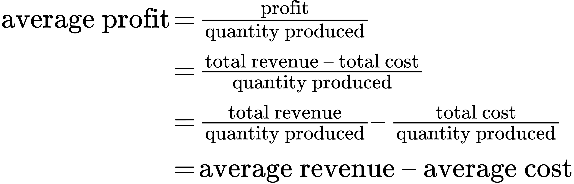

However, note that:

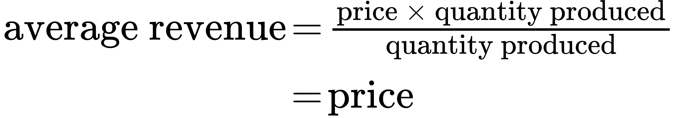

Thus:



This is the firm’s profit margin. This definition implies that if the market price is above average cost, average profit, and thus total profit, will be positive. If price is below average cost, then profits will be negative.

We can compare this marginal cost of producing an additional unit with the marginal revenue gained by selling that additional unit to reveal whether the additional unit is adding to total profit—or not. Thus, marginal cost helps producers understand how increasing or decreasing production affects profits.

### A Variety of Cost Patterns

The pattern of costs varies among industries and even among firms in the same industry. Some businesses have high fixed costs, but low marginal costs. Consider, for example, an internet company that provides medical advice to customers. Consumers might pay such a company directly, or perhaps hospitals or healthcare practices might subscribe on behalf of their patients. Setting up the website, collecting the information, writing the content, and buying or leasing the computer space to handle the web traffic are all fixed costs that the company must undertake before the site can work. However, when the website is up and running, it can provide a high quantity of service with relatively low variable costs, like the cost of monitoring the system and updating the information. In this case, the total cost curve might start at a high level, because of the high fixed costs, but then might appear close to flat, up to a large quantity of output, reflecting the low variable costs of operation. If the website is popular, however, a large rise in the number of visitors will overwhelm the website, and increasing output further could require a purchase of additional computer space.

For other firms, fixed costs may be relatively low. For example, consider firms that rake leaves in the fall or shovel snow off sidewalks and driveways in the winter. For fixed costs, such firms may need little more than a car to transport workers to homes of customers and some rakes and shovels. Still other firms may find that diminishing marginal returns set in quite sharply. If a manufacturing plant tried to run 24 hours a day, seven days a week, little time remains for routine equipment maintenance, and marginal costs can increase dramatically as the firm struggles to repair and replace overworked equipment.

Every firm can gain insight into its task of earning profits by dividing its total costs into fixed and variable costs, and then using these calculations as a basis for average total cost, average variable cost, and marginal cost. However, making a final decision about the profit-maximizing quantity to produce and the price to charge will require combining these perspectives on cost with an analysis of sales and revenue, which in turn requires looking at the market structure in which the firm finds itself. Before we turn to the analysis of market structure in other chapters, we will analyze the firm’s cost structure from a long-run perspective.