

Figure 7.1 Amazon is an American international electronic commerce company that sells books, among many other things, shipping them directly to the consumer. Until recently there were no brick and mortar Amazon stores. (Credit: modification of “Amazon Prime Delivery Van (50072389511)” by Tony Webster/Wikimedia Commons, CC BY 2.0)

Chapter Objectives

In this chapter, you will learn about:

* Explicit and Implicit Costs, and Accounting and Economic Profit
* Production in the Short Run
* Costs in the Short Run
* Production in the Long Run
* Costs in the Long Run

## Introduction to Production, Costs, and Industry Structure

Bring It Home

Amazon

In less than two decades, Amazon.com has transformed the way consumers sell, buy, and even read. Prior to Amazon, independent bookstores with limited inventories in small retail locations primarily sold books. There were exceptions, of course. Borders and Barnes & Noble offered larger stores in urban areas. In the last decade, however, independent bookstores have mostly disappeared, Borders has gone out of business, and Barnes & Noble is struggling. Online delivery and purchase of books has overtaken the more traditional business models. How has Amazon changed the book selling industry? How has it managed to crush its competition?

A major reason for the giant retailer’s success is its production model and cost structure, which has enabled Amazon to undercut the competitors' prices even when factoring in the cost of shipping. Read on to see how firms great (like Amazon) and small (like your corner deli) determine what to sell, at what output, and price.

This chapter is the first of four chapters that explores the *theory of the firm*. This theory explains how firms behave. What does that mean? Let’s define what we mean by the firm. A firm (or producer or business) combines inputs of labor, capital, land, and raw or finished component materials to produce outputs. If the firm is successful, the outputs are more valuable than the inputs. This activity of production goes beyond manufacturing (i.e., making things). It includes any process or service that creates value, including transportation, distribution, wholesale and retail sales.

Production involves a number of important decisions that define a firm's behavior. These decisions include, but are not limited to:

* What product or products should the firm produce?
* How should the firm produce the products (i.e., what production process should the firm use)?
* How much output should the firm produce?
* What price should the firm charge for its products?
* How much labor should the firm employ?

The answers to these questions depend on the production and cost conditions facing each firm. That is the subject of this chapter. The answers also depend on the market structure for the product(s) in question. Market structure is a multidimensional concept that involves how competitive the industry is. We define it by questions such as these:

* How much market power does each firm in the industry possess?
* How similar is each firm’s product to the products of other firms in the industry?
* How difficult is it for new firms to enter the industry?
* Do firms compete on the basis of price, advertising, or other product differences?

Figure 7.2 illustrates the range of different market structures, which we will explore in [Perfect Competition](http://openstax.org/books/principles-microeconomics-3e/pages/8-introduction-to-perfect-competition), [Monopoly](http://openstax.org/books/principles-microeconomics-3e/pages/9-introduction-to-a-monopoly), and [Monopolistic Competition and Oligopoly](http://openstax.org/books/principles-microeconomics-3e/pages/10-introduction-to-monopolistic-competition-and-oligopoly).

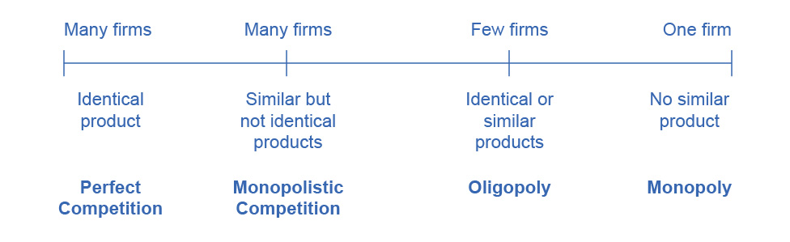

Figure 7.2 The Spectrum of Competition Firms face different competitive situations. At one extreme—perfect competition—many firms are all trying to sell identical products. At the other extreme—monopoly—only one firm is selling the product, and this firm faces no competition. Monopolistic competition and oligopoly fall between the extremes of perfect competition and monopoly. Monopolistic competition is a situation with many firms selling similar, but not identical products. Oligopoly is a situation with few firms that sell identical or similar products.

Let's examine how firms determine their costs and desired profit levels. Then we will discuss the origins of cost, both in the short and long run. Private enterprise, which can be private individual or group business ownership, characterizes the U.S. economy. In the U.S. system, we have the option to organize private businesses as sole proprietorships (one owner), partners (more than one owner), and corporations (legal entitles separate from the owners.

When people think of businesses, often corporate giants like Wal-Mart, Microsoft, or General Motors come to mind. However, firms come in all sizes, as Table 7.1 shows. The vast majority of American firms have fewer than 20 employees. As of 2010, the U.S. Census Bureau counted 5.7 million firms with employees in the U.S. economy. Slightly less than half of all the workers in private firms are at the 17,000 large firms, meaning they employ more than 500 workers. Another 35% of workers in the U.S. economy are at firms with fewer than 100 workers. These small-scale businesses include everything from dentists and lawyers to businesses that mow lawns or clean houses. Table 7.1 does not include a separate category for the millions of small “non-employer” businesses where a single owner or a few partners are not officially paid wages or a salary, but simply receive whatever they can earn.

|  |  |  |
| --- | --- | --- |
| Number of Employees | Firms (% of total firms) | Number of Paid Employees (% of total employment) |
| **Total** | **5,734,538** | **112.0 million** |
| 0–9 | 4,543,315 (79.2%) | 12.3 million (11.0%) |
| 10–19 | 617,089 (10.8%) | 8.3 million (7.4%) |
| 20–99 | 475,125 (8.3%) | 18.6 million (16.6%) |
| 100–499 | 81,773 (1.4%) | 15.9 million (14.2%) |
| 500 or more | 17,236 (0.30%) | 50.9 million (49.8%) |

Table 7.1 Range in Size of U.S. Firms (Source: U.S. Census, 2010 www.census.gov)