## Chapter 15

[1](http://openstax.org/books/principles-microeconomics-3e/pages/15-self-check-questions#ch14mod01_sques01).

1. Poverty falls, inequality rises.
2. Poverty rises, inequality falls.

[2](http://openstax.org/books/principles-microeconomics-3e/pages/15-self-check-questions#ch14mod02_sques01).

Jonathon’s options for working and total income are shown in the following table. His labor-leisure diagram is shown in the figure following the table.

|  |  |  |  |
| --- | --- | --- | --- |
| Number of Work Hours | Earnings from Work | Government Benefits | Total Income |
| 1,500 | $9,000 | $1,000 | $10,000 |
| 1,200 | $7,200 | $2,800 | $10,000 |
| 900 | $5,400 | $4,600 | $10,000 |
| 600 | $3,600 | $6,400 | $10,000 |
| 300 | $1,800 | $8,200 | $10,000 |
| 0 | $0 | $10,000 | $10,000 |

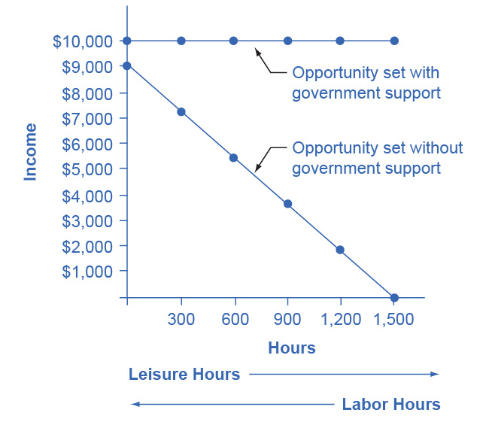

[3](http://openstax.org/books/principles-microeconomics-3e/pages/15-self-check-questions#ch14mod02_sques02).

The following table shows a policy where only 30 cents in government support is pulled right back for every $1 of income earned. Jonathon’s labor-leisure diagram is shown in the figure following the table. “Opportunity set after program” extends from (0, $16,300) to (1,500, $10,000). “Opportunity set before program” slopes downward from (0, $9,000) to (1,500, $0).

|  |  |  |  |
| --- | --- | --- | --- |
| Number of Work Hours | Earnings from Work | Government Benefits | Total Income |
| 1,500 | $9,000 | $7,300 | $16,300 |
| 1,200 | $7,200 | $7,840 | $15,040 |
| 900 | $5,400 | $8,380 | $13,780 |
| 600 | $3,600 | $8,920 | $12,520 |
| 300 | $1,800 | $9,460 | $22,260 |
| 0 | $0 | $10,000 | $10,000 |

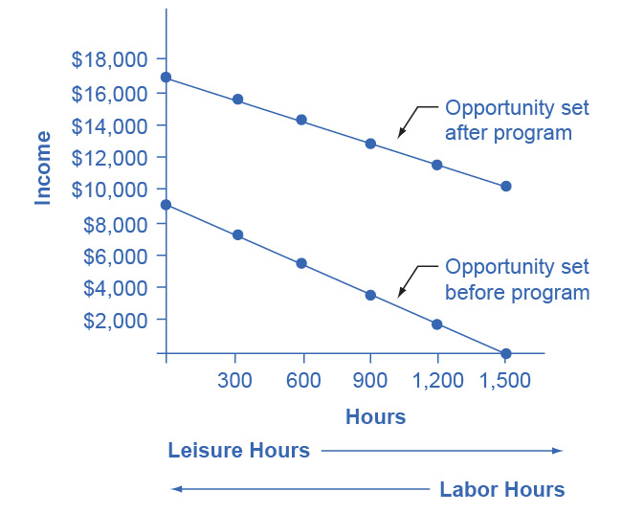

[4](http://openstax.org/books/principles-microeconomics-3e/pages/15-self-check-questions#ch14mod03_sques01).

The earned income tax credit works like this: a family receives a tax break that increases according to how much they work. Families that work more get more. In that sense it loosens the poverty trap by encouraging work. As families earn above the poverty level, the earned income tax credit is gradually reduced. For those near-poor families, the earned income tax credit is a partial disincentive to work.

[5](http://openstax.org/books/principles-microeconomics-3e/pages/15-self-check-questions#ch14mod03_sques02).

TANF attempts to loosen the poverty trap by providing incentives to work in other ways. Specifically, it requires that people work (or complete their education) as a condition of receiving TANF benefits, and it places a time limit on benefits.

[6](http://openstax.org/books/principles-microeconomics-3e/pages/15-self-check-questions#ch14mod04_sques01).

A useful first step is to rank the households by income, from lowest to highest. Then, since there are 10 households total, the bottom quintile will be the bottom two households, the second quintile will be the third and fourth households, and so on up to the top quintile. The quintiles and percentage of total income for the data provided are shown in the following table. Comparing this distribution to the U.S. income distribution for 2005, the top quintile in the example has a smaller share of total income than in the U.S. distribution and the bottom quintile has a larger share. This pattern usually means that the income distribution in the example is more equal than the U.S. distribution.

|  |  |  |
| --- | --- | --- |
| Income | Quintile | % of Total Income |
| $10,000 | Total first quintile income: $22,000 | 6.0% |
| $12,000 |  |  |
| $16,000 | Total second quintile income: $34,000 | 9.2% |
| $18,000 |  |  |
| $24,000 | Total third quintile income: $48,000 | 13.0% |
| $24,000 |  |  |
| $36,000 | Total fourth quintile income: $86,000 | 23.2% |
| $50,000 |  |  |
| $80,000 | Total top quintile income: $180,000 | 48.6% |
| $100,000 |  |  |
| **$370,000** | **Total Income** |  |

[7](http://openstax.org/books/principles-microeconomics-3e/pages/15-self-check-questions#ch14mod04_sques02).

Just from glancing at the quintile information, it is fairly obvious that income inequality increased in the United Kingdom over this time: The top quintile is getting a lot more, and the lowest quintile is getting a bit less. Converting this information into a Lorenz curve, however, is a little trickier, because the Lorenz curve graphs the cumulative distribution, not the amount received by individual quintiles. Thus, as explained in the text, you have to add up the individual quintile data to convert the data to this form. The following table shows the actual calculations for the share of income in 1979 versus 1991. The figure following the table shows the perfect equality line and the Lorenz curves for 1979 and 1991. As shown, the income distribution in 1979 was closer to the perfect equality line than the income distribution in 1991—that is, the United Kingdom income distribution became more unequal over time.

|  |  |  |
| --- | --- | --- |
| Share of income received | 1979 | 1991 |
| Bottom 20% | 7.0% | 6.6% |
| Bottom 40% | 18.5% | 18.1% |
| Bottom 60% | 35.5% | 34.4% |
| Bottom 80% | 60.3% | 57.1% |
| All 100% | 100.0% | 100.0% |

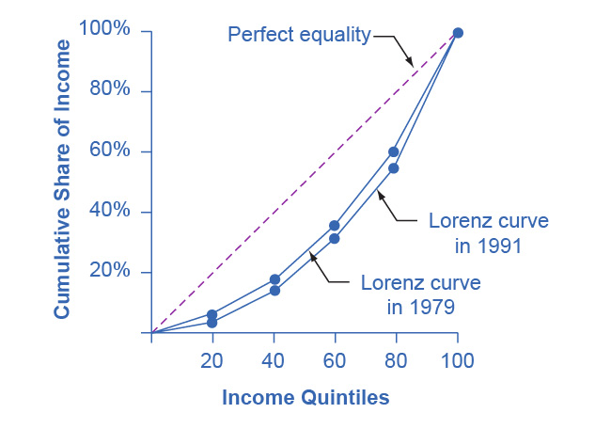

[8](http://openstax.org/books/principles-microeconomics-3e/pages/15-self-check-questions#ch14mod04_sques03).

In the market for low-wage labor, information technology shifts the demand for low-wage labor to the left. One reason is that technology can often substitute for low-wage labor in certain kinds of telephone or bookkeeping jobs. In addition, information technology makes it easier for companies to manage connections with low-wage workers in other countries, thus reducing the demand for low-wage workers in the United States. In the market for high-wage labor, information technology shifts the demand for high-wage labor to the right. By using the new information and communications technologies, high-wage labor can become more productive and can oversee more tasks than before. The following figure illustrates these two labor markets. The combination of lower wages for low-wage labor and higher wages for high-wage labor means greater inequality.

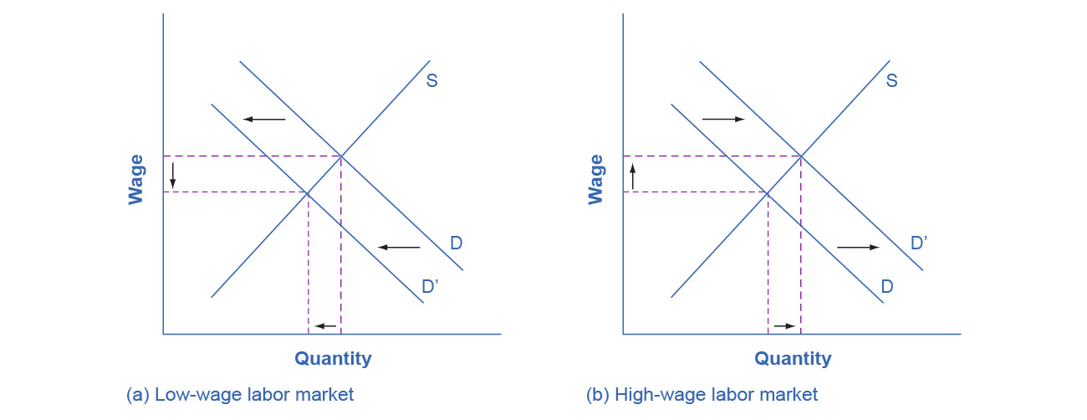

[9](http://openstax.org/books/principles-microeconomics-3e/pages/15-self-check-questions#ch14mod04_sques04).

In the market for low-wage labor, a skills program will shift supply to the left, which will tend to drive up wages for the remaining low-skill workers. In the market for high-wage labor, a skills program will shift supply to the right (because after the training program there are now more high-skilled workers at every wage), which will tend to drive down wages for high-skill workers. The combination of these two programs will result in a lesser degree of inequality. The following figure illustrates these two labor markets. In the market for high-wage labor, a skills program will shift supply to the right, which will tend to drive down wages for high-skill workers.

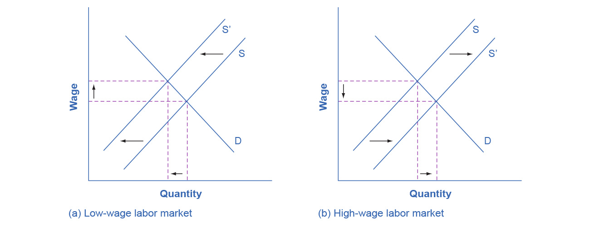

[10](http://openstax.org/books/principles-microeconomics-3e/pages/15-self-check-questions#ch14mod05_sques01).

A very strong push for economic equality might include extremely high taxes on high-wage earners to pay for extremely large government social payments for people with much lower incomes. Such a policy could limit incentives for the high-wage workers, lock the poor into a poverty trap, and thus reduce output. The PPF in this case will have the standard appearance: it will be downward sloping.

[11](http://openstax.org/books/principles-microeconomics-3e/pages/15-self-check-questions#ch14mod05_sques02).

For the second hypothesis, a well-funded social safety net might make people feel that even if their company goes bankrupt or they need to change jobs or industries, they will have some degree of protection. As a result, people may be more willing to allow markets to work without interference, and not to lobby as hard for rules that would prevent layoffs, set price controls, or block foreign trade. In this case, safety net programs that increase equality could also allow the market to work more freely in a way that could increase output. In this case, at least some portion of the PPF between equality and economic output would slope up.

[12](http://openstax.org/books/principles-microeconomics-3e/pages/15-self-check-questions#ch14mod05_sques03).

Pure redistribution is more likely to cause a sharp tradeoff between economic output and equality than policies aimed at the ladder of opportunity. A production possibility frontier showing a strict tradeoff between economic output and equality will be downward sloping. A PPF showing that it is possible to increase equality, at least to some extent, while either increasing output or at least not diminishing it would have a PPF that first rises, perhaps has a flat area, and then falls.

[13](http://openstax.org/books/principles-microeconomics-3e/pages/15-self-check-questions#ch14mod05_sques04).

Many view the redistribution of income to achieve greater equality as taking away from the rich to pay the poor, or as a “zero sum” game. By taking taxes from one group of people and redistributing them to another, the tax system is robbing some of the American Dream.