## Chapter 5

[1](http://openstax.org/books/principles-microeconomics-3e/pages/5-self-check-questions#fs-idp16086976).

From point B to point C, price rises from $70 to $80, and Qd decreases from 2,800 to 2,600. So:

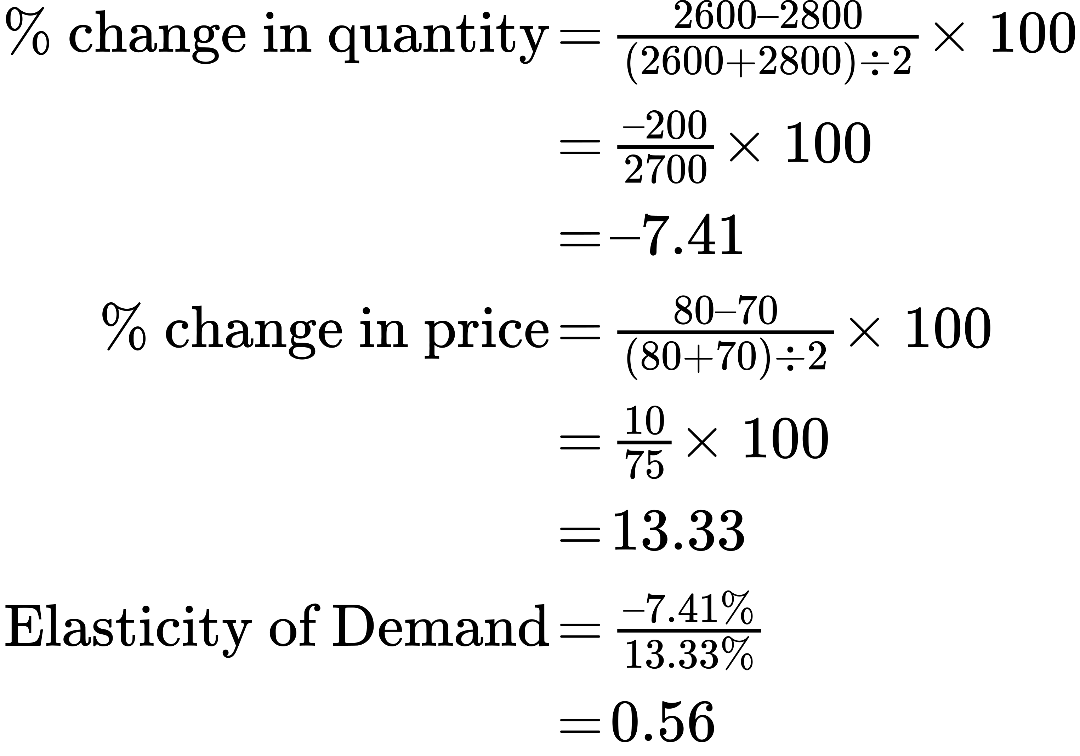

The demand curve is inelastic in this area; that is, its elasticity value is less than one.

Answer from Point D to point E:

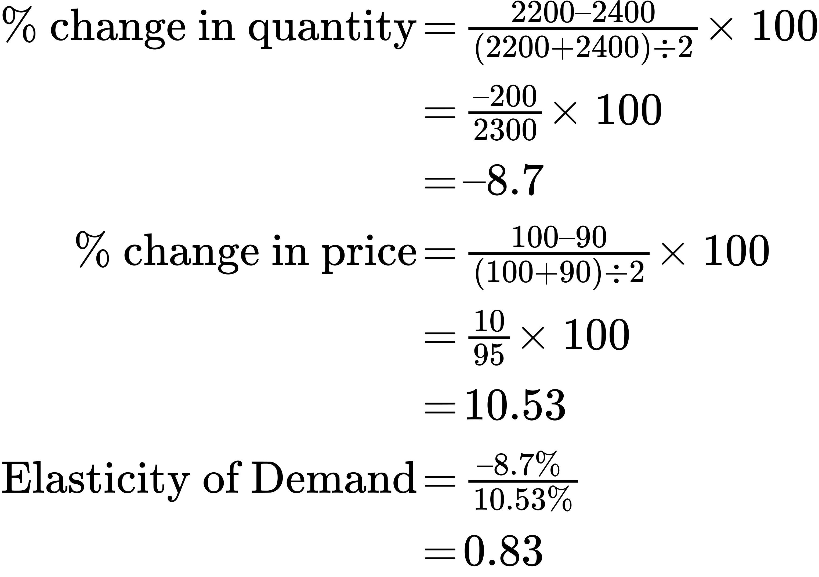

The demand curve is inelastic in this area; that is, its elasticity value is less than one.

Answer from Point G to point H:

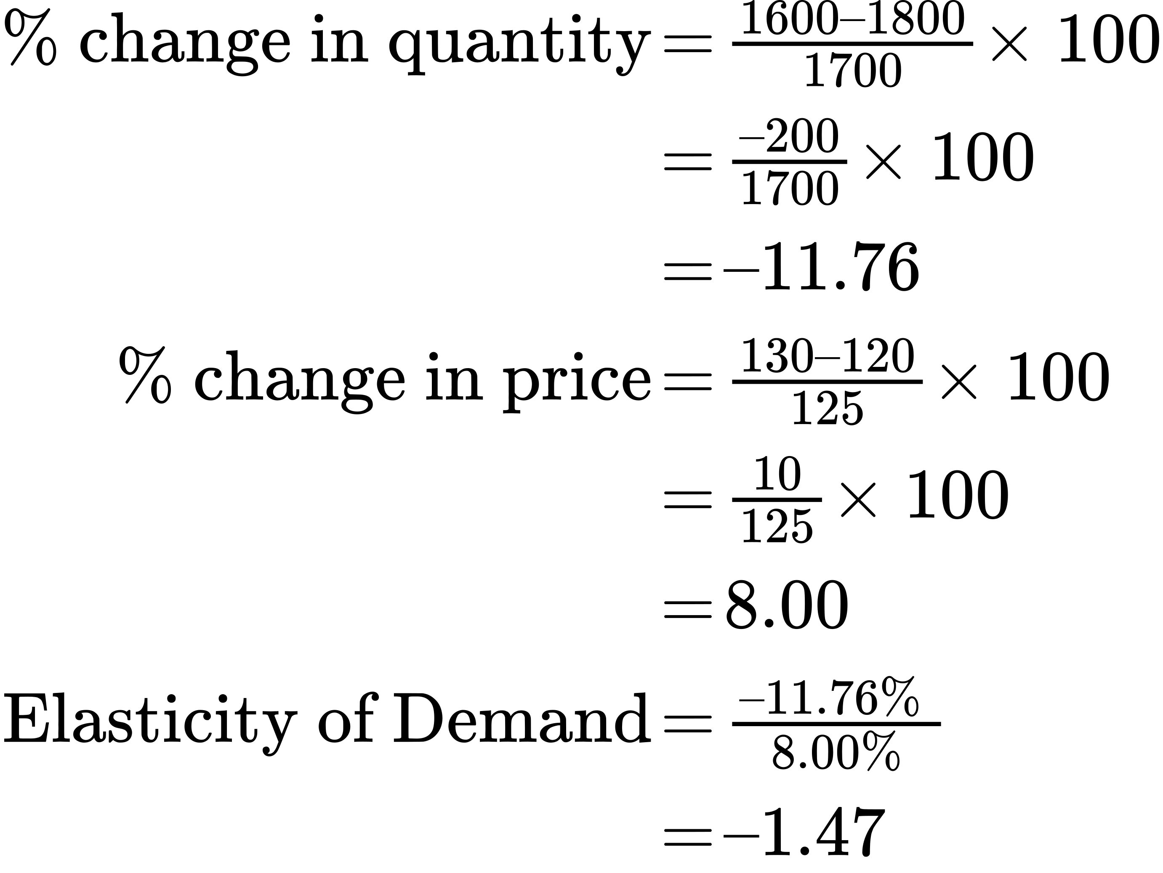

The demand curve is elastic in this interval.

[2](http://openstax.org/books/principles-microeconomics-3e/pages/5-self-check-questions#fs-idm14629328).

From point J to point K, price rises from $8 to $9, and quantity rises from 50 to 70. So:

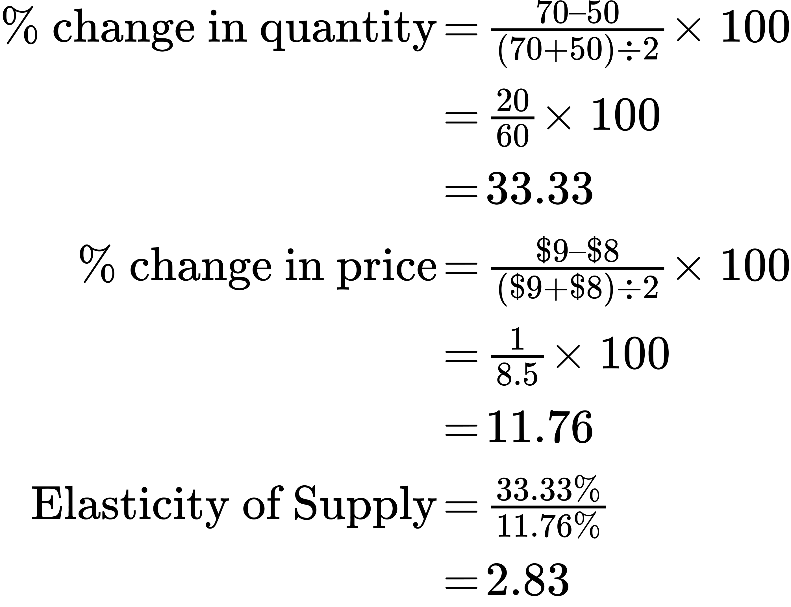

The supply curve is elastic in this area; that is, its elasticity value is greater than one.

From point L to point M, the price rises from $10 to $11, while the Qs rises from 80 to 88:

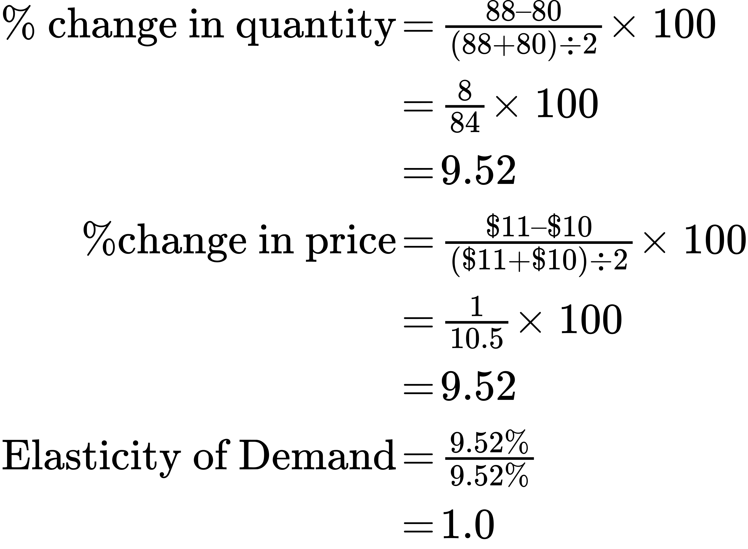

The supply curve has unitary elasticity in this area.

From point N to point P, the price rises from $12 to $13, and Qs rises from 95 to 100:

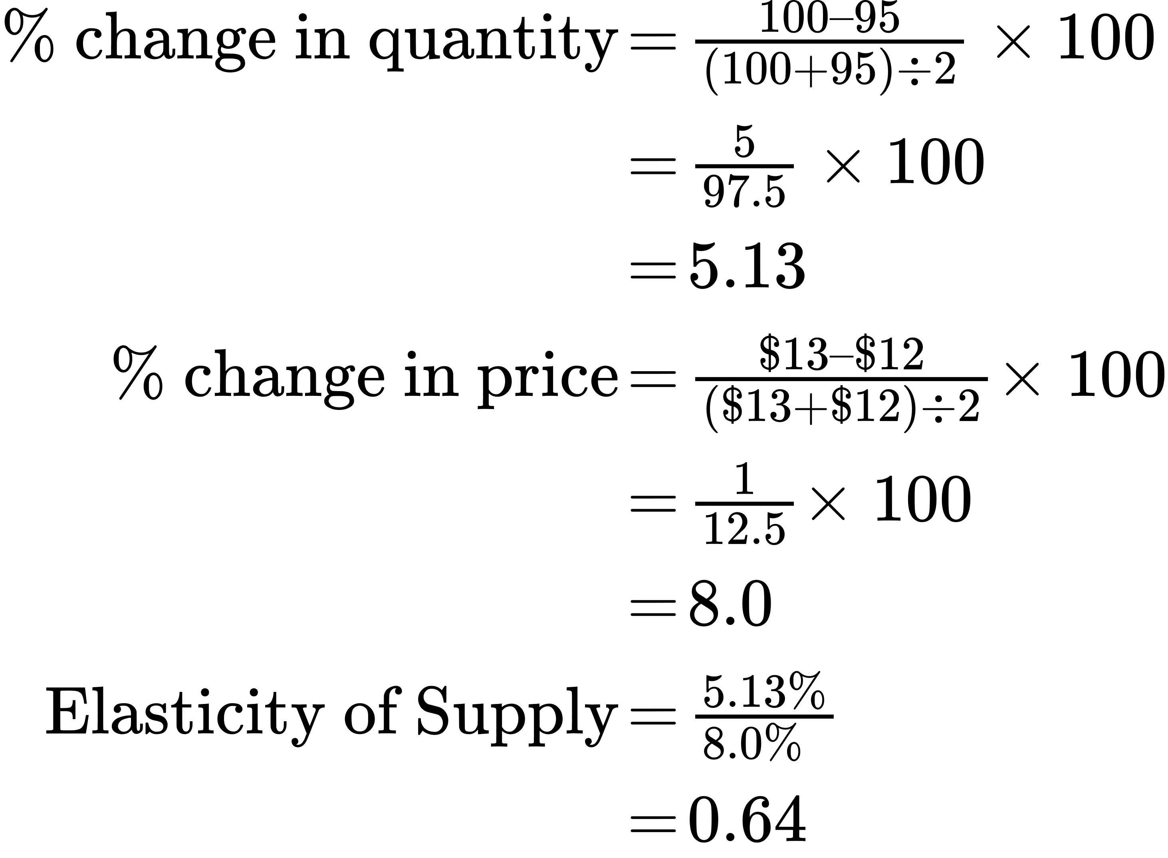

The supply curve is inelastic in this region of the supply curve.

[3](http://openstax.org/books/principles-microeconomics-3e/pages/5-self-check-questions#fs-idp21610480).

The demand curve with constant unitary elasticity is concave because the absolute value of declines in price are not identical. The left side of the curve starts with high prices, and then price falls by smaller amounts as it goes down toward the right side. This results in a slope of demand that is steeper on the left but flatter on the right, creating a curved, concave shape.

[4](http://openstax.org/books/principles-microeconomics-3e/pages/5-self-check-questions#fs-idp15543856).

The constant unitary elasticity is a straight line because the curve slopes upward and both price and quantity are increasing proportionally.

[5](http://openstax.org/books/principles-microeconomics-3e/pages/5-self-check-questions#fs-idp52211440).

Carmakers can pass this cost along to consumers if the demand for these cars is inelastic. If the demand for these cars is elastic, then the manufacturer must pay for the equipment.

[6](http://openstax.org/books/principles-microeconomics-3e/pages/5-self-check-questions#fs-idp1495344).

If the elasticity is 1.4 at current prices, you would advise the company to lower its price on the product, since a decrease in price will be offset by the increase in the amount of the drug sold. If the elasticity were 0.6, then you would advise the company to increase its price. Increases in price will offset the decrease in number of units sold, but increase your total revenue. If elasticity is 1, the total revenue is already maximized, and you would advise that the company maintain its current price level.

[7](http://openstax.org/books/principles-microeconomics-3e/pages/5-self-check-questions#fs-idp34138144).

The percentage change in quantity supplied as a result of a given percentage change in the price of gasoline.

[8](http://openstax.org/books/principles-microeconomics-3e/pages/5-self-check-questions#fs-idp23662496).

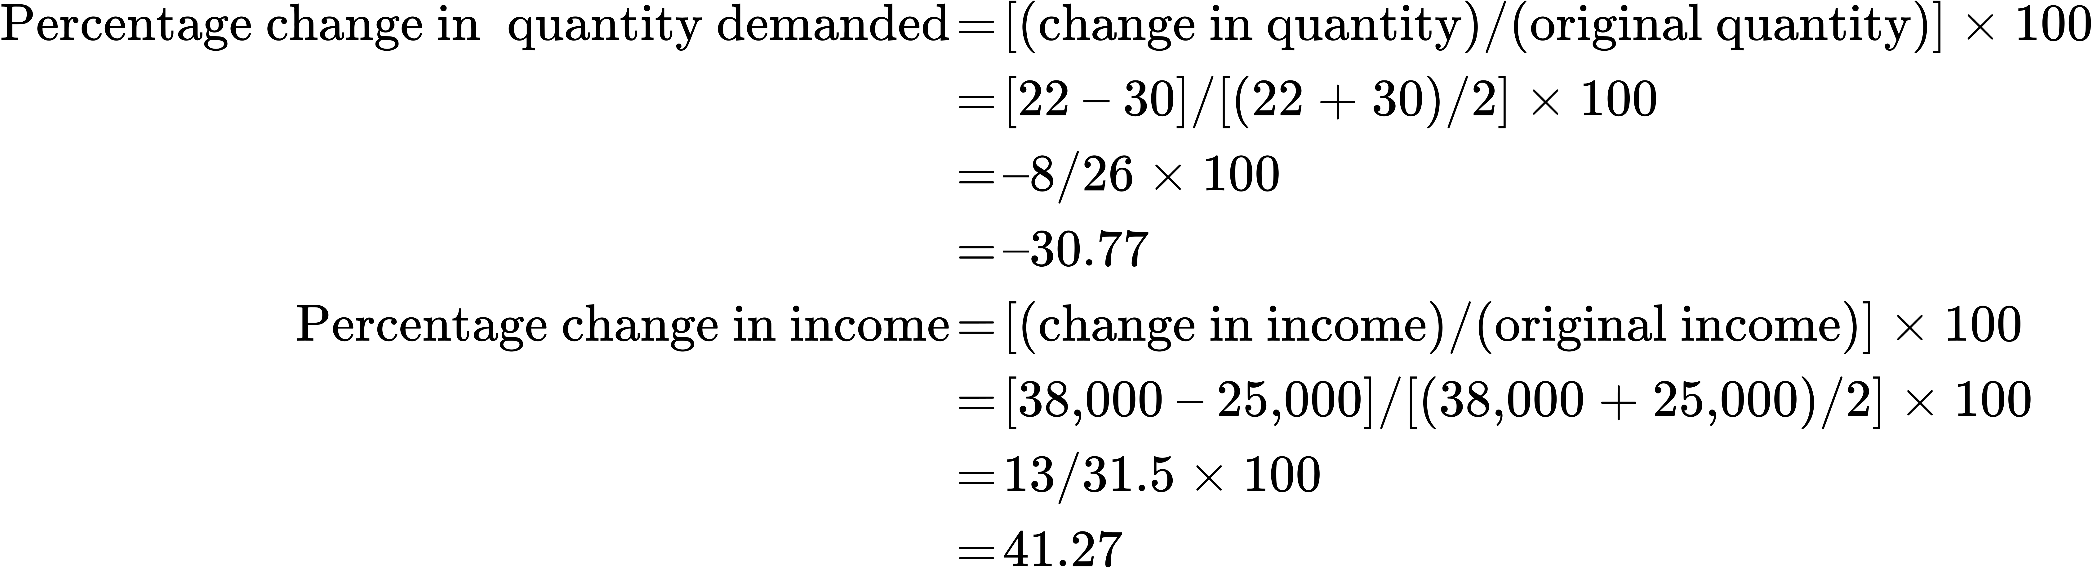

In this example, bread is an inferior good because its consumption falls as income rises.

[9](http://openstax.org/books/principles-microeconomics-3e/pages/5-self-check-questions#fs-idp23027184).

The formula for cross-price elasticity is % change in Qd for apples / % change in P of oranges. Multiplying both sides by % change in P of oranges yields:

% change in Qd for apples = cross-price elasticity X% change in P of oranges

= 0.4 × (–3%) = –1.2%, or a 1.2 % decrease in demand for apples.