## 12.4 The Benefits and Costs of U.S. Environmental Laws

### Learning Objectives

By the end of this section, you will be able to:

* Evaluate the benefits and costs of environmental protection
* Explain the effects of ecotourism
* Apply marginal analysis to illustrate the marginal costs and marginal benefits of reducing pollution

Government economists have estimated that U.S. firms may pay more than $200 billion per year to comply with federal environmental laws. That is a sizable amount of money. Is the money well spent?

### Benefits and Costs of Clean Air and Clean Water

We can divide the benefits of a cleaner environment into four areas: (1) people may stay healthier and live longer; (2) certain industries that rely on clean air and water, such as farming, fishing, and tourism, may benefit; (3) property values may be higher; and (4) people may simply enjoy a cleaner environment in a way that does not need to involve a market transaction. Some of these benefits, such as gains to tourism or farming, are relatively easy to value in economic terms. It is harder to assign a monetary value to others, such as the value of clean air for someone with asthma. It seems difficult to put a clear-cut monetary value on still others, such as the satisfaction you might feel from knowing that the air is clear over the Grand Canyon, even if you have never visited the Grand Canyon, but advanced techniques in economics allow one to generate estimates.

Although estimates of environmental benefits are not precise, they can still be revealing. For example, a study by the Environmental Protection Agency looked at the costs and benefits of the Clean Air Act from 1970 to 1990. It found that total costs over that time period were roughly $500 billion—a huge amount. However, it also found that a middle-range estimate of the health and other benefits from cleaner air was $22 trillion—about 44 times higher than the costs. A more recent EPA study estimated that the environmental benefits to Americans from the Clean Air Act will exceed their costs by a margin of four to one. The EPA estimated that “in 2010 the benefits of Clean Air Act programs will total about $110 billion. This estimate represents the value of avoiding increases in illness and premature death which would have prevailed.” Saying that overall benefits of environmental regulation have exceeded costs in the past, however, is very different from saying that every environmental regulation makes sense. For example, studies suggest that when breaking down emission reductions by type of contaminants, the benefits of air pollution control outweigh the costs primarily for particulates and lead, but when looking at other air pollutants, the costs of reducing them may be comparable to or greater than the benefits. Just because some environmental regulations have had benefits much higher than costs does not prove that every individual regulation is a sensible idea.

### Ecotourism: Making Environmentalism Pay

The definition of ecotourism is a little vague. Does it mean sleeping on the ground, eating roots, and getting close to wild animals? Does it mean flying in a helicopter to shoot anesthetic darts at African wildlife, or a little of both? The definition may be fuzzy, but tourists who hope to appreciate the ecology of their destination—“eco tourists”—are the impetus to a big and growing business. The International Ecotourism Society estimates that international tourists interested in seeing nature or wildlife would take 1.56 billion trips by 2020. While COVID-19 prevented this from happening in 2020, it is clear that there is a strong demand for ecotourism.

Link It Up

Visit The International Ecotourism Society’s [website](http://openstax.org/l/ecotourism) to learn more about The International Ecotourism Society, its programs, and tourism’s role in sustainable community development.

Realizing the attraction of ecotourism, the residents of low-income countries may come to see that preserving wildlife habitats is more lucrative than, say, cutting down forests or grazing livestock. In South Africa, Namibia, and Zimbabwe, for example, ecotourism has given local communities an economic interest in protecting elephant and rhinoceros populations. Some of the leading ecotourism destinations include Costa Rica and Panama in Central America; the Caribbean; Malaysia, and other South Pacific destinations; New Zealand; the Serengeti in Tanzania; the Amazon rain forests; and the Galapagos Islands. In many of these countries and regions, governments have enacted policies whereby they share revenues from ecotourism with local communities, to give people in those local communities a kind of property right that encourages them to conserve their local environment.

Ecotourism needs careful management, so that the combination of eager tourists and local entrepreneurs does not destroy what the visitors are coming to see. And recent research indicates that wild animals that are continually exposed to tourists and vehicles exhibit stress and atypical behaviors. In general, however, well-managed ecotourism is viewed as a net positive, which provides an alternative to damaging the local environment.

### Marginal Benefits and Marginal Costs

We can use the tools of marginal analysis to illustrate the marginal costs and the marginal benefits of reducing pollution. Figure 12.4 illustrates a theoretical model of this situation. When the quantity of environmental protection is low so that pollution is extensive—for example, at quantity Qa—there are usually numerous relatively cheap and easy ways to reduce pollution, and the marginal benefits of doing so are quite high. At Qa, it makes sense to allocate more resources to fight pollution. However, as the extent of environmental protection increases, the cheap and easy ways of reducing pollution begin to decrease, and one must use more costly methods. The marginal cost curve rises. Also, as environmental protection increases, one achieves the largest marginal benefits first, followed by reduced marginal benefits. As the quantity of environmental protection increases to, say, Qb, the gap between marginal benefits and marginal costs narrows. At point Qc the marginal costs will exceed the marginal benefits. At this level of environmental protection, society is not allocating resources efficiently, because it is forfeiting too many resources to reduce pollution.

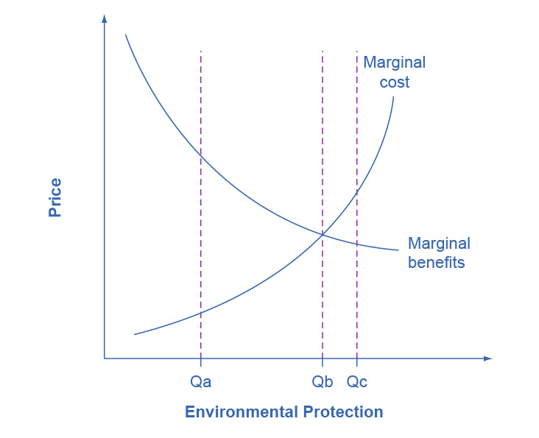

Figure 12.4 Marginal Costs and Marginal Benefits of Environmental Protection Reducing pollution is costly—one must sacrifice resources. The marginal costs of reducing pollution are generally increasing, because one can first make the least expensive and easiest reductions, leaving the more expensive methods for later. The marginal benefits of reducing pollution are generally declining, because one can take the steps that provide the greatest benefit first, and steps that provide less benefit can wait until later.

As society draws closer to Qb, some might argue that it becomes more important to use market-oriented environmental tools to hold down the costs of reducing pollution. Their objective would be to avoid environmental rules that would provide the quantity of environmental protection at Qc, where marginal costs exceed marginal benefits. The following Clear It Up feature delves into how the EPA measures its policies – and the monetary value of our lives.

Clear It Up

What's a life worth?

The U.S. Environmental Protection Agency (EPA) must estimate the value of saving lives by reducing pollution against the additional costs. In measuring the benefits of government environmental policies, the EPA’s National Center for Environmental Economics (NCEE) values a statistical human life at $7.4 million (in 2006 U.S. dollars, which corresponds to a little more than $10.5 million in February 2022.)

Economists value a human life on the basis of studies of the value that people actually place on human lives in their own decisions. For example, some jobs have a higher probability of death than others, and these jobs typically pay more to compensate for the risk. Examples are ocean fishery as opposed to fish farming, and ice trucking in Alaska as opposed to truck driving in the “lower forty-eight” states.

Government regulators use estimates such as these when deciding what proposed regulations are “reasonable,” which means deciding which proposals have high enough benefits to justify their cost. For example, when the U.S. Department of Transportation makes decisions about what safety systems should be required in cars or airplanes, it will approve rules only where the estimated cost per life saved is $3 million or less.

Resources that we spend on life-saving regulations create a tradeoff. A study by W. Kip Viscusi of Vanderbilt University estimated that when a regulation costs $50 million, it diverts enough spending in the rest of the economy from health care and safety expenditures that it costs a life. This finding suggests that any regulation that costs more than $50 million per life saved actually costs lives, rather than saving them.

### References

Ryan, Dave. “New Report Shows Benefits of 1990 Clean Air Amendments Outweigh Costs by Four-to-One Margin,” press release, November 16, 1999. *United States Environmental Protection Agency.* Accessed December 19, 2013. http://www.epa.gov/oar/sect812/r-140.html.

National Center for Environmental Economics (NCEE). “Frequently Asked Questions on Mortality Risk Valuation.” *United States Environmental Protection Agency.* Accessed December 19, 2013. http://yosemite.epa.gov/ee/epa/eed.nsf/pages/MortalityRiskValuation.html#whatvalue World Tourism Organization, “Tourism 2020 Vision.” Accessed December 19, 2013. http://www.world-tourism.org/market_research/facts/market_trends.htm.

Viscusi, Kip W. *Fatal Tradeoffs: Public and Private Responsibilities for Risk.* New York: Oxford University Press, 1995.