## 13.1 Investments in Innovation

### Learning Objectives

By the end of this section, you will be able to:

* Identify the positive externalities of new technology.
* Explain the difference between private benefits and social benefits and give examples of each.
* Calculate and analyze rates of return

Market competition can provide an incentive for discovering new technology because a firm can earn higher profits by finding a way to produce products more cheaply or to create products with characteristics consumers want. As Gregory Lee, CEO of Samsung said, “Relentless pursuit of new innovation is the key principle of our business and enables consumers to discover a world of possibilities with technology.” An innovative firm knows that it will usually have a temporary edge over its competitors and thus an ability to earn above-normal profits before competitors can catch up.

In certain cases, however, competition can discourage new technology, especially when other firms can quickly copy a new idea. Consider a pharmaceutical firm deciding to develop a new drug. On average, it can cost $800 million and take more than a decade to discover a new drug, perform the necessary safety tests, and bring the drug to market. If the research and development (R&D) effort fails—and every R&D project has some chance of failure—then the firm will suffer losses and could even be driven out of business. If the project succeeds, then the firm’s competitors may figure out ways of adapting and copying the underlying idea, but without having to pay the costs themselves. As a result, the innovative company will bear the much higher costs of the R&D and will enjoy at best only a small, temporary advantage over the competition.

Many inventors over the years have discovered that their inventions brought them less profit than they might have reasonably expected.

* Eli Whitney (1765–1825) invented the cotton gin, but then southern cotton planters built their own seed-separating devices with a few minor changes in Whitney’s design. When Whitney sued, he found that the courts in southern states would not uphold his patent rights.
* Thomas Edison (1847–1931) still holds the record for most patents granted to an individual. His first invention was an automatic vote counter, and despite the social benefits, he could not find a government that wanted to buy it.
* Gordon Gould came up with the idea behind the laser in 1957. He put off applying for a patent and, by the time he did apply, other scientists had laser inventions of their own. A lengthy legal battle resulted, in which Gould spent $100,000 on lawyers, before he eventually received a patent for the laser in 1977. Compared to the enormous social benefits of the laser, Gould received relatively little financial reward.
* In 1936, Alan Turing delivered a paper titled, "On Computable Numbers, with an Application to the Entscheidungsproblem," in which he presented the notion of a universal machine (later called the “Universal Turing Machine," and then the "Turing machine") capable of computing anything that is computable. The central concept of the modern computer was based on Turing’s paper. Today scholars widely consider Turing as the father of theoretical computer science and artificial intelligence; however, the UK government prosecuted Turing in 1952 for engaging in same-sex sexual acts and gave him the choice of chemical castration or prison. Turing chose castration and died in 1954 from cyanide poisoning.

A variety of studies by economists have found that the original inventor receives one-third to one-half of the total economic benefits from innovations, while other businesses and new product users receive the rest.

### The Positive Externalities of New Technology

Will private firms in a market economy underinvest in research and technology? If a firm builds a factory or buys a piece of equipment, the firm receives all the economic benefits that result from the investments. However, when a firm invests in new technology, the private benefits, or profits, that the firm receives are only a portion of the overall social benefits. The social benefits of an innovation account for the value of all the positive externalities of the new idea or product, whether enjoyed by other companies or society as a whole, as well as the private benefits the firm that developed the new technology receives. As you learned in [Environmental Protection and Negative Externalities](http://openstax.org/books/principles-microeconomics-3e/pages/12-introduction-to-environmental-protection-and-negative-externalities), positive externalities are beneficial spillovers to a third party, or parties.

Consider the example of the Big Drug Company, which is planning its R&D budget for the next year. Economists and scientists working for Big Drug have compiled a list of potential research and development projects and estimated rates of return. (The rate of return is the estimated payoff from the project.) Figure 13.2 shows how the calculations work. The downward-sloping DPrivate curve represents the firm’s demand for financial capital and reflects the company’s willingness to borrow to finance research and development projects at various interest rates. Suppose that this firm’s investment in research and development creates a spillover benefit to other firms and households. After all, new innovations often spark other creative endeavors that society also values. If we add the spillover benefits society enjoys to the firm’s private demand for financial capital, we can draw DSocial that lies above DPrivate.

If there were a way for the firm to fully monopolize those social benefits by somehow making them unavailable to the rest of us, the firm’s private demand curve would be the same as society’s demand curve. According to Figure 13.2 and Table 13.1, if the going rate of interest on borrowing is 8%, and the company can receive the private benefits of innovation only, then the company would finance $30 million. Society, at the same rate of 8%, would find it optimal to have $52 million of borrowing. Unless there is a way for the company to fully enjoy the total benefits, then it will borrow less than the socially optimal level of $52 million.

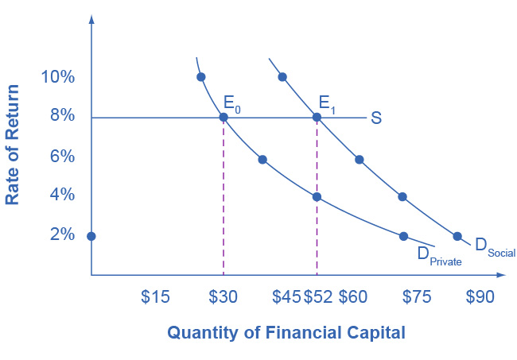

Figure 13.2 Positive Externalities and Technology Big Drug faces a cost of borrowing of 8%. If the firm receives only the private benefits of investing in R&D, then we show its demand curve for financial capital by DPrivate, and the equilibrium will occur at $30 million. Because there are spillover benefits, society would find it optimal to have $52 million of investment. If the firm could keep the social benefits of its investment for itself, its demand curve for financial capital would be DSocial and it would be willing to borrow $52 million.

|  |  |  |
| --- | --- | --- |
| Rate of Return | DPrivate (in millions) | DSocial (in millions) |
| 2% | $72 | $84 |
| 4% | $52 | $72 |
| 6% | $38 | $62 |
| 8% | $30 | $52 |
| 10% | $26 | $44 |

Table 13.1 Return and Demand for Capital

Big Drug’s original demand for financial capital (DPrivate) is based on the profits the firm receives. However, other pharmaceutical firms and health care companies may learn new lessons about how to treat certain medical conditions and are then able to create their own competing products. The social benefit of the drug takes into account the value of all the drug's positive externalities. If Big Drug were able to gain this social return instead of other companies, its demand for financial capital would shift to the demand curve DSocial, and it would be willing to borrow and invest $52 million. However, if Big Drug is receiving only 50 cents of each dollar of social benefits, the firm will not spend as much on creating new products. The amount it would be willing to spend would fall somewhere in between DPrivate and DSocial.

### Why Invest in Human Capital?

The investment in anything, whether it is the construction of a new power plant or research in a new cancer treatment, usually requires a certain upfront cost with an uncertain future benefit. The investment in education, or human capital, is no different. Over the span of many years, a student and her family invest significant amounts of time and money into that student’s education. The idea is that higher levels of educational attainment will eventually serve to increase the student’s future productivity and subsequent ability to earn. Once the student crunches the numbers, does this investment pay off for her?

Almost universally, economists have found that the answer to this question is a clear “Yes.” For example, several studies of the return to education in the United States estimate that the rate of return to a college education is approximately 10-15%. Data in Table 13.2, from the U.S. Bureau of Labor Statistics’ *Usual Weekly Earnings of Wage and Salary Workers, Fourth Quarter 2021,* demonstrate that median weekly earnings are higher for workers who have completed more education. While these rates of return will beat equivalent investments in Treasury bonds or savings accounts, the estimated returns to education go primarily to the individual worker, so these returns are private rates of return to education.

|  |  |  |  |
| --- | --- | --- | --- |
|  | Less than a High School Degree | High School Degree, No College | Bachelor's Degree or Higher |
| Median Weekly Earnings (full-time workers over the age of 25) | $651 | $831 | $1,467 |

Table 13.2 Usual Weekly Earnings of Wage and Salary Workers, Fourth Quarter 2021 (Source: https://www.bls.gov/news.release/pdf/wkyeng.pdf)

What does society gain from investing in the education of another student? After all, if the government is spending taxpayer dollars to subsidize public education, society should expect some kind of return on that spending. Economists like George Psacharopoulos have found that, across a variety of nations, the social rate of return on schooling is also positive. After all, positive externalities exist from investment in education. While not always easy to measure, according to Walter McMahon, the positive externalities to education typically include better health outcomes for the population, lower levels of crime, a cleaner environment and a more stable, democratic government. For these reasons, many nations have chosen to use taxpayer dollars to subsidize primary, secondary, and higher education. Education clearly benefits the person who receives it, but a society where most people have a good level of education provides positive externalities for all.

### Other Examples of Positive Externalities

Although technology may be the most prominent example of a positive externality, it is not the only one. For example, vaccinations against disease are not only a protection for the individual, but they have the positive spillover of protecting others who may become infected. When a number of homes in a neighborhood are modernized, updated, and restored, not only does it increase the homes' value, but other property values in the neighborhood may increase as well.

The appropriate public policy response to a positive externality, like a new technology, is to help the party creating the positive externality receive a greater share of the social benefits. In the case of vaccines, like flu shots, an effective policy might be to provide a subsidy to those who choose to get vaccinated.

Figure 13.3 shows the market for flu shots. The market demand curve DMarket for flu shots reflects only the marginal private benefits (MPB) that the vaccinated individuals receive from the shots. Assuming that there are no spillover costs in the production of flu shots, the market supply curve is given by the marginal private cost (MPC) of producing the vaccinations.

The equilibrium quantity of flu shots produced in the market, where MPB is equal to MPC, is QMarket and the price of flu shots is PMarket. However, spillover benefits exist in this market because others, those who chose not to purchase a flu shot, receive a positive externality in the form of a reduced chance of contracting the flu. When we add the spillover benefits to the marginal private benefit of flu shots, the marginal social benefit (MSB) of flu shots is given by DSocial. Because the MSB is greater than MPB, we see that the socially optimal level of flu shots is greater than the market quantity (QSocial exceeds QMarket) and the corresponding price of flu shots, if the market were to produce QSocial, would be at PSocial. Unfortunately, the marketplace does not recognize the positive externality and flu shots will go under-produced and under-consumed.

How can government try to move the market level of output closer to the socially desirable level of output? One policy would be to provide a subsidy, like a voucher, to any citizen who wishes to get vaccinated. This voucher would act as “income” that one could use to purchase only a flu shot and, if the voucher were exactly equal to the per-unit spillover benefits, would increase market equilibrium to a quantity of QSocial and a price of PSocial where MSB equals MSC (which equals MPC given the assumption that there are no spillover costs in producing the vaccine). Suppliers of the flu shots would receive payment of PSocial per vaccination, while consumers of flu shots would redeem the voucher and only pay a price of PSubsidy. When the government uses a subsidy in this way, it produces the socially optimal quantity of vaccinations.

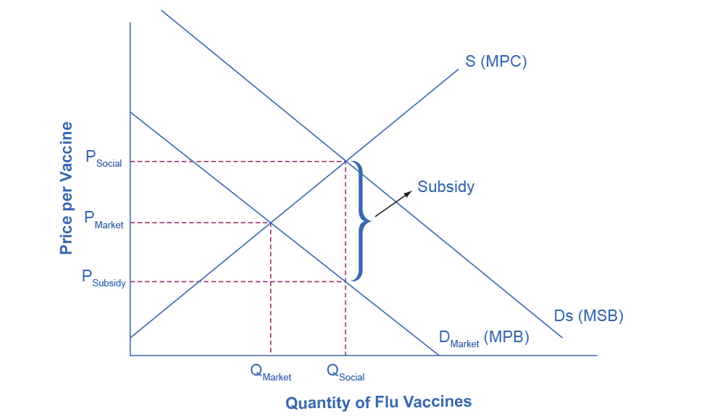

Figure 13.3 The Market for Flu Shots with Spillover Benefits (A Positive Externality) The market demand curve does not reflect the positive externality of flu vaccinations, so only QMarket will be exchanged. This outcome is inefficient because the marginal social benefit exceeds the marginal social cost. If the government provides a subsidy to consumers of flu shots, equal to the marginal social benefit minus the marginal private benefit, the level of vaccinations can increase to the socially optimal quantity of QSocial.

#### Societal Change as an Innovation Outcome

Economist Carlota Perez draws on the lessons of past innovations to understand the current state of our economy. She demonstrates that prior technological turning points, such as the proliferation of railroads and the emergence of mass production, created initial periods of employment and wealth shifting but eventually led to greater well-being and economic growth. After difficult transition periods and sometimes economic meltdowns during the “installment” phase of widespread new technologies, many economies and the people within them have benefited from prolonged periods of economic and lifestyle improvement, including lower unemployment and better quality of life.

Most prior innovation periods, such as the Industrial Revolution, had one significant downside: negative impacts on the environment, such as pollution and habitat destruction. Perez notes that our current revolution—in information and communications technology (ICT)—has the potential for significant positive externalities related to the environment. ICT is shifting many areas of society (and therefore industry) to digital experiences and services that do not require fossil fuels or similar natural resources. Vehicle sharing, product rental-reuse networks, and new manufacturing methods offer the promise of far less consumable consumption. And even though the appearance of delivery trucks and shipping boxes gives the impression of environmental damage, most studies indicate that online shopping is better for the environment than individuals shopping in person. (This is partly attributed to greater efficiency in a few trucks driving to a neighborhood rather than everyone in the neighborhood driving to several stores.) Consumers and governments can spur on those environmental benefits by choosing or partnering with companies that focus on furthering their environmental impact, such as by using solar power to fuel their computer servers or by using electrically powered delivery trucks.

Like other innovations, ICT has created some employment and economic opportunities while it has reduced others. Increased globalization and efficiencies have shuttered businesses and reduced wages in some areas. Perez’s research indicates that those types of employment shifts can be managed through proper regulation and investment (especially in human capital), particularly as firms in the relevant industries become mature and profitable. The prospects aren’t simple: ICT has created megafirms like Amazon and Apple, which despite pleasing their consumers can wield significant power over governments and employees. But on the environmental and societal front at least, ICT has offered a wealth of opportunities and externalities.