## 14.1 The Theory of Labor Markets

### Learning Objectives

By the end of this section, you will be able to:

* Describe the demand for labor in perfectly competitive output markets
* Describe the demand for labor in imperfectly competitive output markets
* Identify what determines the going market rate for labor

Clear It Up

What is the labor market?

The labor market is the term that economists use for all the different markets for labor. There is no single labor market. Rather, there is a different market for every different type of labor. Labor differs by type of work (e.g. retail sales vs. scientist), skill level (entry level or more experienced), and location (the market for administrative assistants is probably more local or regional than the market for university presidents). While each labor market is different, they all tend to operate in similar ways. For example, when wages go up in one labor market, they tend to go up in others too. When economists talk about the labor market, they are describing these similarities.

The labor market, like all markets, has a demand and a supply. Why do firms demand labor? Why is an employer willing to pay you for your labor? It’s not because the employer likes you or is socially conscious. Rather, it’s because your labor is worth something to the employer--your work brings in revenues to the firm. How much is an employer willing to pay? That depends on the skills and experience you bring to the firm.

If a firm wants to maximize profits, it will never pay more (in terms of wages and benefits) for a worker than the value of their marginal productivity to the firm. We call this the first rule of labor markets.

Suppose a worker can produce two widgets per hour and the firm can sell each widget for $4 each. Then the worker is generating $8 per hour in revenues to the firm, and a profit-maximizing employer will pay the worker up to, but no more than, $8 per hour, because that is what the worker is worth to the firm.

Recall the definition of marginal product. Marginal product is the additional output a firm can produce by adding one more worker to the production process. Since employers often hire labor by the hour, we’ll define marginal product as the additional output the firm produces by adding one more worker hour to the production process. In this chapter, we assume that workers in a particular labor market are homogeneous—they have the same background, experience and skills and they put in the same amount of effort. Thus, marginal product depends on the capital and technology with which workers have to work.

A typist can type more pages per hour with an electric typewriter than a manual typewriter, and the typist can type even more pages per hour with a personal computer and word processing software. A ditch digger can dig more cubic feet of dirt in an hour with a backhoe than with a shovel.

Thus, we can define the demand for labor as the marginal product of labor times the value of that output to the firm.

|  |  |  |  |  |
| --- | --- | --- | --- | --- |
| # Workers (L) | 1 | 2 | 3 | 4 |
| MPL | 4 | 3 | 2 | 1 |

Table 14.1 Marginal Product of Labor

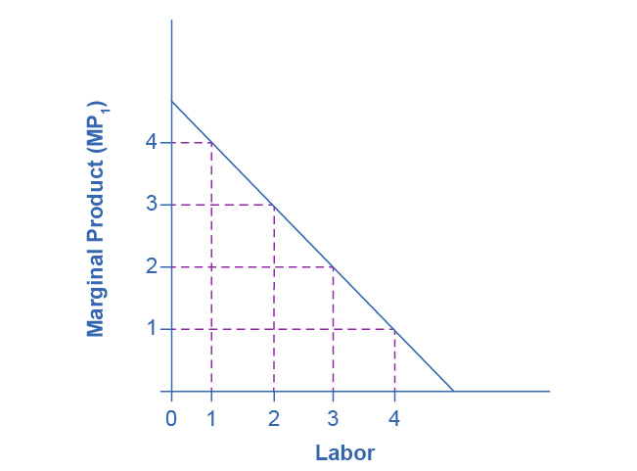

Figure 14.2 Marginal Product of Labor Because of fixed capital, the marginal product of labor declines as the employer hires additional workers.

On what does the value of each worker’s marginal product depend? If we assume that the employer sells its output in a perfectly competitive market, the value of each worker’s output will be the market price of the product. Thus,

Demand for Labor = MPL x P = Value of the Marginal Product of Labor

We show this in Table 14.2, which is an expanded version of Table 14.1

|  |  |  |  |  |
| --- | --- | --- | --- | --- |
| # Workers (L) | 1 | 2 | 3 | 4 |
| MPL | 4 | 3 | 2 | 1 |
| Price of Output | $4 | $4 | $4 | $4 |
| VMPL | $16 | $12 | $8 | $4 |

Table 14.2 Value of the Marginal Product of Labor

Note that the value of each additional worker is less than the value of the ones who came before.

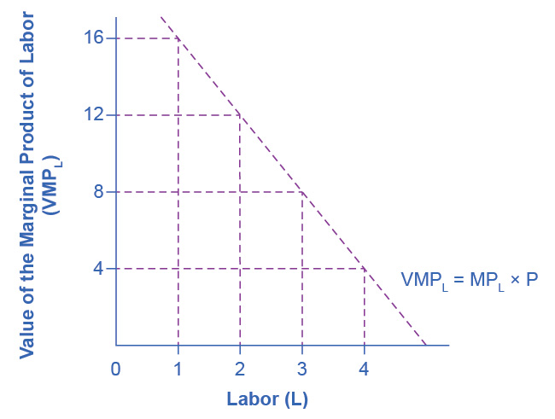

Figure 14.3 Value of the Marginal Product of Labor For firms operating in a competitive output market, the value of additional output sold is the price the firms receive for the output. Since MPL declines with additional labor employed, while that marginal product is worth the market price, the value of the marginal product declines as employment increases.

### Demand for Labor in Perfectly Competitive Output Markets

The question for any firm is how much labor to hire.

We can define a Perfectly Competitive Labor Market as one where firms can hire all the labor they want at the going market wage. Think about secretaries in a large city. Employers who need secretaries can probably hire as many as they need if they pay the going wage rate.

Graphically, this means that firms face a horizontal supply curve for labor, as Figure 14.3 shows.

Given the market wage, profit maximizing firms hire workers up to the point where: Wmkt = VMPL

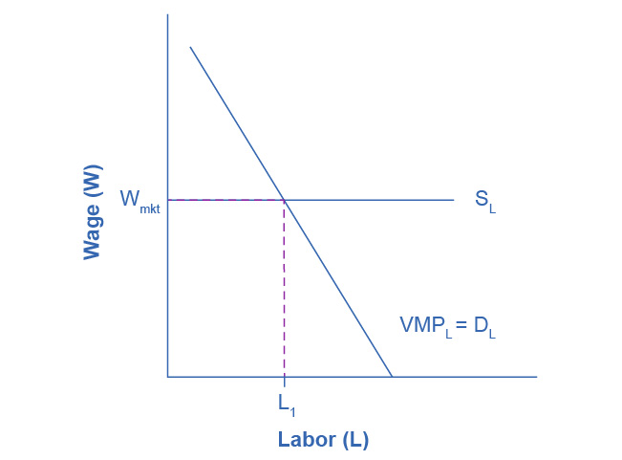

Figure 14.4 Equilibrium Employment for Firms in a Competitive Labor Market In a perfectly competitive labor market, firms can hire all the labor they want at the going market wage. Therefore, they hire workers up to the point L1 where the going market wage equals the value of the marginal product of labor.

Clear It Up

Derived Demand

Economists describe the demand for inputs like labor as a derived demand. Since the demand for labor is MPL*P, it is dependent on the demand for the product the firm is producing. We show this by the P term in the demand for labor. An increase in demand for the firm’s product drives up the product’s price, which increases the firm’s demand for labor. Thus, we derive the demand for labor from the demand for the firm’s output.

### Demand for Labor in Imperfectly Competitive Output Markets

If the employer does not sell its output in a perfectly competitive industry, they face a downward sloping demand curve for output, which means that in order to sell additional output the firm must lower its price. This is true if the firm is a monopoly, but it’s also true if the firm is an oligopoly or monopolistically competitive. In this situation, the value of a worker’s marginal product is the marginal revenue, not the price. Thus, the demand for labor is the marginal product times the marginal revenue.

The Demand for Labor = MPL x MR = Marginal Revenue Product

|  |  |  |  |  |
| --- | --- | --- | --- | --- |
| # Workers (L) | 1 | 2 | 3 | 4 |
| MPL | 4 | 3 | 2 | 1 |
| Marginal Revenue | $4 | $3 | $2 | $1 |
| MRPL | $16 | $9 | $4 | $1 |

Table 14.3 Marginal Revenue Product

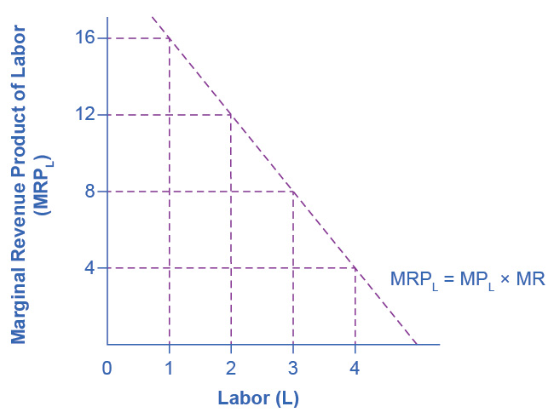

Figure 14.5 Marginal Revenue Product For firms with some market power in their output market, the value of additional output sold is the firm’s marginal revenue. Since MPL declines with additional labor employed and since MR declines with additional output sold, the firm’s marginal revenue declines as employment increases.

Everything else remains the same as we described above in the discussion of the labor demand in perfectly competitive labor markets. Given the market wage, profit-maximizing firms will hire workers up to the point where the market wage equals the marginal revenue product, as Figure 14.6 shows.

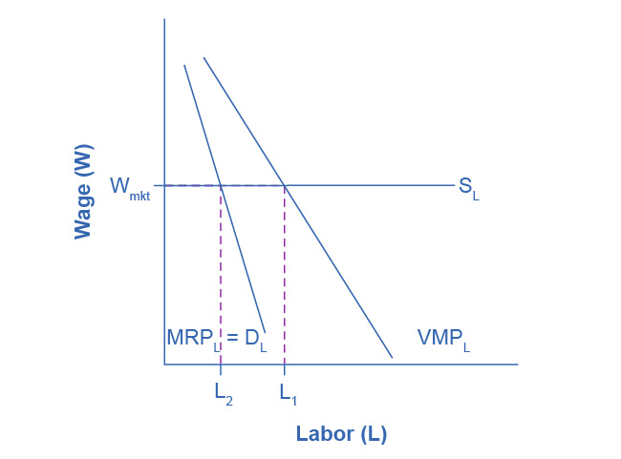

Figure 14.6 Equilibrium Level of Employment for Firms with Market Power For firms with market power in their output market, they choose the number of workers, L2, where the going market wage equals the firm’s marginal revenue product. Note that since marginal revenue is less than price, the demand for labor for a firm which has market power in its output market is less than the demand for labor (L1) for a perfectly competitive firm. As a result, employment will be lower in an imperfectly competitive industry than in a perfectly competitive industry.

Clear It Up

Do Profit Maximizing Employers Exploit Labor?

If you look back at Figure 14.4, you will see that the firm pays only the last worker it hires what they’re worth to the firm. Every other worker brings in more revenue than the firm pays them. This has sometimes led to the claim that employers exploit workers because they do not pay workers what they are worth. Let’s think about this claim. The first worker is worth $x to the firm, and the second worker is worth $y, but why are they worth that much? It is because of the capital and technology with which they work. The difference between workers’ worth and their compensation goes to pay for the capital and technology, without which the workers wouldn’t have a job. The difference also goes to the employer’s profit, without which the firm would close and workers wouldn’t have a job. The firm may be earning excessive profits, but that is a different topic of discussion.

### What Determines the Going Market Wage Rate?

In the chapter on [Labor and Financial Markets](http://openstax.org/books/principles-microeconomics-3e/pages/4-introduction-to-labor-and-financial-markets), we learned that the labor market has demand and supply curves like other markets. The demand for labor curve is a downward sloping function of the wage rate. The market demand for labor is the horizontal sum of all firms’ demands for labor. The supply of labor curve is an upward sloping function of the wage rate. This is because if wages for a particular type of labor increase in a particular labor market, people with appropriate skills may change jobs, and vacancies will attract people from outside the geographic area. The market supply of labor is the horizontal summation of all individuals’ supplies of labor.

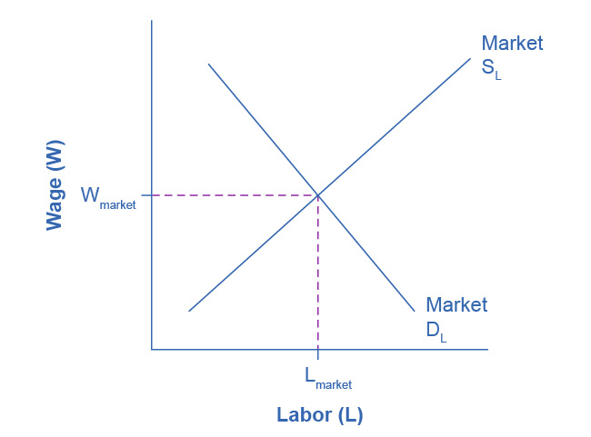

Figure 14.7 The Market Wage Rate In a competitive labor market, the equilibrium wage and employment level are determined where the market demand for labor equals the market supply of labor.

Like all equilibrium prices, the market wage rate is determined through the interaction of supply and demand in the labor market. Thus, we can see in Figure 14.7 for competitive markets the wage rate and number of workers hired.

The FRED database has a great deal of data on labor markets, starting at [the wage rate and number of workers hired](https://openstax.org/l/cat10).

The United States Census Bureau for the Bureau of Labor Statistics publishes *The Current Population Survey*, which is a monthly survey of households (you can find a link to it by going to the FRED database found in the previous link), which provides data on labor supply, including numerous measures of the labor force size (disaggregated by age, gender and educational attainment), labor force participation rates for different demographic groups, and employment. It also includes more than 3,500 measures of earnings by different demographic groups.

*The Current Employment Statistics*, which is a survey of businesses, offers alternative estimates of employment across all sectors of the economy.

The FRED database, found in the previous link, also has a link labeled "Productivity and Costs" has a wide range of data on productivity, labor costs, and profits across the business sector.