## 15.4 Income Inequality: Measurement and Causes

### Learning Objectives

By the end of this section, you will be able to:

* Explain the distribution of income, and analyze the sources of income inequality in a market economy
* Measure income distribution in quintiles
* Calculate and graph a Lorenz curve
* Show income inequality through demand and supply diagrams

Poverty levels can be subjective based on the overall income levels of a country. Typically a government measures poverty based on a percentage of the median income. Income inequality, however, has to do with the distribution of that income, in terms of which group receives the most or the least income. Income inequality involves comparing those with high incomes, middle incomes, and low incomes—not just looking at those below or near the poverty line. In turn, measuring income inequality means dividing the population into various groups and then comparing the groups, a task that we can be carry out in several ways, as the next Clear It Up feature shows.

Clear It Up

How do you separate poverty and income inequality?

Poverty can change even when inequality does not move at all. Imagine a situation in which income for everyone in the population declines by 10%. Poverty would rise, since a greater share of the population would now fall below the poverty line. However, inequality would be the same, because everyone suffered the same proportional loss. Conversely, a general rise in income levels over time would keep inequality the same, but reduce poverty.

It is also possible for income inequality to change without affecting the poverty rate. Imagine a situation in which a large number of people who already have high incomes increase their incomes by even more. Inequality would rise as a result—but the number of people below the poverty line would remain unchanged.

Why did inequality of household income increase in the United States in recent decades? A trend toward greater income inequality has occurred in many countries around the world, although the effect has been more powerful in the U.S. economy. Economists have focused their explanations for the increasing inequality on two factors that changed more or less continually from the 1970s into the 2000s. One set of explanations focuses on the changing shape of American households. The other focuses on greater inequality of wages, what some economists call “winner take all” labor markets. We will begin with how we measure inequality, and then consider the explanations for growing inequality in the United States.

### Measuring Income Distribution by Quintiles

One common way of measuring income inequality is to rank all households by income, from lowest to highest, and then to divide all households into five groups with equal numbers of people, known as quintiles. This calculation allows for measuring the distribution of income among the five groups compared to the total. The first quintile is the lowest fifth or 20%, the second quintile is the next lowest, and so on. We can measure income inequality by comparing what share of the total income each quintile earns.

U.S. income distribution by quintile appears in Table 15.5. In 2020, for example, the bottom quintile of the income distribution received 3.2% of income; the second quintile received 8.1%; the third quintile, 14.0%; the fourth quintile, 22.6%; and the top quintile, 52.2%. The final column of Table 15.5 shows what share of income went to households in the top 5% of the income distribution: 23.0% in 2020. Over time, from the late 1960s to the early 1980s, the top fifth of the income distribution typically received between about 43% to 44% of all income. The share of income that the top fifth received then begins to rise. Census Bureau researchers trace, much of this increase in the share of income going to the top fifth to an increase in the share of income going to the top 5%. The quintile measure shows how income inequality has increased in recent decades.

|  |  |  |  |  |  |  |
| --- | --- | --- | --- | --- | --- | --- |
| Year | Lowest Quintile | Second Quintile | Third Quintile | Fourth Quintile | Highest Quintile | Top 5% |
| 1967 | 4.0 | 10.8 | 17.3 | 24.2 | 43.6 | 17.2 |
| 1970 | 4.1 | 10.8 | 17.4 | 24.5 | 43.3 | 16.6 |
| 1975 | 4.3 | 10.4 | 17.0 | 24.7 | 43.6 | 16.5 |
| 1980 | 4.2 | 10.2 | 16.8 | 24.7 | 44.1 | 16.5 |
| 1985 | 3.9 | 9.8 | 16.2 | 24.4 | 45.6 | 17.6 |
| 1990 | 3.8 | 9.6 | 15.9 | 24.0 | 46.6 | 18.5 |
| 1995 | 3.7 | 9.1 | 15.2 | 23.3 | 48.7 | 21.0 |
| 2000 | 3.6 | 8.9 | 14.8 | 23.0 | 49.8 | 22.1 |
| 2005 | 3.4 | 8.6 | 14.6 | 23.0 | 50.4 | 22.2 |
| 2010 | 3.3 | 8.5 | 14.6 | 23.4 | 50.3 | 21.3 |
| 2015 | 3.1 | 8.2 | 14.3 | 23.2 | 51.1 | 22.1 |
| 2020 | 3.0 | 8.1 | 14.0 | 22.6 | 52.2 | 23.0 |

Table 15.5 Share of Aggregate Income Received by Each Fifth and Top 5% of Households, 1967–2020 (Source: U.S. Census Bureau, https://www.census.gov/data/tables/time-series/demo/income-poverty/historical-income-households.html, Table H-1, All Races.)

It can also be useful to divide the income distribution in ways other than quintiles; for example, into tenths or even into percentiles (that is, hundredths). A more detailed breakdown can provide additional insights. For example, the last column of Table 15.5 shows the income received by the top 5% of the income distribution. Between 1980 and 2020, the share of income going to the top 5% increased by 6.5 percentage points (from 16.5% in 1980 to 23.0% in 2020). From 1980 to 2020 the share of income going to the top quintile increased by 8.1 percentage points (from 44.1% in 1980 to 52.2% in 2013). Thus, the top 20% of householders (the fifth quintile) received over half (51%) of all the income in the United States in 2020.

### Lorenz Curve

We can present the data on income inequality in various ways. For example, you could draw a bar graph that showed the share of income going to each fifth of the income distribution. Figure 15.8 presents an alternative way of showing inequality data in a Lorenz curve. This curve shows the cumulative share of population on the horizontal axis and the cumulative percentage of total income received on the vertical axis.

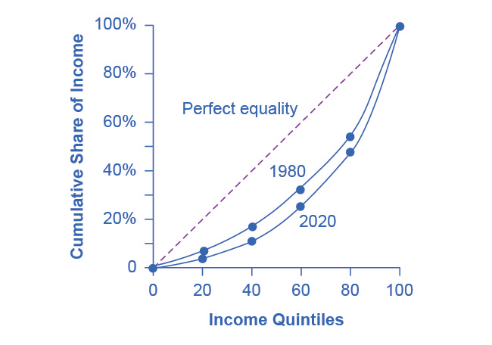

Figure 15.8 The Lorenz Curve A Lorenz curve graphs the cumulative shares of income received by everyone up to a certain quintile. The income distribution in 1980 was closer to the perfect equality line than the income distribution in 2020—that is, the U.S. income distribution became more unequal over time.

Every Lorenz curve diagram begins with a line sloping up at a 45-degree angle. We show it as a dashed line in Figure 15.8. The points along this line show what perfect equality of the income distribution looks like. It would mean, for example, that the bottom 20% of the income distribution receives 20% of the total income, the bottom 40% gets 40% of total income, and so on. The other lines reflect actual U.S. data on inequality for 1980 and 2020.

The trick in graphing a Lorenz curve is that you must change the shares of income for each specific quintile, which we show in the first and third columns of numbers in Table 15.6, into cumulative income, which we show in the second and fourth columns of numbers. For example, the bottom 40% of the cumulative income distribution will be the sum of the first and second quintiles; the bottom 60% of the cumulative income distribution will be the sum of the first, second, and third quintiles, and so on. The final entry in the cumulative income column needs to be 100%, because by definition, 100% of the population receives 100% of the income.

|  |  |  |  |  |
| --- | --- | --- | --- | --- |
| Income Category | Share of Income in 1980 (%) | Cumulative Share of Income in 1980 (%) | Share of Income in 2020 (%) | Cumulative Share of Income in 2020 (%) |
| First quintile | 4.2 | 4.2 | 3.0 | 3.0 |
| Second quintile | 10.2 | 14.4 | 8.1 | 11.1 |
| Third quintile | 16.8 | 31.2 | 14.0 | 25.1 |
| Fourth quintile | 24.7 | 55.9 | 22.6 | 47.7 |
| Fifth quintile | 44.1 | 100.0 | 52.2 | 100.0 |

Table 15.6 Calculating the Lorenz Curve

In a Lorenz curve diagram, a more unequal distribution of income will loop farther down and away from the 45-degree line, while a more equal distribution of income will move the line closer to the 45-degree line. Figure 15.8 illustrates the greater inequality of the U.S. income distribution between 1980 and 2020 because the Lorenz curve for 2020 is farther from the 45-degree line than the Lorenz curve for 1980. The Lorenz curve is a useful way of presenting the quintile data that provides an image of all the quintile data at once. The next Clear It Up feature shows how income inequality differs in various countries compared to the United States.

Clear It Up

How does economic inequality vary around the world?

The U.S. economy has a relatively high degree of income inequality by global standards. As Table 15.7 shows, based on a variety of national surveys for a selection of years in the second decade of this century, the U.S. economy has greater inequality than Germany (along with most Western European countries). The region of the world with the highest level of income inequality is Latin America, illustrated in the numbers for Brazil and Mexico. The level of inequality in the United States is higher than in some of the low-income countries of the world, like India and Nigeria, as well as in some middle-income countries, like China and Russia.

|  |  |  |  |  |  |  |
| --- | --- | --- | --- | --- | --- | --- |
| Country | Survey Year | First Quintile | Second Quintile | Third Quintile | Fourth Quintile | Fifth Quintile |
| United States | 2020 | 3.0% | 8.1% | 14.0% | 22.6% | 52.2% |
| Germany | 2016 | 7.6% | 12.8% | 17.1% | 22.8% | 39.6% |
| Brazil | 2019 | 3.1% | 7.4% | 12.3% | 19.4% | 57.8% |
| Mexico | 2018 | 5.4% | 9.5% | 13.5% | 20.0% | 51.7% |
| China | 2016 | 6.5% | 10.7% | 15.3% | 22.2% | 45.3% |
| India | 2011 | 8.1% | 11.7% | 15.2% | 20.5% | 44.4% |
| Russia | 2018 | 7.1% | 11.2% | 15.2% | 21.4% | 45.1% |
| Nigeria | 2018 | 7.1% | 11.6% | 16.2% | 22.7% | 42.4% |

Table 15.7 Income Distribution in Select Countries (Source: U.S. data from U.S. Census Bureau Table H-1. Other data from The World Bank Poverty and Inequality Data Base, https://datatopics.worldbank.org/world-development-indicators/themes/poverty-and-inequality.html)

Link It Up

Visit this [website](http://openstax.org/l/inequality/) to watch a video of wealth inequality across the world.

### Causes of Growing Inequality: The Changing Composition of American Households

In 1970, 41% of married women were in the labor force, but by 2019, according to the Bureau of Labor Statistics, 58.6% of married women were in the labor force. One result of this trend is that more households have two earners. Moreover, it has become more common for one high earner to marry another high earner. A few decades ago, the common pattern featured a man with relatively high earnings, such as an executive or a doctor, marrying a woman who did not earn as much, like a secretary or a nurse. Often, the woman would leave paid employment, at least for a few years, to raise a family. However, now doctors are marrying doctors and executives are marrying executives, and mothers with high-powered careers are often returning to work while their children are quite young. This pattern of households with two high earners tends to increase the proportion of high-earning households.

According to data in the National Journal, even as two-earner couples have increased, so have single-parent households. Of all U.S. families, in 2021, about 23% were headed by single mothers. The poverty rate among single-parent households tends to be relatively high.

These changes in family structure, including the growth of single-parent families who tend to be at the lower end of the income distribution, and the growth of two-career high-earner couples near the top end of the income distribution, account for roughly half of the rise in income inequality across households in recent decades.

Link It Up

Visit this [website](http://openstax.org/l/US_wealth) to watch a video that illustrates the distribution of wealth in the United States.

### Causes of Growing Inequality: A Shift in the Distribution of Wages

Another factor behind the rise in U.S. income inequality is that earnings have become less equal since the late 1970s. In particular, the earnings of high-skilled labor relative to low-skilled labor have increased. Winner-take-all labor markets result from changes in technology, which have increased global demand for “stars,”—whether the best CEO, doctor, basketball player, or actor. This global demand pushes salaries far above productivity differences associated with educational differences. One way to measure this change is to take workers' earnings with at least a four-year college bachelor’s degree (including those who went on and completed an advanced degree) and divide them by workers' earnings with only a high school degree. The result is that those in the 25–34 age bracket with college degrees earned about 1.85 times as much as high school graduates in 2020, up from 1.59 times in 1995, according to U.S. Census data. Winner-take-all labor market theory argues that the salary gap between the median and the top 1 percent is not due to educational differences.

Economists use the demand and supply model to reason through the most likely causes of this shift. According to the National Center for Education Statistics, in recent decades, the supply of U.S. workers with college degrees has increased substantially. For example, 840,000 four-year bachelor’s degrees were conferred on Americans in 1970. In 2018–2019, 2.0 million such degrees were conferred—an increase of over 138%. In Figure 15.9, this shift in supply to the right, from S0 to S1, by itself should result in a lower equilibrium wage for high-skilled labor. Thus, we can explain the increase in the price of high-skilled labor by a greater demand, like the movement from D0 to D1. Evidently, combining both the increase in supply and in demand has resulted in a shift from E0 to E1, and a resulting higher wage.

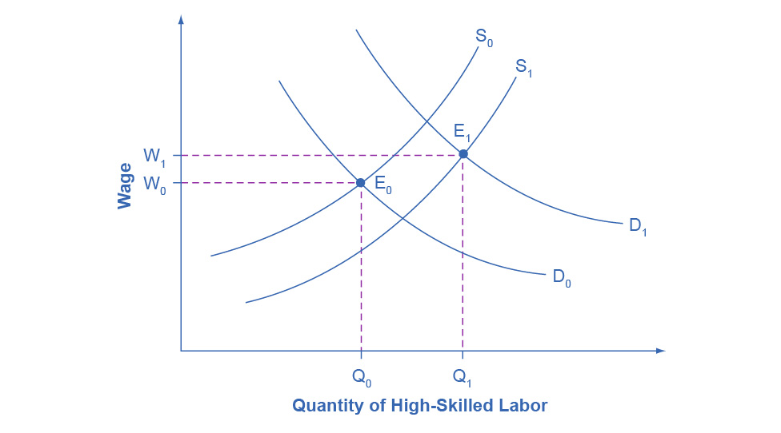

Figure 15.9 Why Would Wages Rise for High-Skilled Labor? The proportion of workers attending college has increased in recent decades, so the supply curve for high-skilled labor has shifted to the right, from S0 to S1. If the demand for high-skilled labor had remained at D0, then this shift in supply would have led to lower wages for high-skilled labor. However, the wages for high-skilled labor, especially if there is a large global demand, have increased even with the shift in supply to the right. The explanation must lie in a shift to the right in demand for high-skilled labor, from D0 to D1. The figure shows how a combination of the shift in supply, from S0 to S1, and the shift in demand, from D0 to D1, led to both an increase in the quantity of high-skilled labor hired and also to a rise in the wage for such labor, from W0 to W1.

What factors would cause the demand for high-skilled labor to rise? The most plausible explanation is that while the explosion in new information and communications technologies over the last several decades has helped many workers to become more productive, the benefits have been especially great for high-skilled workers like top business managers, consultants, and design professionals. The new technologies have also helped to encourage globalization, the remarkable increase in international trade over the last few decades, by making it more possible to learn about and coordinate economic interactions all around the world. In turn, the rising impact of foreign trade in the U.S. economy has opened up greater opportunities for high-skilled workers to sell their services around the world, and lower-skilled workers have to compete with a larger supply of similarly skilled workers around the globe.

We can view the market for high-skilled labor as a race between forces of supply and demand. Additional education and on-the-job training will tend to increase the high-skilled labor supply and to hold down its relative wage. Conversely, new technology and other economic trends like globalization tend to increase the demand for high-skilled labor and push up its relative wage. We can view the greater inequality of wages as a sign that demand for skilled labor is increasing faster than supply. Alternatively, if the supply of lower skilled workers exceeds the demand, then average wages in the lower quintiles of the income distribution will decrease. The combination of forces in the high-skilled and low-skilled labor markets leads to increased income disparity.