## 5.4 Elasticity in Areas Other Than Price

### Learning Objectives

By the end of this section, you will be able to:

* Calculate the income elasticity of demand and the cross-price elasticity of demand
* Calculate the elasticity in labor and financial capital markets through an understanding of the elasticity of labor supply and the elasticity of savings
* Apply concepts of price elasticity to real-world situations

The basic idea of elasticity—how a percentage change in one variable causes a percentage change in another variable—does not just apply to the responsiveness of quantity supplied and quantity demanded to changes in the price of a product. Recall that quantity demanded (Qd) depends on income, tastes and preferences, the prices of related goods, and so on, as well as price. Similarly, quantity supplied (Qs) depends on factors such as the cost of production, as well as price. We can measure elasticity for any determinant of quantity supplied and quantity demanded, not just the price.

### Income Elasticity of Demand

The income elasticity of demand is the percentage change in quantity demanded divided by the percentage change in income.



For most products, most of the time, the income elasticity of demand is positive: that is, a rise in income will cause an increase in the quantity demanded. This pattern is common enough that we refer to these goods as normal goods. However, for a few goods, an increase in income means that one might purchase less of the good. For example, those with a higher income might buy fewer hamburgers, because they are buying more steak instead, or those with a higher income might buy less cheap wine and more imported beer. When the income elasticity of demand is negative, we call the good an inferior good.

We introduced the concepts of normal and inferior goods in [Demand and Supply](http://openstax.org/books/principles-microeconomics-3e/pages/3-introduction-to-demand-and-supply). A higher level of income causes a demand curve to shift to the right for a normal good, which means that the income elasticity of demand is positive. How far the demand shifts depends on the income elasticity of demand. A higher income elasticity means a larger shift. However, for an inferior good, that is, when the income elasticity of demand is negative, a higher level of income would cause the demand curve for that good to shift to the left. Again, how much it shifts depends on how large the (negative) income elasticity is.

### Cross-Price Elasticity of Demand

A change in the price of one good can shift the quantity demanded for another good. If the two goods are complements, like bread and peanut butter, then a drop in the price of one good will lead to an increase in the quantity demanded of the other good. However, if the two goods are substitutes, like plane tickets and train tickets, then a drop in the price of one good will cause people to substitute toward that good, and to reduce consumption of the other good. Cheaper plane tickets lead to fewer train tickets, and vice versa.

The cross-price elasticity of demand puts some meat on the bones of these ideas. The term “cross-price” refers to the idea that the price of one good is affecting the quantity demanded of a different good. Specifically, the cross-price elasticity of demand is the percentage change in the quantity of good A that is demanded as a result of a percentage change in the price of good B.



Substitute goods have positive cross-price elasticities of demand: if good A is a substitute for good B, like coffee and tea, then a higher price for B will mean a greater quantity consumed of A. Complement goods have negative cross-price elasticities: if good A is a complement for good B, like coffee and sugar, then a higher price for B will mean a lower quantity consumed of A.

### Elasticity in Labor and Financial Capital Markets

The concept of elasticity applies to any market, not just markets for goods and services. In the labor market, for example, the wage elasticity of labor supply—that is, the percentage change in hours worked divided by the percentage change in wages—will reflect the shape of the labor supply curve. Specifically:



The wage elasticity of labor supply for teenage workers is generally fairly elastic: that is, a certain percentage change in wages will lead to a larger percentage change in the quantity of hours worked. Conversely, the wage elasticity of labor supply for adult workers in their thirties and forties is fairly inelastic. When wages move up or down by a certain percentage amount, the quantity of hours that adults in their prime earning years are willing to supply changes but by a lesser percentage amount.

In markets for financial capital, the elasticity of savings—that is, the percentage change in the quantity of savings divided by the percentage change in interest rates—will describe the shape of the supply curve for financial capital. That is:



Sometimes laws are proposed that seek to increase the quantity of savings by offering tax breaks so that the return on savings is higher. Such a policy will have a comparatively large impact on increasing the quantity saved if the supply curve for financial capital is elastic, because then a given percentage increase in the return to savings will cause a higher percentage increase in the quantity of savings. However, if the supply curve for financial capital is highly inelastic, then a percentage increase in the return to savings will cause only a small increase in the quantity of savings. The evidence on the supply curve of financial capital is controversial but, at least in the short run, the elasticity of savings with respect to the interest rate appears fairly inelastic.

### Expanding the Concept of Elasticity

The elasticity concept does not even need to relate to a typical supply or demand curve at all. For example, imagine that you are studying whether the Internal Revenue Service should spend more money on auditing tax returns. We can frame the question in terms of the elasticity of tax collections with respect to spending on tax enforcement; that is, what is the percentage change in tax collections derived from a given percentage change in spending on tax enforcement?

With all of the elasticity concepts that we have just described, some of which are in Table 5.4, the possibility of confusion arises. When you hear the phrases “elasticity of demand” or “elasticity of supply,” they refer to the elasticity with respect to price. Sometimes, either to be extremely clear or because economists are discussing a wide variety of elasticities, we will call the elasticity of demand or the demand elasticity the price elasticity of demand or the “elasticity of demand with respect to price.” Similarly, economists sometimes use the term elasticity of supply or the supply elasticity, to avoid any possibility of confusion, the price elasticity of supply or “the elasticity of supply with respect to price.” However, in whatever context, the idea of elasticity always refers to percentage change in one variable, almost always a price or money variable, and how it causes a percentage change in another variable, typically a quantity variable of some kind.

|  |
| --- |
| multiline equation row 1 Income elasticity of demand equals percent sign change in Qd divided by percent sign change in income |
| multiline equation row 1 Cross minus price elasticity of demand equals percent sign change in Qd of good cap A divided by percent sign change in price of good cap B |
| multiline equation row 1 Wage elasticity of labor supply equals percent sign change in quantity of labor supplied divided by percent sign change in wage |
| multiline equation row 1 Wage elasticity of labor demand equals percent sign change in quantity of labor demanded divided by percent sign change in wage |
| multiline equation row 1 Interest rate elasticity of savings equals percent sign change in quantity of savings divided by percent sign change in interest rate |
| multiline equation row 1 Interest rate elasticity of borrowing equals percent sign change in quantity of borrowing divided by percent sign change in interest rate |

Table 5.4 Formulas for Calculating Elasticity

Bring It Home

That Will Be How Much?

How did the 60% price increase in 2011 end up for Netflix? It has been a very bumpy ride.

Before the price increase, there were about 24.6 million U.S. subscribers. After the price increase, 810,000 infuriated U.S. consumers canceled their Netflix subscriptions, dropping the total number of subscribers to 23.79 million. Fast forward to June 2013, when there were 36 million streaming Netflix subscribers in the United States. This was an increase of 11.4 million subscribers since the price increase—an average per quarter growth of about 1.6 million. This growth is less than the 2 million per quarter increases Netflix experienced in the fourth quarter of 2010 and the first quarter of 2011.

During the first year after the price increase, the firm’s stock price (a measure of future expectations for the firm) fell from about $33.60 per share per share to just under $7.80. By the end of 2016, however, the stock price was at $123 per share. By the end of 2021, the stock price was just over $600 per share, and Netflix had more than 214 million subscribers in fifty countries.

What happened? Obviously, Netflix company officials understood the law of demand. Company officials reported, when announcing the price increase, this could result in the loss of about 600,000 existing subscribers. Using the elasticity of demand formula, it is easy to see company officials expected an inelastic response:

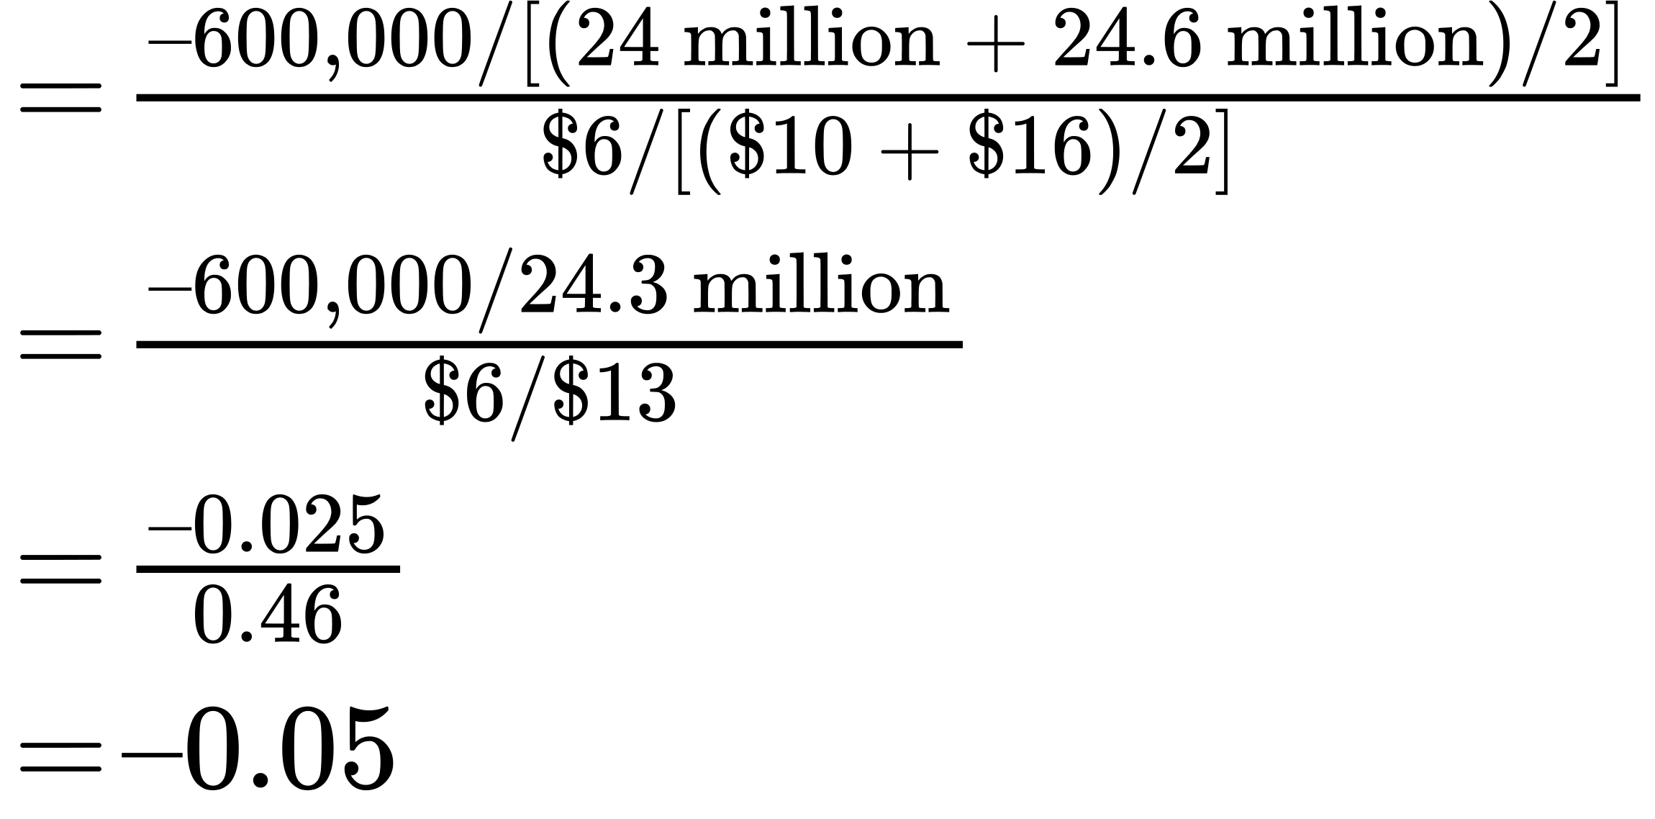

In addition, Netflix officials had anticipated the price increase would have little impact on attracting new customers. Netflix anticipated adding up to 1.29 million new subscribers in the third quarter of 2011. It is true this was slower growth than the firm had experienced—about 2 million per quarter.

Why was the estimate of customers leaving so far off? In the more than two decades since Netflix had been founded, there was an increase in the number of close, but not perfect, substitutes. Consumers now had choices ranging from Vudu, Amazon Prime, Hulu, and Redbox, to retail stores. Jaime Weinman reported in *Maclean’s* that Redbox kiosks are “a five-minute drive for less from 68 percent of Americans, and it seems that many people still find a five-minute drive more convenient than loading up a movie online.” It seems that in 2012, many consumers still preferred a physical DVD disk over streaming video.

What missteps did the Netflix management make? In addition to misjudging the elasticity of demand, by failing to account for close substitutes, it seems they may have also misjudged customers’ preferences and tastes. However, the very substantial increase over time in the number of Netflix subscribers suggests that the preference for streaming video may well have overtaken the preference for physical DVD disks. Netflix, the source of numerous late night talk show laughs and jabs in 2011, may yet have the last laugh.