## Key Concepts and Summary

### 6.1 Consumption Choices

Economic analysis of household behavior is based on the assumption that people seek the highest level of utility or satisfaction. Individuals are the only judge of their own utility. In general, greater consumption of a good brings higher total utility. However, the additional utility people receive from each unit of greater consumption tends to decline in a pattern of diminishing marginal utility.

We can find the utility-maximizing choice on a consumption budget constraint in several ways. You can add up total utility of each choice on the budget line and choose the highest total. You can select a starting point at random and compare the marginal utility gains and losses of moving to neighboring points—and thus eventually seek out the preferred choice. Alternatively, you can compare the ratio of the marginal utility to price of good 1 with the marginal utility to price of good 2 and apply the rule that at the optimal choice, the two ratios should be equal:

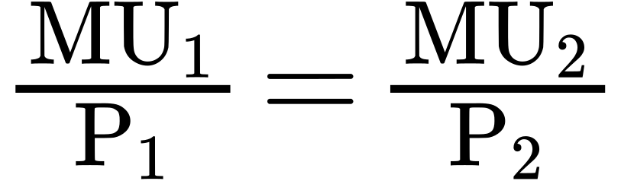

### 6.2 How Changes in Income and Prices Affect Consumption Choices

The budget constraint framework suggest that when income or price changes, a range of responses are possible. When income rises, households will demand a higher quantity of normal goods, but a lower quantity of inferior goods. When the price of a good rises, households will typically demand less of that good—but whether they will demand a much lower quantity or only a slightly lower quantity will depend on personal preferences. Also, a higher price for one good can lead to more or less demand of the other good.

### 6.3 Behavioral Economics: An Alternative Framework for Consumer Choice

People regularly make decisions that seem less than rational, decisions that contradict traditional consumer theory. This is because traditional theory ignores people’s state of mind or feelings, which can influence behavior. For example, people tend to value a dollar lost more than a dollar gained, even though the amounts are the same. Similarly, many people over withhold on their taxes, essentially giving the government a free loan until they file their tax returns, so that they are more likely to get money back than have to pay money on their taxes.