## Chapter 19

[1](http://openstax.org/books/principles-microeconomics-3e/pages/19-self-check-questions#fs-idp150363376).

False. Anything that leads to different levels of productivity between two economies can be a source of comparative advantage. For example, the education of workers, the knowledge base of engineers and scientists in a country, the part of a split-up value chain where they have their specialized learning, economies of scale, and other factors can all determine comparative advantage.

[2](http://openstax.org/books/principles-microeconomics-3e/pages/19-self-check-questions#fs-idp176454304).

Brazil has the absolute advantage in producing beef and the United States has the absolute advantage in autos. The opportunity cost of producing one pound of beef is 1/10 of an auto; in the United States it is 3/4 of an auto.

[3](http://openstax.org/books/principles-microeconomics-3e/pages/19-self-check-questions#fs-idp49111808).

In answering questions like these, it is often helpful to begin by organizing the information in a table, such as in the following table. Notice that, in this case, the productivity of the countries is expressed in terms of how many workers it takes to produce a unit of a product.

|  |  |  |
| --- | --- | --- |
| Country | One Sweater | One Bottle of wine |
| France | 1 worker | 1 worker |
| Tunisia | 2 workers | 3 workers |

In this example, France has an absolute advantage in the production of both sweaters and wine. You can tell because it takes France less labor to produce a unit of the good.

[4](http://openstax.org/books/principles-microeconomics-3e/pages/19-self-check-questions#fs-idp72842560).

1. In Germany, it takes fewer workers to make either a television or a video camera. Germany has an absolute advantage in the production of both goods.
2. Producing an additional television in Germany requires three workers. Shifting those three German workers will reduce video camera production by 3/4 of a camera. Producing an additional television set in Poland requires six workers, and shifting those workers from the other good reduces output of video cameras by 6/12 of a camera, or 1/2. Thus, the opportunity cost of producing televisions is lower in Poland, so Poland has the comparative advantage in the production of televisions. *Note*: Do not let the fractions like 3/4 of a camera or 1/2 of a video camera bother you. If either country was to expand television production by a significant amount—that is, lots more than one unit—then we will be talking about whole cameras and not fractional ones. You can also spot this conclusion by noticing that Poland’s absolute disadvantage is relatively lower in televisions, because Poland needs twice as many workers to produce a television but three times as many to produce a video camera, so the product with the relatively lower absolute disadvantage is Poland’s comparative advantage.
3. Producing a video camera in Germany requires four workers, and shifting those four workers away from television production has an opportunity cost of 4/3 television sets. Producing a video camera in Poland requires 12 workers, and shifting those 12 workers away from television production has an opportunity cost of two television sets. Thus, the opportunity cost of producing video cameras is lower in Germany, and video cameras will be Germany’s comparative advantage.
4. In this example, absolute advantage differs from comparative advantage. Germany has the absolute advantage in the production of both goods, but Poland has a comparative advantage in the production of televisions.
5. Germany should specialize, at least to some extent, in the production of video cameras, export video cameras, and import televisions. Conversely, Poland should specialize, at least to some extent, in the production of televisions, export televisions, and import video cameras.

[5](http://openstax.org/books/principles-microeconomics-3e/pages/19-self-check-questions#fs-idm56281808).

There are a number of possible advantages of intra-industry trade. Both nations can take advantage of extreme specialization and learning in certain kinds of cars with certain traits, like gas-efficient cars, luxury cars, sport-utility vehicles, higher- and lower-quality cars, and so on. Moreover, nations can take advantage of economies of scale, so that large companies will compete against each other across international borders, providing the benefits of competition and variety to customers. This same argument applies to trade between U.S. states, where people often buy products made by people of other states, even though a similar product is made within the boundaries of their own state. All states—and all countries—can benefit from this kind of competition and trade.

[6](http://openstax.org/books/principles-microeconomics-3e/pages/19-self-check-questions#fs-idm20174080).

1. Start by plotting the points on a sketch diagram and then drawing a line through them. The following figure illustrates the average costs of production of semiconductors.

* 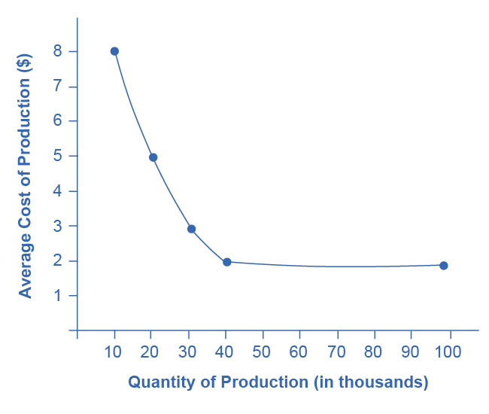
* The curve illustrates economies of scale by showing that as the scale increases—that is, as production at this particular factory goes up—the average cost of production declines. The economies of scale exist up to an output of 40,000 semiconductors; at higher outputs, the average cost of production does not seem to decline any further.

1. At any quantity demanded above 40,000, this economy can take full advantage of economies of scale; that is, it can produce at the lowest cost per unit. Indeed, if the quantity demanded was quite high, like 500,000, then there could be a number of different factories all taking full advantage of economies of scale and competing with each other. If the quantity demanded falls below 40,000, then the economy by itself, without foreign trade, cannot take full advantage of economies of scale.
2. The simplest answer to this question is that the small country could have a large enough factory to take full advantage of economies of scale, but then export most of the output. For semiconductors, countries like Taiwan and Korea have recently fit this description. Moreover, this country could also import semiconductors from other countries which also have large factories, thus getting the benefits of competition and variety. A slightly more complex answer is that the country can get these benefits of economies of scale without producing semiconductors, but simply by buying semiconductors made at low cost around the world. An economy, especially a smaller country, may well end up specializing and producing a few items on a large scale, but then trading those items for other items produced on a large scale, and thus gaining the benefits of economies of scale by trade, as well as by direct production.

[7](http://openstax.org/books/principles-microeconomics-3e/pages/19-self-check-questions#fs-idp62005328).

A nation might restrict trade on imported products to protect an industry that is important for national security. For example, nation X and nation Y may be geopolitical rivals, each with ambitions of increased political and economic strength. Even if nation Y has comparative advantage in the production of missile defense systems, it is unlikely that nation Y would seek to export those goods to nation X. It is also the case that, for some nations, the production of a particular good is a key component of national identity. In Japan, the production of rice is culturally very important. It may be difficult for Japan to import rice from a nation like Vietnam, even if Vietnam has a comparative advantage in rice production.