## Chapter 2

[1](http://openstax.org/books/principles-microeconomics-3e/pages/2-self-check-questions#fs-idp67687232).

The opportunity cost of bus tickets is the number of burgers that must be given up to obtain one more bus ticket. Originally, when the price of bus tickets was 50 cents per trip, this opportunity cost was 0.50/2 = .25 burgers. The reason for this is that at the original prices, one burger ($2) costs the same as four bus tickets ($0.50), so the opportunity cost of a burger is four bus tickets, and the opportunity cost of a bus ticket is .25 burgers (the inverse of the opportunity cost of a burger). With the new, higher price of bus tickets, the opportunity cost rises to $1/$2 or 0.50 burgers. You can see this graphically since the slope of the new budget constraint is steeper than the original one. If Alphonso spends all of his budget on burgers, the higher price of bus tickets has no impact so the vertical intercept of the budget constraint is the same. If he spends his entire budget on bus tickets, he can now afford only half as many, so the horizontal intercept is half as much. In short, the budget constraint rotates clockwise around the vertical intercept, steepening as it goes and the opportunity cost of bus tickets increases.

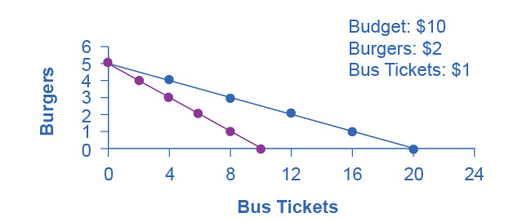

[2](http://openstax.org/books/principles-microeconomics-3e/pages/2-self-check-questions#fs-idp42902064).

Because of the improvement in technology, the vertical intercept of the PPF would be at a higher level of healthcare. In other words, the PPF would rotate clockwise around the horizontal intercept. This would make the PPF steeper, corresponding to an increase in the opportunity cost of education, since resources devoted to education would now mean forgoing a greater quantity of healthcare.

[3](http://openstax.org/books/principles-microeconomics-3e/pages/2-self-check-questions#fs-idm8667296).

No. Allocative efficiency requires productive efficiency, because it pertains to choices along the production possibilities frontier.

[4](http://openstax.org/books/principles-microeconomics-3e/pages/2-self-check-questions#fs-idp46127904).

Both the budget constraint and the PPF show the constraint that each operates under. Both show a tradeoff between having more of one good but less of the other. Both show the opportunity cost graphically as the slope of the constraint (budget or PPF).

[5](http://openstax.org/books/principles-microeconomics-3e/pages/2-self-check-questions#fs-idm126889808).

When individuals compare cost per unit in the grocery store, or characteristics of one product versus another, they are behaving approximately like the model describes.

[6](http://openstax.org/books/principles-microeconomics-3e/pages/2-self-check-questions#fs-idm106259344).

Since an op-ed makes a case for what should be, it is considered normative.

[7](http://openstax.org/books/principles-microeconomics-3e/pages/2-self-check-questions#fs-idm56025936).

Assuming that the study is not taking an explicit position about whether soft drink consumption is good or bad, but just reporting the science, it would be considered positive.