## Chapter 4

[1](http://openstax.org/books/principles-microeconomics-3e/pages/4-self-check-questions#fs-idp159528560).

Changes in the wage rate (the price of labor) cause a movement along the demand curve. A change in anything else that affects demand for labor (e.g., changes in output, changes in the production process that use more or less labor, government regulation) causes a shift in the demand curve.

[2](http://openstax.org/books/principles-microeconomics-3e/pages/4-self-check-questions#fs-idp45547376).

Changes in the wage rate (the price of labor) cause a movement along the supply curve. A change in anything else that affects supply of labor (e.g., changes in how desirable the job is perceived to be, government policy to promote training in the field) causes a shift in the supply curve.

[3](http://openstax.org/books/principles-microeconomics-3e/pages/4-self-check-questions#fs-idm193520).

Since a living wage is a suggested minimum wage, it acts like a price floor (assuming, of course, that it is followed). If the living wage is binding, it will cause an excess supply of labor at that wage rate.

[4](http://openstax.org/books/principles-microeconomics-3e/pages/4-self-check-questions#fs-idm182294112).

Changes in the interest rate (i.e., the price of financial capital) cause a movement along the demand curve. A change in anything else (non-price variable) that affects demand for financial capital (e.g., changes in confidence about the future, changes in needs for borrowing) would shift the demand curve.

[5](http://openstax.org/books/principles-microeconomics-3e/pages/4-self-check-questions#fs-idm102226576).

Changes in the interest rate (i.e., the price of financial capital) cause a movement along the supply curve. A change in anything else that affects the supply of financial capital (a non-price variable) such as income or future needs would shift the supply curve.

[6](http://openstax.org/books/principles-microeconomics-3e/pages/4-self-check-questions#fs-idm107095712).

If market interest rates stay in their normal range, an interest rate limit of 35% would not be binding. If the equilibrium interest rate rose above 35%, the interest rate would be capped at that rate, and the quantity of loans would be lower than the equilibrium quantity, causing a shortage of loans.

[7](http://openstax.org/books/principles-microeconomics-3e/pages/4-self-check-questions#fs-idm28938304).

b and c will lead to a fall in interest rates. At a lower demand, lenders will not be able to charge as much, and with more available lenders, competition for borrowers will drive rates down.

[8](http://openstax.org/books/principles-microeconomics-3e/pages/4-self-check-questions#fs-idp68468928).

a and c will increase the quantity of loans. More people who want to borrow will result in more loans being given, as will more people who want to lend.

[9](http://openstax.org/books/principles-microeconomics-3e/pages/4-self-check-questions#fs-idp53788832).

A price floor prevents a price from falling below a certain level, but has no effect on prices above that level. It will have its biggest effect in creating excess supply (as measured by the entire area inside the dotted lines on the graph, from D to S) if it is substantially above the equilibrium price. This is illustrated in the following figure.

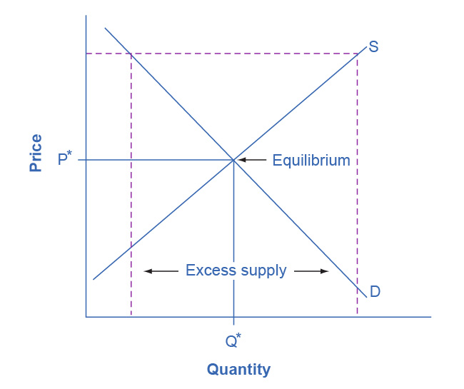

It will have a lesser effect if it is slightly above the equilibrium price. This is illustrated in the next figure.

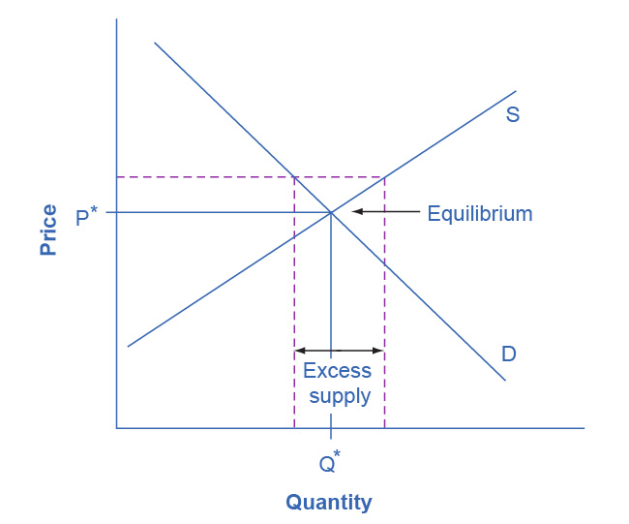

It will have no effect if it is set either slightly or substantially below the equilibrium price, since an equilibrium price above a price floor will not be affected by that price floor. The following figure illustrates these situations.

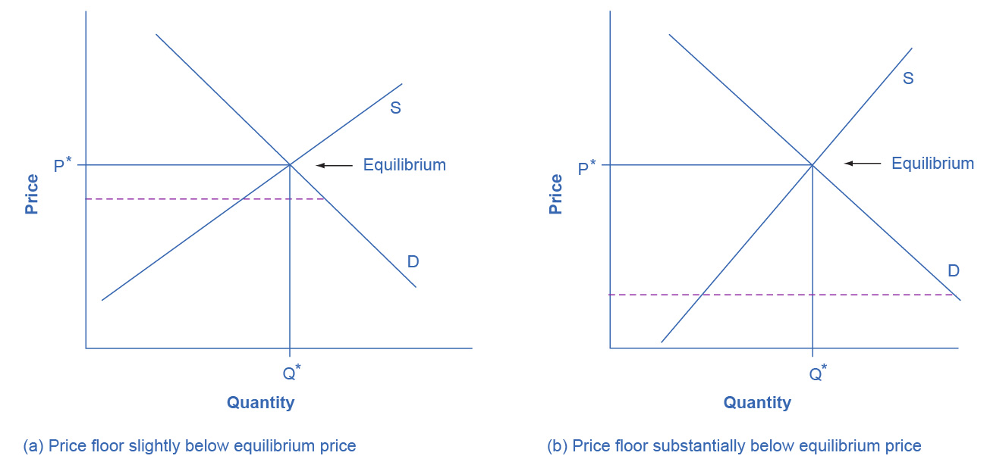

[10](http://openstax.org/books/principles-microeconomics-3e/pages/4-self-check-questions#fs-idm48819088).

A price ceiling prevents a price from rising above a certain level, but has no effect on prices below that level. It will have its biggest effect in creating excess demand if it is substantially below the equilibrium price. The following figure illustrates these situations.

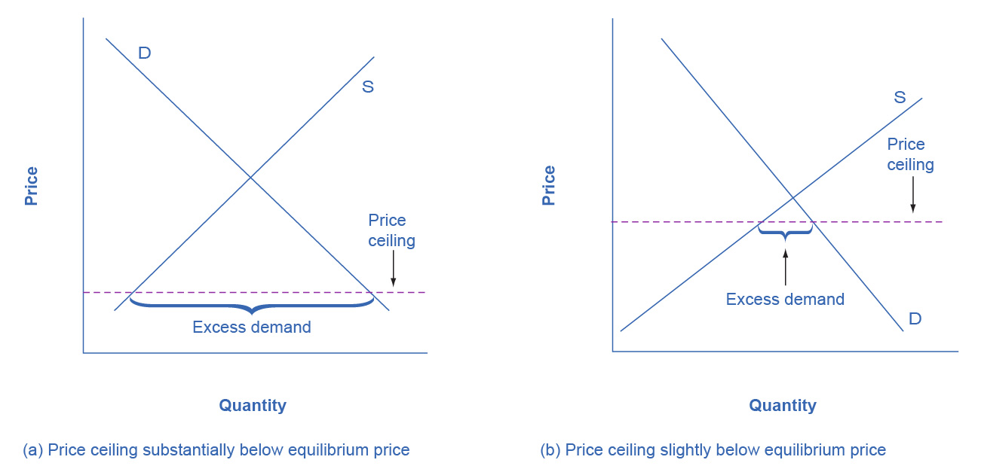

When the price ceiling is set substantially or slightly above the equilibrium price, it will have no effect on creating excess demand. The following figure illustrates these situations.

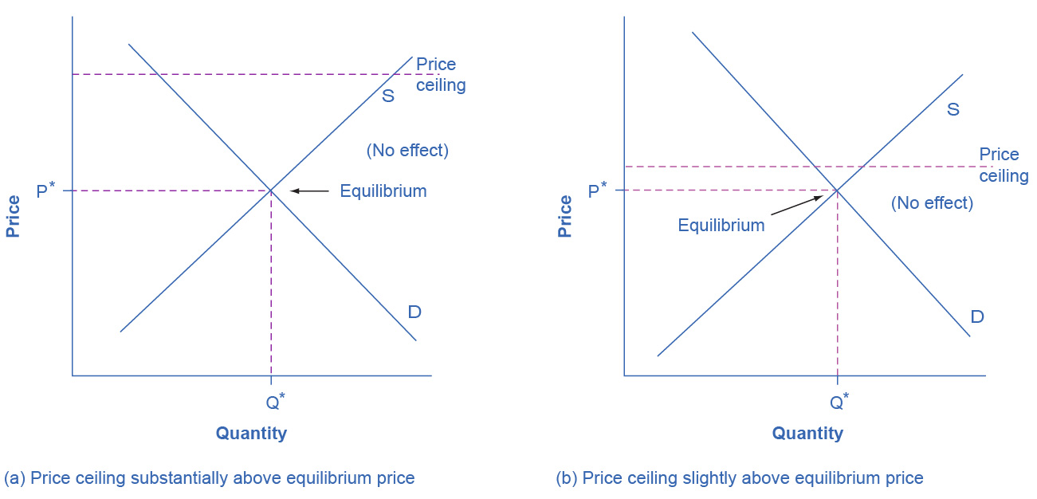

[11](http://openstax.org/books/principles-microeconomics-3e/pages/4-self-check-questions#fs-idp29140256).

Neither. A shift in demand or supply means that at every price, either a greater or a lower quantity is demanded or supplied. A price floor does not shift a demand curve or a supply curve. However, if the price floor is set above the equilibrium, it will cause the quantity supplied on the supply curve to be greater than the quantity demanded on the demand curve, leading to excess supply.

[12](http://openstax.org/books/principles-microeconomics-3e/pages/4-self-check-questions#fs-idp75628784).

Neither. A shift in demand or supply means that at every price, either a greater or a lower quantity is demanded or supplied. A price ceiling does not shift a demand curve or a supply curve. However, if the price ceiling is set below the equilibrium, it will cause the quantity demanded on the demand curve to be greater than the quantity supplied on the supply curve, leading to excess demand.