## Chapter 7

[1](http://openstax.org/books/principles-microeconomics-3e/pages/7-self-check-questions#fs-idm18450688).

Accounting profit = total revenues minus explicit costs = $1,000,000 – ($600,000 + $150,000 + $200,000) = $50,000.

[2](http://openstax.org/books/principles-microeconomics-3e/pages/7-self-check-questions#fs-idp12466368).

Economic profit = accounting profit minus implicit cost = $50,000 – $30,000 = $20,000.

[3](http://openstax.org/books/principles-microeconomics-3e/pages/7-self-check-questions#fs-idm67487424).

|  |  |  |  |  |  |  |
| --- | --- | --- | --- | --- | --- | --- |
| Quantity | Variable Cost | Fixed Cost | Total Cost | Average Variable Cost | Average Total Cost | Marginal Cost |
| 0 | 0 | $30 | $30 | - | - |  |
| 1 | $10 | $30 | $40 | $10.00 | $40.00 | $10 |
| 2 | $25 | $30 | $55 | $12.50 | $27.50 | $15 |
| 3 | $45 | $30 | $75 | $15.00 | $25.00 | $20 |
| 4 | $70 | $30 | $100 | $17.50 | $25.00 | $25 |
| 5 | $100 | $30 | $130 | $20.00 | $26.00 | $30 |
| 6 | $135 | $30 | $165 | $22.50 | $27.50 | $35 |

[4](http://openstax.org/books/principles-microeconomics-3e/pages/7-self-check-questions#fs-idm78693232).

1. Total revenues in this example will be a quantity of five units multiplied by the price of $25/unit, which equals $125. Total costs when producing five units are $130. Thus, at this level of quantity and output the firm experiences losses (or negative profits) of $5.
2. If price is less than average cost, the firm is not making a profit. At an output of five units, the average cost is $26/unit. Thus, at a glance you can see the firm is making losses. At a second glance, you can see that it must be losing $1 for each unit produced (that is, average cost of $26/unit minus the price of $25/unit). With five units produced, this observation implies total losses of $5.
3. When producing five units, marginal costs are $30/unit. Price is $25/unit. Thus, the marginal unit is not adding to profits, but is actually subtracting from profits, which suggests that the firm should reduce its quantity produced.

[5](http://openstax.org/books/principles-microeconomics-3e/pages/7-self-check-questions#eip-561).

The marginal product of the third painter is 75 square feet.

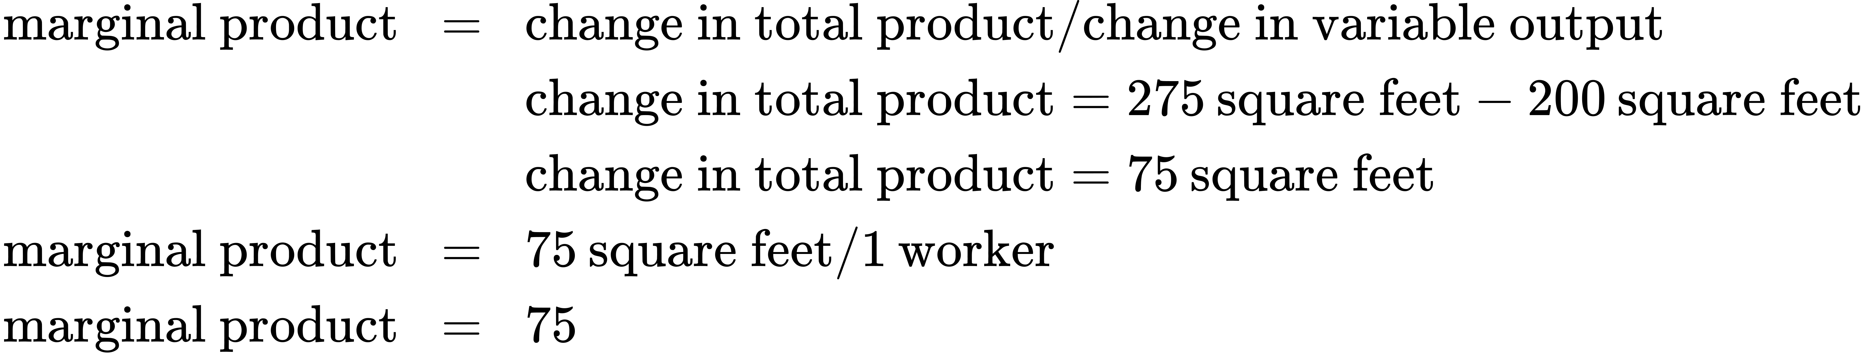

[6](http://openstax.org/books/principles-microeconomics-3e/pages/7-self-check-questions#fs-idm79135792).

The new table should look like this:

|  |  |  |  |
| --- | --- | --- | --- |
|  | Labor Cost | Machine Cost | Total Cost |
| Cost of technology 1 | 10 × $40 = $400 | 2 × $50 = $100 | $500 |
| Cost of technology 2 | 7 × $40 = $280 | 4 × $50 = $200 | $480 |
| Cost of technology 3 | 3 × $40 = $120 | 7 × $50 = $350 | $470 |

The firm should choose production technology 3 since it has the lowest total cost. This makes sense since, with cheaper machine hours, one would expect a shift in the direction of more machines and less labor.

[7](http://openstax.org/books/principles-microeconomics-3e/pages/7-self-check-questions#fs-idm87728624).

|  |  |  |  |
| --- | --- | --- | --- |
|  | Labor Cost | Machine Cost | Total Cost |
| Cost of technology 1 | 10 × $40 = $400 | 2 × $55 = $110 | $510 |
| Cost of technology 2 | 7 × $40 = $280 | 4 × $55 = $220 | $500 |
| Cost of technology 3 | 3 × $40 = $120 | 7 × $55 = $385 | $505 |

The firm should choose production technology 2 since it has the lowest total cost. Because the cost of machines increased (relative to the previous question), you would expect a shift toward less capital and more labor.

[8](http://openstax.org/books/principles-microeconomics-3e/pages/7-self-check-questions#fs-idm73118336).

This is the situation that existed in the United States in the 1970s. Since there is only demand enough for 2.5 firms to reach the bottom of the average cost curve, you would expect one firm will not be around in the long run, and at least one firm will be struggling.