**Homework 1**

**Jamie Andrews**

**Problem 1:**

#-------Homework 1 Question 1 by Jamie Andrews-------

#Import the libraries

import math

# Making the print statements for introduction

print("This program determines the weekly salary of an employee.")

print("The salary is the sum of the hourly rate times the", \

"hours worked, plus the bonus.")

print("For work hours exceeding 40 hours per week, an overtime rate", \

"of 1.5 is applied.")

print("The user must indicate if the worker has received a", \

"bonus by answering a y/n question.")

print("Input consists of: hours worked, hourly rate, bonus.")

print("The output is the total salary for this week.")

# End of print statements for introduction

# Now for program executable statements

# Enter the amount of hours of work (must be float)

# Edit 1/17/17 at 9:00 AM : This line works

hour = float(input('Enter the number of hours worked this week:'))

# Enter the amount of pay per hour (must be in hour)

# Edit 1/17/17 at 9:04 AM : line works but I added the ':' in input statement

rate = float(input("Enter the salary rate per hour" \

"(do not include the '$' sign):"))

#Answer y/n question

#Edit 1/17/17 at 9:12 AM : Line did not work because I used int instead of str

#Edit 1/17/17 at 9:14 AM : Line now works

#Edit 1/17/17 at 9:55 AM : removed string from line (not needed)

bonus = input("Did the worker get a bonus?(y/n)")

#Preparing if/else statement

#Edit 1/17/17 at 10:22 AM : if/else statement finally fixed

if bonus == 'y':

input("Enter bonus:")

print("")

elif bonus == 'n':

print("")

else:

print("")

#preparing second if/else statement

#Edit 01/17/17 at 11:20 AM : if/else statement finally fixed

if hour > 40:

#40 hours or more is overtime

overtime = (hour - 40) * rate * 1.5

#The remaining 40 hours will be under the regular salary

hour = 40

else:

#Otherwise no overtime

overtime = 0

#Calculations for the regular salary and total salary

regular = hour * rate

salary = regular + overtime

#print statement for total salary

print("The total salary is $", "%.2f" % salary, \

"(overtime pay $", "%.2f" % overtime, \

")")

#Edit 01/17/17 at 11:43 AM : p1.py is finished, total time was 4 hours.

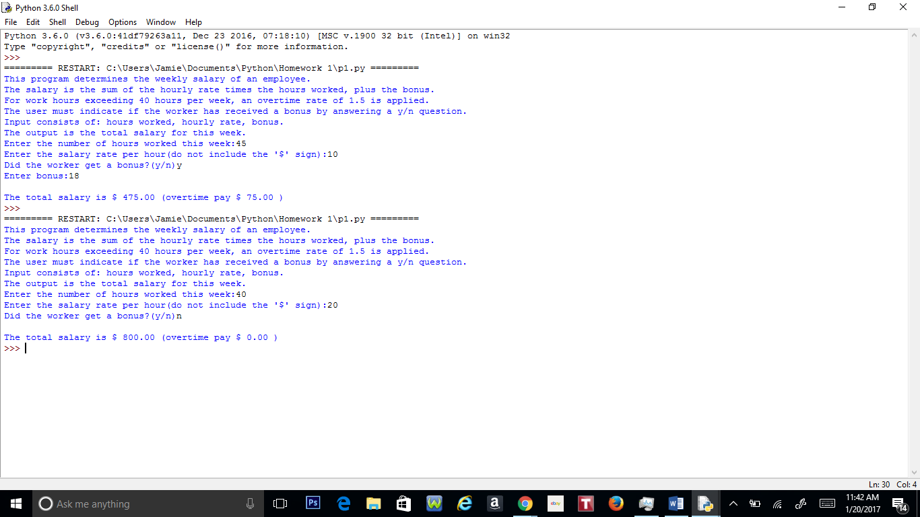

**Problem 2:**

#-----Homework 1 Question 2 by Jamie Andrews -----

#Going to import math first to save the trouble for later

import math

import pylab

#while loop will be installed here

while True:

#Claim my three variables a, b and c

#Edit 01/17/17 at 11:50 AM : these three lines work

a = float(input("Enter a:"))

b = float(input("Enter b:"))

c = float(input("Enter c:"))

#z will represent the discriminant in my program

z = (b**2)-(4 * a * c)

#If/Else statement used for the quadratic formula

#Edit 01/19/17 at 10:00 AM : This statement works

if z < 0:

print("No Real Solutions")

elif z == 0:

x1 = ((-b + math.sqrt(z)) / (2 * a))

print("One Solution:", "%.5f" % x1)

else:

x1 = ((-b + math.sqrt(z)) / (2 * a))

x2 = ((-b - math.sqrt(z)) / (2 * a))

print("Two Solutions:", "%.5f" % x1, "and", "%.5f" % x2)

#Inner loop for the graphing portion of the code

#Preparing the x and y graphs

xs = []

ys = []

#Preparing the domain for the graphing function

x = -5

x0 = 5

#N points

n = 100

#The delta between points

dx = (x0 - x)/n

#Declaring the second while loop

while x <= x0:

xs.append(x)

#Y function should be here

y = (a*x)**2 + (b*x) + c

ys.append(y)

x += dx

#After the loop

pylab.plot(xs,ys,"bo-")

pylab.show()

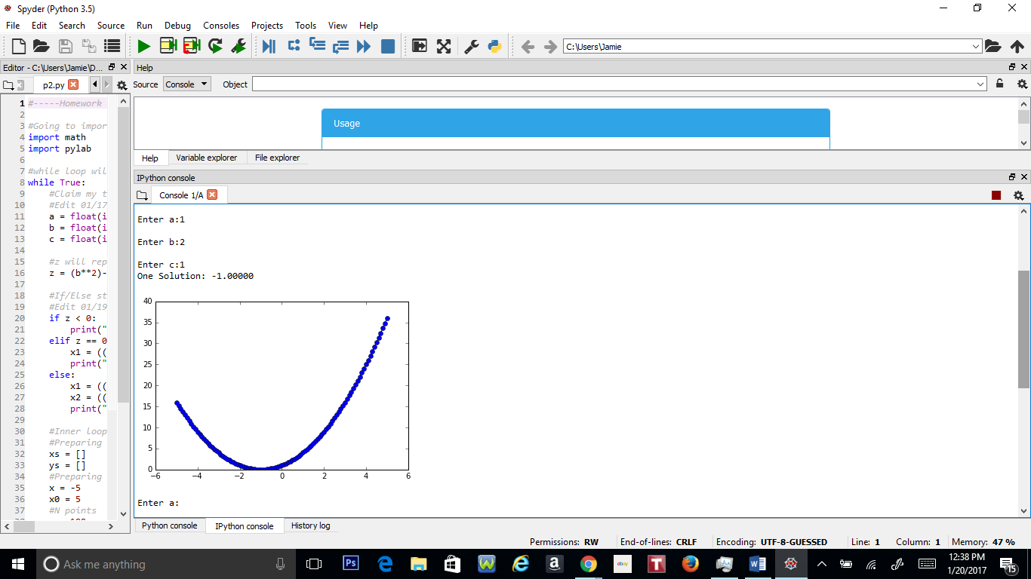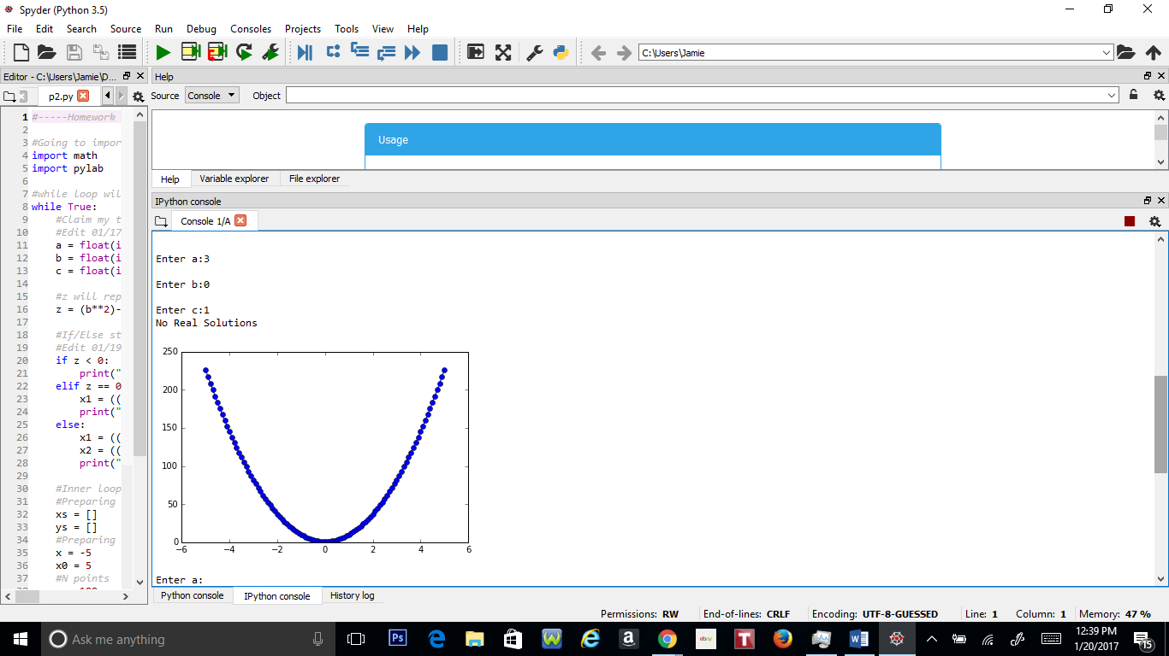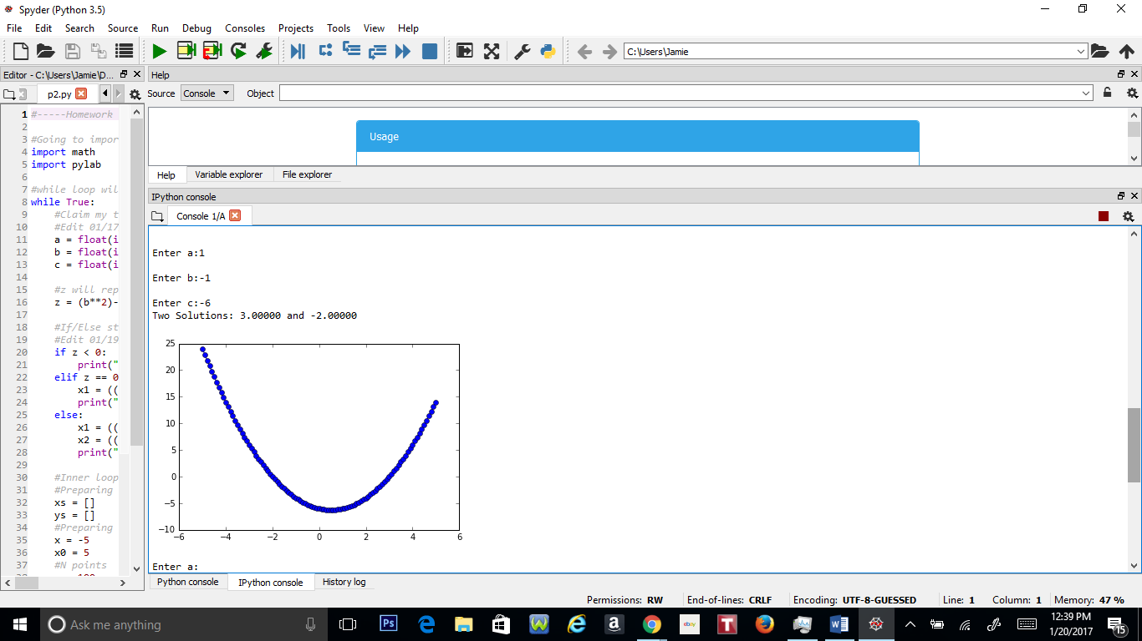

**Problem 3:**

#-----Homework #1 Question 3 by Jamie Andrews-----

#---------Algorithm Here-----------

#1. Make sure to import all libraries before writing out anything.

#2. Make a while loop for program to calculating coin change.

#3. Declare the variables for quarter, dime, and penny.

#4. Declare an input to enter the amount with.

#5. Declare float variable to equal to amount the user has inputted in system.

#6. Make if/else statement for if input is negative, the program should print "Invalid input."

# Otherwise the program moves on to step 7.

#7. Declare 5 variables for calculations for the amount of quarters, dimes and pennies in the amount

#user has inputted.

#8. Declare a variable to calculate the total of coins in amount inputted.

#9. Print the statement stating the amount the user has inputted, number of coins, and

#coin total.

#1.Import the libraries

import math

#2.While loop

while True:

#3.declare variables

quarter = .25

dime = .10

penny = .01

#4. Make input

givemoney = input("Enter the amount:")

#5. Declare float

givemoney = float(givemoney)

#6. If input negative

if givemoney < 0:

print ("Invalid input.")

else:

#7. Declare variables for calculations

q = givemoney // quarter

qtotal = givemoney - (q * quarter)

d = qtotal // dime

dtotal = qtotal - (d * dime)

p = dtotal // penny

#8. Declare variable for coin total

c = q + d + p

#9. Print statement

print("$","%.2f" % givemoney, "makes","%i" % q , "quarters,","%i" % d, "dimes, and", \

"%i" % p, "pennies (", "%i" % c, "coins), total amount in coins: $", \

"%.2f" % givemoney)

