- Descargar e Instalar GitHub Desktop:
  - Visita https://desktop.github.com/
  - Descarga e instala la aplicación.
- Configurar GitHub Desktop:
  - Abre GitHub Desktop.
  - Inicia sesión con tu cuenta de GitHub. Si no tienes, entras en la web Github y te creas una cuenta.
- Clonar el Repositorio:
  - En GitHub Desktop, selecciona "File" > "Clone repository".
  - Selecciona la pestaña "URL".
  - Copia https://github.com/vicevil77/RETOS_CIBERSEGURIDAD y pégalo en dicho campo.
  - Selecciona la ubicación y haz clic en "Clone".

lll
Un saludo.
echaurren

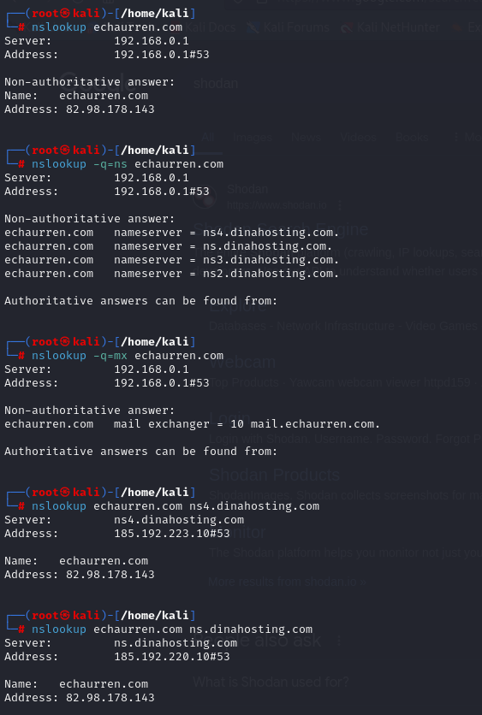

Whois
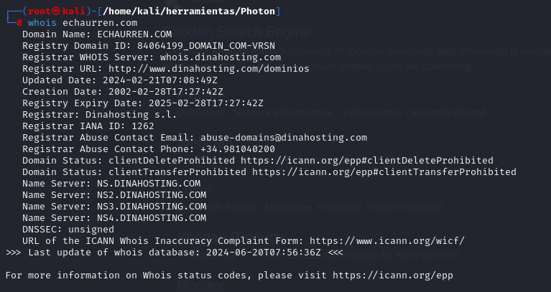
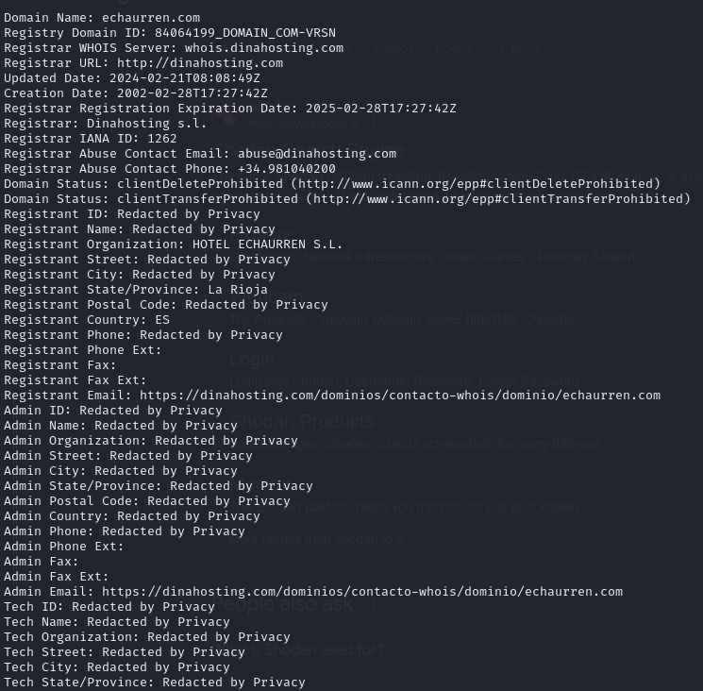
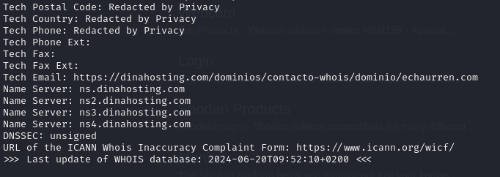

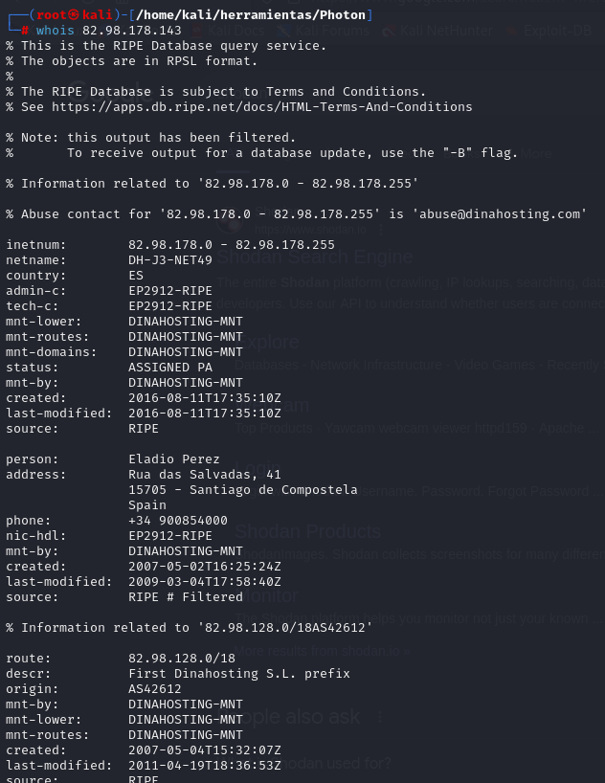

Photo
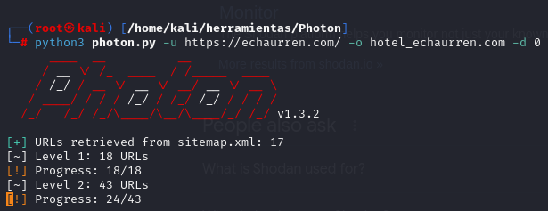
https://cookiedatabase.org/tcf/purposes/
https://c809f281.sibforms.com/serve/MUIEAGVaNaYwHc8XmKl4iZHKfr4XULeLOzL9NQlujHfmebwBopSF1PHu5KILwZLaZDIeRl-UbiA44gCaMTMzHqKhK3-SS4xGrsBb_BOZI7E9qBueHzvLIOvjh6nBRiCBRls86MPcgrDa_EAAoc1rfZxbNN0cYCeo4bwj8Fd-FRkp_uI0aehI7dClznL5kykAJo3-UndKCKxREUNV
http://open.spotify.com/user/ulb82urhfgvsfmu8ts1n76mmd
http://sedeagpd.gob.es/sede-electronica-web/
https://support.mozilla.org/en-US/kb/cookies-information-websites-store-on-your-computer
http://goo.gl/maps/JGEvUsnybTH6c4q28
https://support.apple.com/en-ie/guide/safari/sfri11471/mac
https://support.microsoft.com/en-us/windows/delete-and-manage-cookies-168dab11-0753-043d-7c16-ede5947fc64d
https://support.microsoft.com/en-us/microsoft-edge/delete-cookies-in-microsoft-edge-63947406-40ac-c3b8-57b9-2a946a29ae09
https://support.google.com/chrome/answer/95647?hl=en&amp;co=GENIE.Platform%3DDesktop
https://echaurren.com/wp-content/uploads/4.-SteakTartar_EchaurrenTraidicon.jpg
/pdfs/cartas/tradicion_menu_degustacion_frances.pdf
https://echaurren.com/wp-content/uploads/el_portal_menu_degustacion_frances-1.pdf
https://echaurren.com/wp-content/uploads/5.desayuno.jpg
https://echaurren.com/wp-content/uploads/5.ElPortaldeEchaurren.jpg
https://echaurren.com/wp-content/uploads/5.Helado_ElPortaldeEchaurren.jpg
https://echaurren.com/wp-content/uploads/5._HZM0641.jpg
/pdfs/cartas/el_cuartito_ingles_frances.pdf
https://echaurren.com/producto/experiencia-gastronomica-echaurren-tradicion/?add-to-cart=2909
https://echaurren.com/producto/experiencia-escapada-tradicion/?add-to-cart=2907
https://echaurren.com/producto/experiencia-gastronomica-el-portal-de-echaurren/?add-to-cart=2916
https://echaurren.com/producto/experiencia-escapada-el-portal-de-echaurren/?add-to-cart=2907
https://echaurren.com/producto/experiencia-gastronomica-echaurren-tradicion/?add-to-cart=6209
https://echaurren.com/producto/experiencia-gastronomica-el-portal-de-echaurren/?add-to-cart=2907
https://echaurren.com/producto/experiencia-escapada-el-portal-de-echaurren/?add-to-cart=2909
https://echaurren.com/producto/experiencia-dos-dias-gastronomicos/?add-to-cart=2917
https://echaurren.com/producto/experiencia-gastronomica-echaurren-tradicion/?add-to-cart=2914
https://echaurren.com/producto/experiencia-gastronomica-echaurren-tradicion/?add-to-cart=2907
https://echaurren.com/producto/experiencia-escapada-el-portal-de-echaurren/?add-to-cart=6209
https://echaurren.com/producto/experiencia-dos-dias-gastronomicos/?add-to-cart=2919
https://echaurren.com/producto/experiencia-escapada-tradicion/?add-to-cart=2919
https://echaurren.com/producto/experiencia-gastronomica-el-portal-de-echaurren/?add-to-cart=2917
https://echaurren.com/producto/experiencia-escapada-tradicion/?add-to-cart=2911
https://echaurren.com/producto/experiencia-escapada-el-portal-de-echaurren/?add-to-cart=2917
https://echaurren.com/producto/experiencia-gastronomica-el-portal-de-echaurren/?add-to-cart=2909
https://echaurren.com/producto/experiencia-escapada-tradicion/?add-to-cart=2916
https://echaurren.com/producto/experiencia-dos-dias-gastronomicos/?add-to-cart=2916
https://echaurren.com/producto/experiencia-dos-dias-gastronomicos/?add-to-cart=2907
https://echaurren.com/experiencias//producto/experiencia-gastronomica-el-portal-de-echaurren/
https://echaurren.com/producto/experiencia-gastronomica-echaurren-tradicion/?add-to-cart=2909
https://echaurren.com/trabaja-con-nosotros/
https://echaurren.com/producto/experiencia-gastronomica-echaurren-tradicion/?add-to-cart=6209
https://echaurren.com/a-casa//contacto/
https://echaurren.com/politica-de-privacidad/tel:941354047
https://echaurren.com/en/work-with-us/
https://echaurren.com/en//en/contact/
https://echaurren.com/en/contact/tel:+34941354047
https://echaurren.com/producto/experiencia-gastronomica-echaurren-tradicion/?add-to-cart=2907
https://echaurren.com/en/gastronomy//en/a-casa/
https://echaurren.com/experiencias/
https://echaurren.com/en/a-casa//en/contact/
https://echaurren.com/trabaja-con-nosotros/tel:941354047
https://echaurren.com/mailto:
https://echaurren.com/producto/ambientador-para-casa/
https://echaurren.com/a-casa/tel:941
https://echaurren.com/a-casa.html
https://echaurren.com/tapas.html
https://echaurren.com/restaurante-bistro-el-cuartito/
https://echaurren.com/gastronomia//contacto/
https://echaurren.com/a-casa/tel:941354047
https://echaurren.com/ezcaray-2/
https://echaurren.com/producto/experiencia-gastronomica-el-portal-de-echaurren/?add-to-cart=2916
https://echaurren.com/restaurante-bistro-el-cuartito//contacto/
https://echaurren.com/gastronomia.html
https://echaurren.com/en/a-casa/tel:941
https://echaurren.com/producto/experiencia-gastronomica-echaurren-tradicion/tel:941354047
https://echaurren.com/producto/experiencia-escapada-el-portal-de-echaurren/?add-to-cart=2909
https://echaurren.com/tel:+34
https://echaurren.com/politica-de-privacidad/
https://echaurren.com/en/product/el-portal-de-echaurren-gastronomic-experience/
https://echaurren.com/en/experiencies//en/contact/
https://echaurren.com/producto/kit-regalo-echaurren/
https://echaurren.com/producto/experiencia-dos-dias-gastronomicos/?add-to-cart=2919
https://echaurren.com/en/contact/tel:+34
https://echaurren.com/producto/experiencia-escapada-tradicion/?add-to-cart=2911
https://echaurren.com/experiencias//producto/experiencia-escapada-tradicion/
https://echaurren.com/experiencias//contacto/
https://echaurren.com/en/contact//en/contact/
https://echaurren.com/producto/experiencia-gastronomica-el-portal-de-echaurren/?add-to-cart=2909
https://echaurren.com/en/the-echaurren-family//en/contact/
https://echaurren.com/producto/experiencia-dos-dias-gastronomicos/?add-to-cart=2907
https://echaurren.com/en/the-echaurren-family/tel:+34941354047
https://echaurren.com/en/contact/mailto:
https://echaurren.com/producto/libro-hecho-en-casa/
https://echaurren.com/en/gastronomy/tel:+34941354047
https://echaurren.com/en/experiencies//en/product/tradicion-getaway-experience/
https://echaurren.com/producto/experiencia-escapada-el-portal-de-echaurren/?add-to-cart=2907
https://echaurren.com/producto/delantal-echaurren/
https://echaurren.com/boutique/
https://echaurren.com/producto/pol-contreras-chocolates/
https://echaurren.com//ezcaray-2//contacto/
https://echaurren.com/en/legal-warning/tel:+34941354047
https://echaurren.com/ezcaray//contacto/
https://echaurren.com/a-casa/mailto:info@echaurren.com
https://echaurren.com/en/cookies-policy/
https://echaurren.com/en/legal-warning//en/contact/
https://echaurren.com/en/gastronomy/
https://echaurren.com/producto/experiencia-gastronomica-el-portal-de-echaurren/
https://echaurren.com/producto/experiencia-escapada-tradicion/tel:941354047
https://echaurren.com/producto/experiencia-escapada-tradicion/?add-to-cart=2919
https://echaurren.com/mailto:susana@echaurren.com
https://echaurren.com/producto/experiencia-gastronomica-el-portal-de-echaurren/?add-to-cart=2917
https://echaurren.com/en/experiencies//en/product/el-portal-de-echaurren-gastronomic-experience/
https://echaurren.com/tel:941354047
https://echaurren.com/en//en/the-echaurren-family/
https://echaurren.com//ezcaray-2/
https://echaurren.com/en/echaurren-tradicion-restaurant/tel:+34941354047
https://echaurren.com/en/privacy-policy/
https://echaurren.com/en/el-portal-de-echaurren-restaurant/
https://echaurren.com/125aniversario.html
https://echaurren.com/en/
https://echaurren.com/el-portal.html
https://echaurren.com/carrito/tel:941354047
https://echaurren.com/gastronomia/tel:941354047
https://echaurren.com/contacto//contacto/
https://echaurren.com/gastronomia/
https://echaurren.com/en/ezcaray/tel:+34941354047
https://echaurren.com/producto/experiencia-dos-dias-gastronomicos/
https://echaurren.com//contacto//contacto/
https://echaurren.com/en/product/echaurren-tradicion-gastronomic-experience/
https://echaurren.com/producto/experiencia-escapada-el-portal-de-echaurren/?add-to-cart=6209
https://echaurren.com/en/legal-warning/
https://echaurren.com//contacto//politica-de-privacidad/
https://echaurren.com/en/product/tradicion-getaway-experience/
https://echaurren.com/a-casa/
https://echaurren.com/en/echaurren-tradicion-restaurant/
https://echaurren.com//contacto/tel:+34
https://echaurren.com/producto/experiencia-escapada-tradicion/?add-to-cart=2916
https://echaurren.com/producto/experiencia-dos-dias-gastronomicos/?add-to-cart=2916
https://echaurren.com/restaurante-el-portal-de-echaurren//contacto/
https://echaurren.com/carrito//contacto/
https://echaurren.com/restaurante-echaurren-tradicion/tel:941354047
https://echaurren.com/aviso-legal/tel:941354047
https://echaurren.com/en/product/the-two-days-of-gastronomy-experience/
https://echaurren.com/experiencias//producto/experiencia-escapada-el-portal-de-echaurren/
https://echaurren.com/producto/cuchillo-de-cocina-echaurren/
https://echaurren.com/trabaja-con-nosotros.html
https://echaurren.com/en/bistro-el-cuartito-restaurant/
https://echaurren.com/bistro.html
https://echaurren.com/condiciones-generales-de-compra/
https://echaurren.com/trabaja-con-nosotros//contacto/
https://echaurren.com/en/legal-warning/tel:941354047
https://echaurren.com/tradicion.html
https://echaurren.com/producto/experiencia-escapada-el-portal-de-echaurren/
https://echaurren.com/
https://echaurren.com
https://echaurren.com/en/contact/
https://echaurren.com/producto/experiencia-escapada-el-portal-de-echaurren/tel:941354047
https://echaurren.com/en//en/ezcaray/
https://echaurren.com/trabaja-con-nosotros/mailto:susana@echaurren.com
https://echaurren.com/la-arboleda.html
https://echaurren.com//familia-echaurren/tel:941354047
https://echaurren.com/politica-de-cookies/tel:941354047
https://echaurren.com/contacto//politica-de-privacidad/
https://echaurren.com/contacto/tel:+34
https://echaurren.com/producto/historia-de-ezcaray-cuaderno/
https://echaurren.com/en/general-conditions-of-sale/
https://echaurren.com/en/tel:+34941354047
https://echaurren.com/contacto.html
https://echaurren.com/restaurante-el-portal-de-echaurren/tel:941354047
https://echaurren.com//contacto/
https://echaurren.com/carrito/
https://echaurren.com/en/work-with-us/mailto:susana@echaurren.com
https://echaurren.com/experiencias//producto/experiencia-dos-dias-gastronomicos/
https://echaurren.com/politica-de-cookies/
https://echaurren.com/gastronomia//a-casa/
https://echaurren.com/restaurante-echaurren-tradicion/
https://echaurren.com/producto/experiencia-dos-dias-gastronomicos/?add-to-cart=2917
https://echaurren.com/en/the-echaurren-family/
https://echaurren.com/en/cookies-policy//en/contact/
https://echaurren.com/politica-de-cookies//contacto/
https://echaurren.com/producto/experiencia-gastronomica-el-portal-de-echaurren/tel:941354047
https://echaurren.com/aviso-legal.html
https://echaurren.com/en/gastronomy//en/contact/
https://echaurren.com/en/cart/
https://echaurren.com/familia-echaurren/tel:941354047
https://echaurren.com/producto/experiencia-escapada-el-portal-de-echaurren/?add-to-cart=2917
https://echaurren.com/en/product/el-portal-de-echaurren-giveaway-experience/
https://echaurren.com/ezcaray/tel:941354047
https://echaurren.com/restaurante-echaurren-tradicion//contacto/
https://echaurren.com//contacto/tel:941354047
https://echaurren.com/ezcaray-2/tel:941354047
https://echaurren.com/politica-de-privacidad//contacto/
https://echaurren.com/contacto/mailto:
https://echaurren.com//ezcaray-2/tel:941354047
https://echaurren.com/en/experiencies//en/product/the-two-days-of-gastronomy-experience/
https://echaurren.com/aviso-legal//contacto/
https://echaurren.com/producto/cena-jazz-echaurren/
https://echaurren.com/familia-echaurren/
https://echaurren.com/en/a-casa/
https://echaurren.com/en/experiencies//en/product/el-portal-de-echaurren-giveaway-experience/
https://echaurren.com//contacto/mailto:
https://echaurren.com/producto/experiencia-gastronomica-el-portal-de-echaurren/?add-to-cart=2907
https://echaurren.com/en/cookies-policy/tel:+34941354047
https://echaurren.com/ezcaray/
https://echaurren.com/producto/experiencia-gastronomica-echaurren-tradicion/?add-to-cart=2914
https://echaurren.com/en/ezcaray//en/contact/
https://echaurren.com/producto/experiencia-escapada-tradicion/
https://echaurren.com//familia-echaurren//contacto/
https://echaurren.com/producto/experiencia-gastronomica-echaurren-tradicion/
https://echaurren.com/familia-echaurren//contacto/
https://echaurren.com/en/echaurren-tradicion-restaurant//en/contact/
https://echaurren.com/contacto/tel:941354047
https://echaurren.com/experiencias//producto/experiencia-gastronomica-echaurren-tradicion/
https://echaurren.com/contacto/
https://echaurren.com/en/contact//en/privacy-policy/
https://echaurren.com/experiencias/tel:941354047
https://echaurren.com/tel:941
https://echaurren.com/en/experiencies/
https://echaurren.com//familia-echaurren/
https://echaurren.com/mailto:info@echaurren.com
https://echaurren.com/producto/experiencia-escapada-tradicion/?add-to-cart=2907
https://echaurren.com/cookies.html
https://echaurren.com/experiencias.html
https://echaurren.com/aviso-legal/
https://echaurren.com/en/ezcaray/
https://echaurren.com/ezcaray.html
https://echaurren.com/familia-echaurren.html
https://echaurren.com/en/a-casa/mailto:info@echaurren.com
https://echaurren.com/condiciones-generales-de-compra/tel:941354047
https://echaurren.com/producto/experiencia-dos-dias-gastronomicos/tel:941354047
https://echaurren.com/restaurante-el-portal-de-echaurren/
https://echaurren.com/ezcaray-2//contacto/
https://echaurren.com/en/legal-warning/info@echaurren.com
https://echaurren.com/en/experiencies/tel:+34941354047
https://echaurren.com/en/work-with-us//en/contact/
https://echaurren.com/politica-de-privacidad/mailto:protecciondatos@echaurren.com
https://echaurren.com/condiciones-generales-de-compra//contacto/
https://echaurren.com/en/a-casa/tel:+34941354047
https://echaurren.com/restaurante-bistro-el-cuartito/tel:941354047
https://echaurren.com/politica-privacidad.html
https://echaurren.com/en/work-with-us/tel:+34941354047

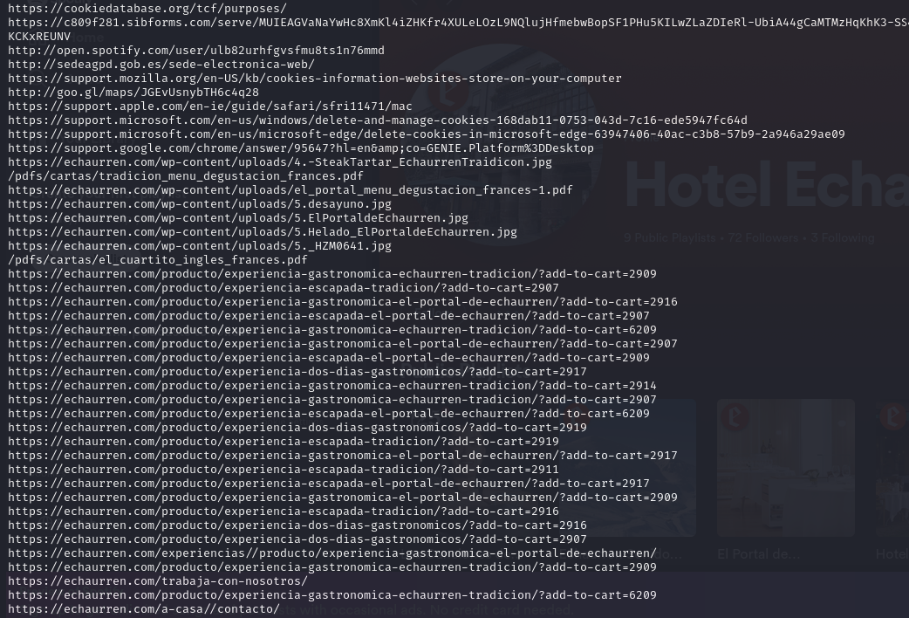

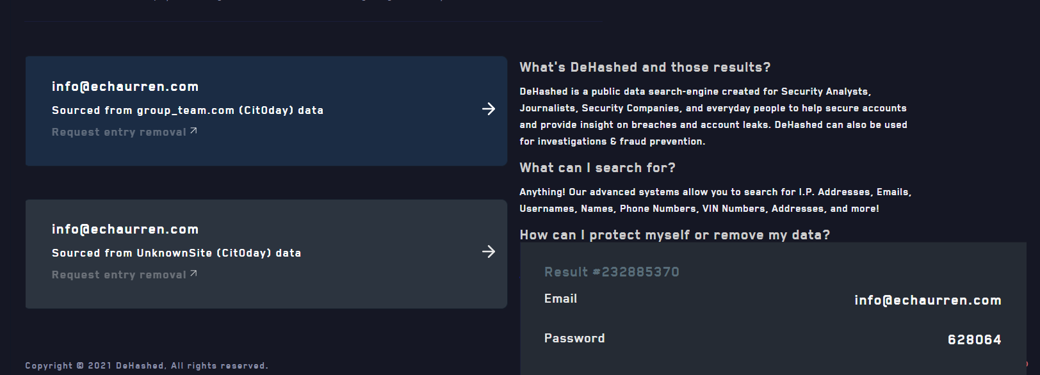

Geolocalización
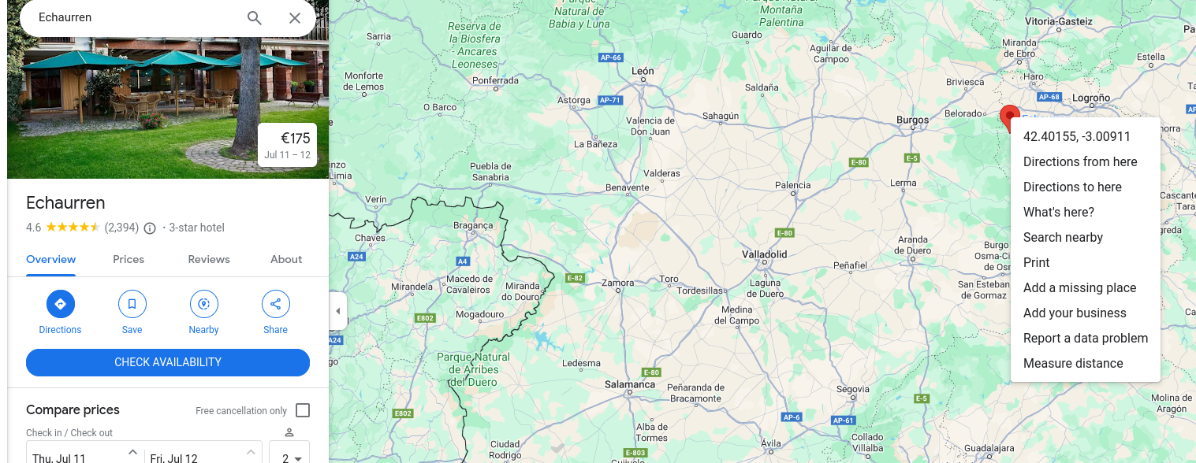

Cuenta de spotify
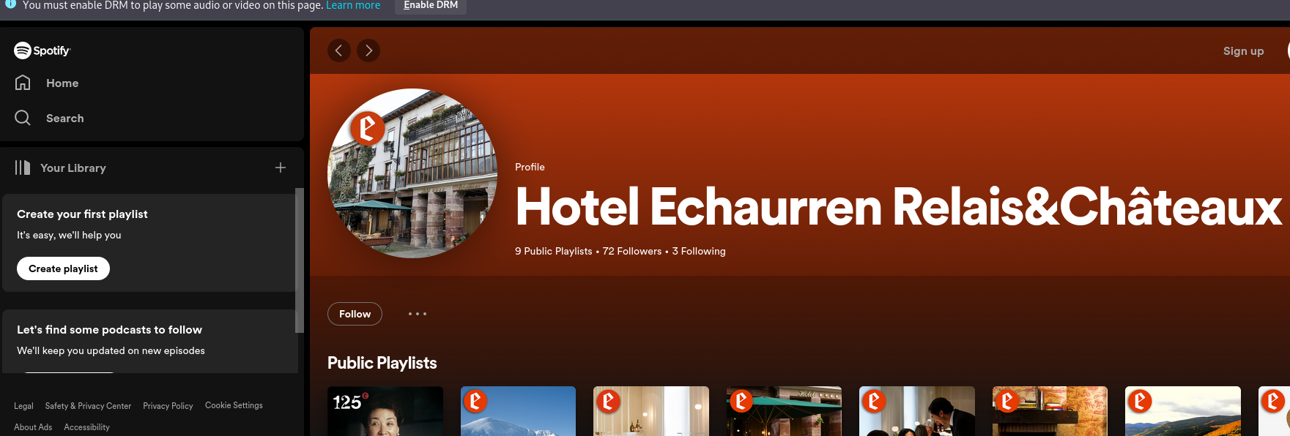

Nombre e imagen
Fraancis Paniego
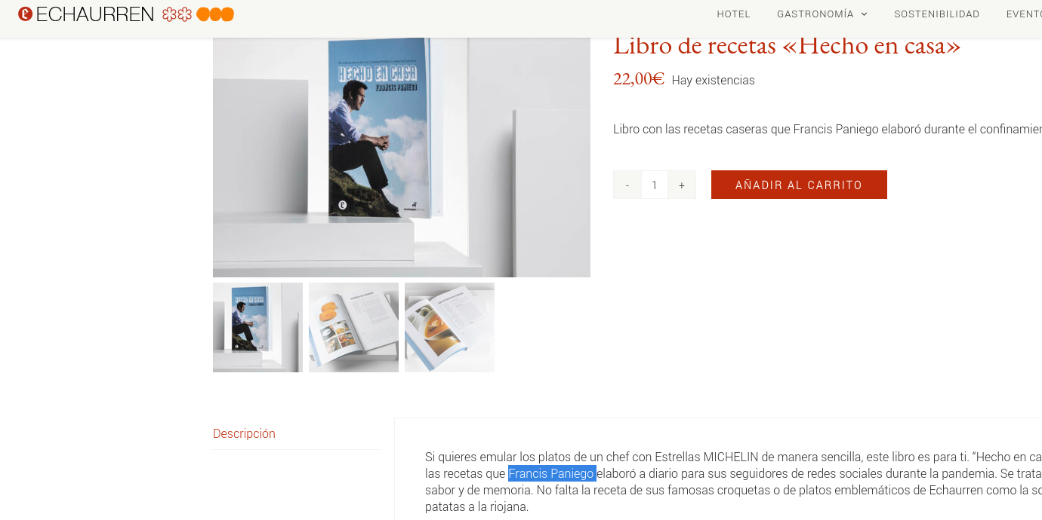

Usando Amass

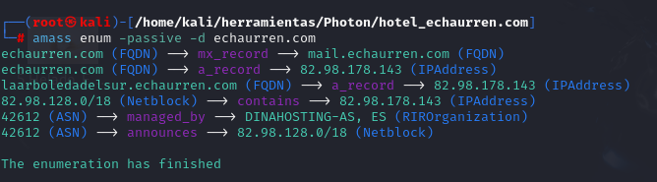
Subdominio nuevo
Laarboledadelsur

