# Lab2-3: UML class diagram – CONCEPTUAL MODEL

Goal of this lab is to practice the usage of UML class diagram.

For the diagrams you can use tools like Signavio, Argo UML, Astah, Star UML, Plant UML.

Define the conceptual diagram for the following cases.

## Movie shop

A movie shop proposes movies for purchase or hiring. A catalogue lists the movies available.

The shop also offers subscription cards. Subscribers can purchase cards and upload on them a credit, using cash or a credit card.

Only subscribers are allowed hiring movies with their own card.

Credit is updated on the card during rent operations.

Both users and subscribers can buy a movie and their data are saved in the related order.

The shop must monitor the availability of movies and purchase them from distributors when needed.

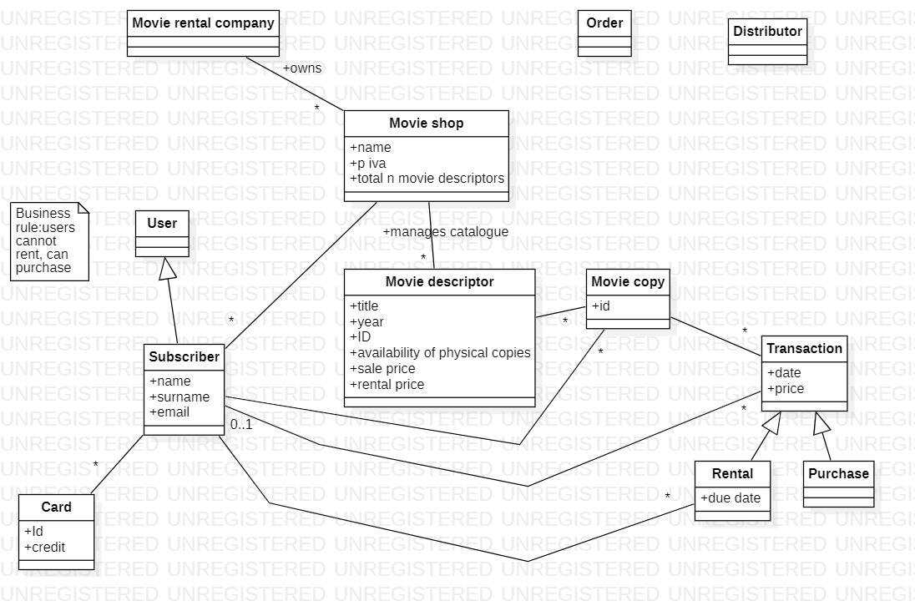

## University

In a university there are different classrooms, offices and departments. A department has a name and it contains many offices. A person working at the university has a unique ID and can be a professor or an employee.

* A professor can be a full, associate or assistant professor and he/she is enrolled in one department.
* Offices and classrooms have a number ID, and a classroom has a number of seats.
* Every Employee works in an office

## Airlines

An airline operates flights. Each airline has an ID.

Each flight has a code a departure airport and an arrival airport: an airport has a unique identifier.

Each flight has a pilot and a co-pilot, and it uses an aircraft of a certain type; a flight has also a departure time and an arrival time.

An airline owns a set of aircrafts of different types.

An aircraft can be in a working state or it can be under repair, and in a particular moment an aircraft can be landed or airborne.

A company has a set of pilots: each pilot has an experience level: 1 is minimum, 3 is maximum.

A type of aircraft may need a particular number of pilots, with a different role (Ex. captain, co-pilot, navigator): there must be at least one captain and one co-pilot, and a captain must have a level 3.

## Robotic vacuum cleaner

Since several years robotic vacuum cleaners (RVC) are available. An RVC is capable of cleaning the floors of a house in autonomous mode.

An RVC system is composed of the robot itself and a charging station. The charging station is connected to an electric socket in the house, and allows charging the battery on board of the robot.

The robot itself is composed of mechanical and electric parts, a computer, and sensors. One infrared sensor in the frontal part recognizes obstacles, another infrared sensor always on the frontal part recognizes gaps (like a downhill staircase). A sensor on the battery reads the charge of the battery. The computer collects data from the sensors and controls the movement of four wheels. Another sensor on one of the wheels computes direction and distance traveled by the robot.

Finally on top of the robot there are three switches: on-off, start, learn.

The learn button starts a procedure that allows the robot to map the space in the house. With a certain algorithm the robot moves in all directions, until it finds obstacles or gaps, and builds an internal map of this space. By definition the robot cannot move beyond obstacles, like walls or closed doors, and beyond gaps taller than 1cm.

The starting point of the learn procedure must be the charging station. When the map is built the robot returns to the charging station and stops.

The start button starts a cleaning procedure. The robot, starting from the charging station, covers and cleans all the space in the house, as mapped in the ‘learn’ procedure.

In all cases when the charge of the battery is below a certain threshold, the robot returns to the charging station. When recharged, the robot completes the mission, then returns to the charging station and stops.