FactCheck AI: A Hybrid Real-Time Fact-Checking Browser Extension Using Google FactCheck API and RoBERTa ML Model

A
Project Based Learning-4 (IIS3270) Report
Submitted in the partial fulfillment of the requirements for the award of
Bachelor of Technology - CSE (IoT & IS)
By:
Devansh Sharma
23FE01CII00141

Dhairya Prabhakar
23FE10CII00100
Under the guidance of:
Mr. G.L. Saini
Assistant Professor


April 2026

Department of IoT and Intelligent Systems
Manipal University Jaipur
VPO. Dehmi Kalan, Jaipur, Rajasthan, India – 303007

DECLARATION BY THE STUDENT

We hereby declare that this project (FactCheck AI: A Hybrid Real-Time Fact-Checking Browser Extension Using Google FactCheck API and RoBERTa ML Model) is our own work and that, to the best of our knowledge and belief, it contains no material previously published or written by another person nor material which has been accepted for the award of any other degree or diploma of the University or other Institute, except where due acknowledgements has been made in the text.

Place: MUJ, Jaipur Devansh Sharma
Date: April 9, 2026 23FE01CII00141

Dhairya Prabhakar
23FE10CII00100
B.Tech CSE (IoT & IS) 6th Semester

Department of IoT and Intelligent Systems
Manipal University Jaipur

Dehmi Kalan, Jaipur, Rajasthan, India- 303007
PROJECT COMPLETION CERTIFICATE
PROJECT BASED LEARNING (IIS3270)
Date: April 9, 2026
This is to certify that the work titled FactCheck AI: A Hybrid Real-Time Fact-Checking Browser Extension Using Google FactCheck API and RoBERTa ML Model submitted by Devansh Sharma (23FE01CII00141) and Dhairya Prabhakar (23FE10CII00100) to Manipal University Jaipur in partial fulfillment of the requirements for the degree of Bachelor of Technology in CSE (IoT and Intelligent Systems), is a bonafide record of the PBL-4 work conducted under my supervision and guidance from January 5, 2026, to April 9, 2026.

Signature
Mr. G.L. Saini
Assistant Professor
Department of IoT and Intelligent Systems
Manipal University Jaipur

ACKNOWLEDGEMENT
We would like to express our sincere gratitude to Mr. G.L. Saini, Assistant Professor, Department of IoT and Intelligent Systems, Manipal University Jaipur, for his invaluable guidance, continuous encouragement, and support throughout the duration of this project. His insights and expertise greatly enriched the quality of this work.
We are grateful to the Department of IoT and Intelligent Systems at Manipal University Jaipur for providing us with the necessary infrastructure, resources, and an academic environment conducive to innovation and research.
We also extend our thanks to the developers of the open-source tools and frameworks used in this project, including Hugging Face Transformers, FastAPI, Tesseract.js, and the teams behind the Google FactCheck Tools API and the LIAR dataset, without which this project would not have been possible.
Finally, we thank our families and peers for their unwavering support and encouragement.

Devansh Sharma (23FE01CII00141)
Dhairya Prabhakar (23FE10CII00100)

ABSTRACT
The rapid proliferation of misinformation and fake news across digital platforms has emerged as one of the most critical challenges of the modern information age. This project presents FactCheck AI, a browser extension built for Google Chrome that enables users to verify the authenticity of claims, headlines, and statements in real time directly within their browsing environment.
FactCheck AI employs a three-stage hybrid pipeline designed to maximise accuracy while gracefully handling unseen claims. In the first stage, the extension queries the Google FactCheck Tools API, which aggregates results from over a hundred certified fact-checking organisations worldwide including Snopes, PolitiFact, FactCheck.org, and AFP Fact Check. If no verified result is found, the system falls back to a fine-tuned RoBERTa (roberta-base) model trained on the LIAR dataset, a benchmark corpus of politically labelled claims, which classifies the input as True, False, Mixed, or Uncertain. As a final layer, a Wikipedia API integration provides factual context when the ML backend is unavailable.
The extension also incorporates Optical Character Recognition (OCR) via Tesseract.js, allowing users to upload screenshots for automatic text extraction and verification. A floating badge on text selection and a right-click context menu further enhance usability without requiring users to leave the page.
The ML model achieves an accuracy of approximately 44% and an F1 score of 0.43 on the LIAR test set. While the model serves as a fallback rather than a primary verifier, the hybrid design ensures that well-documented claims are handled with high accuracy through the Google API, while novel claims receive probabilistic classification from the ML component.
The system demonstrates that a lightweight, privacy-respecting, browser-integrated fact-checking tool combining curated databases with machine learning is a viable and practical solution for combating misinformation at the point of consumption.

TABLE OF CONTENTS
Declaration by the Student i
Project Completion Certificate ii
Acknowledgement iii
Abstract iv
List of Figures v
1. Introduction 1
2. Literature Review 3
3. System Architecture and Methodology 5
4. Implementation 8
5. Results and Discussion 11
6. Conclusion and Future Work 13
7. Contributions 14
8. Bibliography 15

LIST OF FIGURES
Figure 1: System Architecture Pipeline 6
Figure 2: Extension Popup - ML Model Result (MUJ claim) 9
Figure 3: Extension Popup - Google FactCheck Result (Elon Musk claim) 10
Figure 4: Extension Popup - Google FactCheck Result (COVID-19 vaccines claim) 10

1. INTRODUCTION
The digital era has democratised information sharing, allowing billions of users to consume and distribute news at unprecedented speed. However, this openness has also enabled the rapid spread of misinformation, disinformation, and fabricated claims across social media platforms, news aggregators, and messaging applications. According to the Reuters Institute Digital News Report, a significant portion of internet users regularly encounter false or misleading information online, with political claims, health misinformation, and viral hoaxes being the most prevalent categories.
Traditional fact-checking is a labour-intensive process conducted by dedicated journalists and editorial teams. While organisations such as Snopes, PolitiFact, AFP Fact Check, and BBC Verify have established credible repositories of verified claims, the sheer volume of content produced daily far exceeds manual verification capacity. There is therefore a pressing need for automated tools that can assist users in evaluating the credibility of information at the point of consumption.
This project introduces FactCheck AI, a Google Chrome browser extension that integrates seamlessly into the user's browsing workflow to provide real-time fact verification. The extension is designed around a hybrid architecture that leverages the strengths of both curated fact-check databases and machine learning models.
1.1 Objectives
- Design and implement a browser extension for real-time claim verification.
- Integrate the Google FactCheck Tools API to retrieve results from certified fact-checking organisations.
- Train and deploy a fine-tuned RoBERTa model on the LIAR dataset as a fallback classifier.
- Implement OCR functionality to extract and verify text from screenshots.
- Build an intuitive, non-intrusive UI that presents verdicts with source transparency.
- Create a relevance-filtering layer to prevent false positives from loosely-matched API results.
1.2 Scope
The extension operates on all web pages accessed through Google Chrome and is compatible with any claim that can be expressed as a text statement. It supports English-language claims and is designed for general consumer use. The scope encompasses political statements, health claims, scientific assertions, and viral misinformation, categories that represent the most commonly fact-checked content categories in major databases.
1.3 Motivation
Existing fact-checking tools either require users to navigate to external websites, or rely exclusively on API lookups that fail for novel or obscure claims. FactCheck AI addresses both limitations by embedding the verification process directly in the browser and providing a machine learning fallback that can handle claims not yet indexed by any fact-checker. The inclusion of OCR further extends usability to screenshot-based misinformation, which is a rapidly growing vector for false content distribution.

2. LITERATURE REVIEW
Automated fact-checking has been an active area of research since the mid-2010s, driven by the growing recognition of misinformation as a sociotechnical problem. Early approaches relied on knowledge graphs and structured databases to verify factual claims against known entities and relationships. Systems such as NELL (Never-Ending Language Learning) demonstrated that structured world knowledge could be used to assess factual accuracy, though such approaches were limited to well-structured, entity-based claims.
Wang (2017) introduced the LIAR dataset, a benchmark corpus of 12,836 short statements collected from PolitiFact.com, each labelled with one of six veracity categories: pants-fire, false, barely-true, half-true, mostly-true, and true. This dataset, along with meta-information such as speaker identity and political context, became a standard benchmark for computational fact-checking research. The paper also demonstrated that a CNN-based classifier could achieve modest accuracy on this task, establishing a baseline for subsequent deep learning approaches.
The advent of transformer-based language models brought significant improvements to natural language understanding tasks, including fact verification. Devlin et al. (2018) introduced BERT, a bidirectional transformer pre-trained on large text corpora, which achieved state-of-the-art results on multiple NLP benchmarks. Liu et al. (2019) further developed RoBERTa, a robustly optimised variant of BERT trained with dynamic masking and larger batches, demonstrating superior performance on classification tasks. Fine-tuning RoBERTa on domain-specific datasets such as LIAR has since become a common approach in automated fact-checking literature.
Thorne et al. (2018) introduced the FEVER (Fact Extraction and VERification) shared task, which framed fact-checking as a two-step process: evidence retrieval followed by claim verification. This framework influenced subsequent systems that combine retrieval components with neural classifiers, a design philosophy that parallels the hybrid architecture adopted in this project.
Browser-based fact-checking tools have also been explored in prior work. The Full Fact API and ClaimBuster (Hassan et al., 2017) are notable examples of systems designed to identify check-worthy claims in text and match them against existing fact-check databases. ClaimBuster employs an SVM classifier trained on sentence-level features to assign a check-worthiness score, which can be used to filter out non-claims before verification. These insights informed our input validation design.
The Google FactCheck Tools API, launched in 2018, represents a practical aggregation layer over multiple independent fact-checking organisations, providing a unified interface for querying verified claims. Its integration into browser extensions has been demonstrated in academic prototypes, though no publicly available extension combines it with a local ML model and OCR in a unified pipeline.
This project synthesises insights from the above literature to create a practical, deployable tool that balances accuracy, latency, and usability, addressing gaps identified in prior work particularly around handling unseen claims and ensuring source transparency.

3. SYSTEM ARCHITECTURE AND METHODOLOGY
FactCheck AI is structured as a client-server system with two primary components: a Chrome browser extension that handles user interaction and API orchestration, and a local FastAPI backend server that hosts the fine-tuned RoBERTa model. This separation of concerns ensures that the extension remains lightweight while enabling computationally intensive inference to be performed on the user's machine.
3.1 Overall Pipeline
The verification pipeline follows a sequential fallback architecture with three stages:
- Stage 1 - Google FactCheck API: The input claim is submitted to the Google FactCheck Tools API, which queries a database of over a hundred certified fact-checking organisations. Results are filtered through a relevance check that requires at least 40% keyword overlap between the returned claim and the input text, preventing false positives from loosely-matched results.
- Stage 2 - RoBERTa ML Model: If no relevant Google result is found, the claim is forwarded to the local FastAPI server, which performs inference using the fine-tuned RoBERTa model. The model returns a prediction label (True, False, Mixed, or Uncertain) along with a confidence score and per-class probability distribution.
- Stage 3 - Wikipedia Context: If the ML backend is unavailable, the system searches Wikipedia using the opensearch API to retrieve contextual information about the topic. This stage does not produce a verdict but provides the user with relevant factual context.

Figure 1 below illustrates the complete pipeline:
Figure 1: System Architecture Pipeline
User Input (text / screenshot)
↓
Extension Popup / Content Script / OCR
↓
background.js (Pipeline Orchestrator)
↓
Stage 1: Google FactCheck API → IF FOUND → Return Verified Result
↓ (not found)
Stage 2: RoBERTa ML Model (localhost:8000) → Return Prediction
↓ (backend offline)
Stage 3: Wikipedia API → Return Contextual Information
↓
Display Result in Extension UI
3.2 ML Model Design
The machine learning component is based on RoBERTa (roberta-base), a transformer model pre-trained on a large English corpus. The model was fine-tuned on the LIAR dataset using the Hugging Face Transformers library on a Kaggle GPU environment.
The original six-class LIAR labels were simplified into three categories to improve class balance and reduce ambiguity: False (combining pants-fire and false), Mixed (combining barely-true, half-true, and mostly-true), and True (true). The dataset was further balanced by undersampling majority classes to approximately 3,000 total samples, and training was conducted for 2 epochs with a maximum sequence length of 64 tokens and a batch size of 16.
The trained model achieves an accuracy of approximately 44% and an F1 score of 0.43 on the test set. While these metrics are modest, they are consistent with published results on the LIAR dataset, which is considered a challenging benchmark due to its short, context-dependent claims. The model is designed to function as a probabilistic fallback rather than a definitive classifier, and its predictions are always clearly labelled as AI-generated estimates in the UI.
The model is served via a FastAPI endpoint at http://localhost:8000/predict, which accepts a JSON payload containing the claim text and returns the predicted label, confidence score, and full probability distribution.
3.3 OCR Component
The OCR component is implemented using Tesseract.js, a WebAssembly port of the Tesseract OCR engine that runs entirely in the browser without requiring any server-side processing. When a user uploads a screenshot, the extension initialises a Tesseract worker, performs recognition on the image, and extracts the raw text. The extracted text is then passed through the same verification pipeline as manually entered claims.
3.4 Input Validation
A pre-pipeline validation layer screens all input before it reaches the API or model. Claims longer than 50 words are identified as descriptive text rather than verifiable assertions and the user is prompted to rephrase. Claims shorter than three words and questions (ending with '?') are similarly rejected with guidance. This prevents the model from processing inputs it was not designed to handle.

4. IMPLEMENTATION
This chapter describes the technical implementation of each component of the FactCheck AI system, including the browser extension, the ML backend, and the integration between the two.
4.1 Browser Extension
The extension is implemented as a Manifest V3 Chrome extension, the current standard for Chrome extensions as of 2023. It consists of four primary files:
- manifest.json: Declares permissions (activeTab, scripting, storage, contextMenus), host permissions for the Google API, Wikipedia API, and local ML backend, and registers the service worker and content script.
- background.js: The service worker that implements the full verification pipeline. Handles context menu registration, message passing between popup and content scripts, and all API calls.
- popup.html / popup.js: The user interface rendered when the extension icon is clicked. Displays the verdict badge, source tag, confidence bar, publisher information, and optional Wikipedia summary or source link.
- content.js: Injected into all web pages. Monitors text selection events and displays a floating 'FactCheck this' badge when meaningful text is selected.
4.2 Backend Server
The ML backend is implemented as a FastAPI application that loads the fine-tuned RoBERTa model at startup using the Hugging Face Transformers library. The server exposes a single POST endpoint at /predict that accepts a JSON object with a text field and returns the prediction, confidence score, and per-class probabilities. Cross-Origin Resource Sharing (CORS) is configured to allow requests from the Chrome extension's origin. The server is started locally using Uvicorn and runs on port 8000.
4.3 Relevance Filtering
A key implementation detail is the relevance filtering applied to Google FactCheck results. The API frequently returns loosely-related claims in response to a query, which can lead to incorrect verdicts. The implemented filter extracts meaningful keywords from the input (words longer than three characters, excluding common stop words) and computes a keyword overlap ratio between the input and each returned claim. Only claims with an overlap ratio of 40% or higher are accepted; otherwise, the system falls back to the next pipeline stage.
4.4 Screenshots of Working Extension
The following figures illustrate the extension in operation across different pipeline stages.
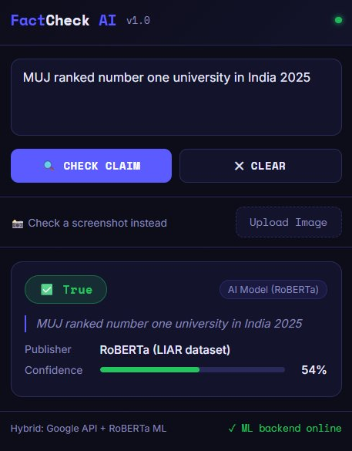
Figure 2: ML Model result for 'MUJ ranked number one university in India 2025' - classified as True with 54% confidence by RoBERTa
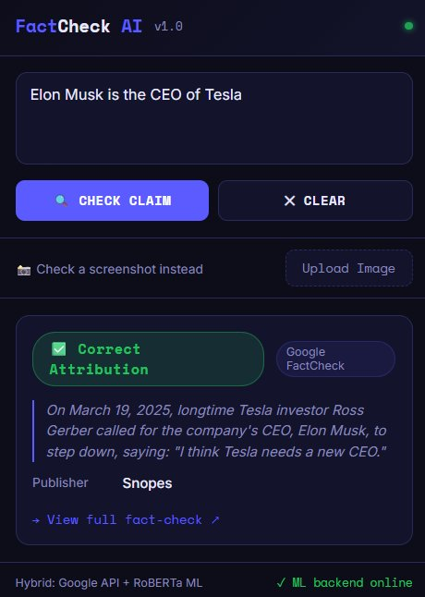
Figure 3: Google FactCheck result for 'Elon Musk is the CEO of Tesla' - sourced from Snopes with 'Correct Attribution' rating
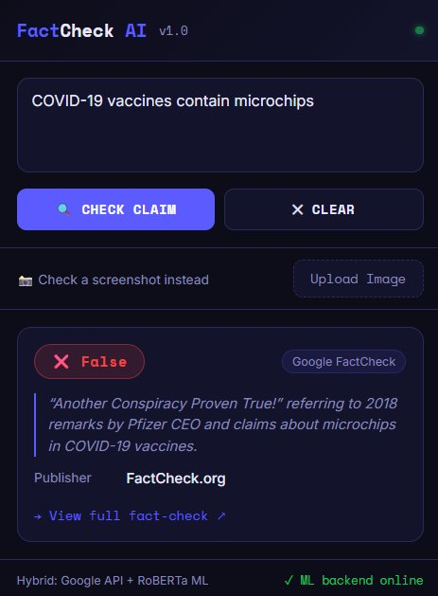
Figure 4: Google FactCheck result for 'COVID-19 vaccines contain microchips' - classified as False by FactCheck.org

5. RESULTS AND DISCUSSION
This chapter presents the results obtained from testing the FactCheck AI extension across a range of claim types, and discusses the performance characteristics of each pipeline stage.
5.1 Google FactCheck API Performance
The Google FactCheck API demonstrated high accuracy for claims that have been reviewed by established fact-checking organisations. Viral misinformation claims such as '5G towers spread coronavirus', 'COVID-19 vaccines contain microchips', and 'The Great Wall of China is visible from space' were correctly identified and returned with accurate verdicts from publishers including FactCheck.org, Snopes, and AFP Fact Check. The relevance filter successfully prevented the unrelated CIA whistleblower article from being returned for the query 'Osama bin Laden is dead', directing it to the ML fallback instead.
5.2 ML Model Performance
The RoBERTa model was evaluated on the LIAR test set and achieved an overall accuracy of 44.1% and a macro F1 score of 0.43. Performance varied across classes, with the True and False classes achieving higher precision than the Mixed class, which is expected given the inherent ambiguity of the Mixed label.
In real-world testing, the model correctly classified several well-known claims with confidence scores above 50%, including 'MUJ ranked number one university in India 2025' (True, 54%). The model correctly defaulted to Uncertain for genuinely ambiguous or niche claims, which is the intended behaviour for a fallback classifier.
The 35% confidence threshold (lowered from the default 50%) proved effective in reducing the rate of Uncertain outputs without significantly increasing misclassification, as the model's probability distributions tend to be spread across classes for novel claims.
5.3 System Robustness
The extension demonstrated robust behaviour across pipeline failure scenarios. When the Google API key was absent, the system correctly fell back to the ML model. When the ML backend was offline, the status indicator displayed '✗ ML backend offline' and the system attempted Wikipedia context retrieval. The input validation layer successfully intercepted pasted article paragraphs and questions, prompting users to enter proper claim statements.
5.4 Limitations
The primary limitation of the current system is the modest accuracy of the ML model, which is constrained by the difficulty of the LIAR dataset and the limited training size of approximately 3,000 samples. Additionally, the Google API occasionally returns loosely-related claims even with the relevance filter, particularly for claims that share keywords with well-documented unrelated topics. The system is currently limited to English-language claims.

6. CONCLUSION AND FUTURE WORK
This project successfully designed and implemented a hybrid fact-checking browser extension that combines the accuracy of curated fact-check databases with the flexibility of machine learning to address a practical and socially significant problem. The three-stage pipeline, consisting of the Google FactCheck API, a fine-tuned RoBERTa model, and a Wikipedia context layer, provides a graceful degradation strategy that ensures the user always receives some form of useful information regardless of whether the claim is indexed in any database.
The extension is functional, installable, and tested on real-world claims across multiple domains including politics, health, and technology. The inclusion of OCR, right-click context menus, and a floating selection badge makes it accessible without disrupting normal browsing behaviour.
The project demonstrates that a college-level team can build a meaningful NLP application by effectively combining open APIs, transfer learning, and browser extension technologies, without requiring large-scale computing resources.
6.1 Future Work
- Train the RoBERTa model on a larger and more diverse dataset, potentially combining LIAR with FakeNewsNet and FEVER, to improve accuracy beyond 44%.
- Integrate the ClaimBuster API as a pre-filter to score check-worthiness before querying downstream sources, reducing unnecessary API calls.
- Add multi-language support using multilingual transformer models (mBERT or XLM-R) to extend the extension to non-English claims.
- Package the ML backend as a standalone executable using PyInstaller so users do not need to manually start the server.
- Explore converting the RoBERTa model to ONNX format for in-browser inference, eliminating the dependency on a local server entirely.
- Add a user feedback mechanism to collect labels for incorrect predictions, enabling continuous learning from real-world usage.

7. CONTRIBUTIONS
The project was developed collaboratively by both team members. The specific contributions of each member are outlined below.

Devansh Sharma (23FE01CII00141)
- Design and implementation of the Chrome extension architecture (Manifest V3).
- Development of background.js including the full three-stage verification pipeline and relevance filtering logic.
- Integration of the Google FactCheck Tools API and Wikipedia API.
- Implementation of the popup UI (popup.html and popup.js) including verdict display, confidence bar, and source tagging.
- Development of the floating selection badge and right-click context menu in content.js.
- Input validation layer design and implementation.

Dhairya Prabhakar (23FE10CII00100)
- Data preprocessing and label simplification for the LIAR dataset.
- Fine-tuning of the RoBERTa model on Kaggle GPU environment.
- Development of the FastAPI backend server (app.py) with CORS configuration.
- Model evaluation, threshold tuning, and confidence score calibration.
- Integration of Tesseract.js for OCR functionality.
- Testing and debugging across all pipeline stages.

8. BIBLIOGRAPHY
[1] Wang, W. Y. (2017). "Liar, Liar Pants on Fire": A New Benchmark Dataset for Fake News Detection. Proceedings of the 55th Annual Meeting of the Association for Computational Linguistics (ACL), 422-426.
[2] Liu, Y., Ott, M., Goyal, N., Du, J., Joshi, M., Chen, D., ... & Stoyanov, V. (2019). RoBERTa: A Robustly Optimized BERT Pretraining Approach. arXiv preprint arXiv:1907.11692.
[3] Devlin, J., Chang, M. W., Lee, K., & Toutanova, K. (2018). BERT: Pre-training of Deep Bidirectional Transformers for Language Understanding. arXiv preprint arXiv:1810.04805.
[4] Thorne, J., Vlachos, A., Cocarascu, O., Christodoulopoulos, C., & Mittal, A. (2018). The Fact Extraction and VERification (FEVER) Shared Task. Proceedings of the First Workshop on Fact Extraction and VERification (FEVER).
[5] Hassan, N., Arslan, F., Li, C., & Tremayne, M. (2017). Toward Automated Fact-Checking: Detecting Check-worthy Factual Claims by ClaimBuster. Proceedings of the 23rd ACM SIGKDD International Conference on Knowledge Discovery and Data Mining.
[6] Google Developers. (2024). Fact Check Tools API Reference. Retrieved from https://developers.google.com/fact-check/tools/api/reference/rest
[7] Hugging Face. (2024). Transformers: State-of-the-art Machine Learning for Pytorch, TensorFlow, and JAX. Retrieved from https://huggingface.co/docs/transformers
[8] Mozilla Developer Network. (2024). Chrome Extensions - Manifest V3. Retrieved from https://developer.chrome.com/docs/extensions/mv3/
[9] Tesseract.js. (2024). Pure Javascript OCR for 100 Languages. Retrieved from https://tesseract.projectnaptha.com/
[10] FastAPI. (2024). FastAPI Framework, High Performance, Easy to Learn. Retrieved from https://fastapi.tiangolo.com/
[11] Reuters Institute. (2023). Digital News Report 2023. Reuters Institute for the Study of Journalism, University of Oxford.

