Jane Lee

PUI Section D

TA Amber Horvath

10/11/2020

Live site: https://janeglee.github.io/homework_5/

Repository link: https://github.com/janeglee/homework_5.git

Assignment 5 – Web HTML and CSS Prototypes

The three user interface bugs found in my heuristic evaluation were font family availability, image sizes, and the home screen logo transitioning too quickly. The font I had used in my Figma prototyped was “Abel,” which is not a common font and may not show up properly on customers’ devices that do not have that font package installed. I chose to go with “arial narrow” on my website as it is a standard font that most, if not all, systems can detect and properly display. I ensured that the image sizes were smaller so that they are not the cause of having to scroll on the screen and so that they load faster. I received a comment on my prototype of the home screen logo transitioning too quickly to the menu and that customers may not catch it at first. I removed the transition and enabled a “click” action so that customers can see and appreciate the logo on the home screen, and then they can click on the logo to be directed to the menu.

One challenge I found was the actual implementation of my HTML and CSS knowledge. Although I had completed the “Codecademy” online courses, when it came to doing everything on my own from scratch, I was lost and frustrated. However, once I started to put things together, it was a fun and rewarding experience.

Another big challenge I encountered was applying styles to certain sections. I had wanted to apply the rounded corners to the images in the menu only, but it was applied to all images, including the logo in the navigation bar and the image in the product detail page. I thought it would be as simple as creating classes for the different images, but it created more issues and changed the layout because the same style I wanted across the website was now applied to only one class. I applied the style I wanted for each class, and it was fixed.

Finally, another challenge I encountered that seemed easy to fix was in fact not so easy to fix. I could not get the text to align side by the side with the images on the product detail page. I tried playing around with “align-content,” “align-items,” and different spacings, but there was no visible change. I finally figured out that I had to make use of the “flush” style and I also had to organize the text in such a way that they all were nested under one “div.”

The brand identities that my design choices reflect are aesthetic, minimalist, and accessible. The buttons on the website each have a purpose and are not redundant. There is only enough content and wording as needed to get the point across. The website is easily accessible to many customers – even the ones who are not so tech-savvy. Each button is clearly labeled, there is “alt” text on each image for customers who cannot see the pictures or are using accessibility tools, and the process of ordering is straightforward and clear.

Home Logo that transitions too fast to the menu page.

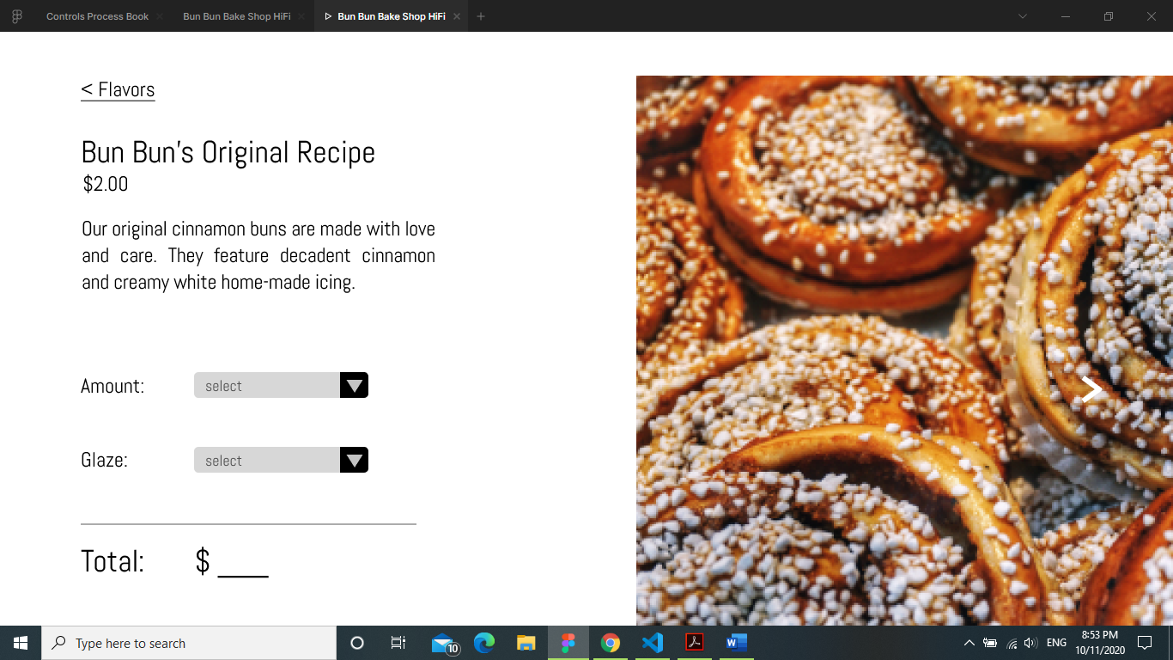

Font is “Abel.” Picture is overflowing and too big for the screen.

**Resources:**

**http://www.w3schools.com**