**What are three conclusions we can make about Kickstarter campaigns given the provided data?**

Conclusion 1 : Considering the ratio of “successful” and “failed”, Music category seems to have the highest ratio of the likelihood to succeed.

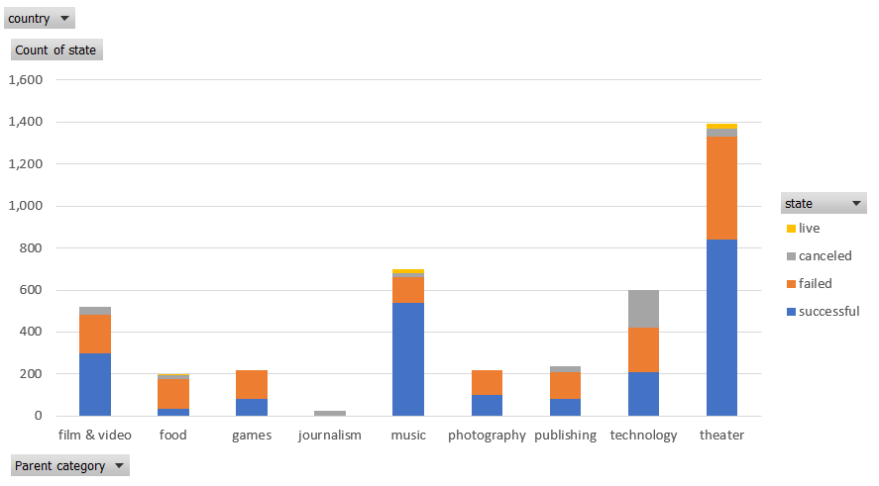

Conclusion 2 : The highest number of projects (as wells as number of successful and failed) falls under sub-category “plays”.

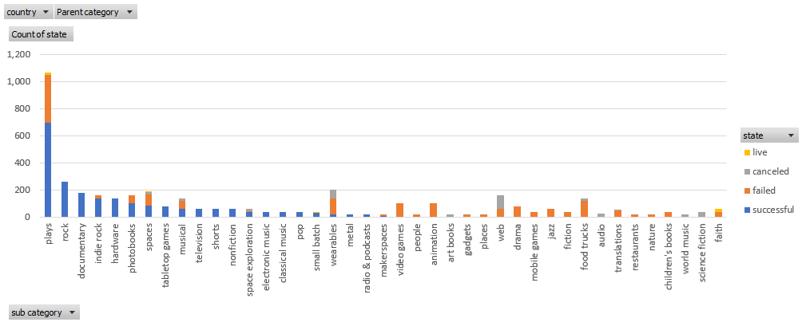

Conclusion 3 : December (holiday season) is the time where projects are least likely to be successful.

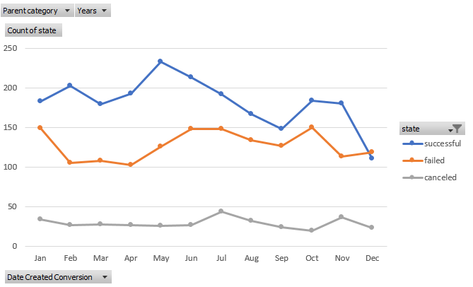

**What are some of the limitations of this dataset?**

From this dataset, it is difficult to find out the length of each project.

**What are some other possible tables/graphs that we could create?**

By looking at the distribution of country, we can see most number of projects are from USA, then next highest number is from UK.

