User Manual for Janelia Ethoscope

Author: Salma Elmalaki

Original User Manual is by  [Gilestro lab](https://lab.gilest.ro/" \t "_blank)

https://qgeissmann.gitbooks.io/ethoscope-manual/using-ethoscopes/starting-your-first-experiment.html

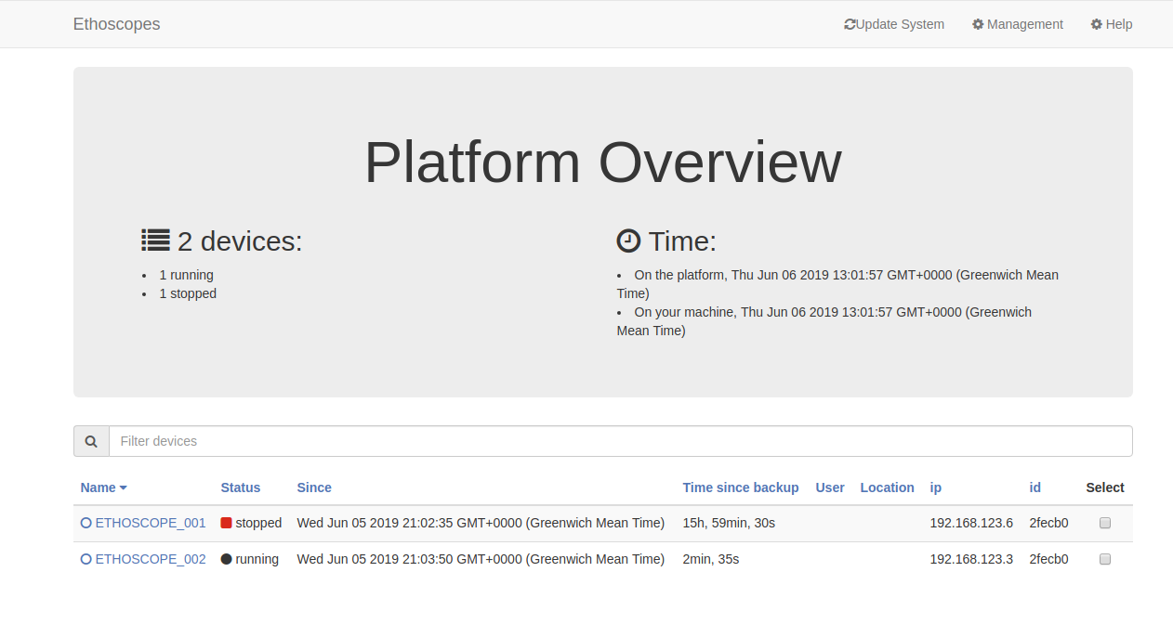  
Ethoscope main page

Use Google Chrome

Use <http://0.0.0.0:8000> to connect to the Ethoscope server

The available devices will be listed, click on the required device to set its testing parameters

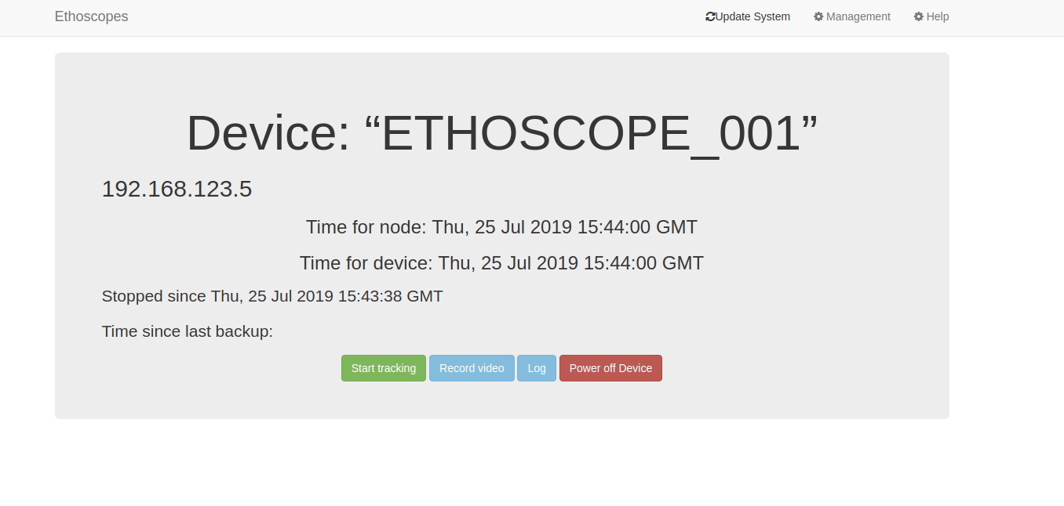

A new tab will be opened when you click on one of the devices

Press “Start tracking”

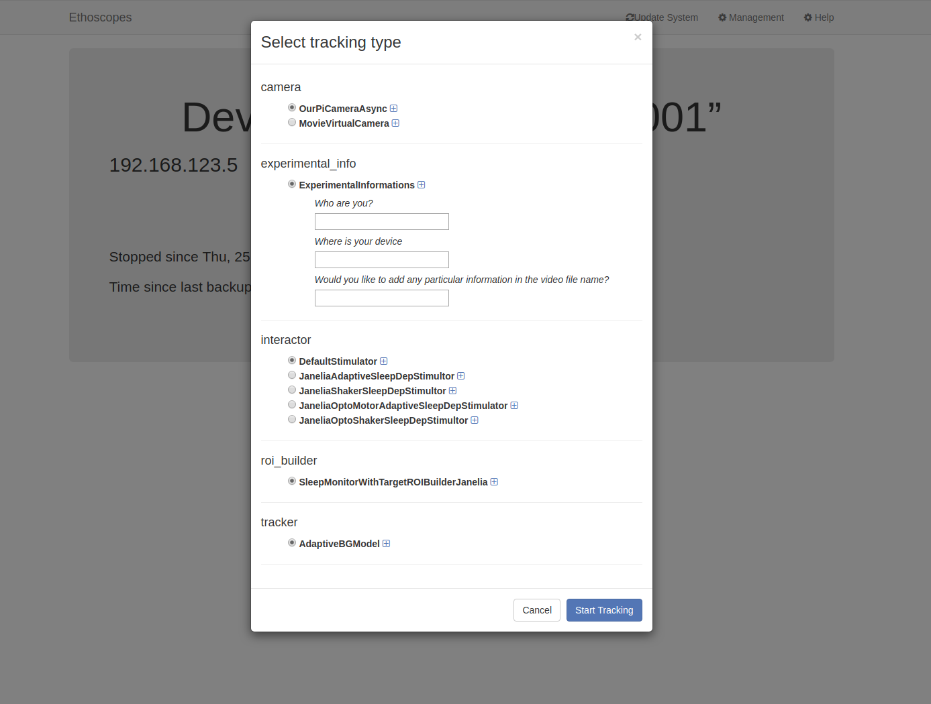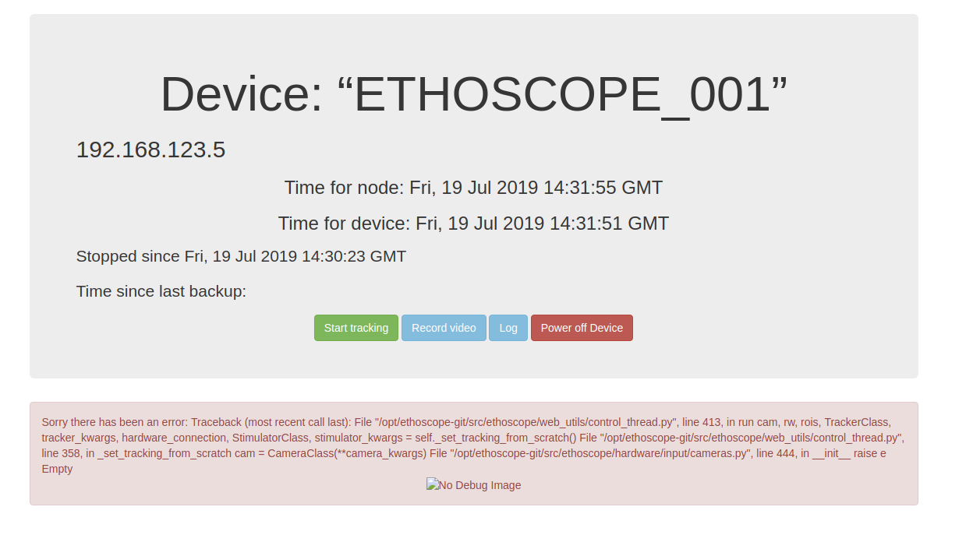

Choose the interactor

1. Default Stimulator: No stimulation is applied, just tracking.
2. JaneliaAdaptiveSleepDepStimulator:

Moto-stimulus is applied in an adaptive way, no opto stimulus

1. JaneliaShakerSleepDepStimulator:

Moto-stimulus as an oscillation of the tube, no opto stimulus, not adaptive

1. JaneliaOptoMotorAdaptiveSleepDepStimulator:

Same as JaneliaAdaptiveSleepDepStimulator but with opto-stimulus

1. JaneliaOptoShakerSleepDepStimulator:

Same as JaneliaShakerSleepDepStimulator but with opto-stimulus

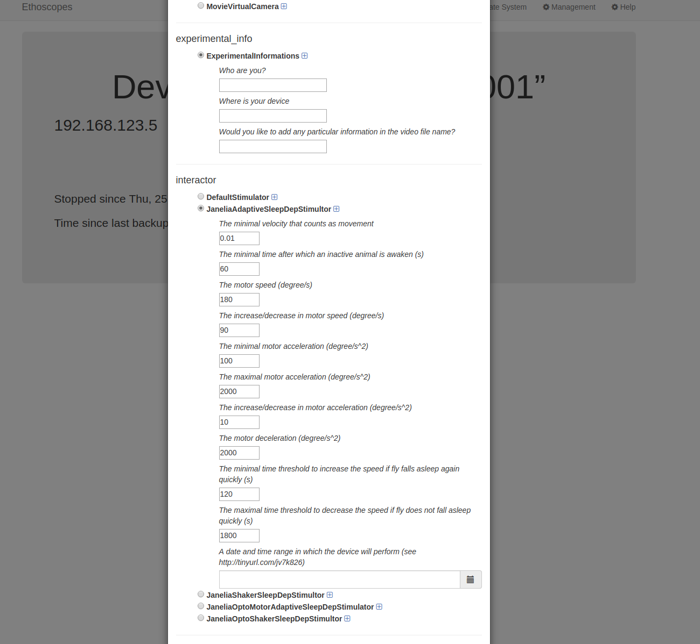

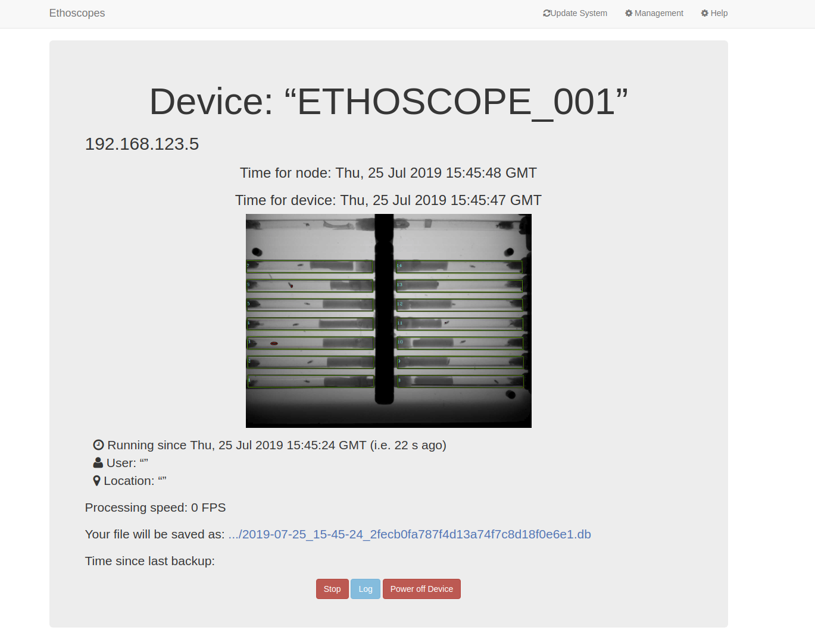

Select the parameters

The parameters are loaded with default values as shown in the figure.

You can also specify the date and time range for which the stimulus will be applied. By default (empty), the stimulus will be applied as soon as the experiment starts.

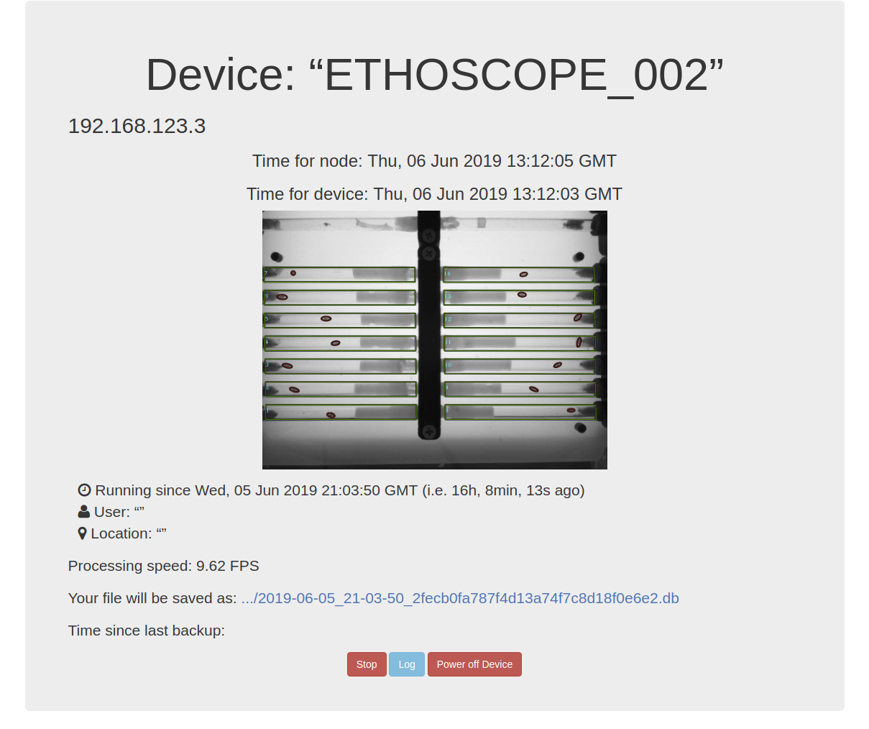

Tracking page

The tracking information is opened for the specified device.

The tracking information is saved in /ethoscope\_results/ but you can directly downloaded it from this page by clicking on it (the file is available after 5 min from the start of the experiment)

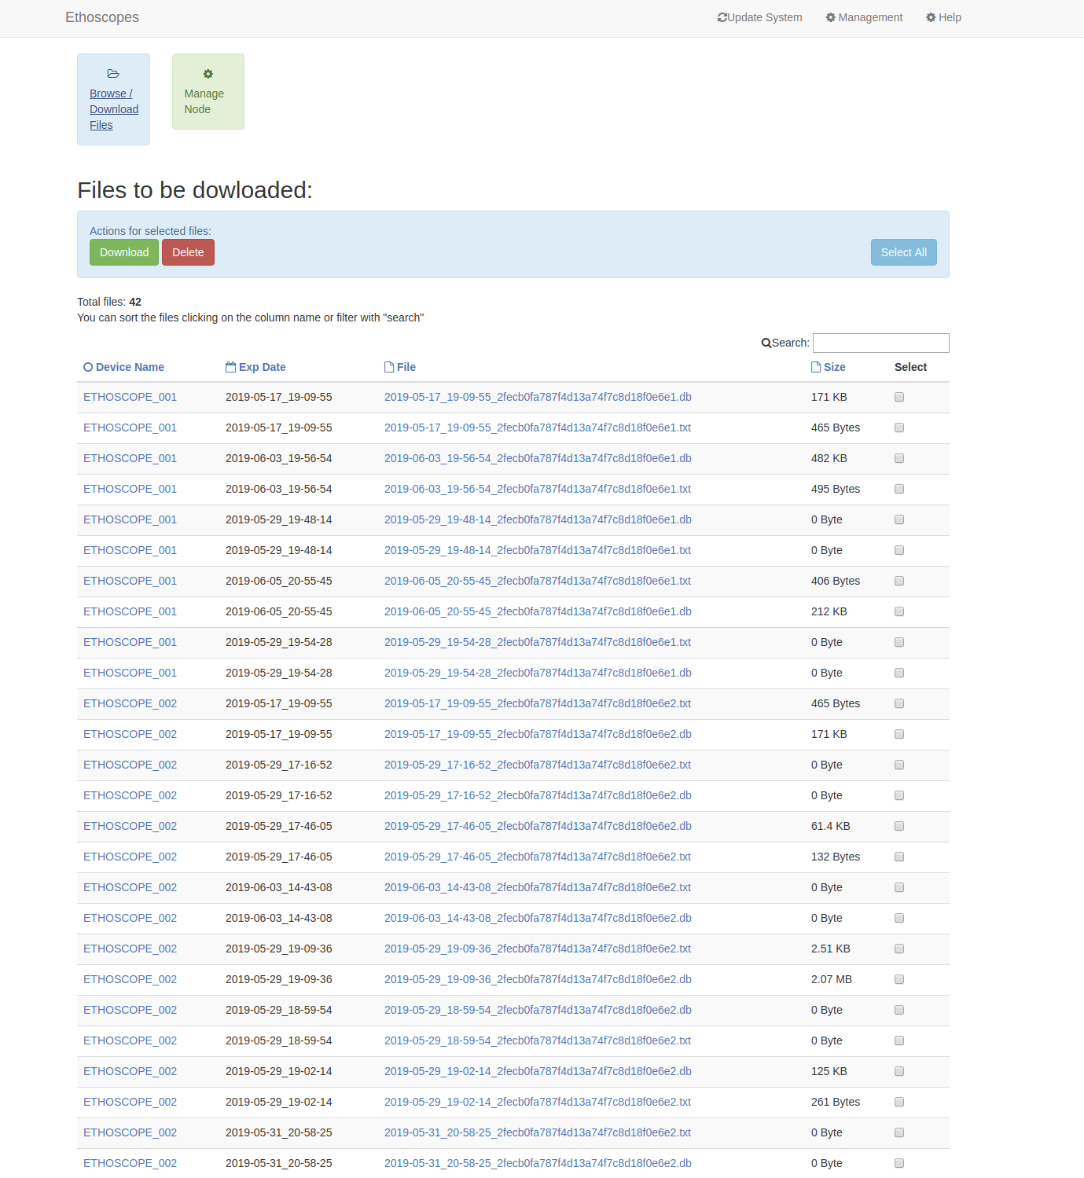

Management page

Click the Management tab and you can have access to all the databases collected by the server over several experiments and for multiple devices.

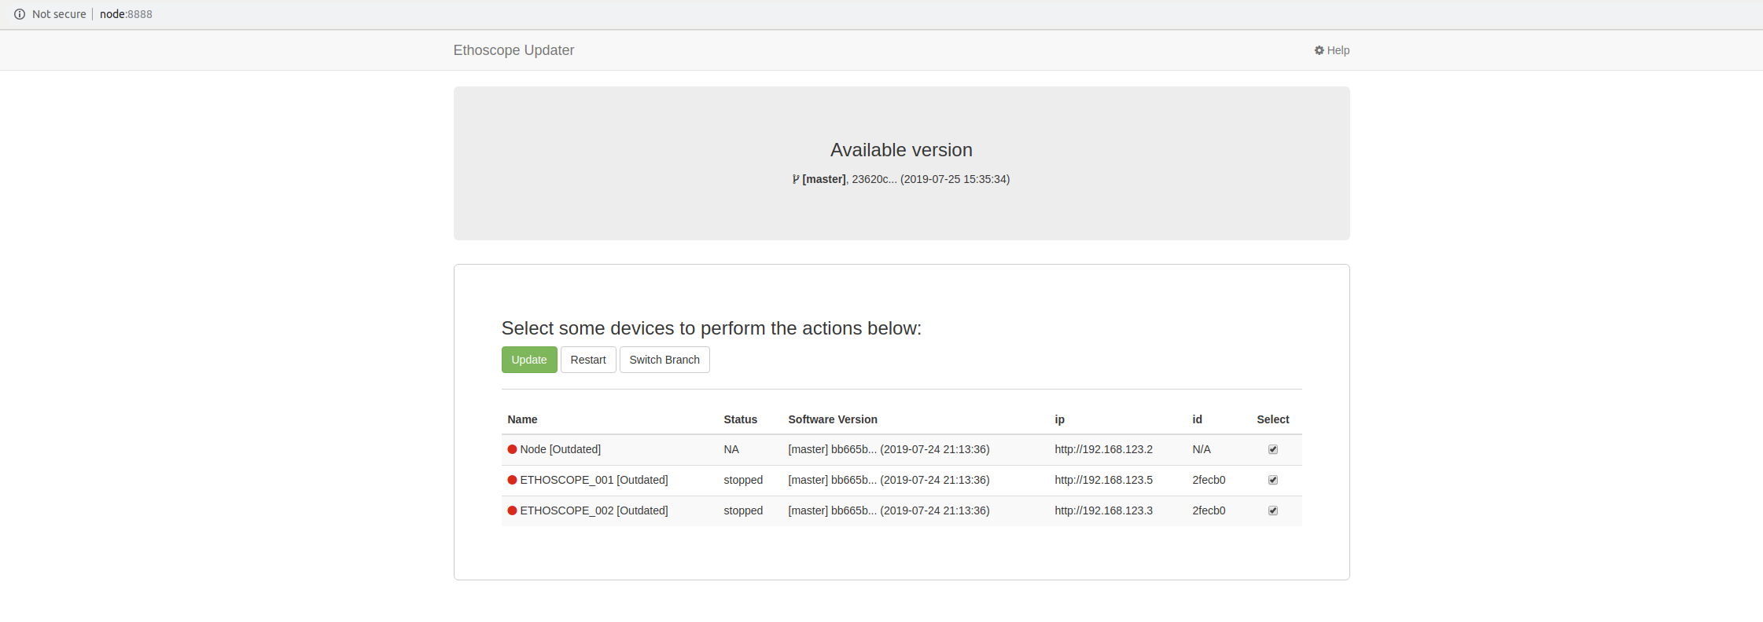

Update page

Select the Update System tab and you can update the server (node), and the devices with the github code if there are any changes in master repo.

The red circle beside the device indicates that it needs to be updated with the latest repo version.

If it is updated, the circle will be green.

To update the devices, they should not be running (no active tracking) is taking place while you do the update. You will receive an update error if you attempt to update a running device.

You may need to refresh the update page to see the new changes. Depending on the network connectivity and the network card used, the time taken to see the changes on the update page is around 1 to 4 minutes.

Troubleshooting

# To restart the server:

On the terminal:

sudo systemctl restart ethoscope\_node.service

sudo systemctl restart ethoscope\_update\_node.service

sudo systemctl restart ethoscope\_backup.service

# To restart any device:

On the terminal:

ssh [pi@192.168.123.3](mailto:pi@192.168.123.3) (or whatever ip of the device you want to restart)

Pass: e001@hhmi

Sudo systemctl restart ethoscope\_device.service

Sudo systemctl restart ethoscope\_update.service

To view the service log messages, for example, “ethoscope\_node.service”

sudo journalctl -u ethoscope\_node.service -e 🡪 on the server machine

# Dead flies:

If the fly is dead, the stimulator will run trying to wake it up. However, there will be no data of this interaction of the stimulus in the resulting database. The database keeps the position by tracking the fly. However, if this tracking information is lost (fly is dead), there will be no record of the fly and hence, no record of this stimulus.

The stimulus is only recorded when the fly is spotted (not dead)

Adaptive Stimulus

The following figure describes how to set the parameters in the adaptive stimulus.

The acceleration parameters are also set the same way.

