NeuTu (v0.9)

Introduction

NeuTu is open source software for reconstructing neurons from light microscope images. The current version is built specifically for bight-field microscopy and optimized for biocytin-stained neurons.

It loads a TIFF image or stack and displays it in a 2D window. If the TIFF file has multiple slices (e.g. 3D image), the user can use mouse or keyboard to scroll through slice by slice to view a certain plane of the image. It also has a 3D visualization function of displaying a neuron represented by a tree structure, which is often saved in an SWC format. NeuTu can load an SWC file directly and show it in a 3D visualization window.

The main function of NeuTu is to generate a neuron structure from a TIFF image with user interaction, which mainly consists of mouse clicks. There is a major automated step during reconstruction to convert a 2D mask into a 3D neuron structure. But the automated reconstruction is not error-free, so the user needs to correct the errors by manual editing.

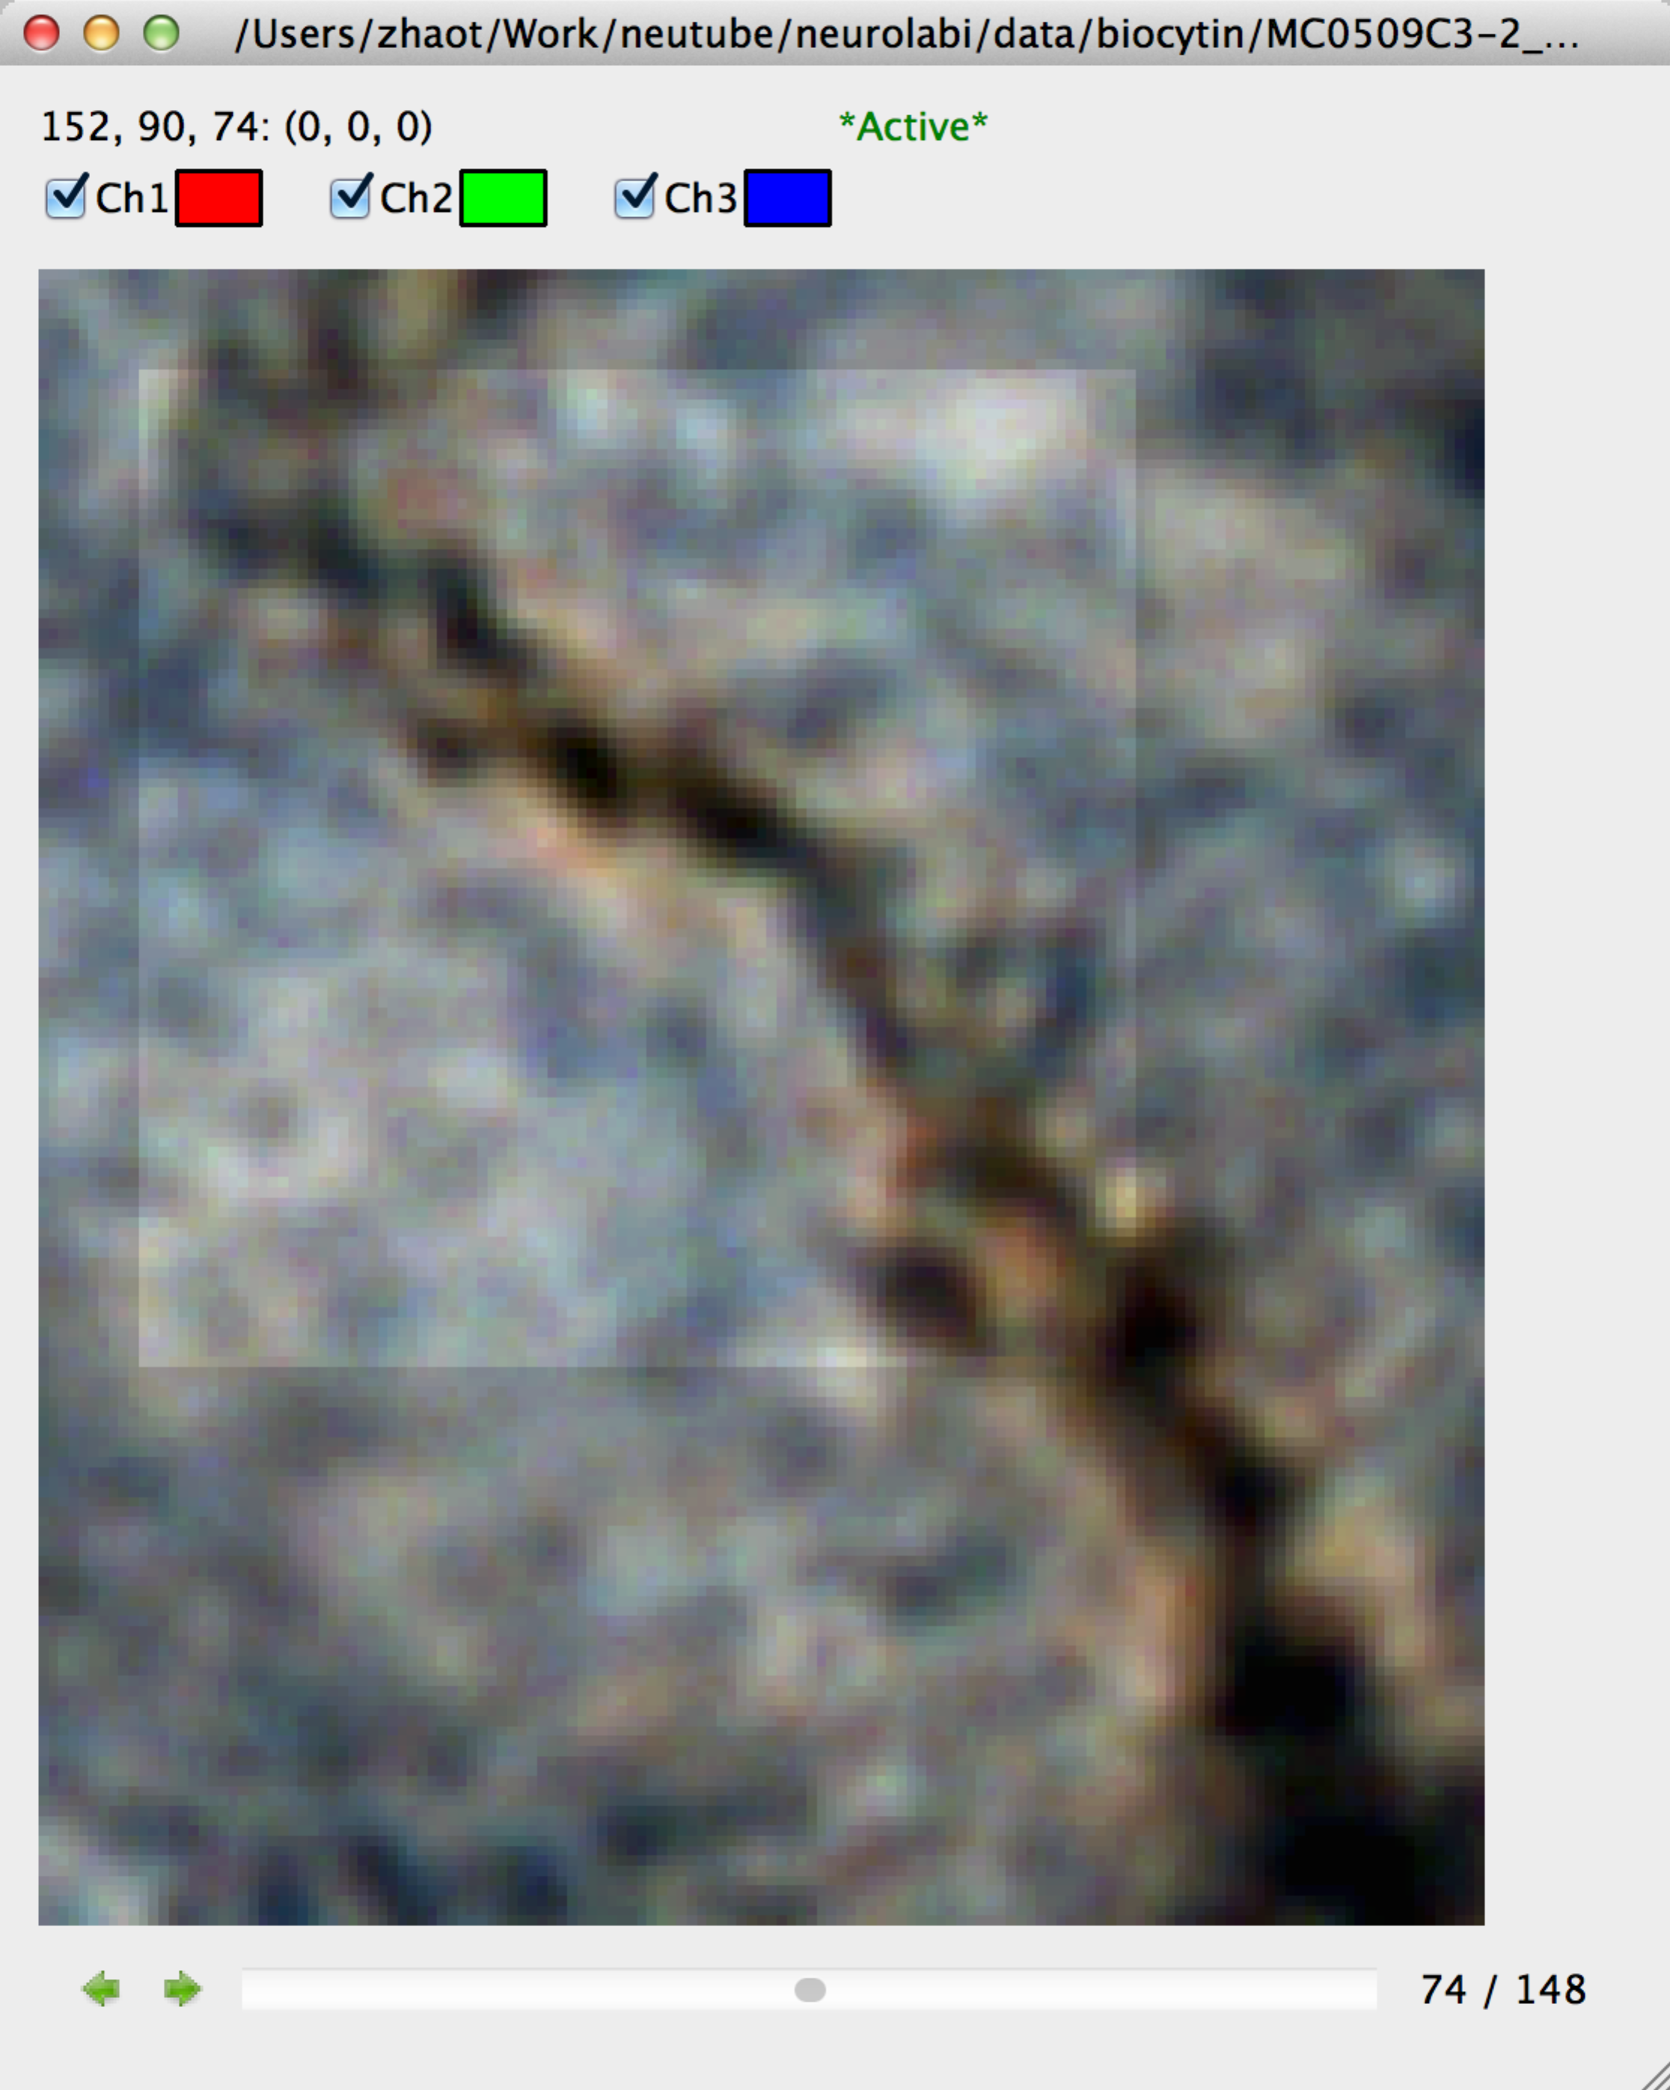

A screenshot of the main window

Reconstruct a neuron in NeuTu

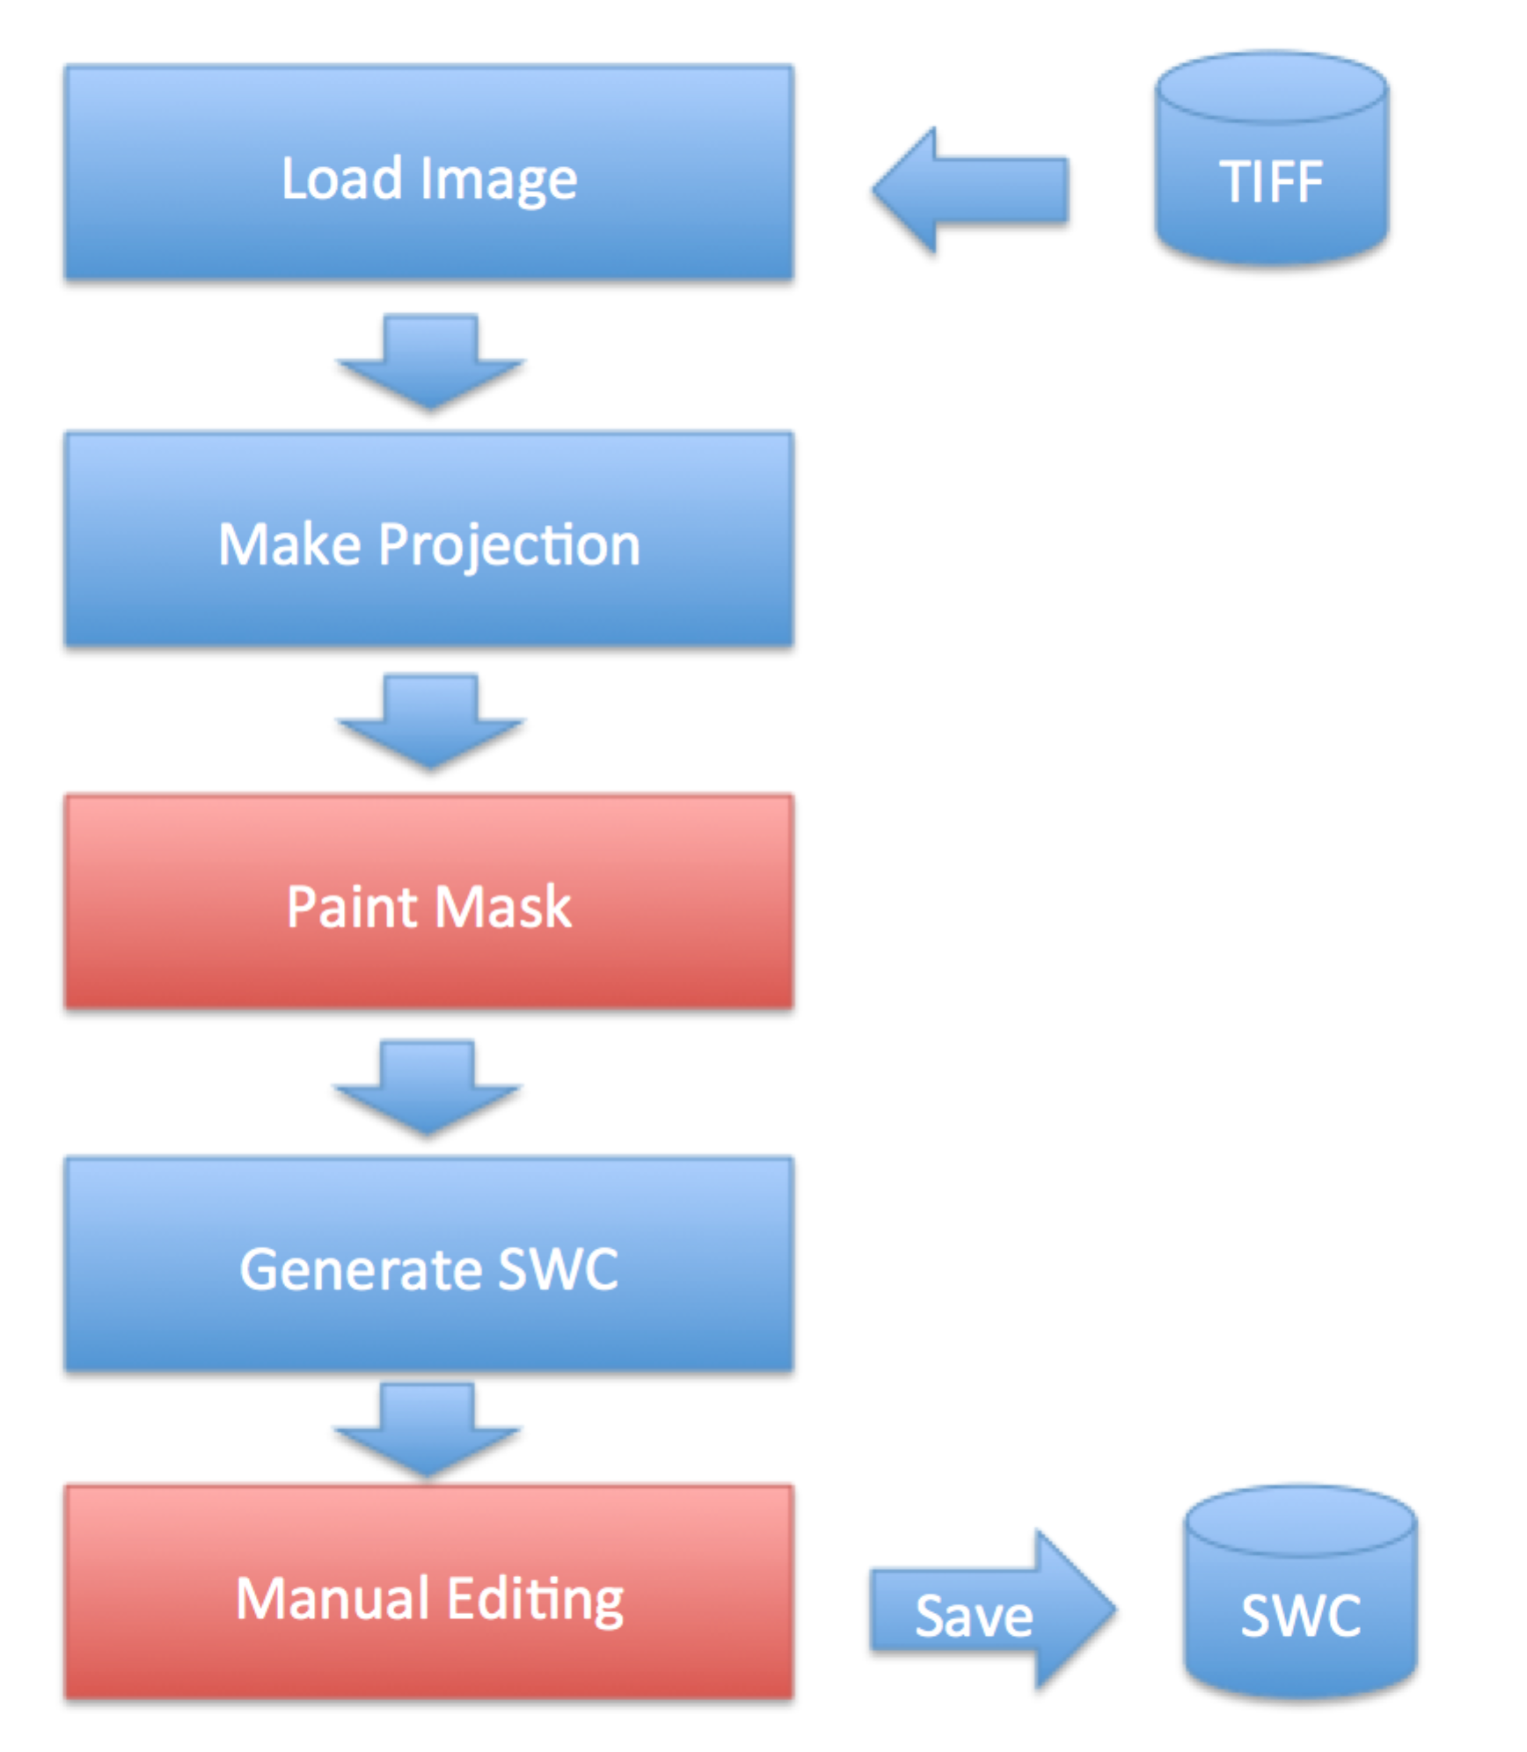

Menu

File

File > Open…

Open a file, which can be a TIFF or an SWC file.

File > Import > Image Sequence

Import a sequence of images. When a TIFF file is selected, the program will analyze the pattern of the file name and extract the base name and ending number. All TIFF files with the same base name will be loaded after being sorted in the ascending order of the ending number.

File > Expand Current >
File > Expand Current > SWC
Add an SWC file to the current document.

File > Expand Current > Mask
Add a mask to the current document.

------------------------------
File > Save Image/Stack
Save the current image/stack as a TIFF file.

File > Export > Mask
Export the current mask as a TIFF file.

Edit

Edit > Undo/Redo

NeuTu supports unlimited Undo/Redo operation.

View
View > Normal
Set the view mode to normal, which shows the current 3D image slice by slice.

View > Z Project
Show the image as the maximum intensity of its Z-projection.

View > 3D View
Show 3D visualization of the data.

View > 3D View w/o Volume
Show 3D visualization of the data without volume rendering, i.e. it does not show any image data.

View > Adjust > Brightness/Contrast
Activate the dialog of adjusting brightness and contrast of the current image. The adjustment applies to all slices.

View > Object Mode
Set the object view mode, which is for SWC only in the current version.

View > Object Mode > Dense
Show objects in the dense mode, which to show most details.

View > Object Mode > Sparse
Show objects in the sparse mode. It displays only key nodes for an SWC object.

View > Object Mode > Skeleton
Show objects in the skeleton mode. Only the skeletons are shown if they are available.

View > Autosaved
Show all files saved automatically. This is to recover reconstruction after crash.

View > Information
Show information of the current document.

Tools

Tools > Process
Tools > Process > Extract Channel
Extract a channel from a multi-channel image.

Tools > Process > Invert
Invert the color of the current image.

Tools > Process > Make Projection
Make Z-projection for mask painting.

Tools > Trace > Mask→SWC
Convert mask into a SWC structure. The 3D visualization window will be shown automatically after the conversion.

Tools > Manage Objects
Show the list of objects in the current document.

Mask Painting

Right click on the projection image to pop up the context menu for painting
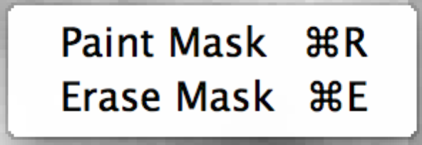

Short cut:

Turn on painting: Ctrl (Cmd) + R
Turn on erasing: Ctrl (Cmd) + E

Turn off: right click or Esc

SWC Editing:

Left mouse click to select a node

Ctrl/Shift mouse click to select multiple nodes

Right mouse click to bring up the context Menu:

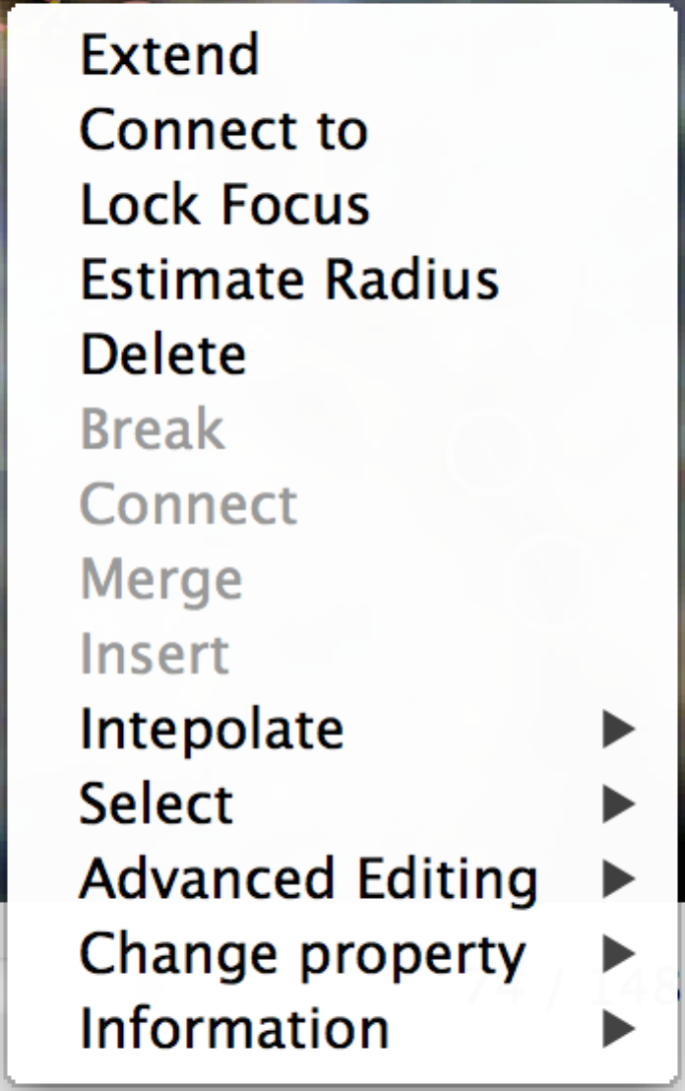

Extend

Extend a node by following image signal

Connect to

Connect the selected node to the target node

Lock Focus

Lock the focus point of selected nodes to adjust their Z positions

Estimate Radius

Automatically estimate the radii of the selected nodes

Delete

Delete the selected nodes

Break

Break the links among selected nodes. Nothing is done if no nodes in the selection are connected directly.

Connect

Connect the selected based on their distances.

Merge

Merge the selected nodes into one node.

Insert

Insert a node between two connected nodes.

Select

Select > Downstream
Select downstream nodes

Select > Upstream
Select upstream nodes

Select > Neighbors
Select the neighbors of the currently selected nodes

Select > Host branch
Select the branches containing the currently selected nodes

Select > All connected nodes
Select all nodes that belong to the trees containing the currently selected nodes

Select > All nodes
Select all nodes, no matter what

Shortcut keys for SWC Editing

Ctrl+G : Add a SWC node
A: Move node to left
D: Move node to right
S: Move down node
W: Move up node
Q: Make node smaller
E: Make node larger

