Table of Contents
1. Repository Information
1.1. Description
2. Images
3. Schematic
4. Gerbers
5. Bill of Materials
5.1. PCB Parts
5.2. Supplemental Parts
5.3. Vendor Parts Lists
6. Supplemental Documentation
6.1. Assembly Instructions

Repository Information
Name
audio_controller_3x2
Version
1.2
License
Open-Source Hardware
URL
https://github.com/janelia-kicad/audio_controller_3x2
Author
Peter Polidoro
Email
peterpolidoro@gmail.com

Description
This board plays audio through a pcb mounted speaker and/or external stereo speakers.

Images
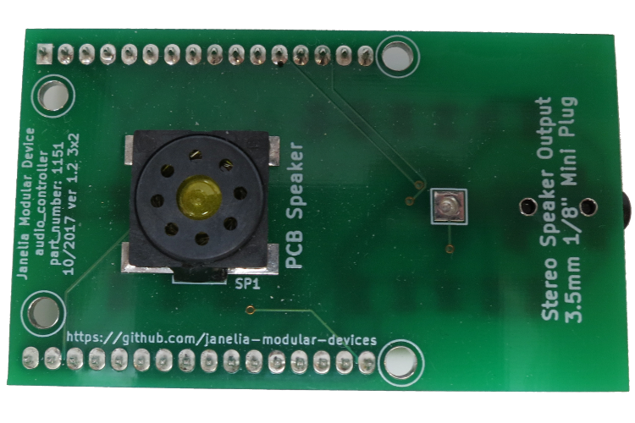
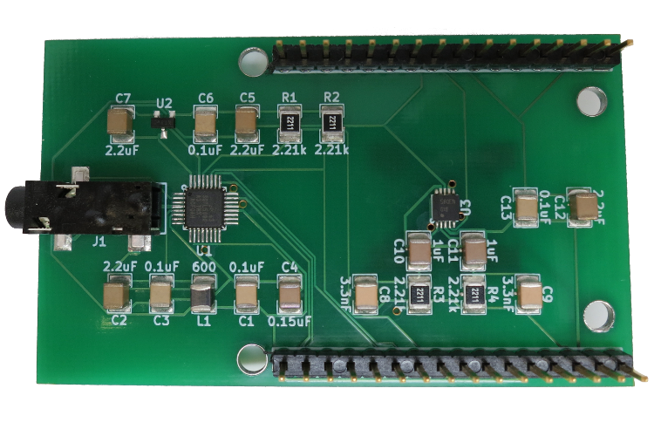

Schematic
./schematic/audio_controller_3x2.pdf
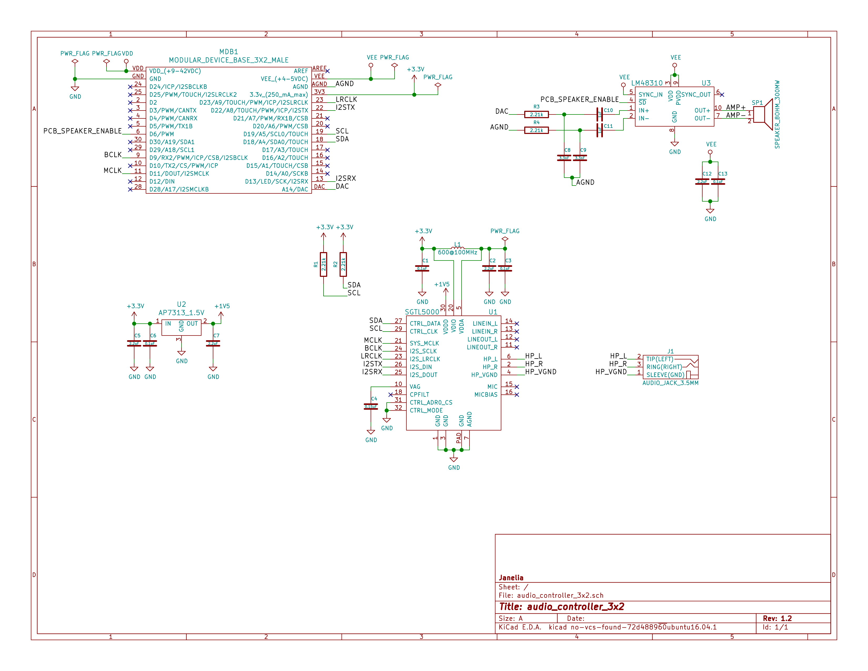

Gerbers
Send gerbers zip file to your favorite PCB manufacturer for fabrication.
./gerbers/audio_controller_3x2_v1.2.zip
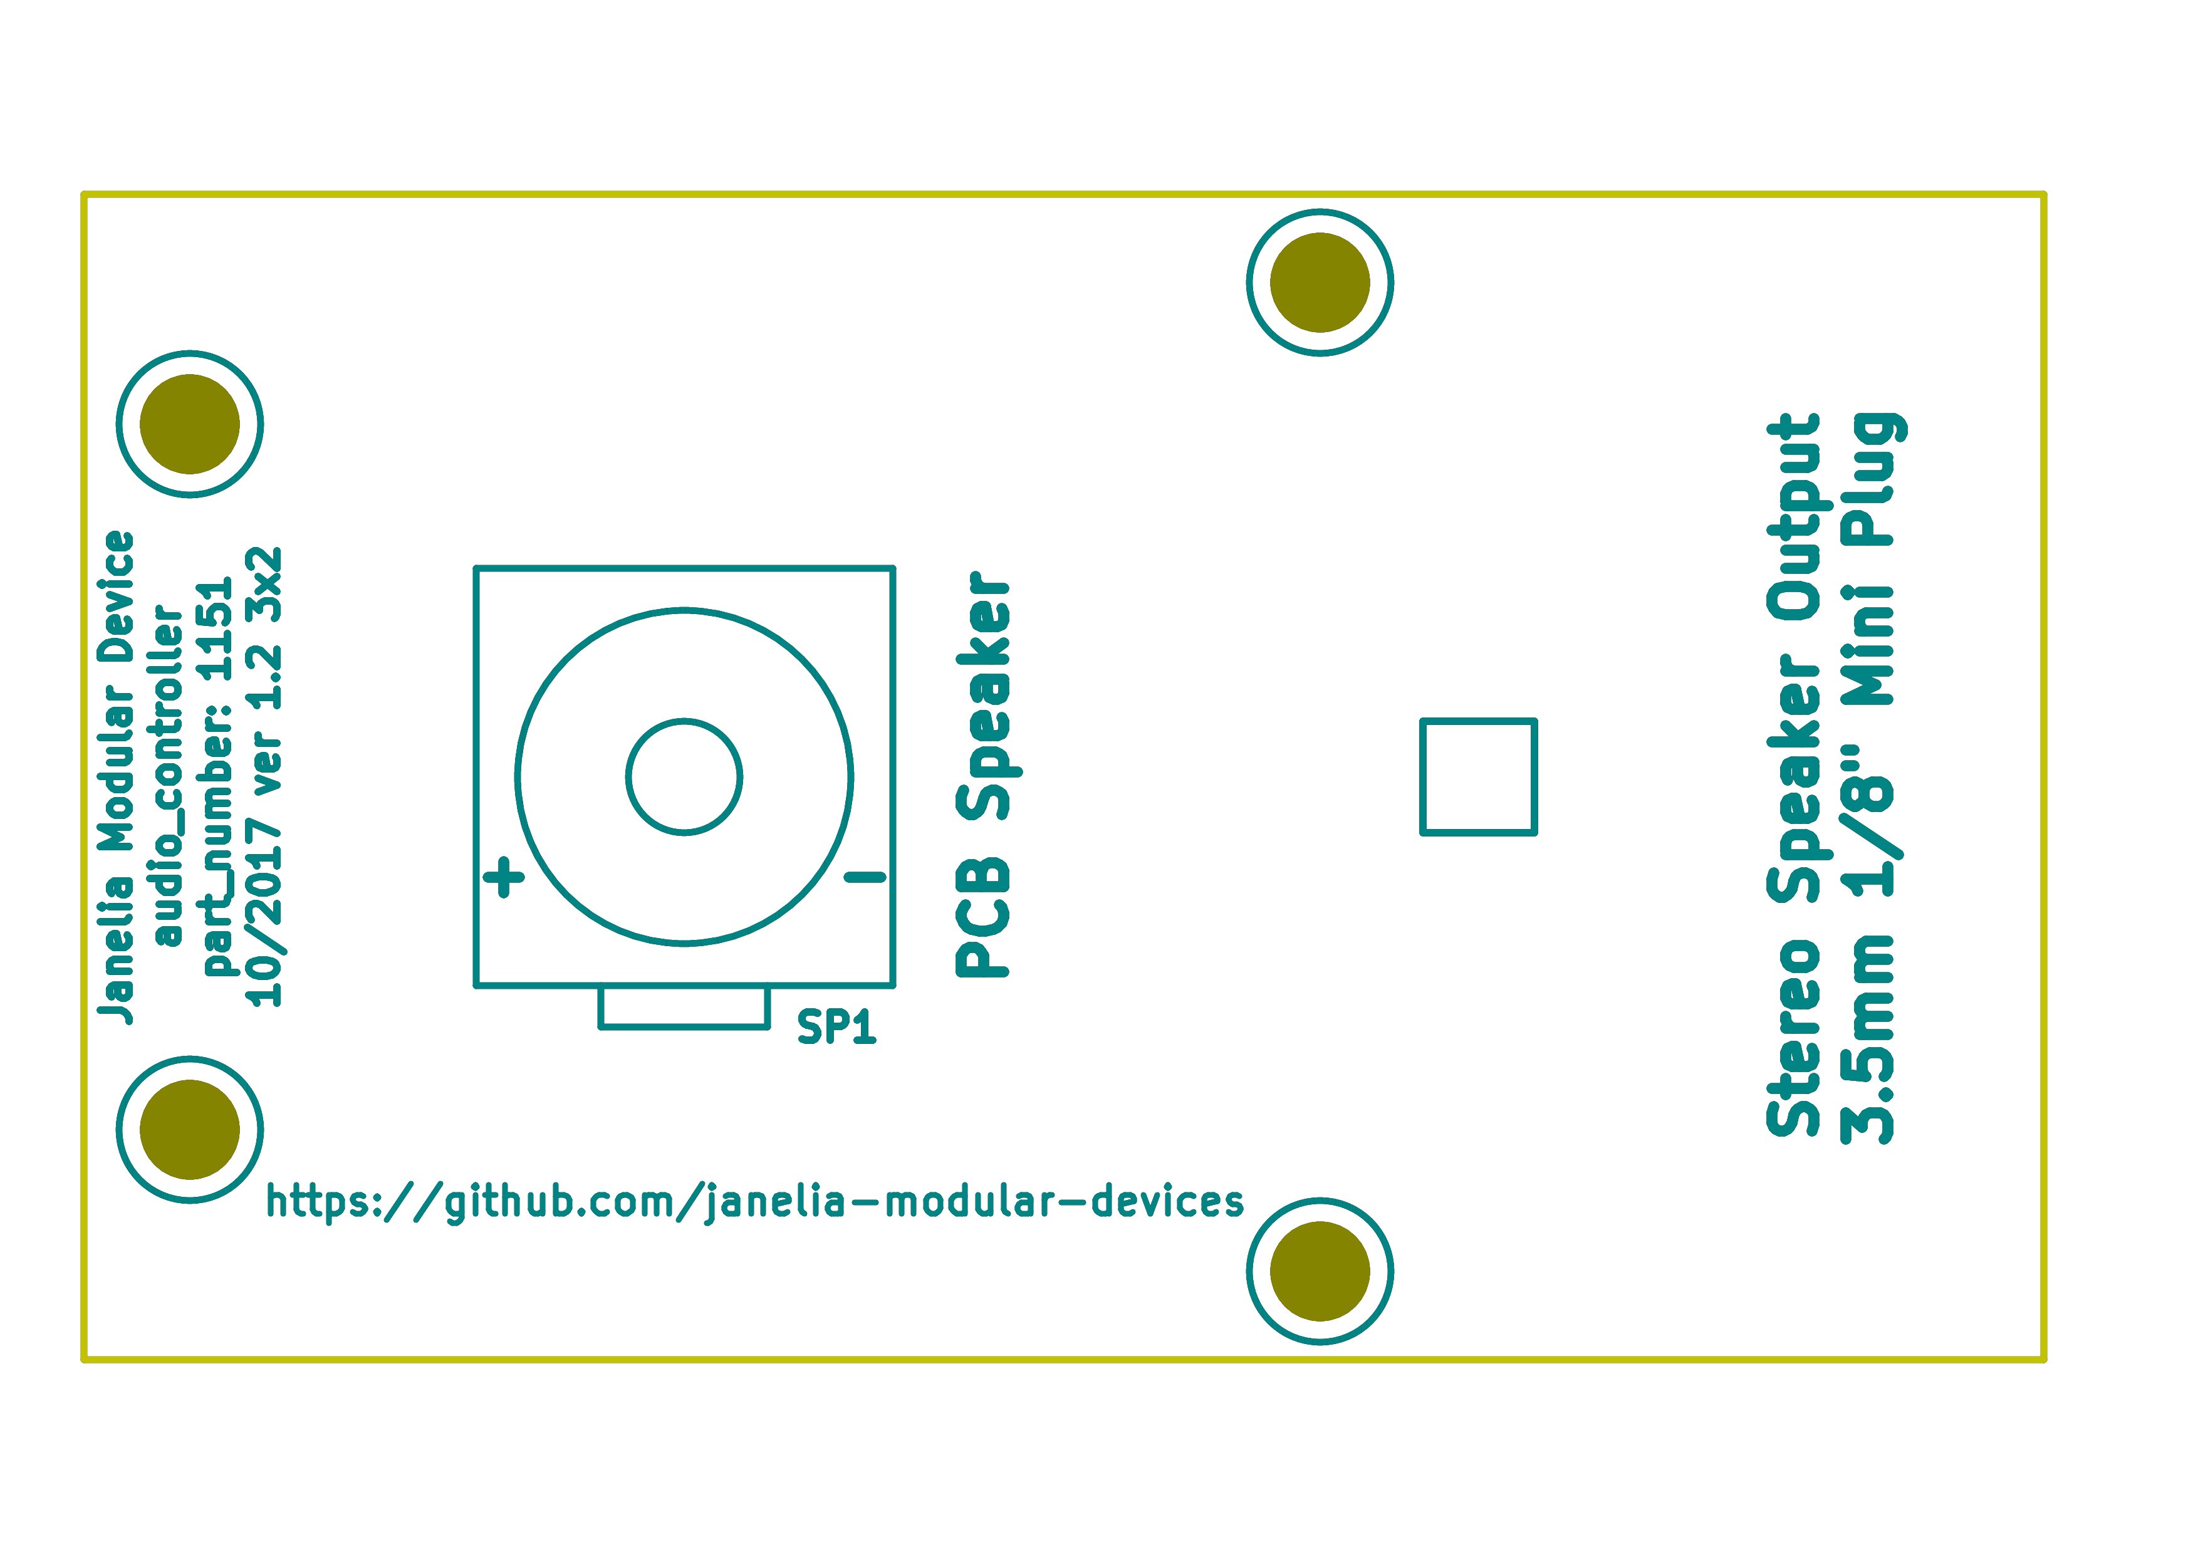
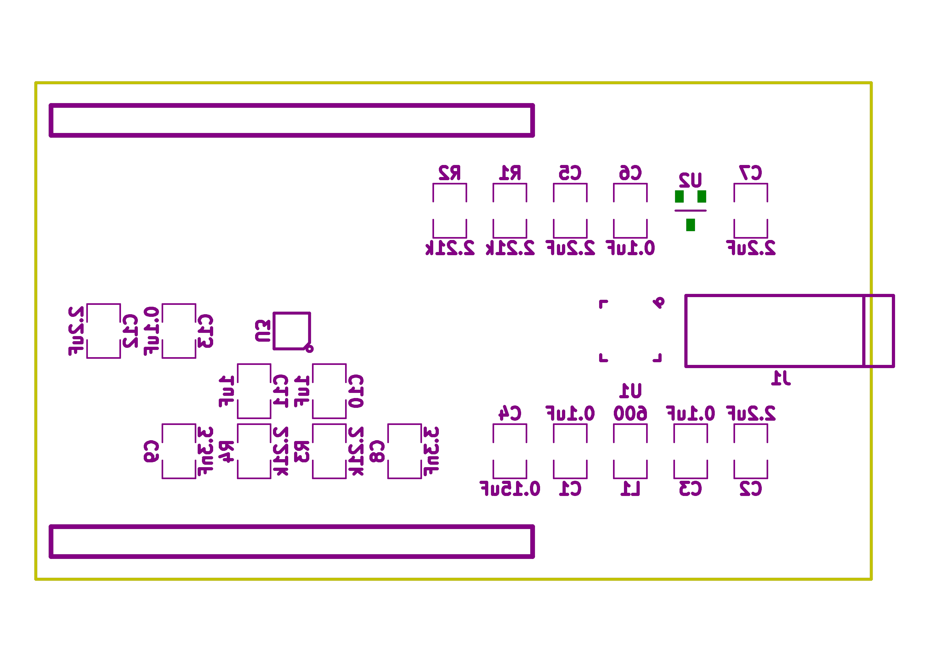

Bill of Materials

PCB Parts
Item | Reference(s) | Quantity | PartNumber | Vendor | Description
1 | C1 C13 C3 C6 | 4 | 399-13229-1-ND | digikey | CAP CER 0.1UF 100V X7R 1210
2 | C10 C11 | 2 | 399-8219-1-ND | digikey | CAP CER 1UF 100V X7R 1210
3 | C12 C2 C5 C7 | 4 | 478-3591-1-ND | digikey | 2.2uF 50V Ceramic Capacitor X7R 1210
4 | C4 | 1 | 399-15599-1-ND | digikey | 0.15uF 100V Ceramic Capacitor X7R 1210
5 | C8 C9 | 2 | 478-5964-1-ND | digikey | CAP CER 3300PF 2KV X7R 1210
6 | J1 | 1 | CP-3523SJCT-ND | digikey | 3.50mm Headphone Phone Jack Stereo Connector Solder
7 | L1 | 1 | 587-1755-1-ND | digikey | FERRITE BEAD 600 OHM 1210 1LN
8 | MDB1 | 2 | S1011E-16-ND | digikey | 16 Position Header Through Hole Male Pins
9 | R1 R2 R3 R4 | 4 | P2.21KAACT-ND | digikey | RES SMD 2.21K OHM 1% 1/2W 1210
10 | SP1 | 1 | 102-3539-1-ND | digikey | SPEAKER 8OHM 300MW TOP PORT 87DB
11 | U1 | 1 | SGTL5000XNAA3R2CT-ND | digikey | Stereo Audio Interface 32-QFN
12 | U2 | 1 | AP7313-15SAG-7DICT-ND | digikey | Linear Voltage Regulator IC Positive Fixed 1 Output 1.5V 150mA SOT-23-3
13 | U3 | 1 | LM48310SD/NOPBCT-ND | digikey | IC AMP AUDIO PWR 2.6W MONO 10SON

Supplemental Parts
Item | Quantity | PartNumber | Vendor | Description
1 | 1 | N82E16836121042 | newegg | Logitech Z130 5W Speakers

Vendor Parts Lists
./bom/digikey_parts.csv
./bom/supplemental_newegg_parts.csv

Supplemental Documentation

Assembly Instructions
- Solder surface mount and through hole components onto the pcb.

