Table of Contents
1. Repository Information
1.1. Description
2. Images
3. Schematic
4. Gerbers
5. Bill of Materials
5.1. PCB Parts
5.2. Supplemental Parts
5.3. Vendor Parts Lists
6. Supplemental Documentation
6.1. Assembly Instructions

Repository Information
Name
modular_device_base_3x2
Version
1.2
License
Open-Source Hardware
URL
https://github.com/janelia-kicad/modular_device_base_3x2
Author
Peter Polidoro
Email
peterpolidoro@gmail.com

Description
This board is the base of 3x2 format modular devices. It is a breakout board for the microprocessor, with connections for power, communication, and top boards.

Images
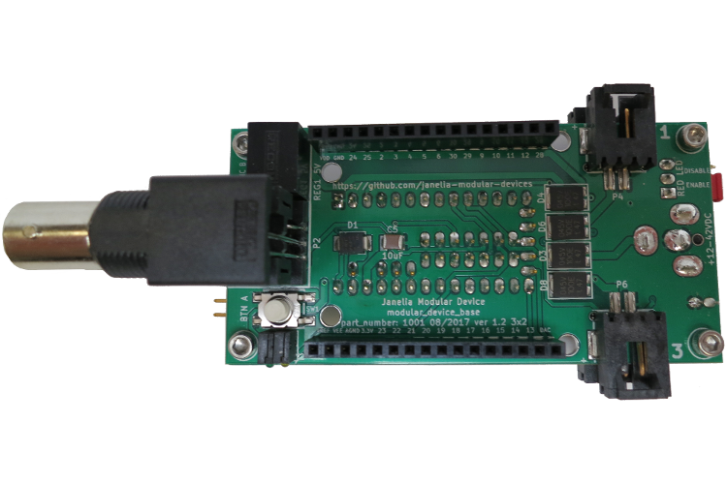
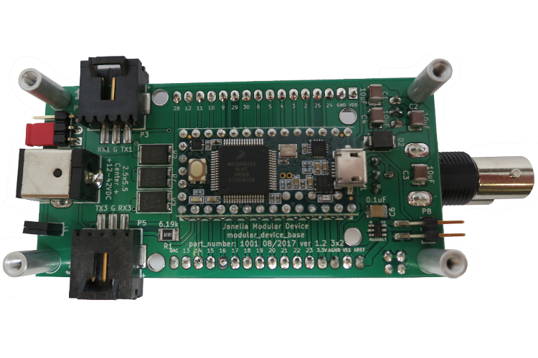

Schematic
./schematic/modular_device_base_3x2.pdf
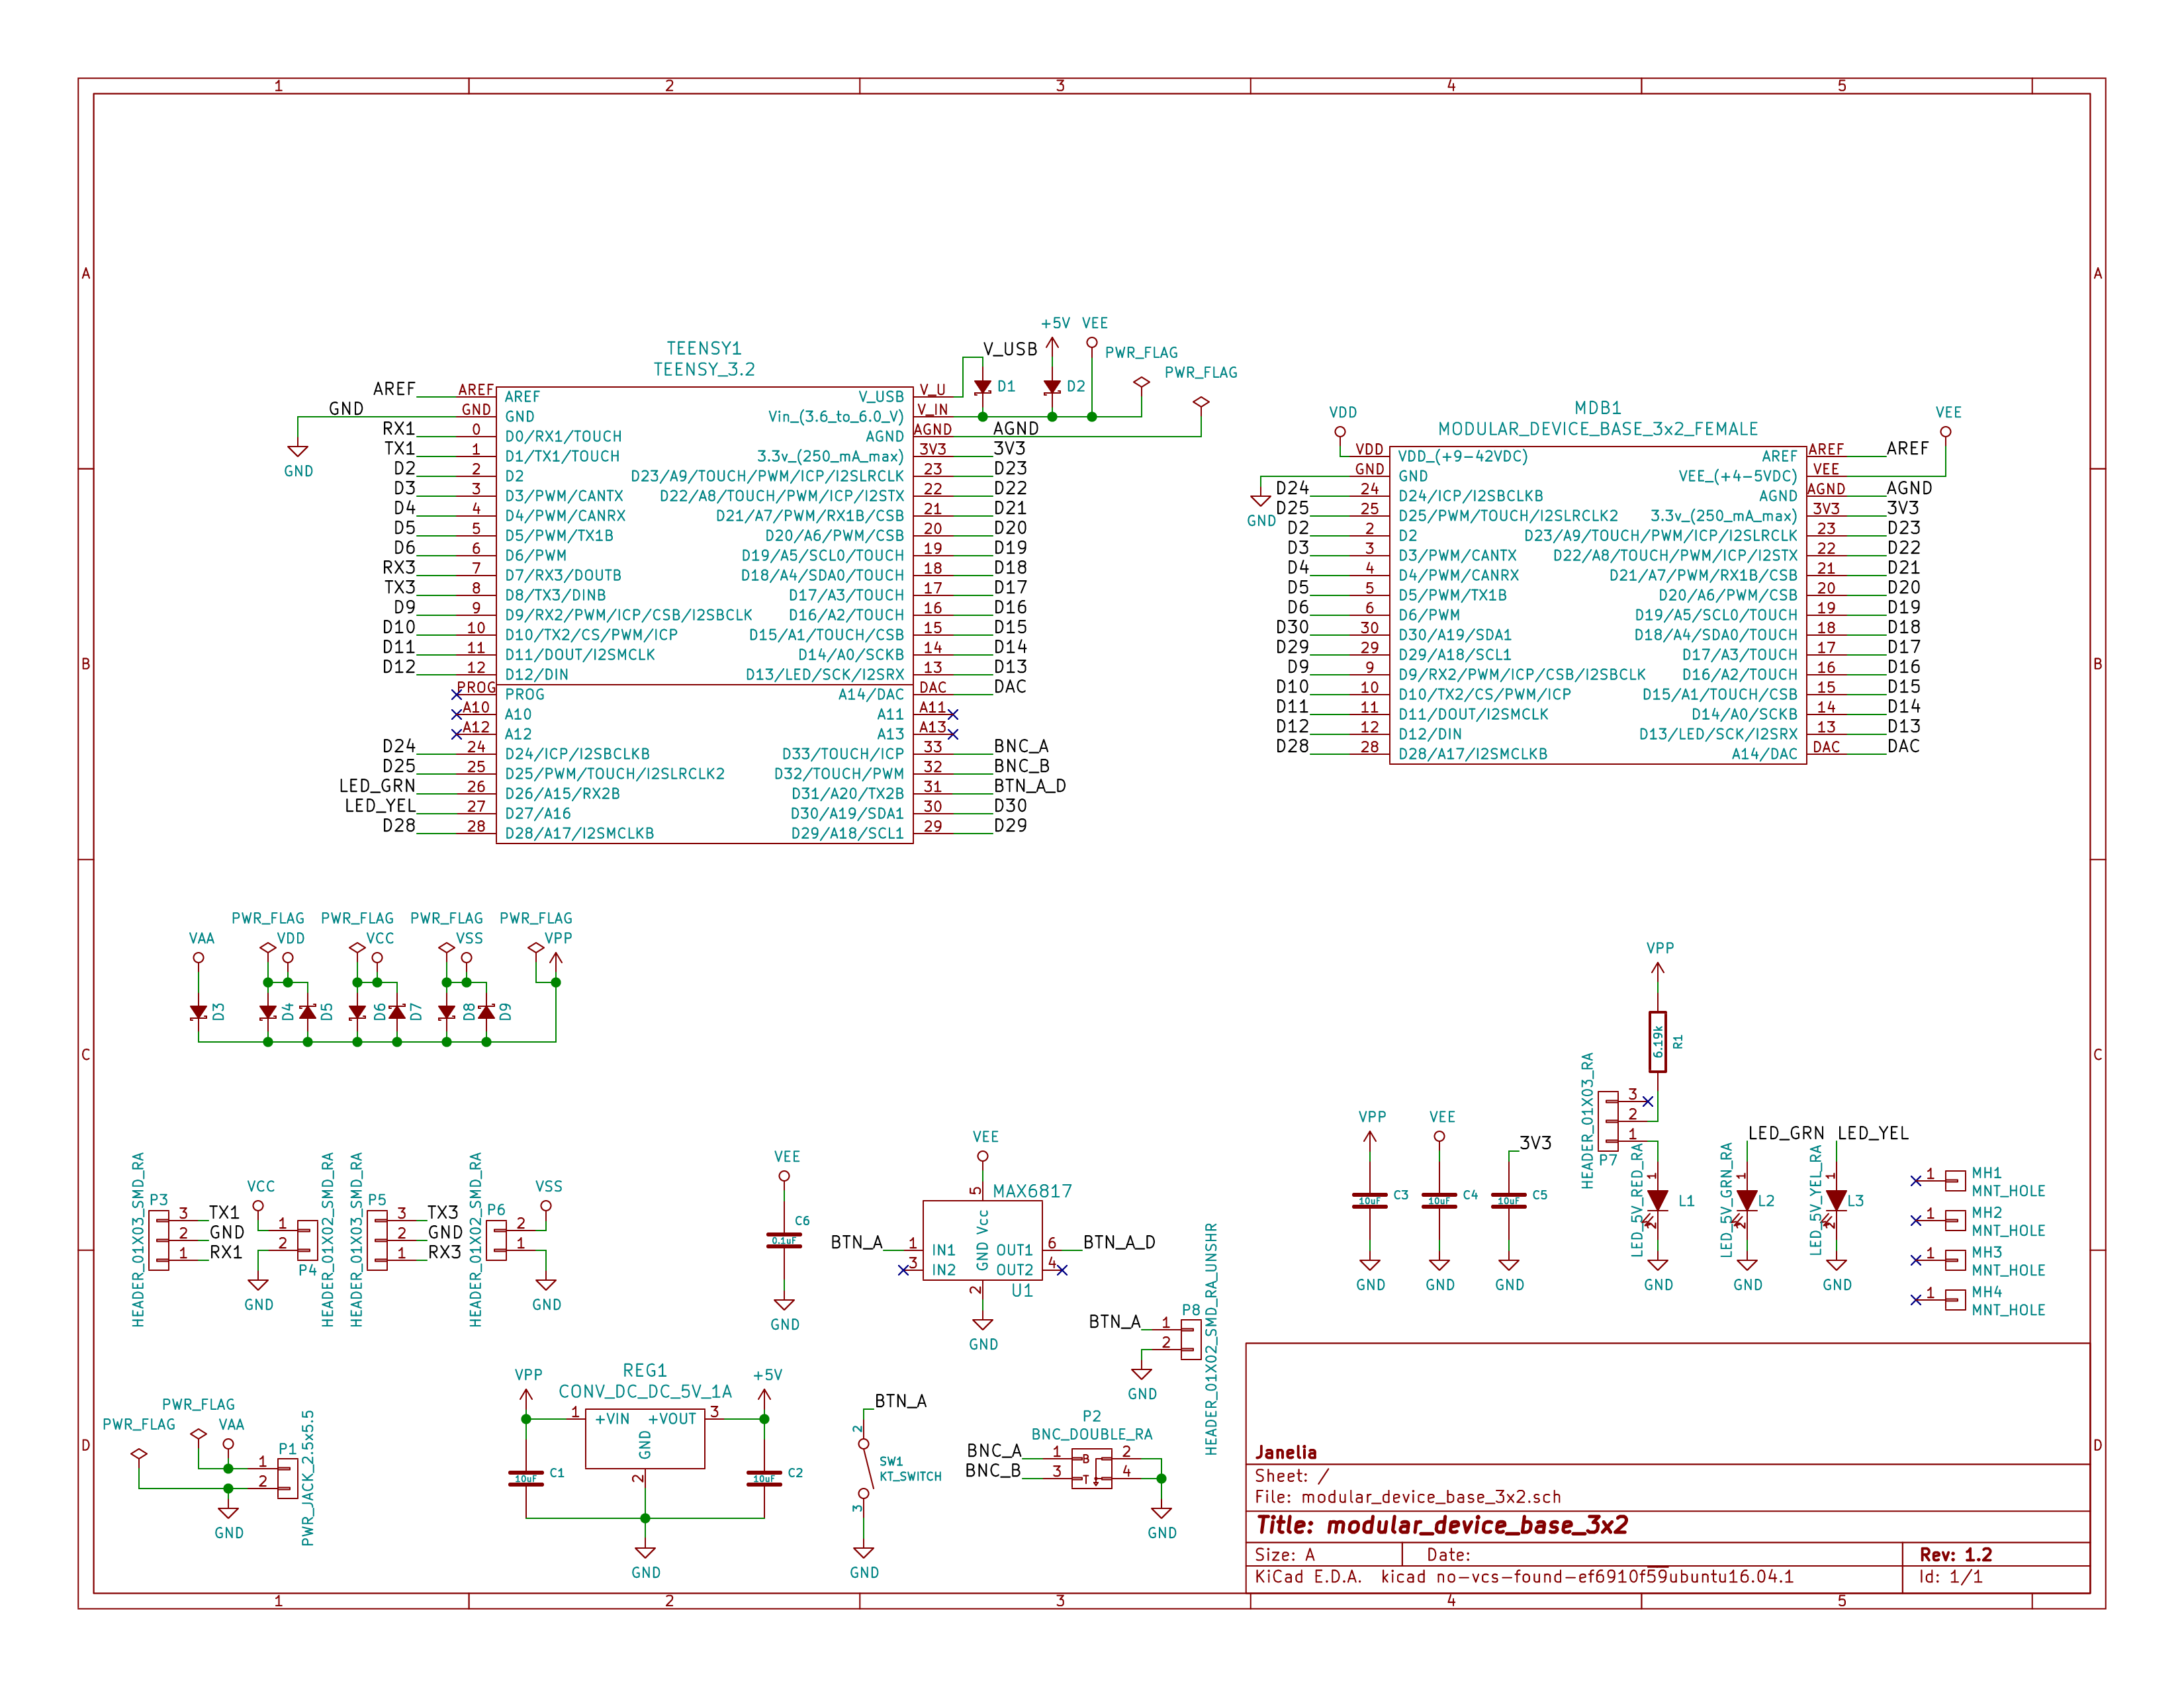

Gerbers
Save gerbers zip file and send to your favorite PCB manufacturer for fabrication.
./gerbers/modular_device_base_3x2_v1.2.zip
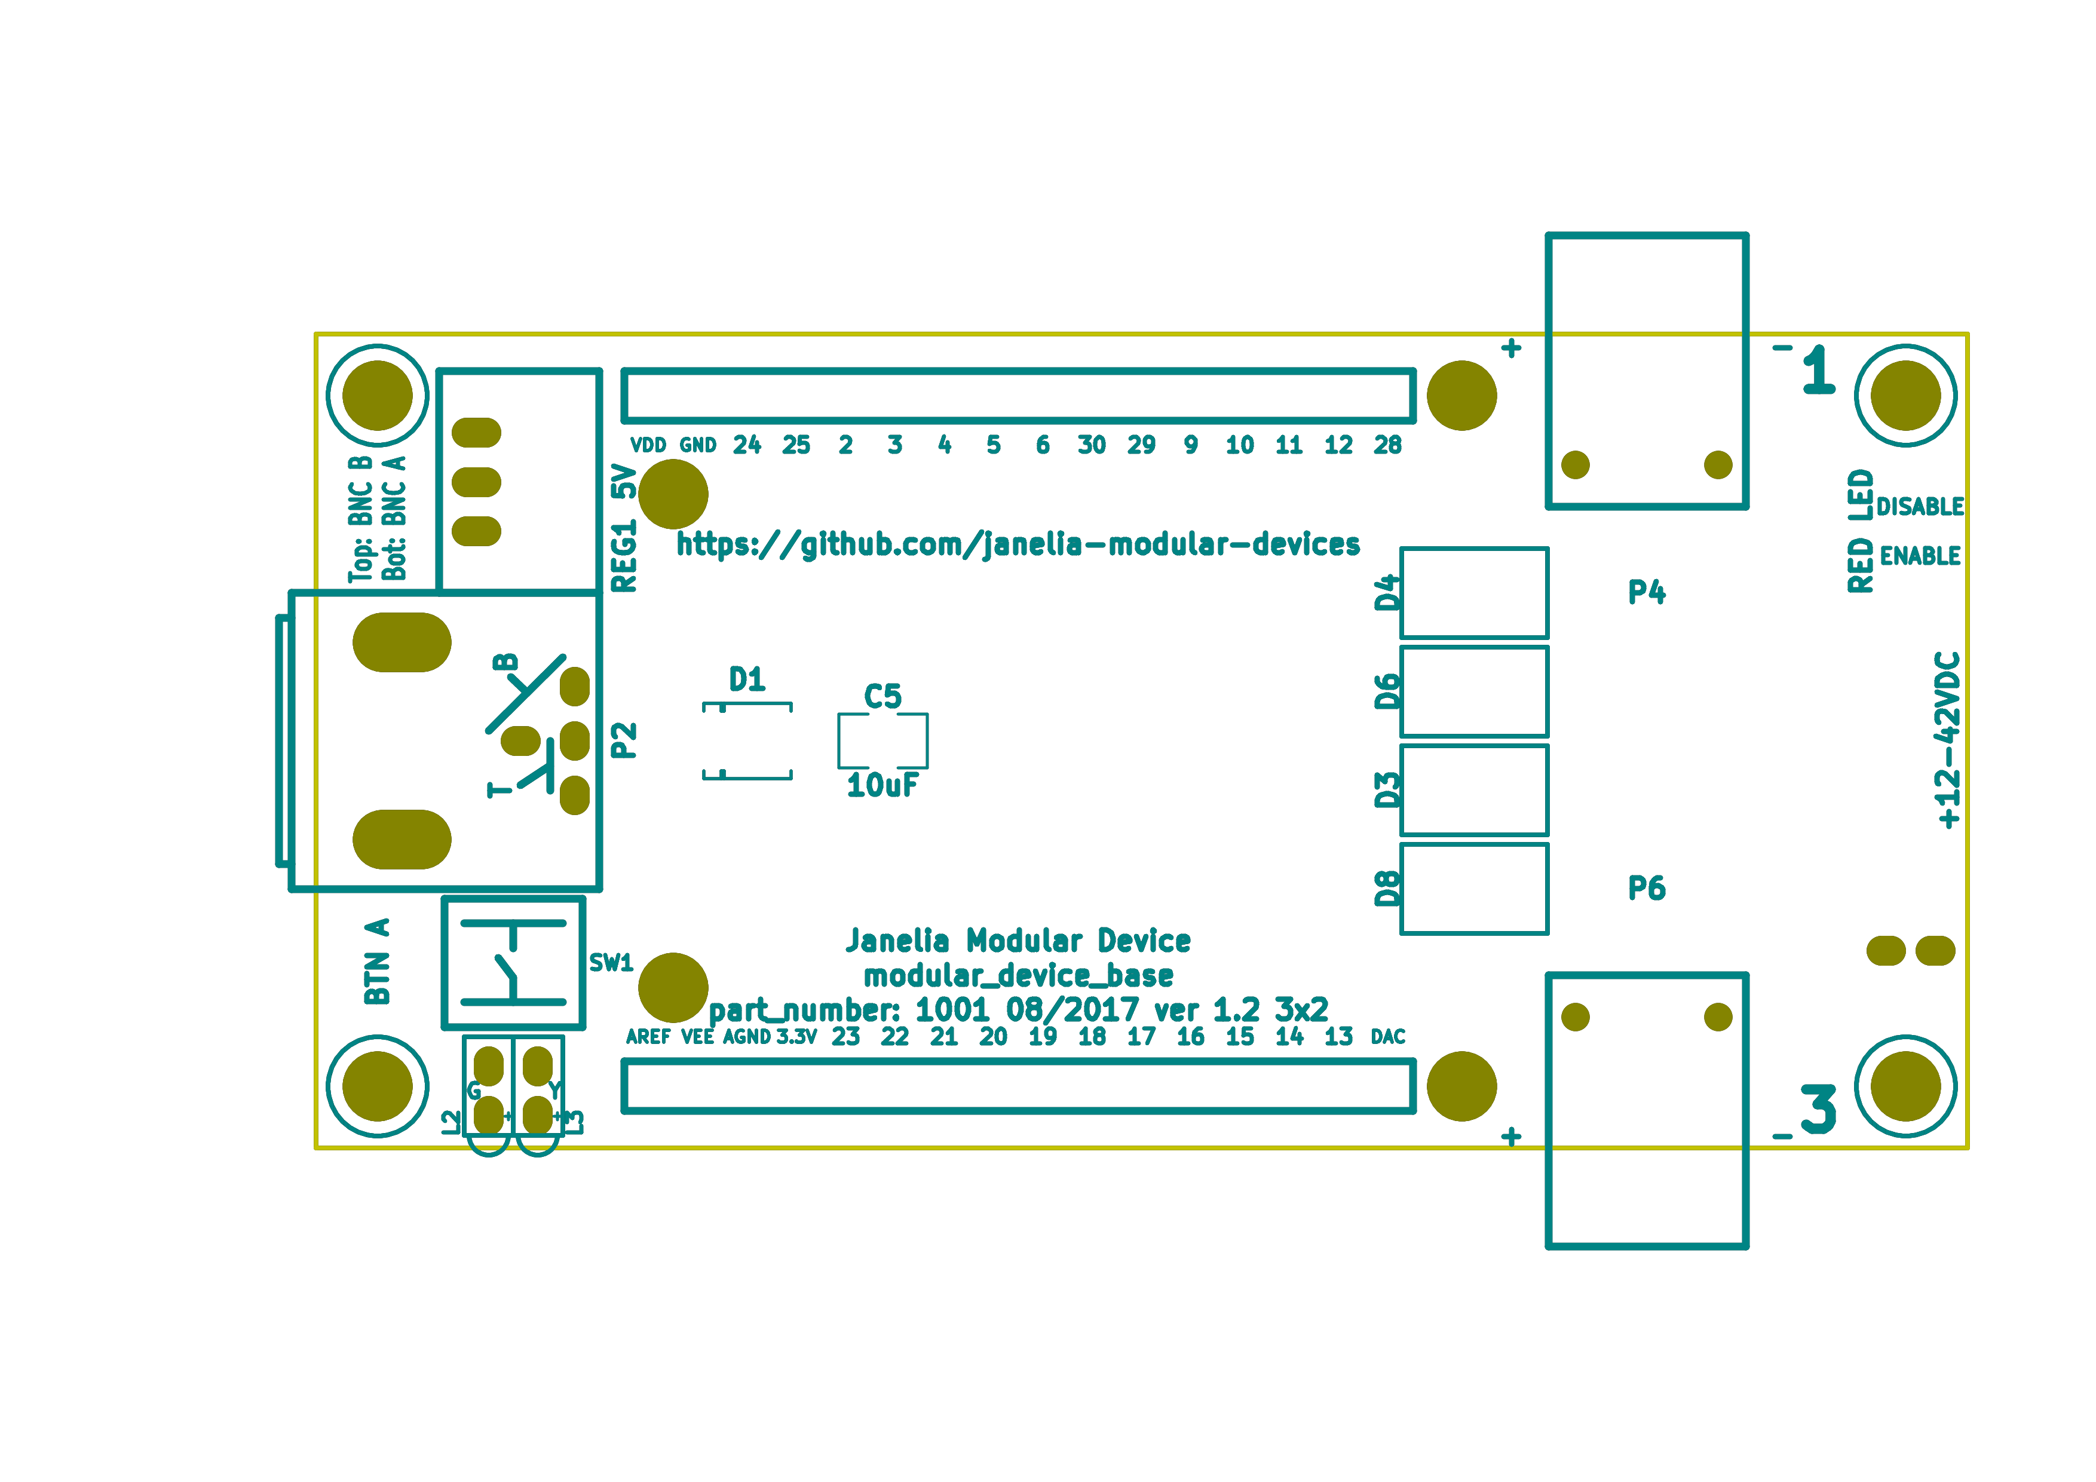
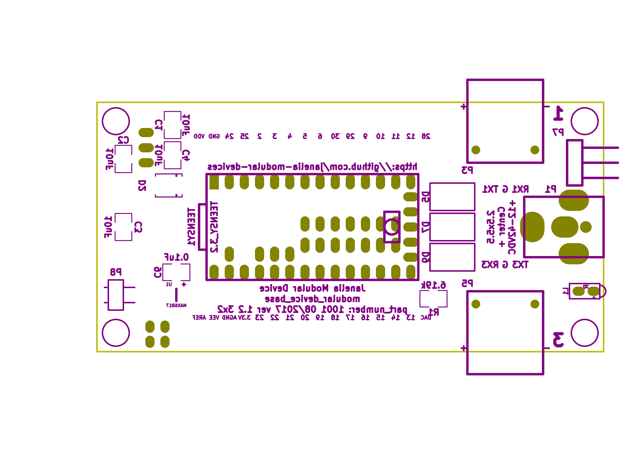

Bill of Materials

PCB Parts
Item | Reference(s) | Quantity | PartNumber | Vendor | Description
1 | C1 C2 C3 C4 C5 | 5 | 445-4536-1-ND | digikey | CAP CER 10UF 50V 10% X7S 1210
2 | C6 | 1 | 399-13229-1-ND | digikey | CAP CER 0.1UF 100V X7R 1210
3 | D1 D2 | 2 | LSM115JE3/TR13CT-ND | digikey | DIODE SCHOTTKY 15V 1A DO214BA
4 | D3 D4 D5 D6 D7 D8 D9 | 7 | 568-11697-1-ND | digikey | DIODE SCHOTTKY 45V 10A CFP15
5 | L1 | 1 | 350-1712-ND | digikey | LED 2MM 5V RT ANGLE RED PCMNT
6 | L2 | 1 | 350-1717-ND | digikey | LED 2MM 5V RT ANGLE GREEN PCMNT
7 | L3 | 1 | 350-1719-ND | digikey | LED 2MM 5V RT ANGLE YELLOW PCMNT
8 | MDB1 | 2 | S7049-ND | digikey | 16 Position Header Through Hole Female Socket
9 | MH1 MH2 MH3 MH4 | 4 | 36-2027-ND | digikey | Round Standoff Threaded 4-40 Aluminum 0.500in 0.187in
10 | P1 | 1 | CP-063BH-ND | digikey | CONN PWR JACK DC 2.5X5.5 8A T/H
11 | P2 | 1 | ACX1655-ND | digikey | CONN BNC JACK R/A 75 OHM PCB
12 | P3 P5 | 2 | A100890CT-ND | digikey | CONN HEADER 3POS R/A SMD GOLD
13 | P4 P6 | 2 | A100903CT-ND | digikey | CONN HEADER 2POS R/A SMD GOLD
14 | P7 | 1 | 732-5336-ND | digikey | CONN HEADER 3 POS RA 2.54
15 | P8 | 1 | SAM10781-ND | digikey | CONN HEADER 2POS .100in SNGL SMD
16 | R1 | 1 | P6.19KAACT-ND | digikey | RES SMD 6.19K OHM 1% 1/2W 1210
17 | REG1 | 1 | 945-1395-5-ND | digikey | CONV DC/DC 1A 5V OUT SIP VERT
18 | SW1 | 1 | CKN1860CT-ND | digikey | SWITCH TACTILE SPST-NO 1VA 32V
19 | TEENSY1 | 1 | 1568-1231-ND | digikey | DEV TEENSY 3.2 13736
20 | U1 | 1 | MAX6817EUT+TCT-ND | digikey | IC DEBOUNCER SWITCH DUAL SOT23-6

Supplemental Parts
Item | Quantity | PartNumber | Vendor | Description
1 | 1 | EPS594-ND | digikey | 30 WATT DESKTOP POWER SUPPLY 24V
2 | 1 | 993-1037-ND | digikey | CORD 3COND NEMA PLUG 320-C5
3 | 1 | A106625CT-ND | digikey | 14 Positions Header Unshrouded Breakaway Connector 0.100in 2 row SMD
4 | 2 | S1011EC-24-ND | digikey | 24 Positions Header Unshrouded Breakaway Connector 0.100in 1 row Through
5 | 1 | S9001-ND | digikey | CONN JUMPER SHORTING GOLD FLASH
6 | 1 | AE10342-ND | digikey | CABLE USB-A TO MICRO USB-B 2M

Vendor Parts Lists
./bom/digikey_parts.csv
./bom/supplemental_digikey_parts.csv

Supplemental Documentation

Assembly Instructions
- Cut the bottom trace on the Teensy board that connects the 5V pads according to these instructions https://www.pjrc.com/teensy/external_power.html.
- Solder through hole header pins into every Teensy 0.1 inch header hole.
- Solder surface mount header pins onto the bottom of the Teensy making sure they are properly aligned.
- Solder surface mount and through hole components onto the pcb.
- Solder the Teensy into the pcb making sure it is properly aligned.
- Connect header jumper to RED LED enable pins.

