Table of Contents
1. Repository Information
1.1. Description
2. Images
3. Schematic
4. Gerbers
5. Bill of Materials
5.1. PCB Parts
5.2. Supplemental Parts
5.3. Vendor Parts Lists

Repository Information
Name
modular_device_base_5x3
Version
1.2
License
Open-Source Hardware
URL
https://github.com/janelia-kicad/modular_device_base_5x3
Author
Peter Polidoro
Email
peterpolidoro@gmail.com

Description
This board is the base of 5x3 format modular devices. It is a breakout board for the microprocessor, with connections for power, communication, and top boards.

Images
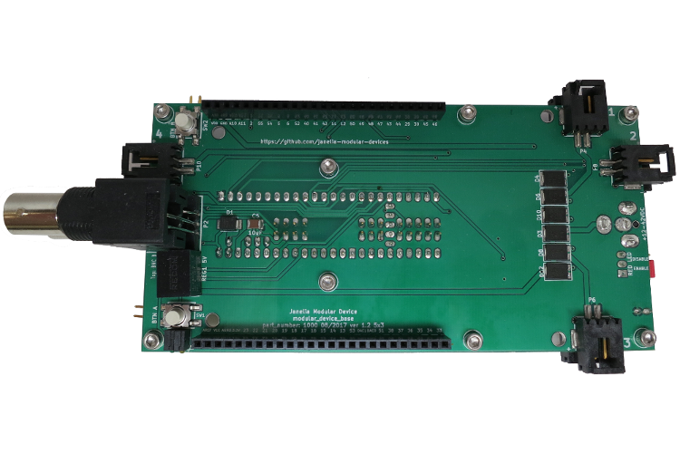
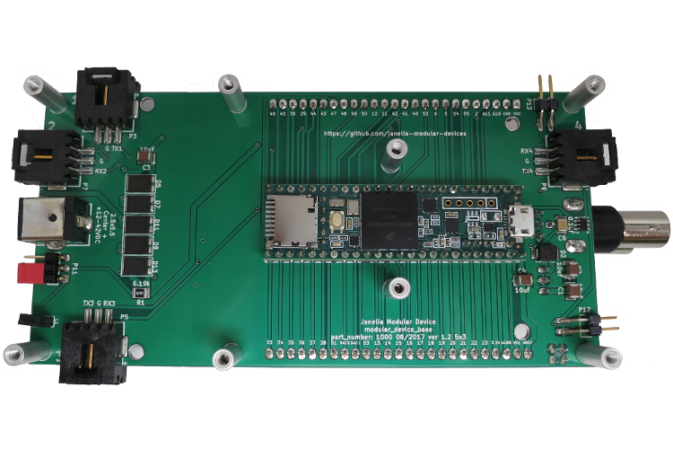

Schematic
./schematic/modular_device_base_5x3.pdf
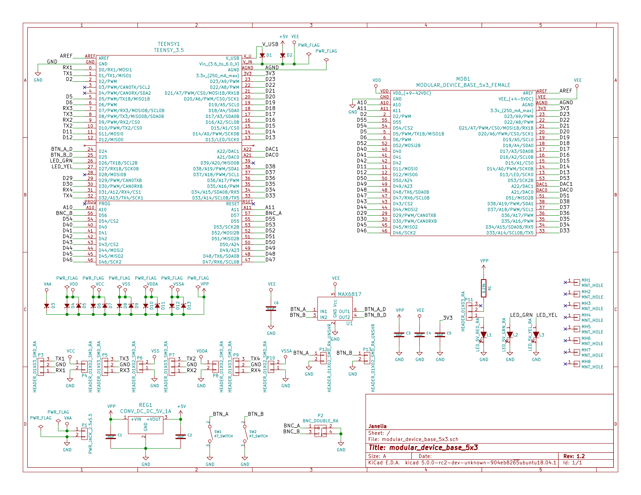

Gerbers
Save gerbers zip file and send to your favorite PCB manufacturer for fabrication.
./gerbers/modular_device_base_5x3_v1.2.zip
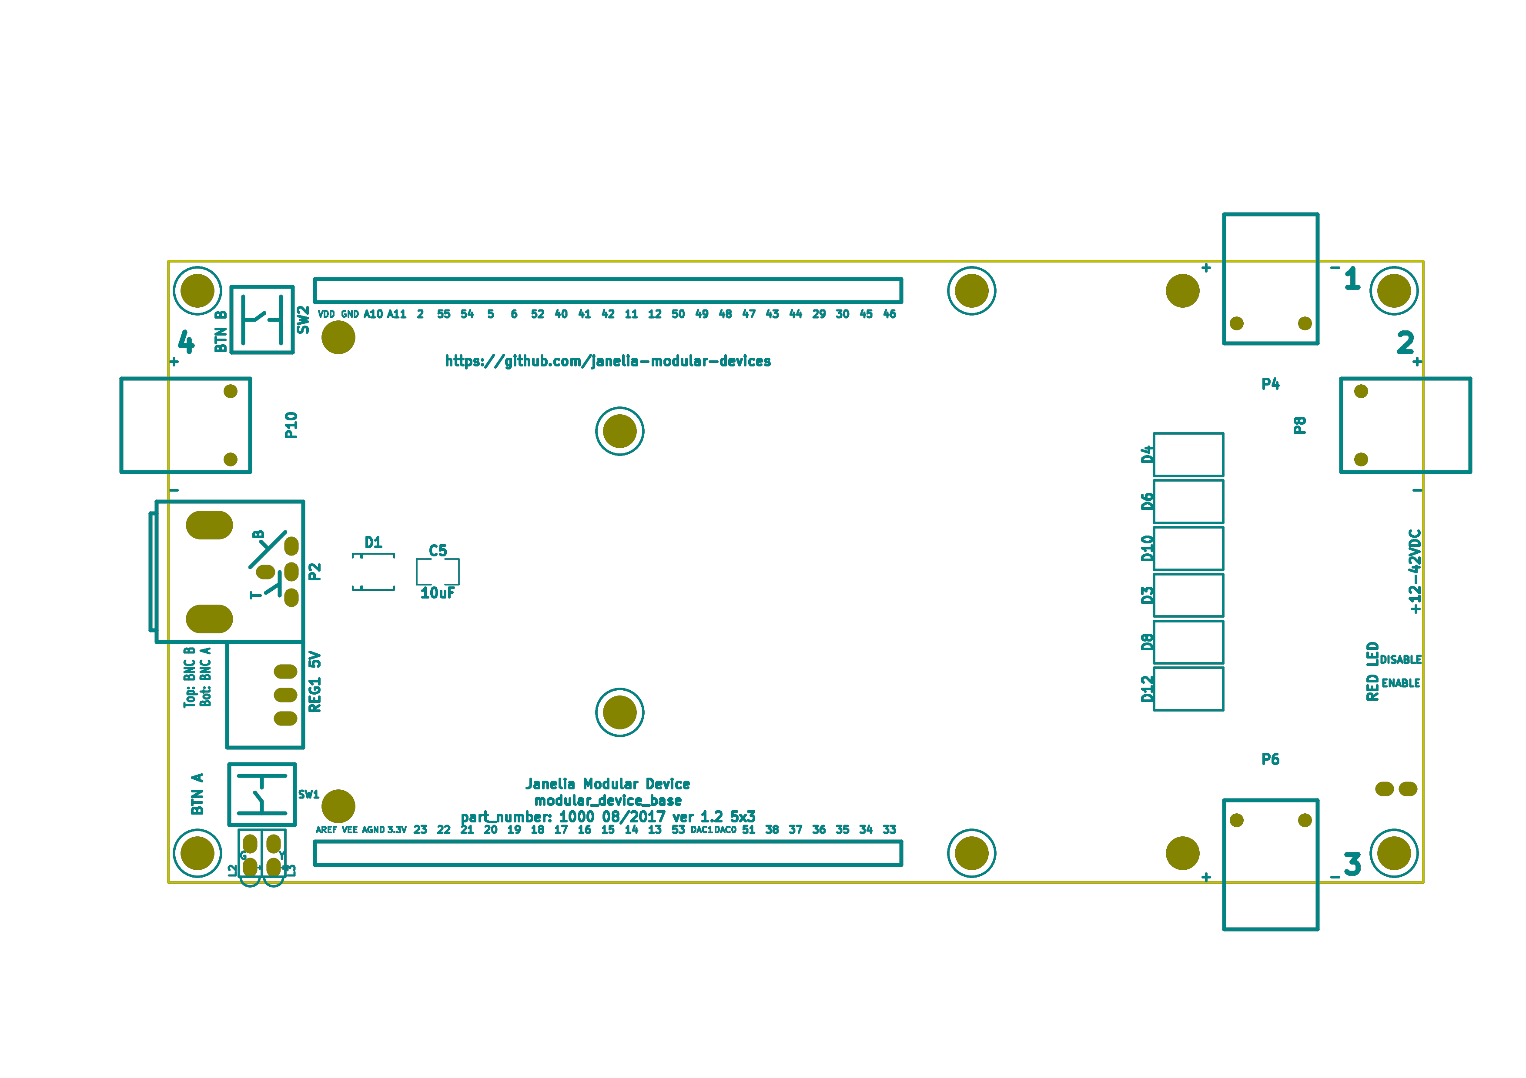
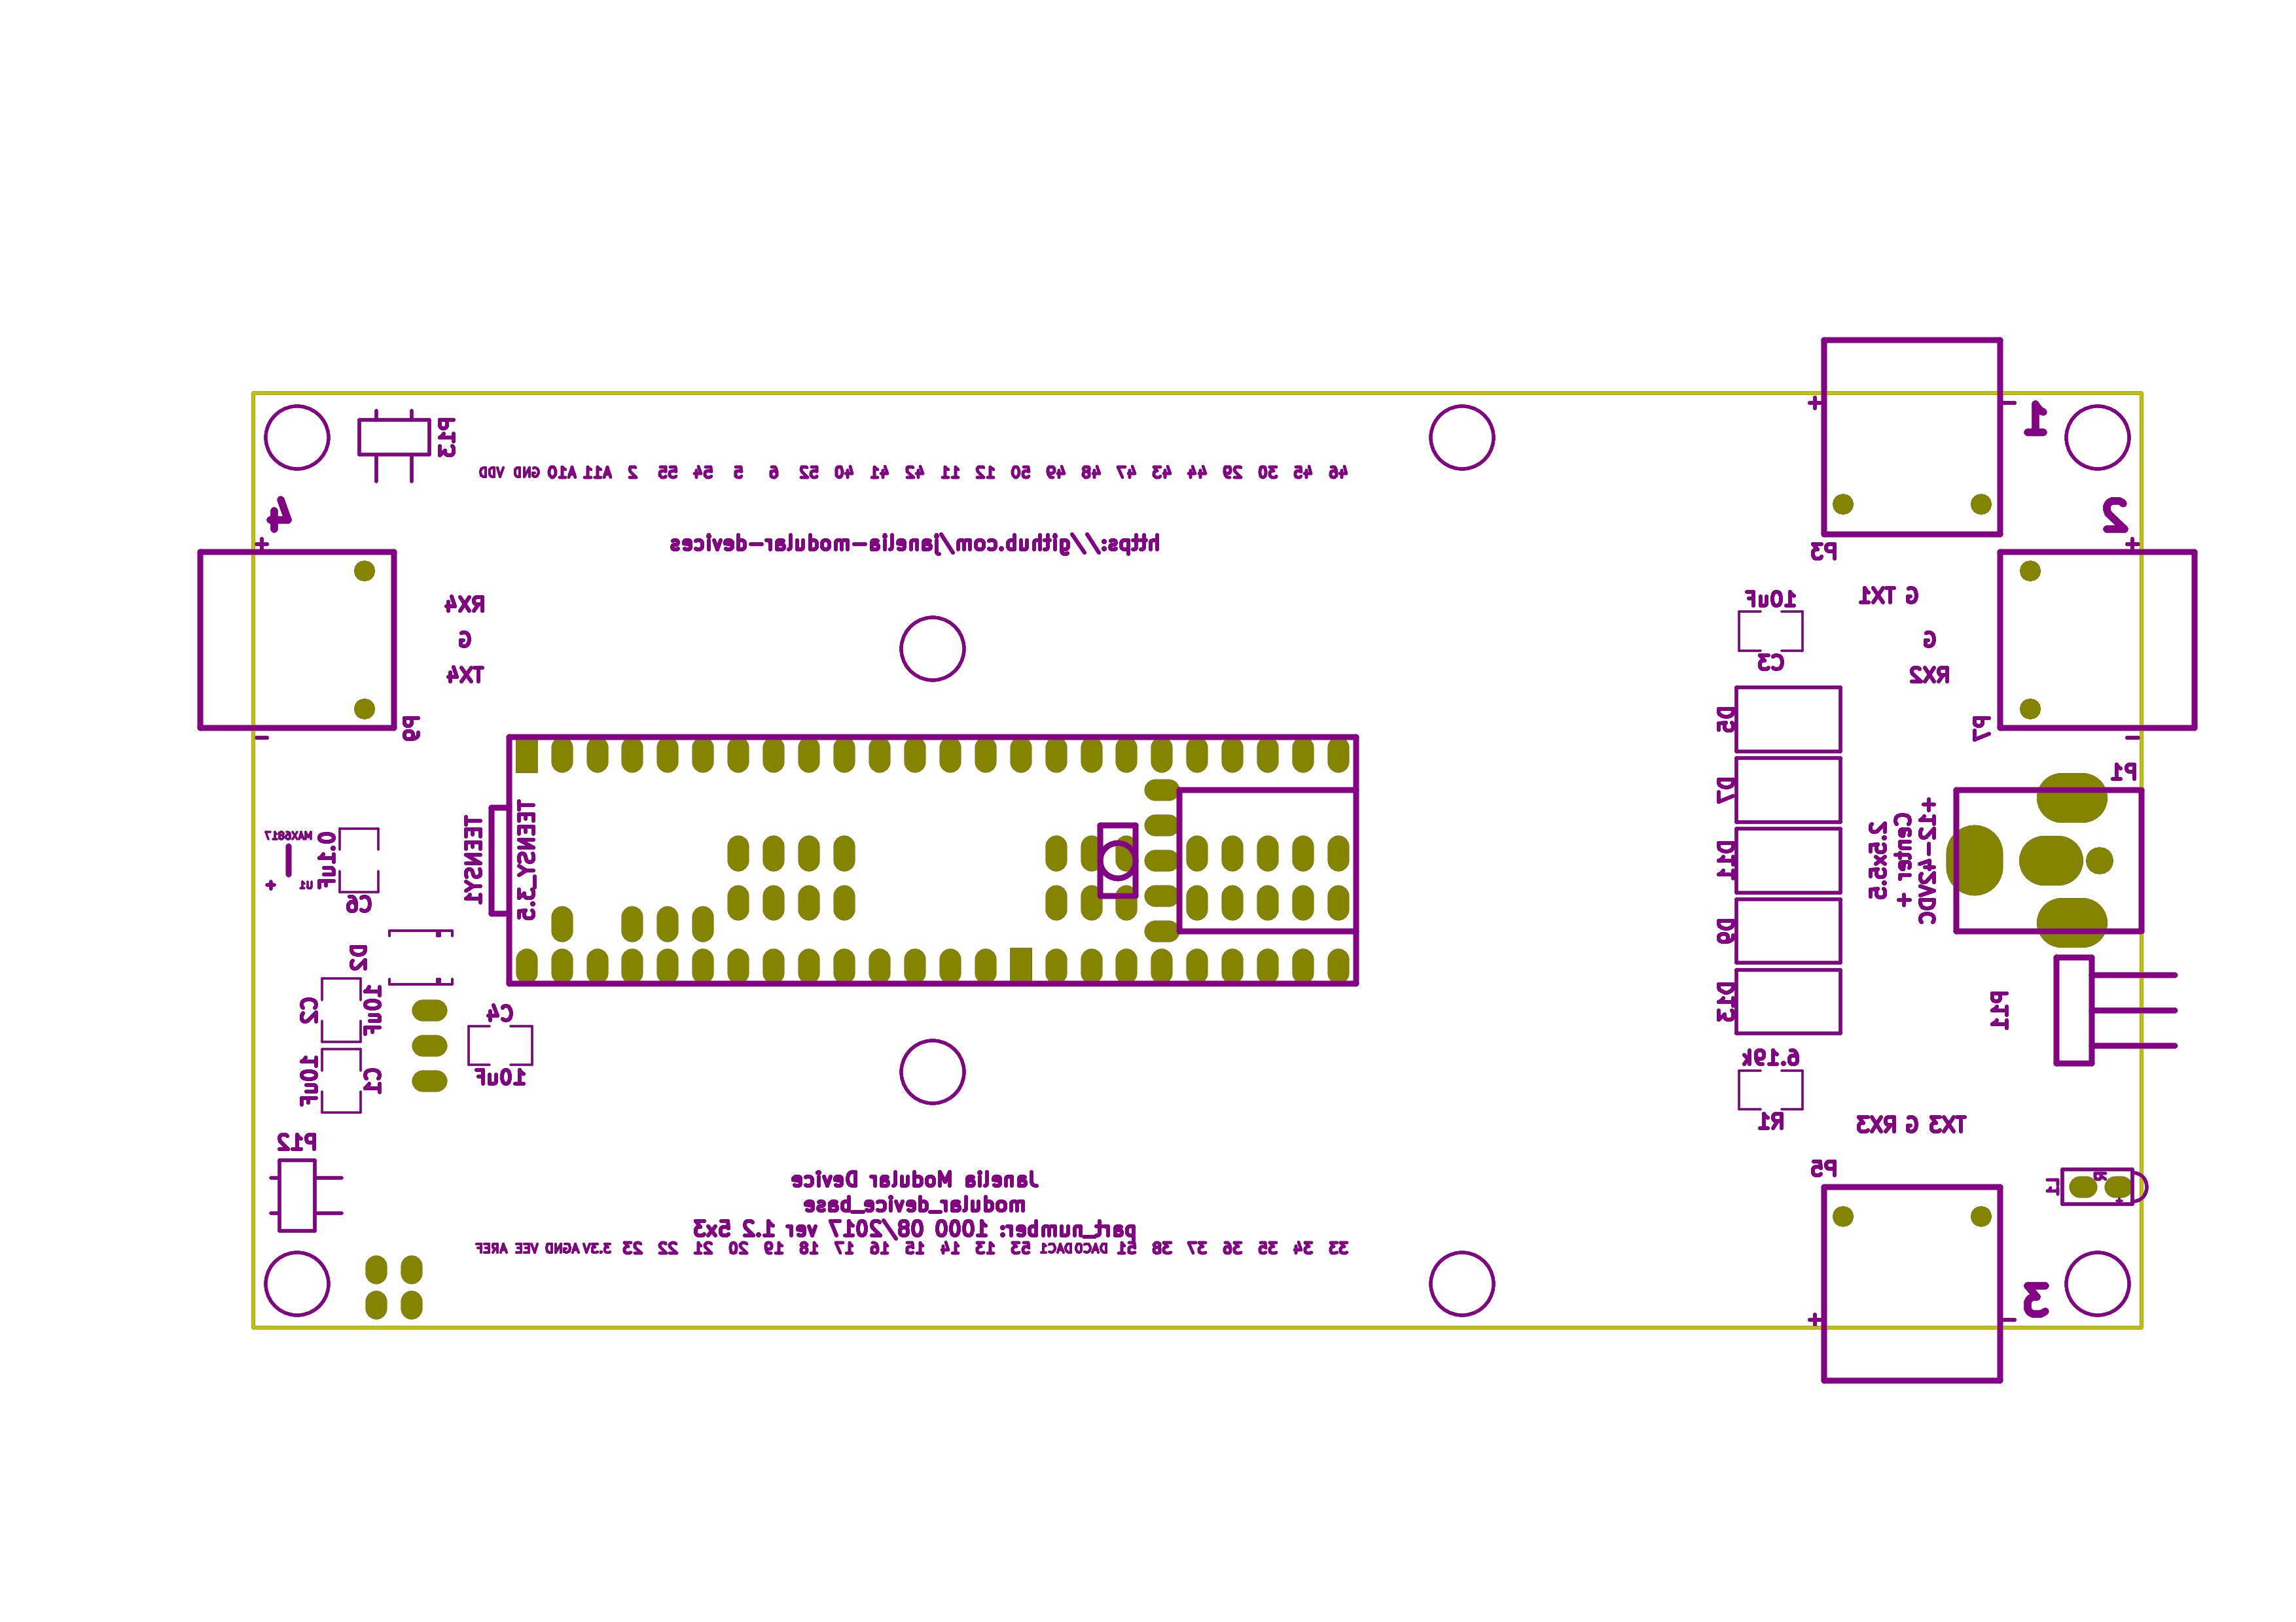

Bill of Materials

PCB Parts
Item | Reference(s) | Quantity | PartNumber | Vendor | Description
1 | C1 C2 C3 C4 C5 | 5 | 445-4536-1-ND | digikey | CAP CER 10UF 50V 10% X7S 1210
2 | C6 | 1 | 399-13229-1-ND | digikey | CAP CER 0.1UF 100V X7R 1210
3 | D1 D2 | 2 | LSM115JE3/TR13CT-ND | digikey | DIODE SCHOTTKY 15V 1A DO214BA
4 | D10 D11 D12 D13 D3 D4 D5 D6 D7 D8 D9 | 11 | 568-11697-1-ND | digikey | DIODE SCHOTTKY 45V 10A CFP15
5 | L1 | 1 | 350-1712-ND | digikey | LED 2MM 5V RT ANGLE RED PCMNT
6 | L2 | 1 | 350-1717-ND | digikey | LED 2MM 5V RT ANGLE GREEN PCMNT
7 | L3 | 1 | 350-1719-ND | digikey | LED 2MM 5V RT ANGLE YELLOW PCMNT
8 | MDB1 | 2 | S7058-ND | digikey | 25 Position Header Through Hole Female Socket
9 | MH1 MH2 MH3 MH4 MH5 MH6 MH7 MH8 | 8 | 36-2027-ND | digikey | Round Standoff Threaded 4-40 Aluminum 0.500in 0.187in
10 | P1 | 1 | CP-063BH-ND | digikey | CONN PWR JACK DC 2.5X5.5 8A T/H
11 | P10 P4 P6 P8 | 4 | A100903CT-ND | digikey | CONN HEADER 2POS R/A SMD GOLD
12 | P11 | 1 | 732-5336-ND | digikey | CONN HEADER 3 POS RA 2.54
13 | P12 P13 | 2 | SAM10781-ND | digikey | CONN HEADER 2POS .100in SNGL SMD
14 | P2 | 1 | ACX1655-ND | digikey | CONN BNC JACK R/A 75 OHM PCB
15 | P3 P5 P7 P9 | 4 | A100890CT-ND | digikey | CONN HEADER 3POS R/A SMD GOLD
16 | R1 | 1 | P6.19KAACT-ND | digikey | RES SMD 6.19K OHM 1% 1/2W 1210
17 | REG1 | 1 | 945-1395-5-ND | digikey | CONV DC/DC 1A 5V OUT SIP VERT
18 | SW1 SW2 | 2 | CKN1860CT-ND | digikey | SWITCH TACTILE SPST-NO 1VA 32V
19 | TEENSY1 | 1 | 1568-1443-ND | digikey | TEENSY 3.5
20 | U1 | 1 | MAX6817EUT+TCT-ND | digikey | IC DEBOUNCER SWITCH DUAL SOT23-6

Supplemental Parts
Item | Quantity | PartNumber | Vendor | Description
1 | 1 | 62-1187-ND | digikey | AC/DC DESKTOP ADAPTER 24V 90W
2 | 1 | 993-1037-ND | digikey | CORD 3COND NEMA PLUG 320-C5
3 | 2 | A106625CT-ND | digikey | 14 Positions Header Unshrouded Breakaway Connector 0.100in 2 row SMD
4 | 3 | S1011EC-24-ND | digikey | 14 Positions Header Unshrouded Breakaway Connector 0.100in 1 row Through
5 | 1 | S9001-ND | digikey | CONN JUMPER SHORTING GOLD FLASH
6 | 1 | AE10342-ND | digikey | CABLE USB-A TO MICRO USB-B 2M
7 | 2 | 492-1077-ND | digikey | ROUND SPACER 4 NYLON 7/16in

Vendor Parts Lists
./bom/digikey_parts.csv
./bom/supplemental_digikey_parts.csv

