Table of Contents
1. Repository Information
1.1. Description
2. Images
3. Hardware
3.1. modular_device_base_5x3
3.1.1. Repository Information
3.1.2. Images
3.1.3. Schematic
3.1.4. Gerbers
3.1.5. Bill of Materials
3.1.6. Supplemental Documentation
3.2. modular_device_remote_switch
3.2.1. Repository Information
3.2.2. Images
3.2.3. Schematic
3.2.4. Bill of Materials
3.2.5. Supplemental Documentation
3.3. stepper_controller_5x3
3.3.1. Repository Information
3.3.2. Images
3.3.3. Schematic
3.3.4. Gerbers
3.3.5. Bill of Materials
3.3.6. Supplemental Documentation

Repository Information
Name
spinning_platform_controller
License
BSD, Open-Source Hardware
URL
https://github.com/janelia-modular-devices/spinning_platform_controller.git
Author
Peter Polidoro
Email
peterpolidoro@gmail.com

Description
This…

Images
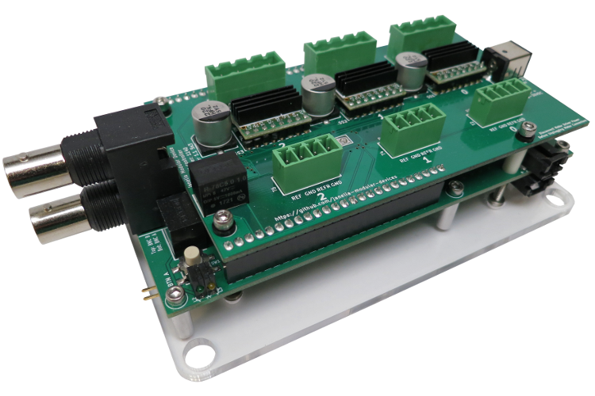
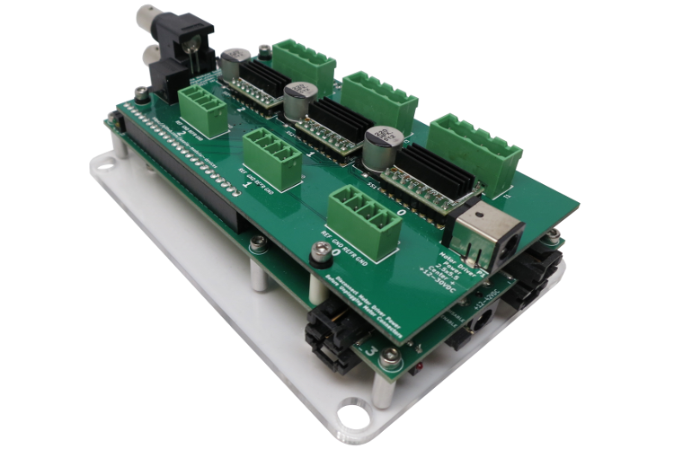

Hardware

modular_device_base_5x3

Repository Information
Name
modular_device_base_5x3
Version
1.2
License
Open-Source Hardware
URL
https://github.com/janelia-kicad/modular_device_base_5x3
Author
Peter Polidoro
Email
peterpolidoro@gmail.com
- Description
This board is the base of 5x3 format modular devices. It is a breakout board for the microprocessor, with connections for power, communication, and top boards.

Images
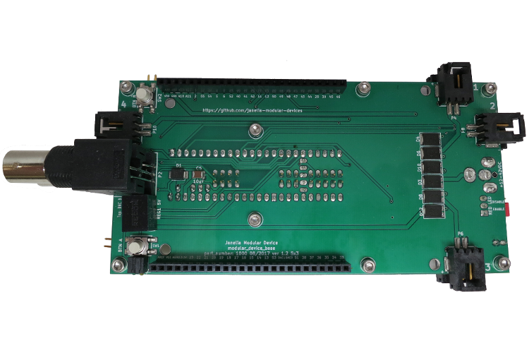
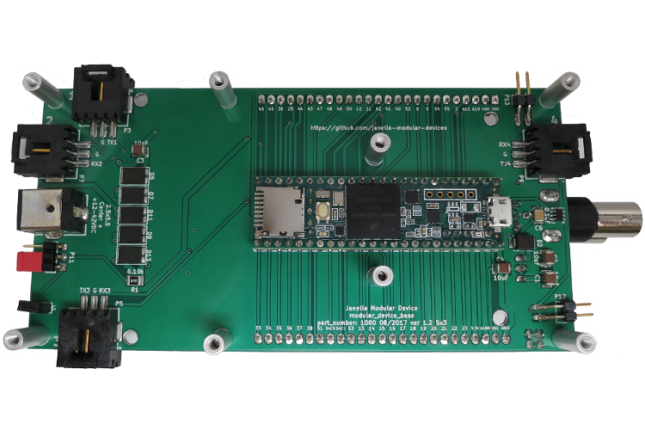

Schematic
./hardware/modular_device_base_5x3/schematic/modular_device_base_5x3.pdf
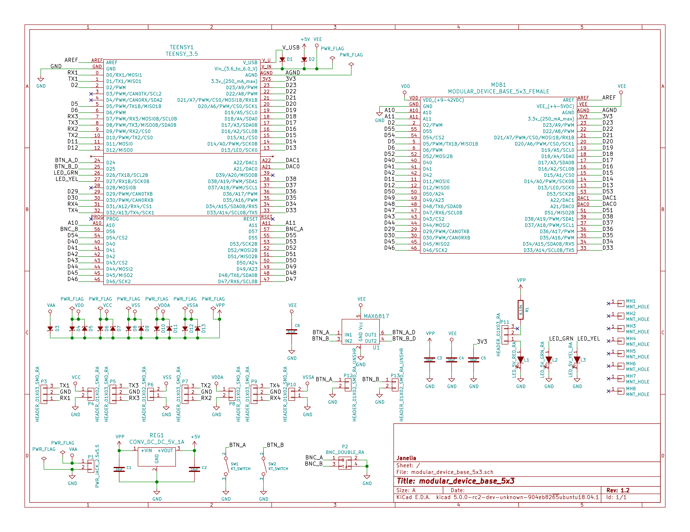

Gerbers
Send gerbers zip file to your favorite PCB manufacturer for fabrication.
./hardware/modular_device_base_5x3/gerbers/modular_device_base_5x3_v1.2.zip
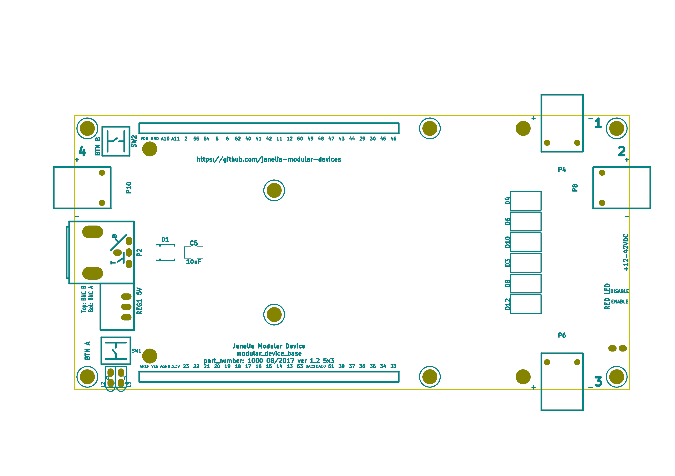
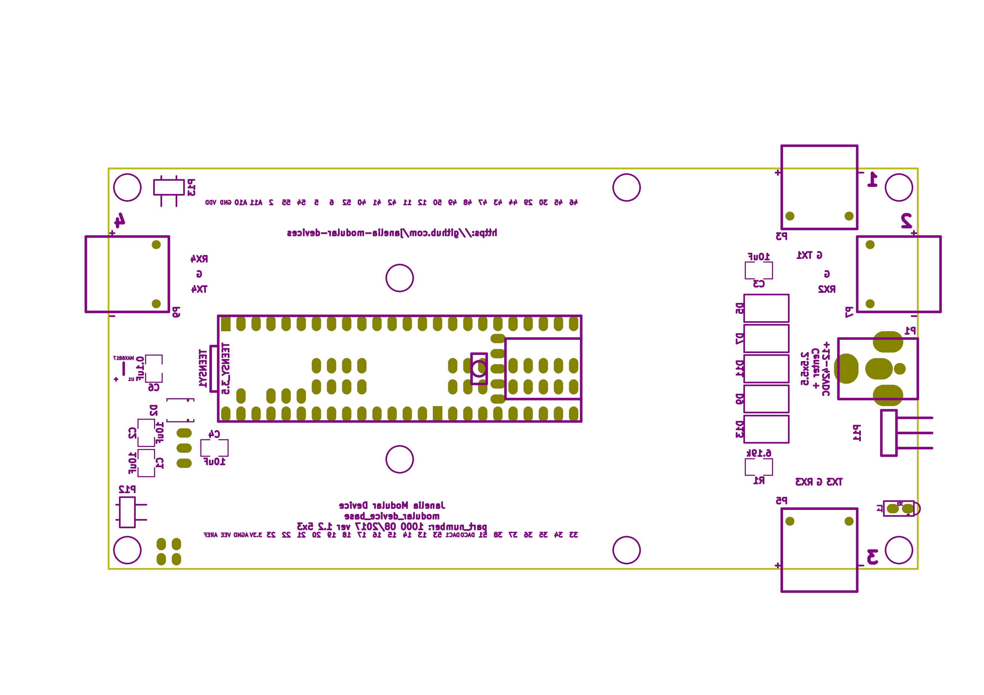

Bill of Materials
- PCB Parts
Item | Reference(s) | Quantity | PartNumber | Vendor | Description
1 | C1 C2 C3 C4 C5 | 5 | 445-4536-1-ND | digikey | CAP CER 10UF 50V 10% X7S 1210
2 | C6 | 1 | 399-13229-1-ND | digikey | CAP CER 0.1UF 100V X7R 1210
3 | D1 D2 | 2 | LSM115JE3/TR13CT-ND | digikey | DIODE SCHOTTKY 15V 1A DO214BA
4 | D10 D11 D12 D13 D3 D4 D5 D6 D7 D8 D9 | 11 | 568-11697-1-ND | digikey | DIODE SCHOTTKY 45V 10A CFP15
5 | L1 | 1 | 350-1712-ND | digikey | LED 2MM 5V RT ANGLE RED PCMNT
6 | L2 | 1 | 350-1717-ND | digikey | LED 2MM 5V RT ANGLE GREEN PCMNT
7 | L3 | 1 | 350-1719-ND | digikey | LED 2MM 5V RT ANGLE YELLOW PCMNT
8 | MDB1 | 2 | S7058-ND | digikey | 25 Position Header Through Hole Female Socket
9 | MH1 MH2 MH3 MH4 MH5 MH6 MH7 MH8 | 8 | 36-2027-ND | digikey | Round Standoff Threaded 4-40 Aluminum 0.500in 0.187in
10 | P1 | 1 | CP-063BH-ND | digikey | CONN PWR JACK DC 2.5X5.5 8A T/H
11 | P10 P4 P6 P8 | 4 | A100903CT-ND | digikey | CONN HEADER 2POS R/A SMD GOLD
12 | P11 | 1 | 732-5336-ND | digikey | CONN HEADER 3 POS RA 2.54
13 | P12 P13 | 2 | SAM10781-ND | digikey | CONN HEADER 2POS .100in SNGL SMD
14 | P2 | 1 | ACX1655-ND | digikey | CONN BNC JACK R/A 75 OHM PCB
15 | P3 P5 P7 P9 | 4 | A100890CT-ND | digikey | CONN HEADER 3POS R/A SMD GOLD
16 | R1 | 1 | P6.19KAACT-ND | digikey | RES SMD 6.19K OHM 1% 1/2W 1210
17 | REG1 | 1 | 945-1395-5-ND | digikey | CONV DC/DC 1A 5V OUT SIP VERT
18 | SW1 SW2 | 2 | CKN1860CT-ND | digikey | SWITCH TACTILE SPST-NO 1VA 32V
19 | TEENSY1 | 1 | 1568-1443-ND | digikey | TEENSY 3.5
20 | U1 | 1 | MAX6817EUT+TCT-ND | digikey | IC DEBOUNCER SWITCH DUAL SOT23-6
- Supplemental Parts
Item | Quantity | PartNumber | Vendor | Description
1 | 1 | 62-1187-ND | digikey | AC/DC DESKTOP ADAPTER 24V 90W
2 | 1 | 993-1037-ND | digikey | CORD 3COND NEMA PLUG 320-C5
3 | 2 | A106625CT-ND | digikey | 14 Positions Header Unshrouded Breakaway Connector 0.100in 2 row SMD
4 | 3 | S1011EC-24-ND | digikey | 14 Positions Header Unshrouded Breakaway Connector 0.100in 1 row Through
5 | 1 | S9001-ND | digikey | CONN JUMPER SHORTING GOLD FLASH
6 | 1 | AE10342-ND | digikey | CABLE USB-A TO MICRO USB-B 2M
7 | 2 | 492-1077-ND | digikey | ROUND SPACER 4 NYLON 7/16in
- Vendor Parts Lists
./hardware/modular_device_base_5x3/bom/digikey_parts.csv
./hardware/modular_device_base_5x3/bom/supplemental_digikey_parts.csv

Supplemental Documentation
- Assembly Instructions
  - Cut the bottom trace on the Teensy board that connects the 5V pads according to these instructions https://www.pjrc.com/teensy/external_power.html.
  - Solder through hole header pins into every Teensy 0.1 inch header hole.
  - Solder surface mount header pins onto the bottom of the Teensy making sure they are properly aligned.
  - Solder surface mount and through hole components onto the pcb.
  - Solder the Teensy into the pcb making sure it is properly aligned.
  - Connect header jumper to RED LED enable pins.

modular_device_remote_switch

Repository Information
Name
modular_device_remote_switch
Version
1.0
License
Open-Source Hardware
URL
https://github.com/janelia-kicad/modular_device_remote_switch
Author
Peter Polidoro
Email
peterpolidoro@gmail.com
- Description
This switch connects to modular devices to allow remote button presses.

Images
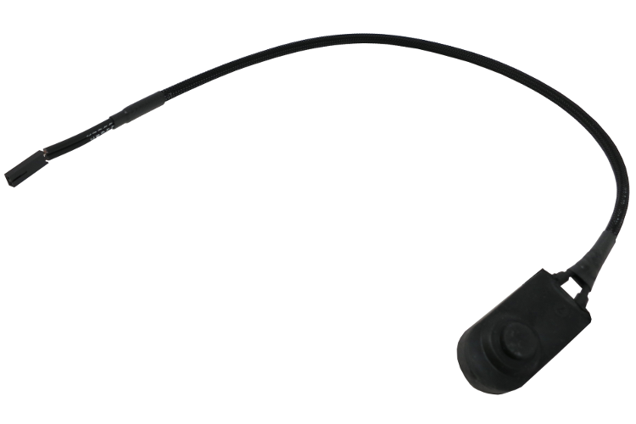
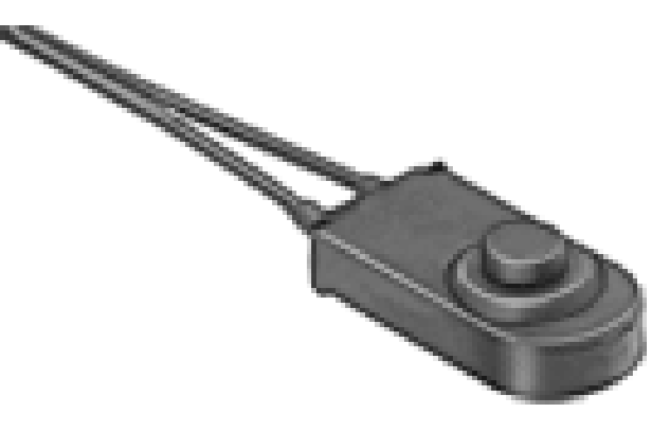
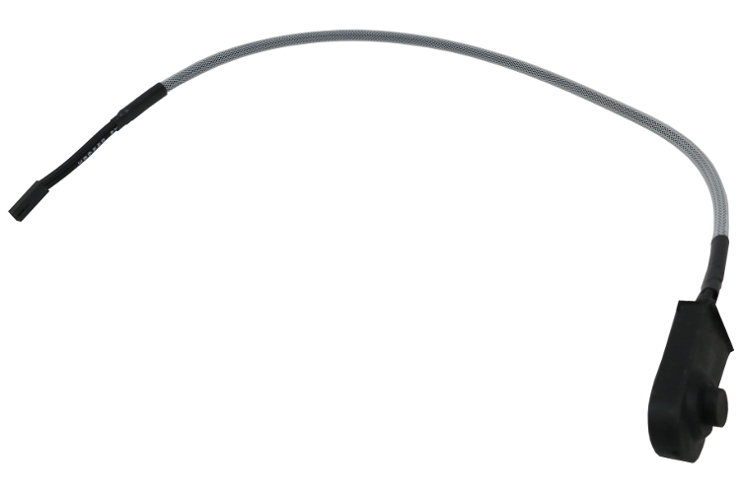

Schematic
./hardware/modular_device_remote_switch/schematic/modular_device_remote_switch.pdf
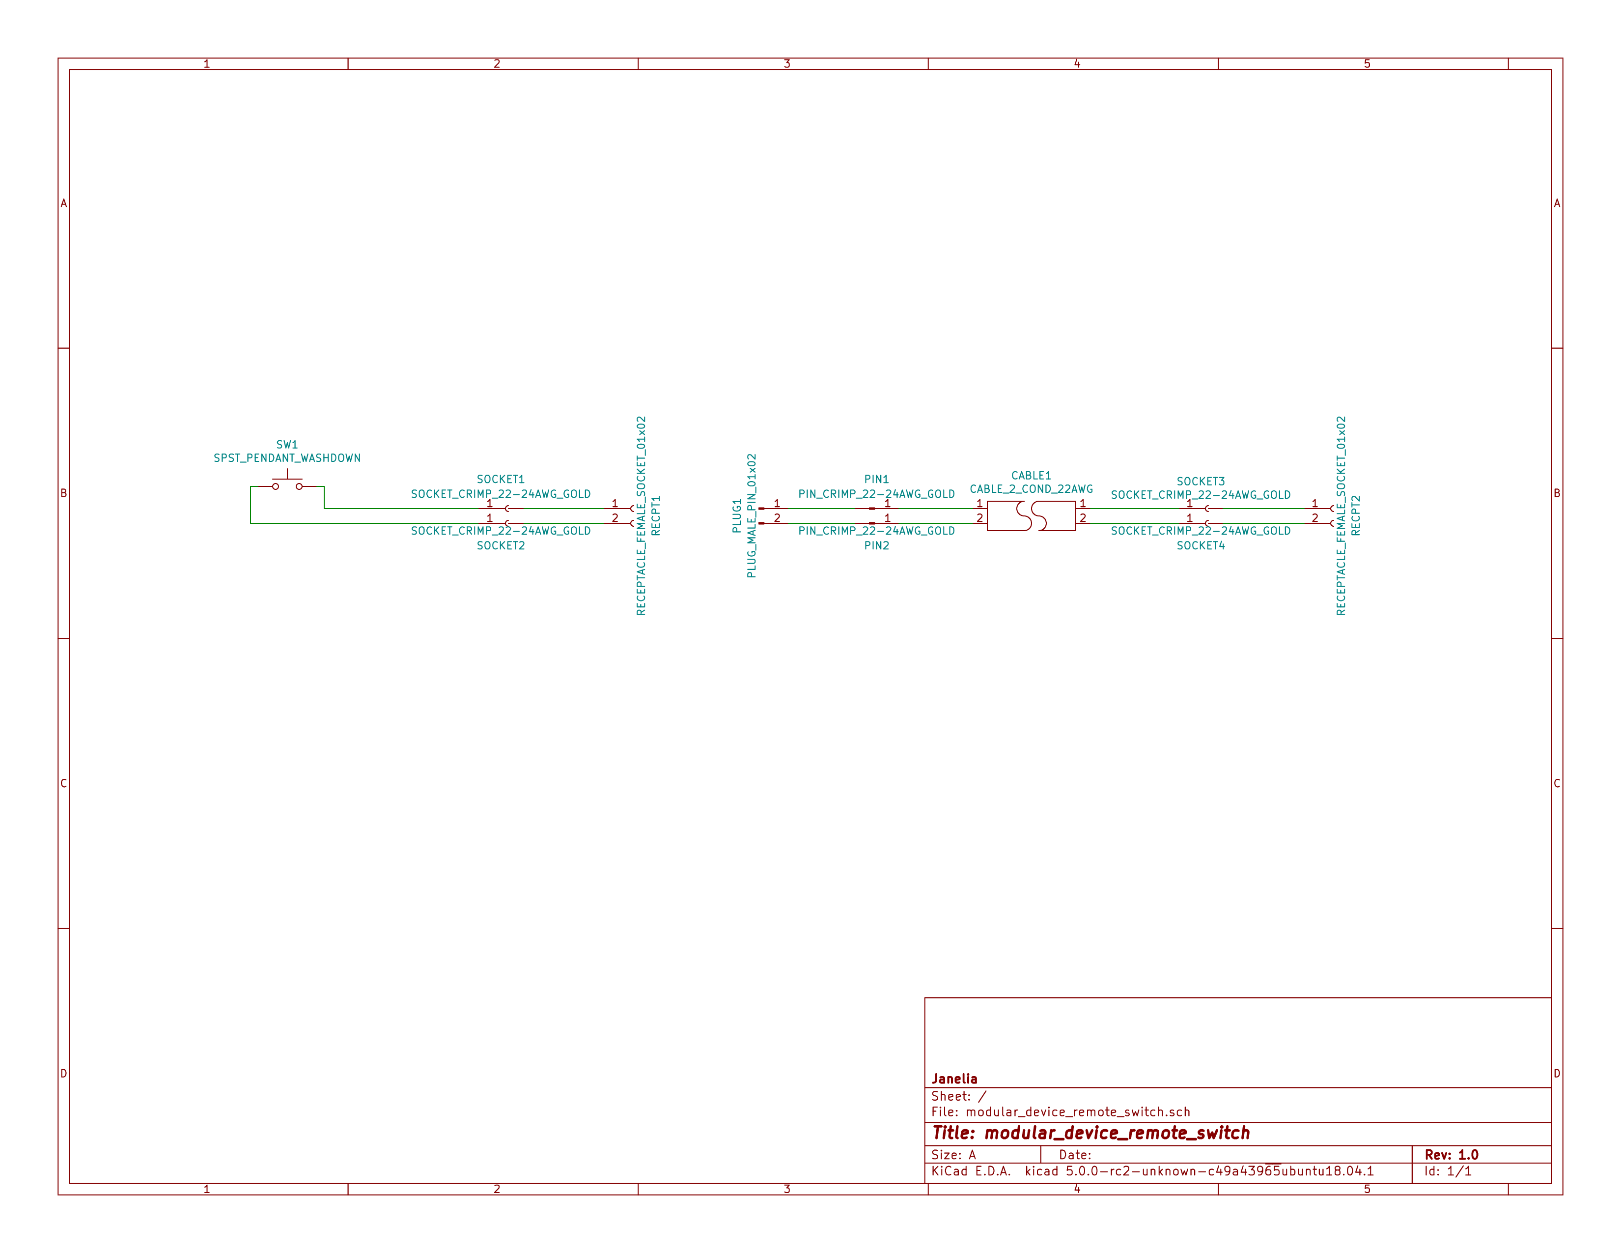

Bill of Materials
- PCB Parts
Item | Reference(s) | Quantity | PartNumber | Vendor | Description
1 | CABLE1 | 1 | A120-100-ND | digikey | MULTI-PAIR 2COND 22AWG 100FT
2 | PIN1 PIN2 | 2 | WM2515-ND | digikey | CONN TERM MALE 22-24AWG GOLD
3 | PLUG1 | 1 | WM2533-ND | digikey | CONN HOUSING MALE 2POS .100
4 | RECPT1 RECPT2 | 2 | WM2800-ND | digikey | CONN HOUSING 2POS .100 SINGLE
5 | SOCKET1 SOCKET2 SOCKET3 SOCKET4 | 4 | WM2512-ND | digikey | CONN TERM FEMALE 22-24AWG GOLD
6 | SW1 | 1 | 6944K11 | mcmaster | Pendant Switch Washdown Push Button
- Supplemental Parts
Item | Quantity | PartNumber | Vendor | Description
1 | 1 | VFP014-1R0-ND | digikey | HEATSHRK VFP876 0.25 inch X 1 inch 50PCS
2 | 1 | 1030-1001-ND | digikey | SLEEVING 0.125 inch X 225 feet BLACK
3 | 1 | 1030-1333-ND | digikey | SLEEVING 0.125 inch X 225 feet RED
4 | 1 | 1030-1332-ND | digikey | SLEEVING 0.125 inch X 225 feet PURPLE
5 | 1 | 1030-1331-ND | digikey | SLEEVING 0.125 inch X 225 feet GREEN
6 | 1 | 1030-1334-ND | digikey | SLEEVING 0.125 inch X 225 feet YELLOW
- Vendor Parts Lists
./hardware/modular_device_remote_switch/bom/digikey_parts.csv
./hardware/modular_device_remote_switch/bom/mcmaster_parts.csv
./hardware/modular_device_remote_switch/bom/supplemental_digikey_parts.csv

Supplemental Documentation
- Assembly Instructions
  - Choose 0.125 inch expandable sleeving color and cut to 18 inches.
  - Expand sleeving and slip over the two pendant switch wires, pushing it over the wires until the sleeve is within 0.5 inches from the switch.
  - Slip one 0.25 inch x 1 inch heat shrink tube over the wires and expanded sleeveing and push it as close to the switch as possible so it is covering one fraying end of the sleeving.
  - Slip another 0.25 inch x 1 inch heat shrink tube over the wires and expanded sleeving and push it until the center of the heat shrink tube is about 1.5 inches from the ends of the switch wires so it is covering the second fraying end of the sleeving.
  - Use a heat gun to shrink both heat shrink tubes on the sleeving and switch wires.
  - Use wire cutter to trim the two switch wires to the same length.
  - Use wire stripper to remove 0.1 inches of insulation from each of the two switch wires.
  - Use crimp tool to crimp one socket onto the end of each switch wire, using a total of two sockets.
  - Insert each of the two sockets into one receptacle connector, either wire can be placed into the pin 1 position, the placement position is not imporant.
  - Cut the 2-conductor cable to the desired length and remove 2 inches of the cable jacket from each of the two ends of the cable.
  - Slip a 0.25 inch x 1 inch heat shrink tube over each end of the cable jacket and use a heat gun to shrink it into place.
  - Use wire cutter to trim the two cable wires to the same length on each side of the cable.
  - Use wire stripper to remove 0.1 inches of insulation from each end of the two wires in the cable.
  - One one end of the cable, use crimp tool to crimp one socket onto the end of each the two cable wires, using a total of two sockets.
  - Insert each of the two sockets into one receptacle connector, either wire can be placed into the pin 1 position, the placement position is not imporant.
  - One the other end of the cable, use crimp tool to crimp one pin onto the end of each the two cable wires, using a total of two pins.
  - Insert each of the two pins into one plug connector, either wire can be placed into the pin 1 position, the placement position is not imporant.
  - Insert the receptacle connector attached to the switch into the plug connector on the cable.
  - Insert the receptacle connector attached to the cable into a two-pin BTN connector on the modular device.

stepper_controller_5x3

Repository Information
Name
stepper_controller_5x3
Version
1.1
License
Open-Source Hardware
URL
https://github.com/janelia-kicad/stepper_controller_5x3
Author
Peter Polidoro
Email
peterpolidoro@gmail.com
- Description
This board controls up to 3 stepper motors with optional forward and reverse limit switches for each motor.

Images
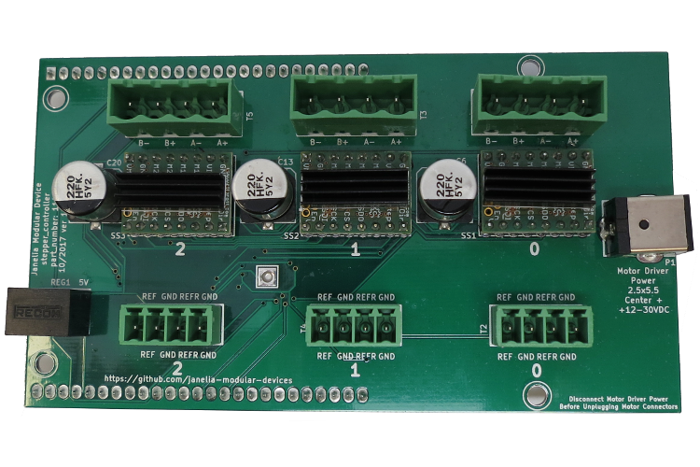
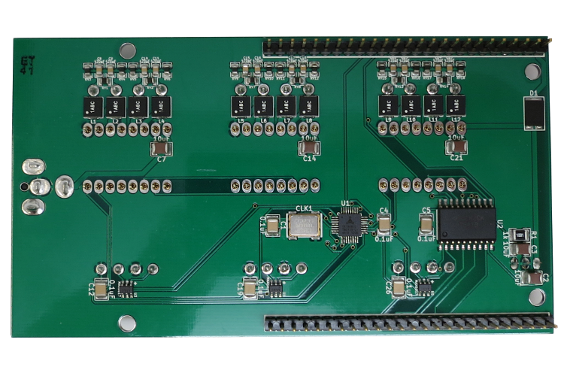

Schematic
./hardware/stepper_controller_5x3/schematic/stepper_controller_5x3.pdf
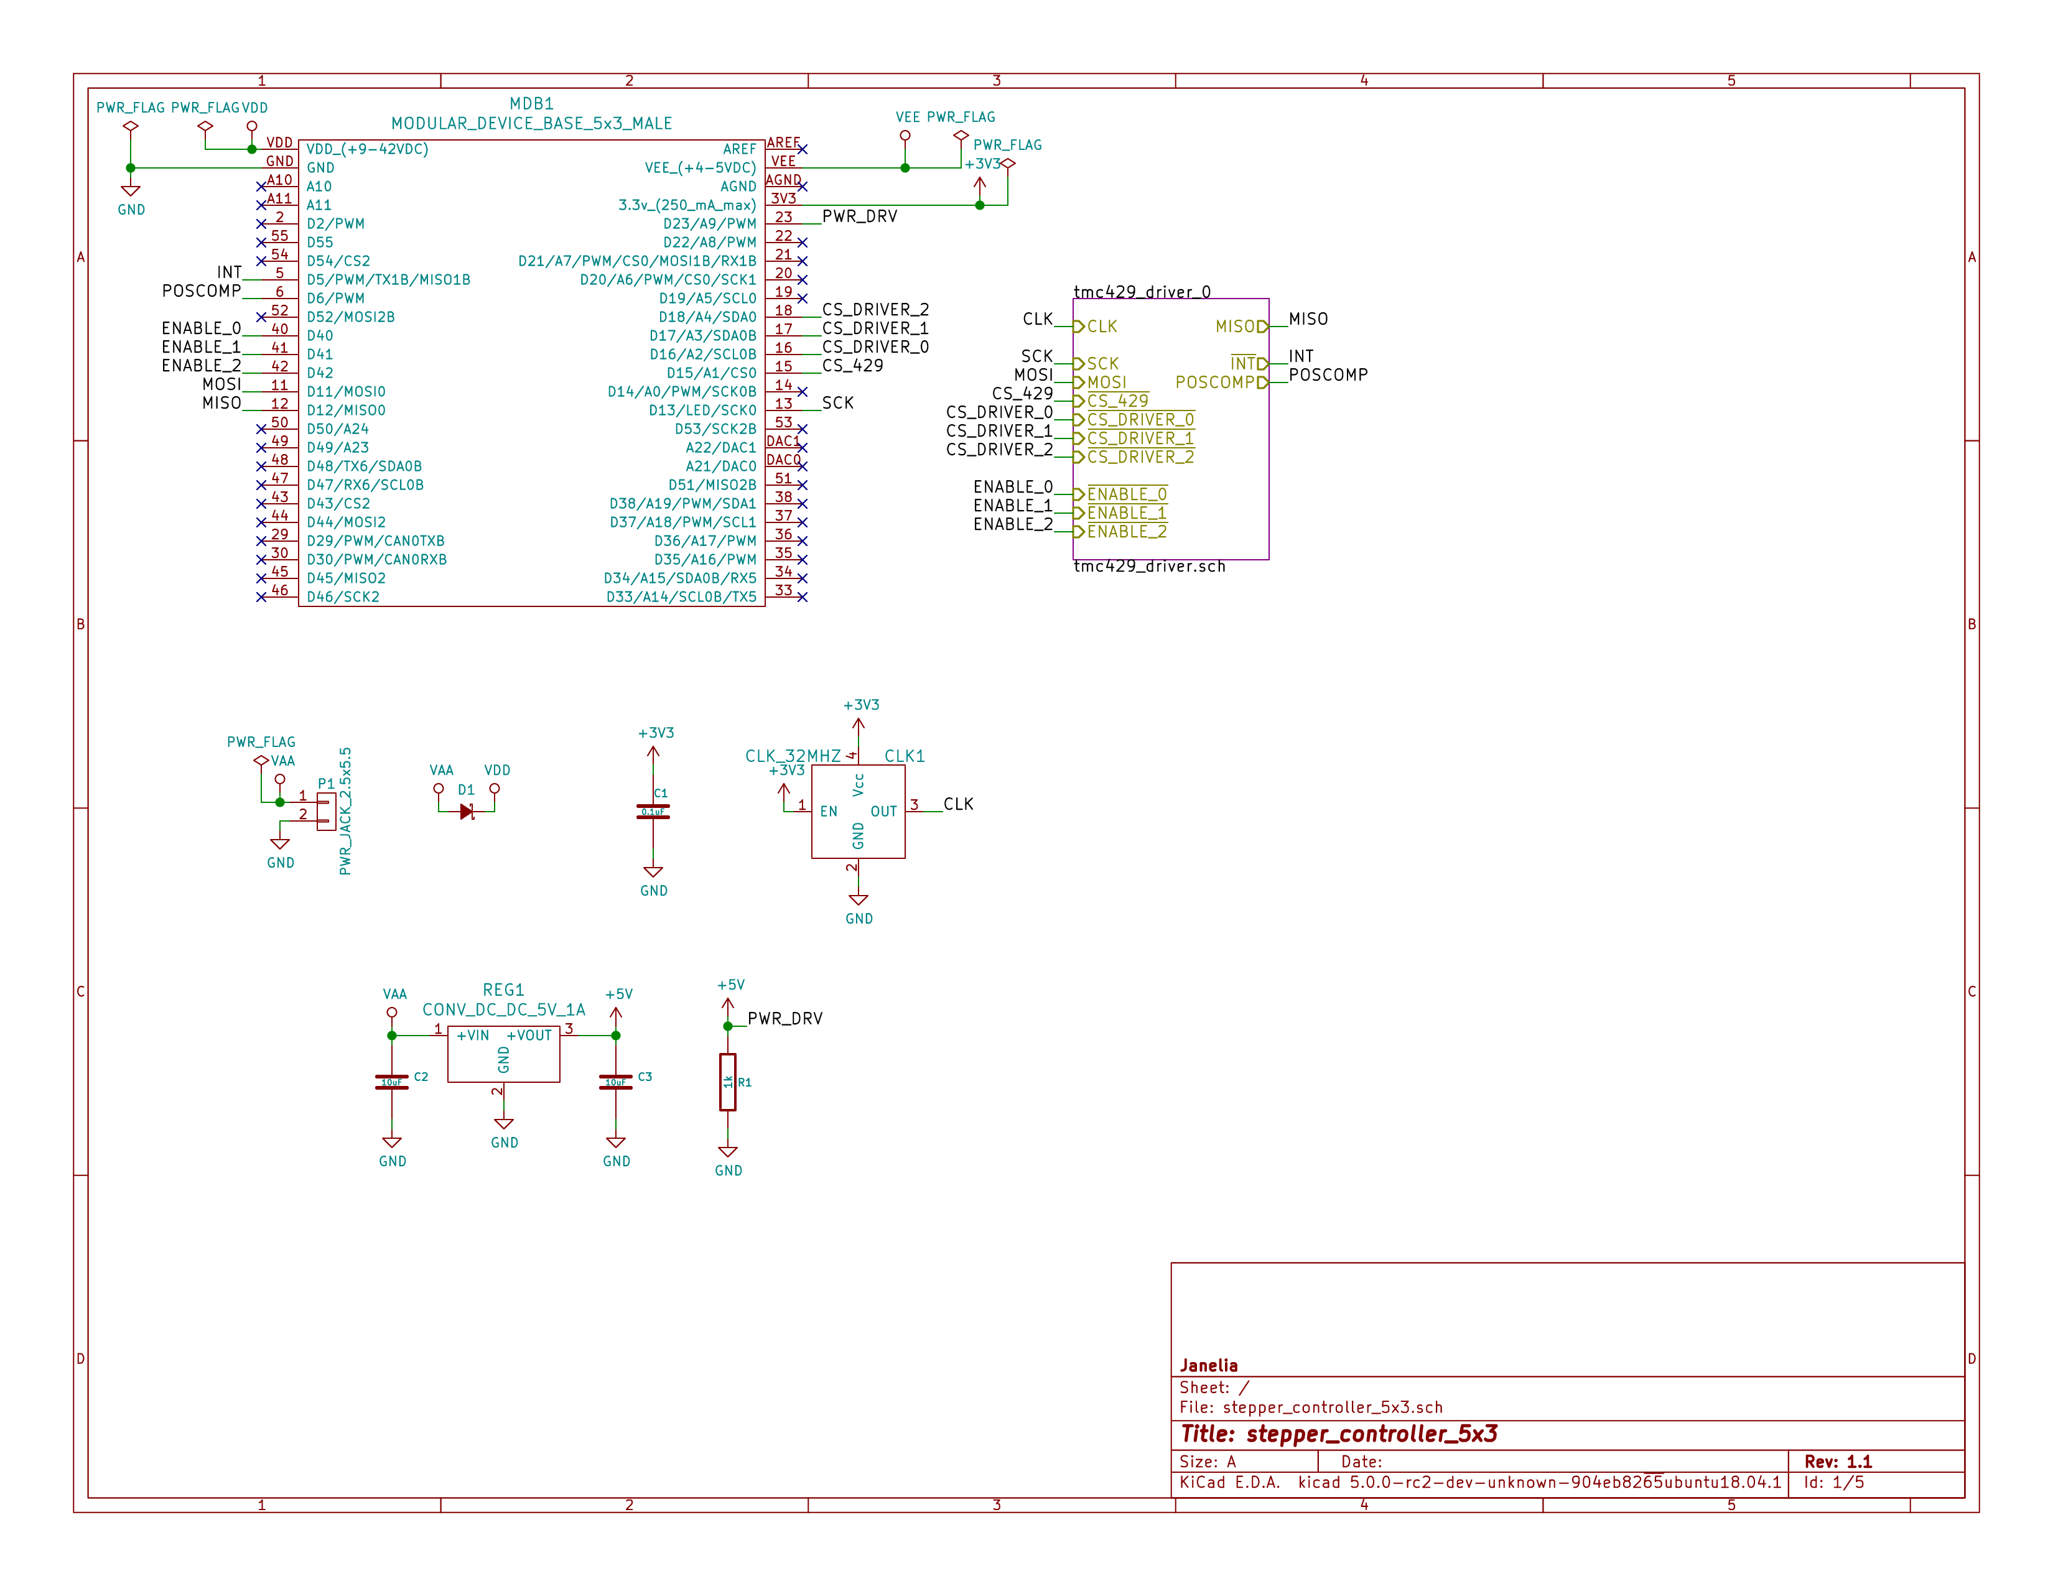
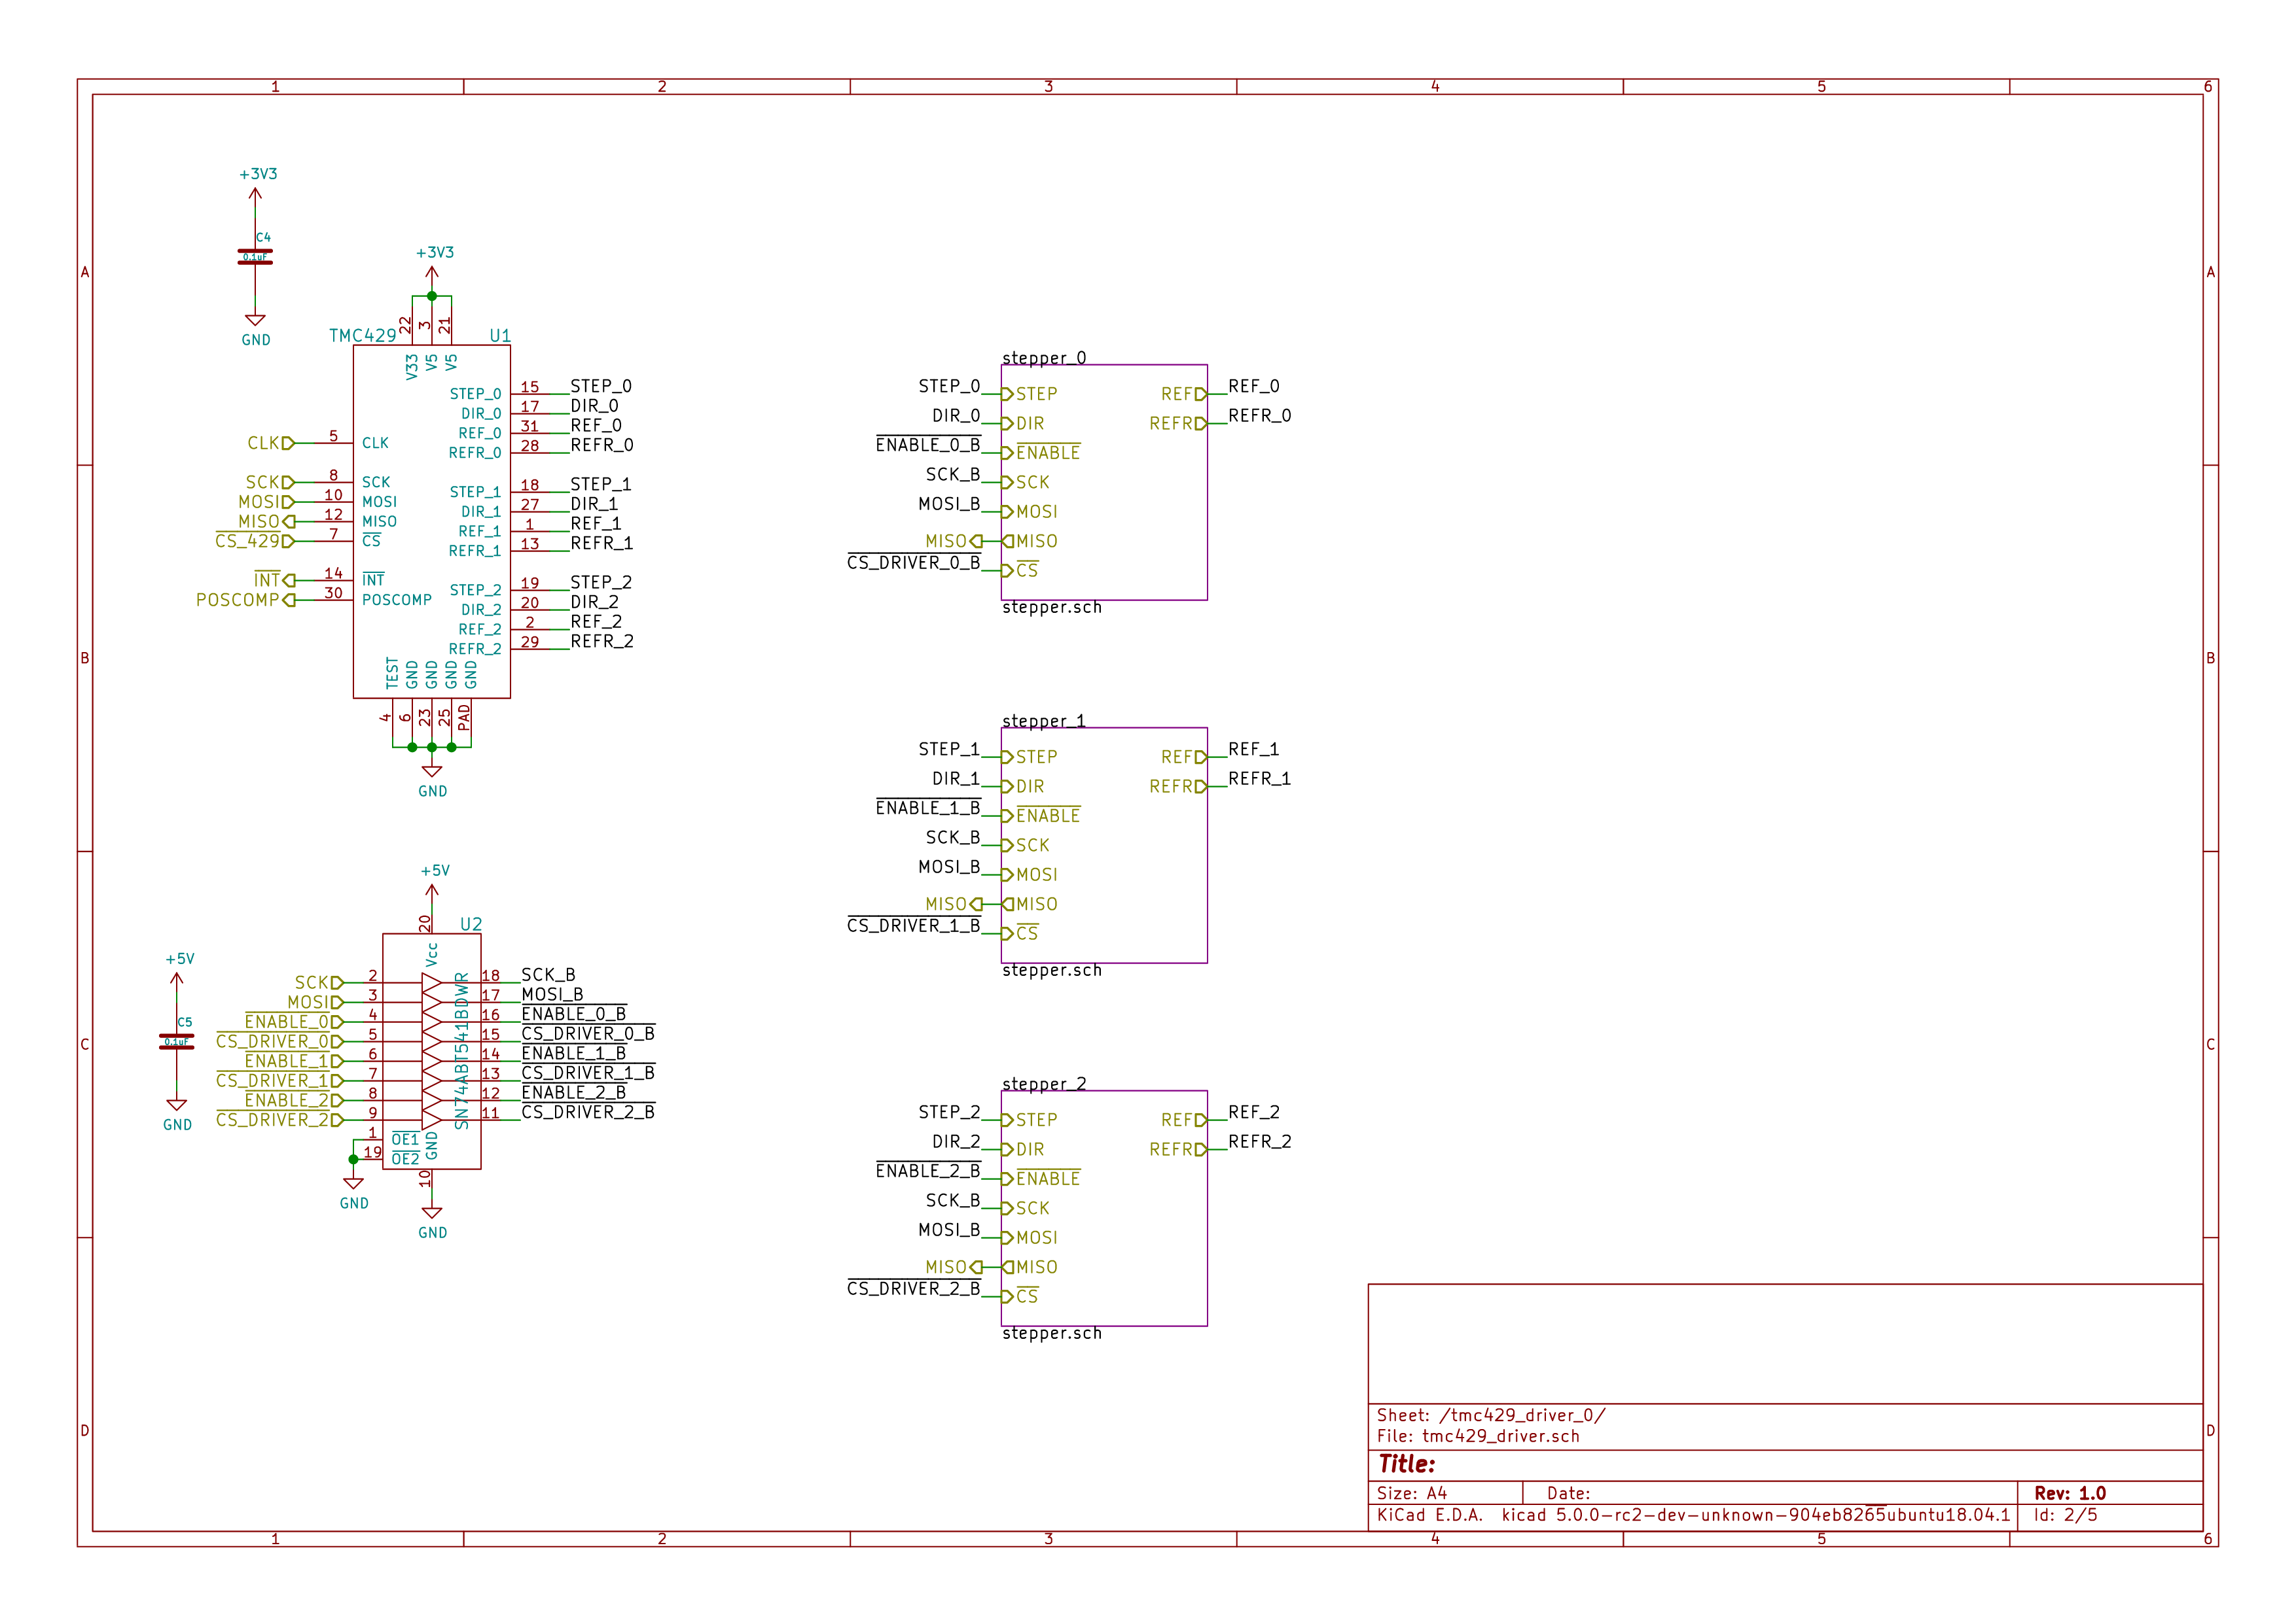
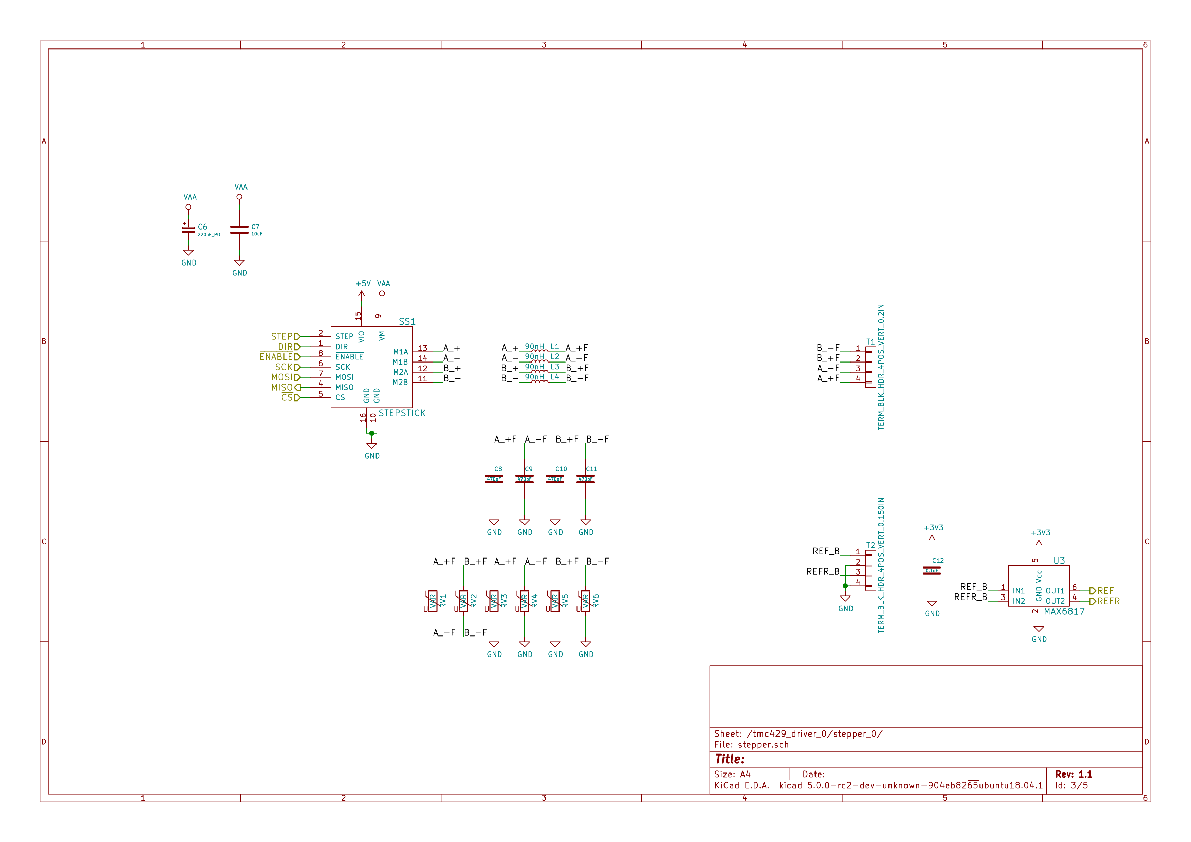
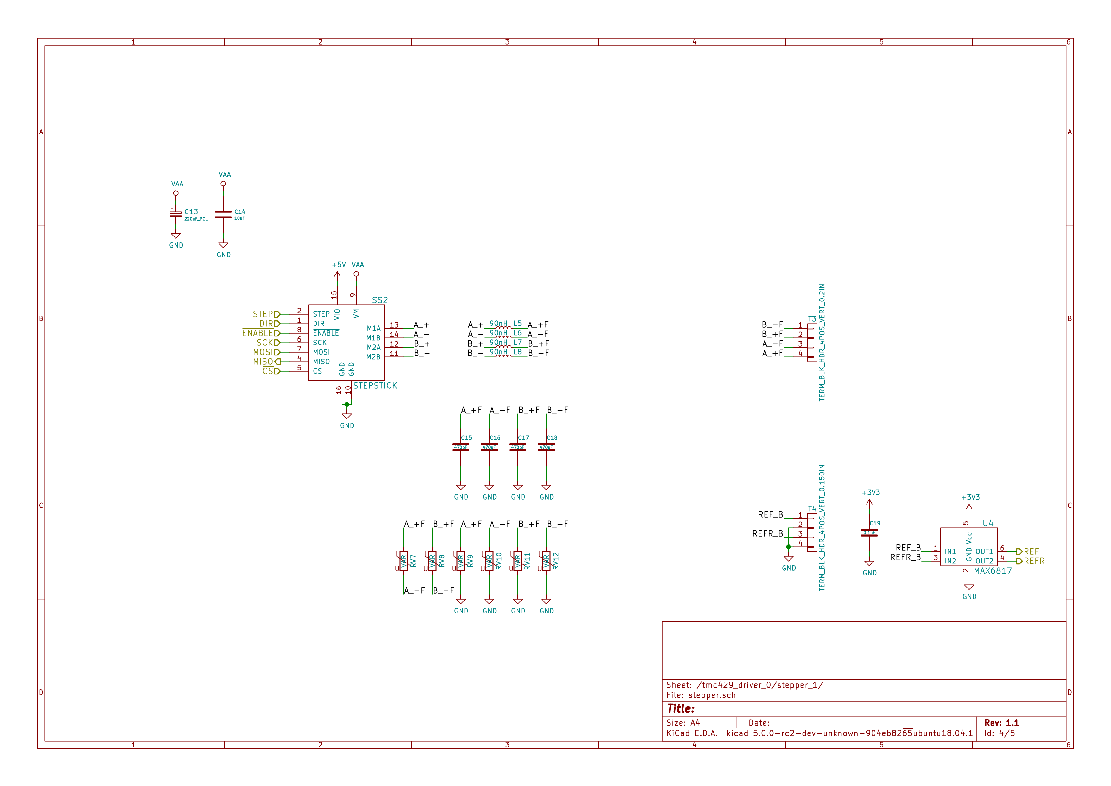
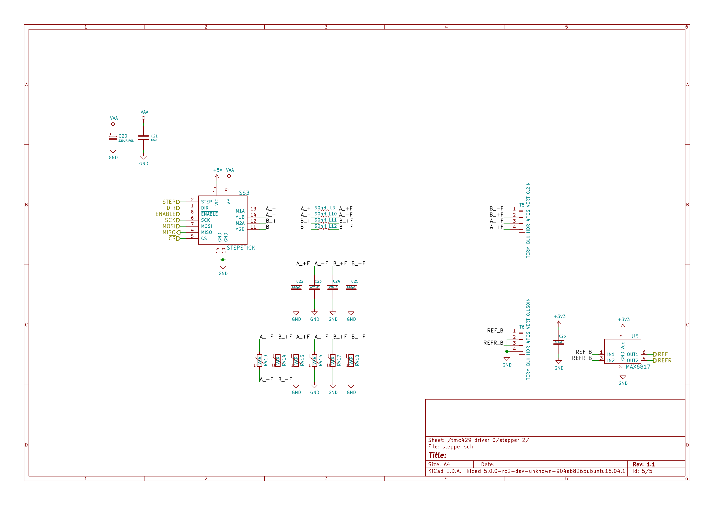

Gerbers
Send gerbers zip file to your favorite PCB manufacturer for fabrication.
./hardware/stepper_controller_5x3/gerbers/stepper_controller_5x3_v1.1.zip
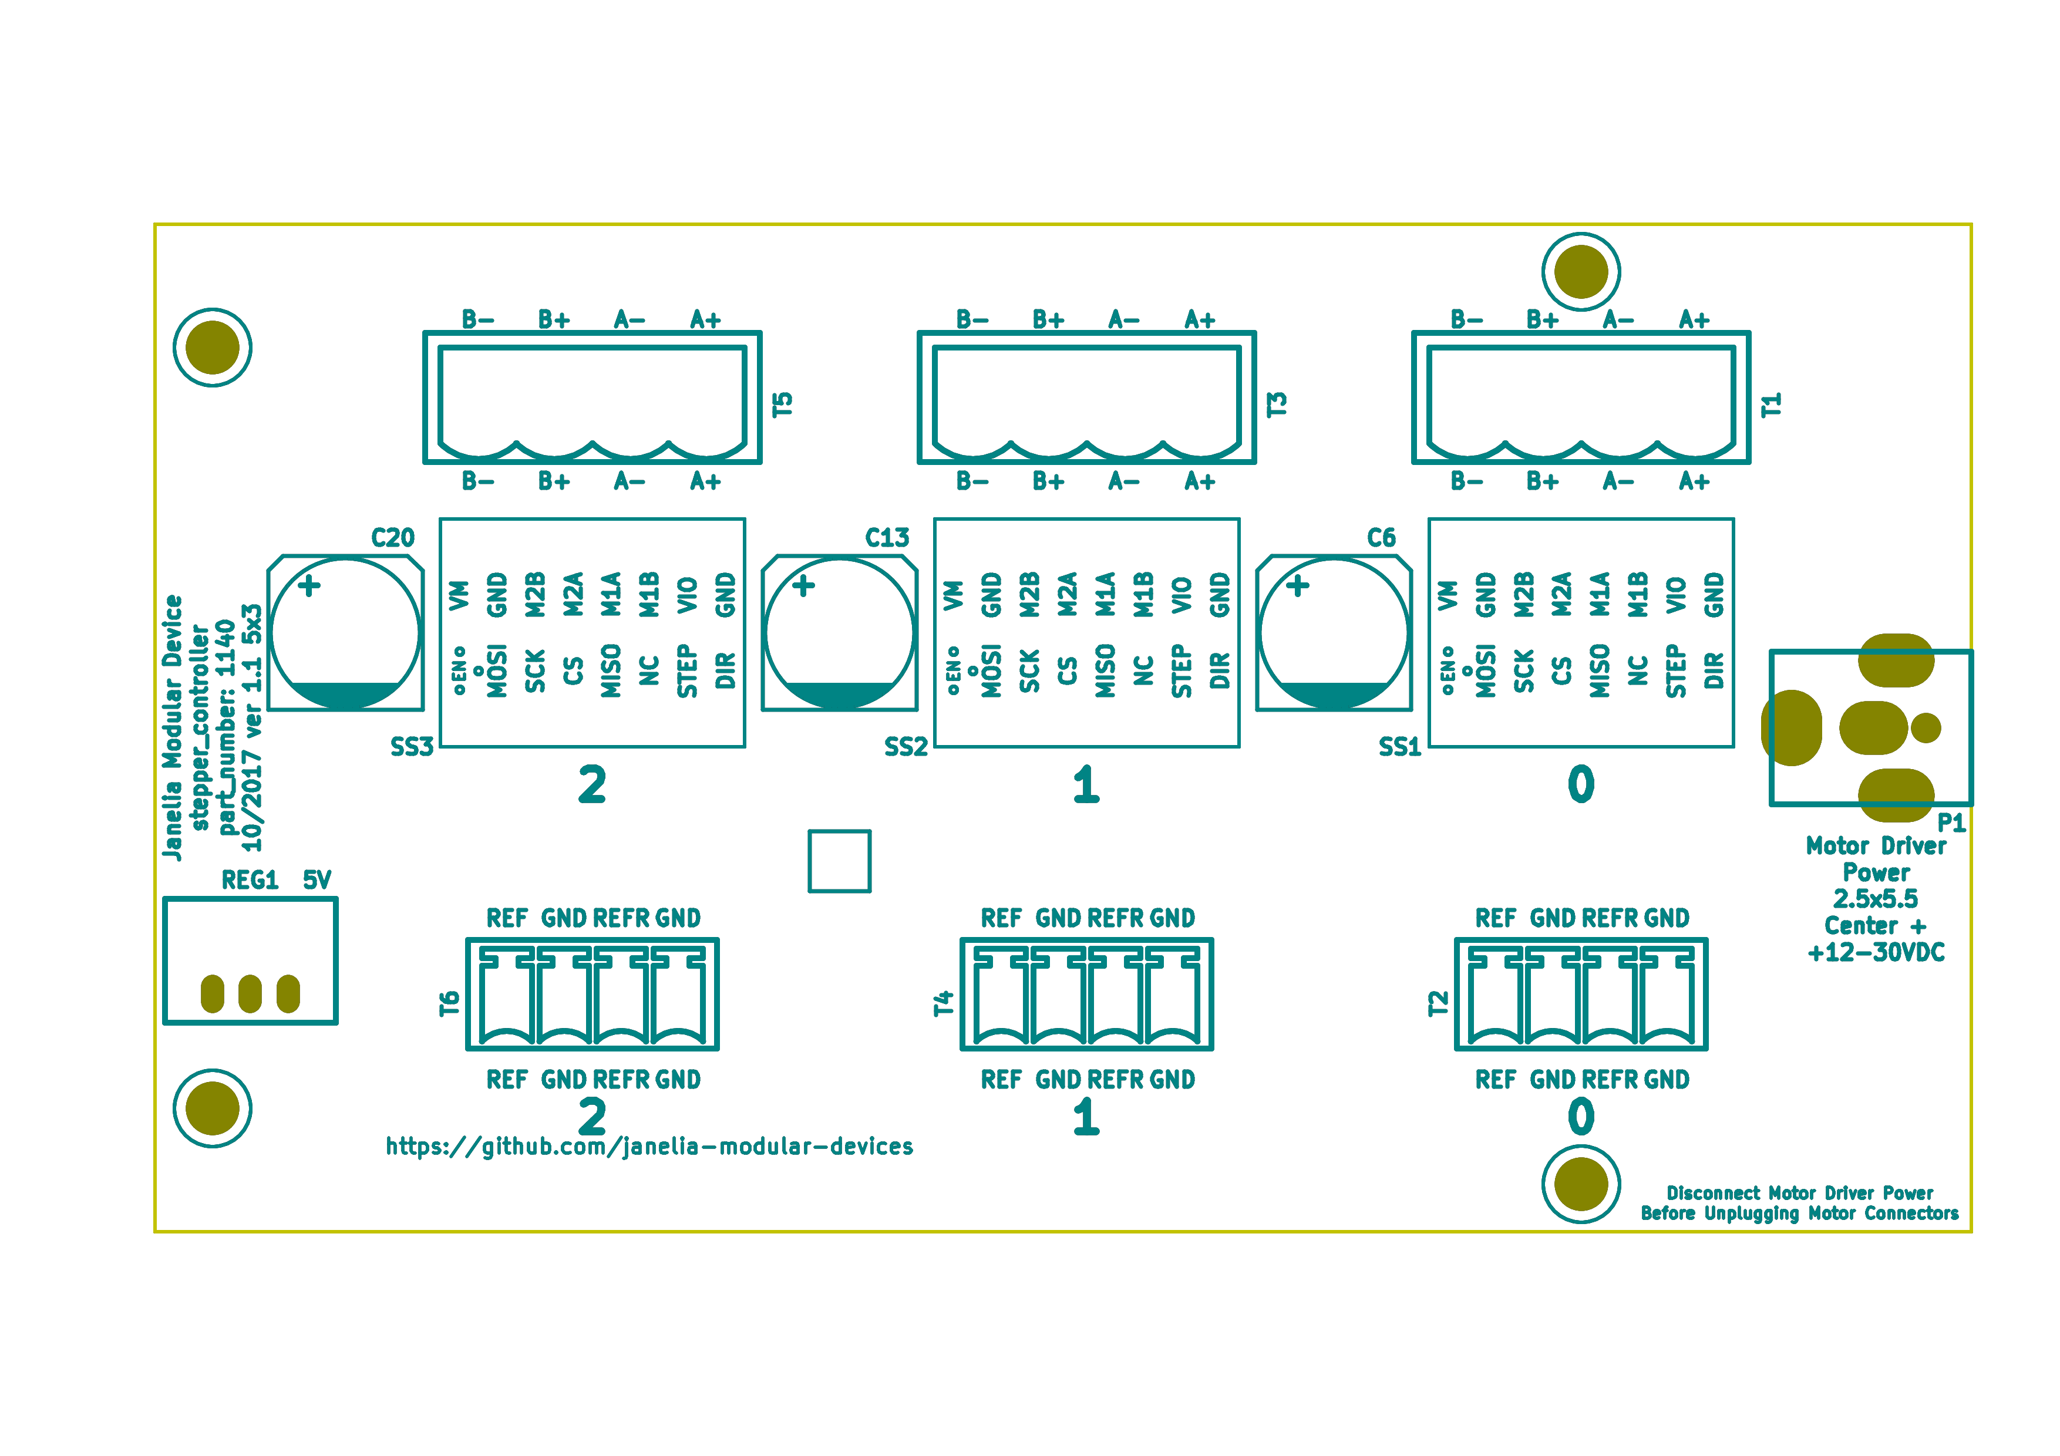
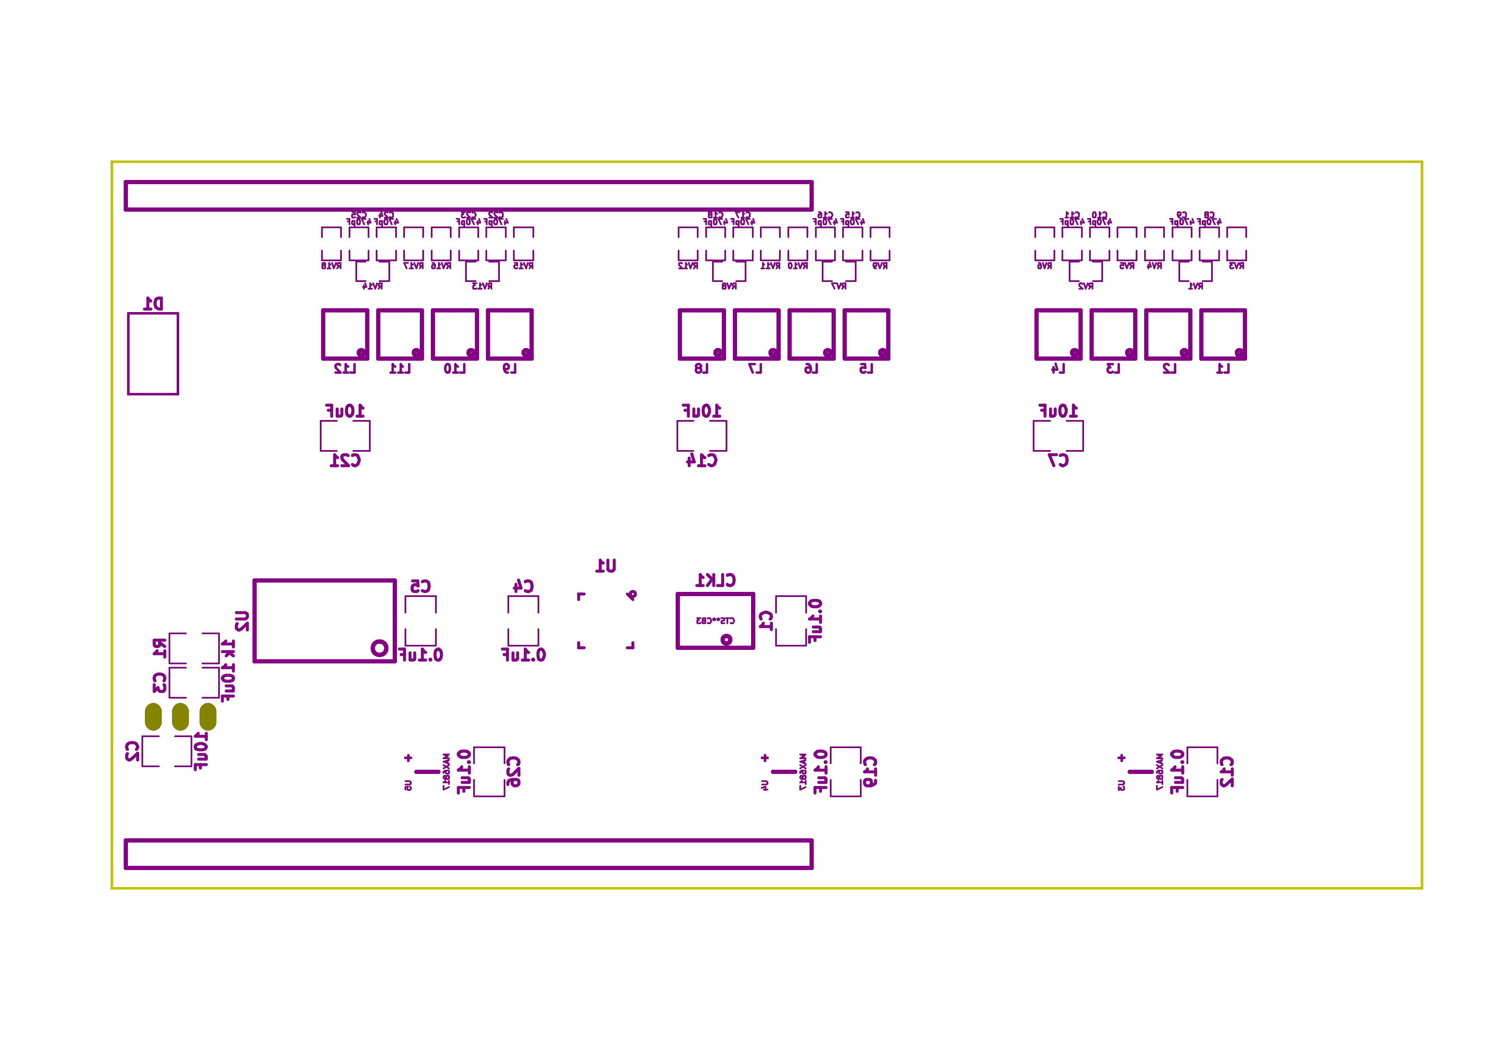

Bill of Materials
- PCB Parts
Item | Reference(s) | Quantity | PartNumber | Vendor | Description
1 | C1 C12 C19 C26 C4 C5 | 6 | 399-13229-1-ND | digikey | CAP CER 0.1UF 100V X7R 1210
2 | C10 C11 C15 C16 C17 C18 C22 C23 C24 C25 C8 C9 | 12 | 478-1350-1-ND | digikey | CAP CER 470PF 100V X7R 0805
3 | C13 C20 C6 | 3 | PCE3812CT-ND | digikey | CAP ALUM 220UF 20% 50V SMD
4 | C14 C2 C21 C3 C7 | 5 | 445-4536-1-ND | digikey | CAP CER 10UF 50V 10% X7S 1210
5 | CLK1 | 1 | CTX277LVCT-ND | digikey | OSC XO 32.000MHZ HCMOS TTL SMD
6 | D1 | 1 | 568-11697-1-ND | digikey | DIODE SCHOTTKY 45V 10A CFP15
7 | L1 L10 L11 L12 L2 L3 L4 L5 L6 L7 L8 L9 | 12 | XC2328CT-ND | digikey | FIXED IND 90NH 8A 8.5 MOHM SMD
8 | MDB1 | 2 | S1011E-25-ND | digikey | 25 Positions Header Breakaway Connector 0.1in
9 | P1 | 1 | CP-063BH-ND | digikey | CONN PWR JACK DC 2.5X5.5 8A T/H
10 | R1 | 1 | P1.00KAACT-ND | digikey | RES SMD 1K OHM 1% 1/2W 1210
11 | REG1 | 1 | 945-1395-5-ND | digikey | CONV DC/DC 1A 5V OUT SIP VERT
12 | RV1 RV10 RV11 RV12 RV13 RV14 RV15 RV16 RV17 RV18 RV2 RV3 RV4 RV5 RV6 RV7 RV8 RV9 | 18 | 495-7454-1-ND | digikey | VARISTOR 47V 80A 0805
13 | SS1 SS2 SS3 | 48 | ED90331-ND | digikey | CONN PIN RCPT .025-.037 SOLDER
14 | T1 T3 T5 | 3 | 277-1152-ND | digikey | TERM BLOCK HDR 4POS VERT 5.08MM
15 | T2 T4 T6 | 3 | 277-1223-ND | digikey | TERM BLOCK HDR 4POS VERT 3.81MM
16 | U1 | 1 | 1460-1071-1-ND | digikey | IC MOTOR CONTROLLER SPI 32QFN
17 | U2 | 1 | 296-14668-1-ND | digikey | Buffer Non-Inverting 1 Element 8 Bit per Element Push-Pull Output 20-SOIC
18 | U3 U4 U5 | 3 | MAX6817EUT+TCT-ND | digikey | IC DEBOUNCER SWITCH DUAL SOT23-6
- Supplemental Parts
Item | Quantity | PartNumber | Vendor | Description
1 | 3 | 277-1013-ND | digikey | TERM BLOCK PLUG 4POS STR 5.08MM
2 | 3 | 277-1042-ND | digikey | TERM BLOCK PLUG 4POS 5.08MM
3 | 3 | 277-1163-ND | digikey | TERM BLOCK PLUG 4POS STR 3.81MM
4 | 3 | 277-1193-ND | digikey | TERM BLOCK PLUG 4POS 90DEG 3.81MM
5 | 3 | 1460-1187-ND | digikey | TMC2130 STEPPER DRIVER BOARD
6 | 3 | 501100B00000G-ND | digikey | HEATSINK 14-DIP/16-DIP
7 | 1 | 3M10315-ND | digikey | TAPE ADHESIVE TRANSFER 1/2in X5YD
- Vendor Parts Lists
./hardware/stepper_controller_5x3/bom/digikey_parts.csv
./hardware/stepper_controller_5x3/bom/supplemental_digikey_parts.csv

Supplemental Documentation
- Assembly Instructions
  - Solder header pins into the stepper driver board(s), making note of TOP label. Insert header pins on bottom of board so that the long unsoldered header pins point down when the TOP label faces up.
  - Expose one side of the thermal adhesive tape and attach to the bottom of the heatsink. Trim tape so it does not extend beyond heatsink edges.
  - Expose the other side of the thermal adhesive tape and attach the heatsink to the stepper driver board on the side with the TOP label.
  - Solder surface mount and through hole components onto the pcb.
  - Insert stepper driver board(s) into pin receptacles.

