Imbalanced Data Analysis in Machine Learning
To predict the success of bank telemarketing
Minjie XU 2019-06-25
Abstract
In this report we address the problem of classification on imbalanced classes dataset to predict if the client will subscribe a bank term deposit. We use a number of machine learning and deep learning algorithms: random forest tree, logistic regression, linear supporting vector machine and multi-layer perceptron neural network, to perform the classification. Combining those algorithms with four ways of rebalancing methods, we are able to compare precision, recall, 10-fold cross-validation scores and auc-roc curve of the mentioned method-combinations.
Furthermore, we discuss the reasons of differences among rebalancing methods on different algorithms. LinearSVC has best performance considering processing time and performance indices. Using randomly undersampling, it can achieve the classification sensitivity (recall) of 0.67 and precision of 0.27 with an auc score of 0.72 on class yes.
In the end, we took logistic regression algorithm as example to build up our cost-based model, using cross validation to find out the best lowcost rate for class “no” (Known that cost for class “yes” is assigned as 1). Meanwhile we compared it with the f1 score targeted model with best class_weight parameter.

Problem Statement
Imbalanced data is a problem that an analyst may face while dealing with data analysis. Imbalanced data has a feature that most observations belong to one class while less observations belong to one or other classes. The problem in this project is a two-class problem, which shows a feature that most observations belong to one class. Imbalanced data will make it difficult and challenging for data analysis and model learning. In this project, the results are clients’ decisions (yes or no) of subscription of a deposit. Bank managers need to focus on people who subscripted the deposit and pay less attention to clients who refused to subscribe deposit.
Accuracy rate is not the only judgment criterion. For a bank manager, if given a model showing an accuracy of 94%, and he may think this model is working well. However, if exploring deeper, he will find out that all 94% accuracy is principally contributed by the majority class, while the true target is to distinguish the minority class, in which case this model is useless.
We use two terms to judge if the model can separate the minority class from the majority class: precision and recall. The cross-validation scores of recall and precision and auc-roc curve can be sued to estimate the model performance. The following discussions explain the two terms further.
The definition of precision of a class is how trustable the result is when the model show that a certain point belongs to that class. The recall of a class expresses how well the model detects that class. The following table shows how the two terms judge model performance.
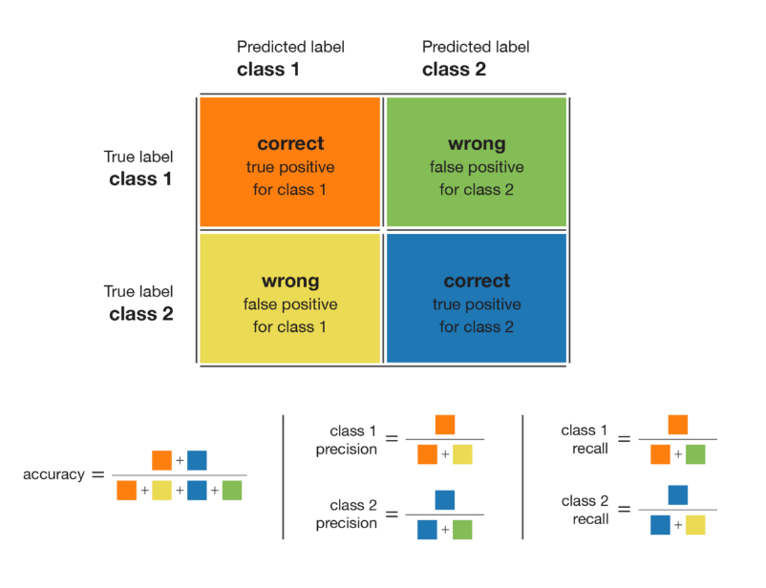
Figure 1: Confusion matrix in machine learning

Four combinations are present for compare in Table 1.

Table 1: Two terms judge performance table
Combination | Model performance
high recall + high precision | the class is perfectly handled
low recall + high precision | cannot detect the class well but is highly trustable when it does
high recall + low precision | the class is well detected but the model also includes points of other classes in it
low recall + low precision | the class is poorly handled

In our case, we have 36548 clients did not subscribe to term deposit, while 4640 clients subscribed to term deposit. The model is totally build based on data. If we had to train a classifier on these imbalanced data, the accuracy of the classifier would be maximal when always answering not “willing” to subscribe: since if we always say a client belongs to class “no”, we can detect all subscripted clients.
However, the true target of the model is to detect the class “yes”, which is the minority class. Therefore, the classifier with imbalanced dataset cannot do a good job on separating the two classes. If we rebalanced the two classes and make the two distributions equally scaled, a classifier will not keep answering “no” all the time.
To sum up, this study considered the typical case of bank marketing campaign dataset with three main objectives. First, to predict customer response to bank marketing by applying four classifiers namely, Random Forest, Logistic Regression, Linear SVC and Multilayer Perceptron Neural Network (MLPNN). The second objective was to identify the imbalanced dataset, rebalanced data and their effects when adapted in different machine learning classifiers. The third objective was to test the cost-based model on the imbalanced bank marketing dataset and evaluate its performance.
Data Description
The dataset for our project is based on “Bank Marketing” UCI dataset. The binary classification goal is to predict if the client will subscribe a bank term deposit (variable y).
Data resource: https://archive.ics.uci.edu/ml/datasets/bank+marketing

Table 2: Bank marketing dataset description
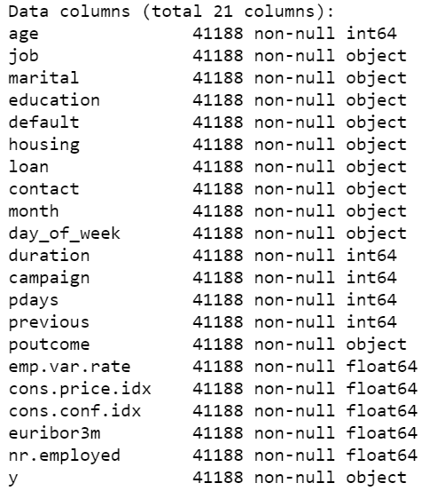
The dataset has 41188 rows and 21 columns. Within the dataset, 20 variables (predictors) including 11 categorical variables and 9 numerical variables which shows in figure 3, as well as 1 dependent response (variable y). The basic statistic information of numeric variables is show below:

Table 3: Basic statistic information of dataset
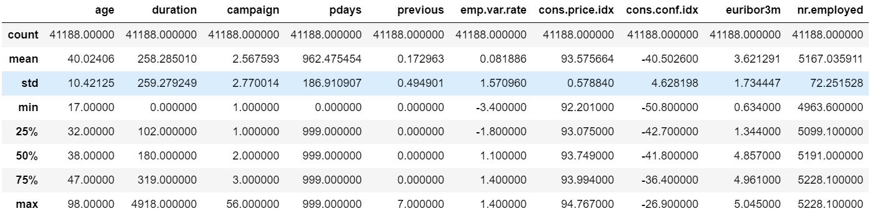

The 20 variables cover bank client data (age, job, marital, education, default, housing, loan), contact of current campaign (contact type, month, day of week, duration), other contact attributes (number of contacts in this campaign, days passed by after last contact, number of contacts before this campaign, outcome of previous campaign) and social and economic context attributes (employment variation rate, consumer price index, consumer confidence index, euribor 3 month rate, number of employees).
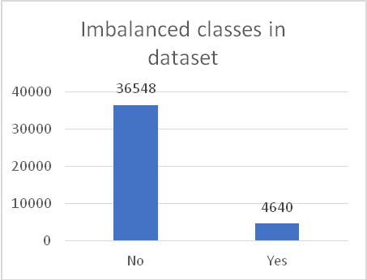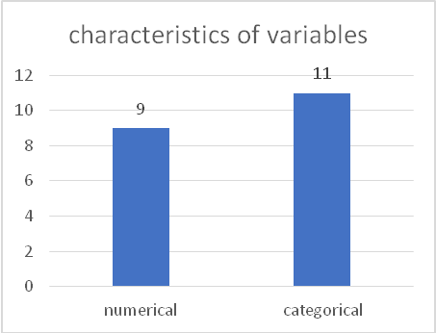
Figure 2: Imbalanced classes in dataset Figure 3: Characteristics of variables

Data manipulation
We start from numerical variables. For the classification model, all variables should be independent, since collinearity reduced the accuracy of the estimates of parameters (the variance grow in the direction of co linearity). Working through correlation heatmap in Figure 4, we find three variables are highly correlated (correlation coefficient greater than 90%). They are emp.var.rate, euribor3m and nr.employed. We only kept the first one and dropped the last two since the emp.var.rate has less unique values.
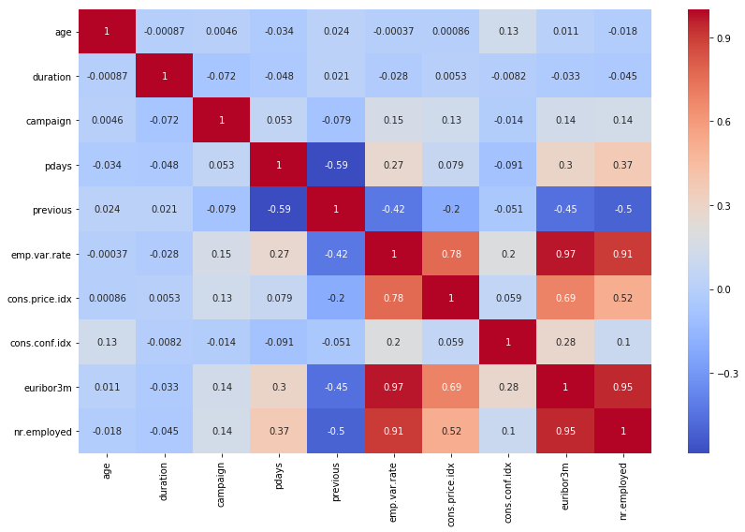
Figure 4: Correlation coefficient of numerical variables

Furthermore, for this classification problems, we plotted numerical variables with dependent variable y. This helped us determine the clusters if exists of classes 0 and 1. The results show no clusters exist. During data exploration analysis, we found “age” has 78 different unique values and “duration” has 1544 different unique values. We should bin these variables accordingly. We use quantiles to split variable values into bins to keep their distribution characteristics. In addition, we removed “duration” variable as requested in the description file because we intent to have a realistic predictive model.
We also found the variables “campaign” have several levels (unique values) with low frequencies. Such levels don’t help as chances are they would not be available in test set. With the help of Decision Trees (figure 5), we have been able to convert a numerical variable into a categorical one and get a quick user segmentation by binning the numerical variable in subgroups. This process will reduce the variance in our datasets. Without this process, there could be missmatch between training and testing data, and the model will treat them as missing values, which also leads to missing information.

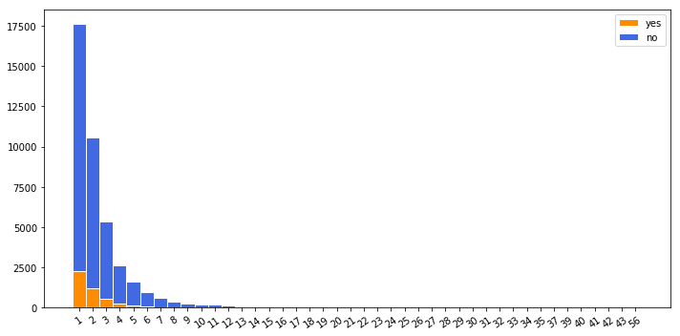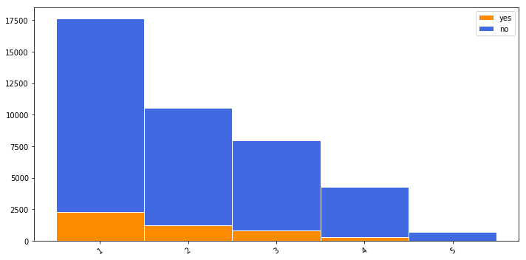
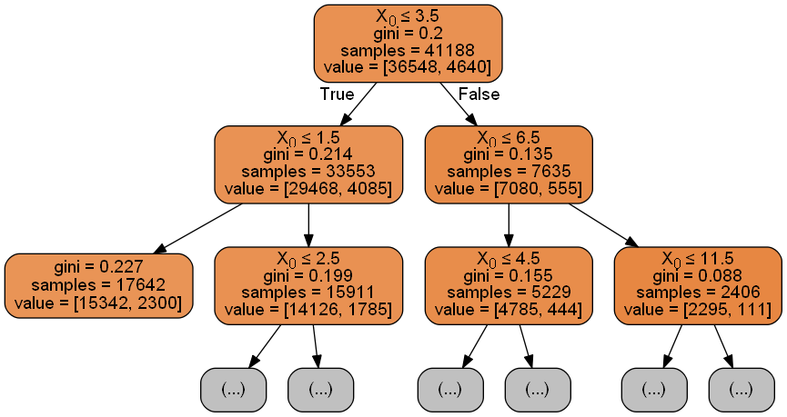
Figure 5. Example of decision trees to bin numerical variable “campaign”. left: before binning. right: after binning. middle: decision tree for “campaign”.

Similarly, categorical variables can be more clearly visualized by dodged bar charts. In the dodged bar chart, the categorical variables and dependent variables adjacent to each other are plotted, from which severe imbalanced classes are also found. The next step is to encode these categorical variables via sklearn LabelEncoder.
The last column is the response consisted of “yes” and “no” two classes. The severity of imbalanced classes in data is shown in figure 2. The majority class “no” consists 88.7% of the population. In other words, with a decent machine learning algorithm, our model would get 88.7% model accuracy. In absolute figures, it looks incredible, but our performance would depend on how good we can predict the minority classes.

Methodology and Implementation
In our study, we took two common machine learning methods to train a model: tree-based logical rules developed according to splitting criterion and parameterized models updated by gradient descent.
When building a tree-based model (such as random forest tree), our objective is to find logical rules which are capable of taking the full dataset and separating out the observations into their different classes and then to average the effect of many trees. In other words, we'd like each split in the tree to increase the purity of observations such that the data is filtered into homogeneous groups. If we have a majority class present, the top of the decision tree is likely to learn splits which separate out the majority class into pure groups at the expense of learning rules which separate the minority class.
As for a parameterized model by gradient descent to minimize our loss function, many machine learning models are subject to a frequency bias in with they place more emphasis on learning from data observation which occur more commonly. They update the parameter values in the direction which benefit the majority class.
- Rebalancing dataset
We choose 4 ways to address the class imbalance:
a. Add class weight parameter in sklearn-learn work
Theoretically, the weight for each class which can place more emphasis on the minority classes such that the final result is a classifier which can learn equally from all classes.
b. Oversampling by imblearn package in python:
This way can simply alter the dataset by randomly sample the minority classes and simply duplicate the sampled minority observations until we have reached a balanced dataset.
c. Undersampling by imblearn package in python:
This technique can achieve class balance by randomly remove data of the majority class to make the model easier to learn characteristics about the minority classes.
d. Combination of oversampling (SMOTE) and undersampling (ENN)
SMOTE can generate noisy samples by interpolating new points between marginal outliers and inliers. ENN can be solved by cleaning the space resulting from over-sampling.
To compare the effect of rebalancing, we also implement the models on the original imbalanced dataset, as control group.
- Classifiers
a. Random Forest
Random Forest is an ensemble learning algorithm for classification and regression. Random Forest generates a multitude of decision tree classifies based on the aggregated decision of those trees. For a set of predictors x1, x2, …xn and their respective label y, bagging repeatedly select a random sample (Xb, Yb) with replacement. Each classification tree fb is trained using a different random sample (Xb, Yb) where b ranges from 1…B, B is the number of estimators. Finally, a majority vote is taken of predictions of these B trees.
We implemented random forest algorithm by using RandomForestClassfier from sklearn.ensemble provided by scikit-learn, We experimented using 100 estimators (trees) using both presence and frequency features.

b. Logistic Regression
Logistic regression is generally used where the dependent variable is Binary. The algorithm of Maximum Likelihood Estimation (MLE) determines the regression coefficient for the model that accurately predicts the probability of the binary dependent variable. The algorithm stops when the convergence criterion is met, or maximum number of iterations are reached. Since the probability of any event lies between 0 and 1 (or 0% to 100%), when we plot the probability of dependent variable by independent factors, it will demonstrate an ‘S’ shape curve.
We implemented Logistic regression algorithm by using LogisticRegression from sklearn.ensemble provided by scikit-learn, We experimented using default parameter setting.

c. Linear SVC
SVM also known as support vector machine, is a non-probabilistic binary linear classifier. Linear SVM is the SVM algorithm with linear kernel and Linear SVM is faster and can scale a lot better. Therefore, we choose Linear SVM rather than SVM in our case. For a training set of points (Xi,Yi), where x is the feature vector and y is the class, we want to find the maximum-margin 2D-hyperplane that divides the point with yi=1 and yi=-1. We want to maximize the margin in order to separate the points well.
We utilize the LinearSVC available in sklearn. We set the C term to be 1 as default. C term is the penalty parameter of the error term, which influences the misclassification on the objective function. We also set dual=False, since our number of samples is greater than the number of features.

d. Multi-layer Perceptron neutral network
MLP is a class of feed-forward neural networks, which has at least three layers of neurons. Each neuron uses a non-linear activation function and learns with supervision using backpropagation algorithm. It performs well in complex classification problems by learning non-linear models.
We used keras with TensorFlow backend to implement the Multi-layer Perceptron model, since the MPLclassifier does not contain class_weight parameter which allows us to balance our dataset. Working through keras, we used the rectifier (‘relu’) activation function on the first two hidden-layers and the sigmoid function in the output layer. For each layer, we select the number of neutrons in hidden-layers equal to the average of input number of variables (which is 17 in our case) and output number of variable (which is 1 in our case). We also define epoch=100 and batch_size equal to 64, taking the calculation speed into account.

Performance
There are two types of wrong values to consider before deciding on the more important class:
- False positive, means the client will not subscribe to term deposit, but the model thinks he will
- False negative, means the client will subscribe to term deposit, but the model says he will not.
In our opinion, the first one is not good but it is OK, we just waste time and human resources to call them and then get a bad result, while the second one is most harmful, since we think they will refuse to subscribe and we choose to not call them, in that way, we miss our true clients and have true economical loss.
To be specific, we wish to have a high rate of true positive and a low rate of false negative. Alternatively say, one of the most important traits of the model is having a relatively high recall for class “yes”, another is a relatively high precision for class “yes”.
We perform experiments using various different classifiers. The dataset is split into 70% training data and 30% testing data. We use 10-fold of the training dataset for validation of our models to check against overfitting. Besides, ROC Curves are used to summarize the trade-off between the true positive rate and false positive rate for a predictive model using different probability thresholds. The area under the curve (AUC) is used as a summary of the model skill. Then, A high cross-validation scores (recall and precision) means low possibility of overfitting problem and would adapt well with new data.
For each algorithm, we list the cross-validation scores (recall and precision respectively), auc-roc curve, precision for class “yes” and recall for class “yes”.

Random Forest
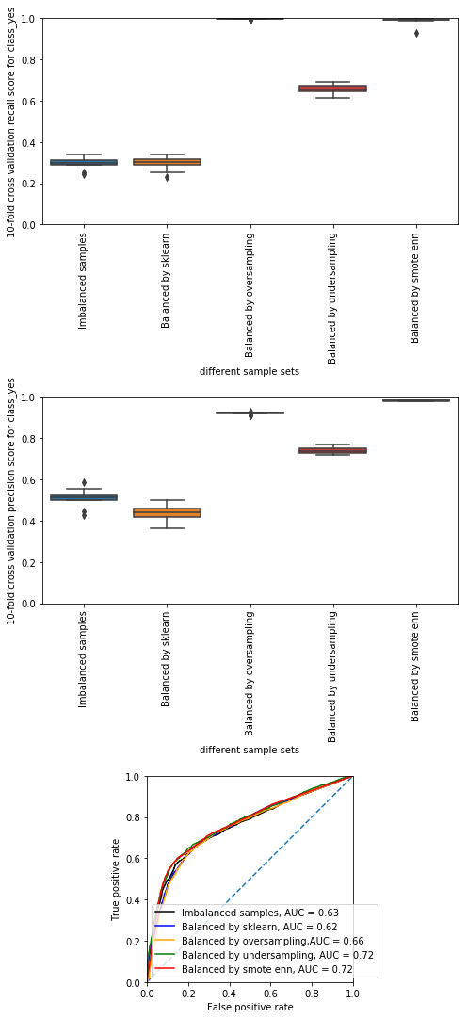
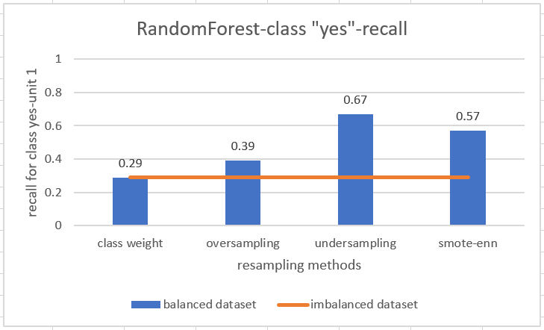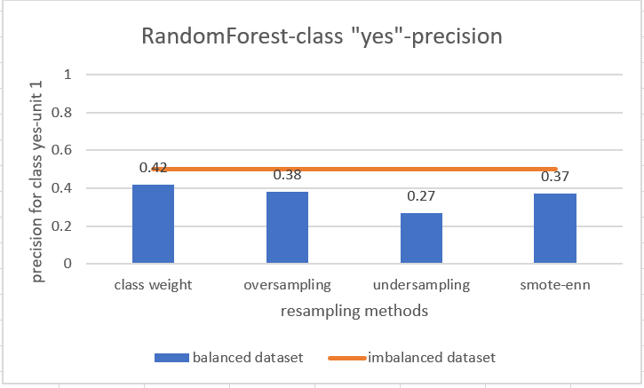
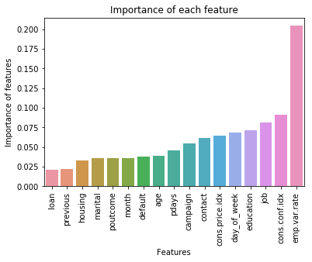

The smote-enn method outperforms the other resampling method combined with random forest algorithm: it has higher recall and precision for the minority class, also with a higher auc score.
It makes sense for the pit of cross-validation score for undersampling (lower than oversampling and smote-enn) because it has less sample amount. Since random forest split square root number of predictors each time, the resampling with larger sample amount can enlarge the effect of split, which can reduce possibility of overfitting.
However, the class_weight parameter in sklearn RandomForest seems to have little effect on increase of the recall rate.
The bottom right plot is the importance of features estimated by random forest on imbalanced dataset. The two most important features are “emp.var.rate” and “cons.conf.idx”.

Logistic Regression
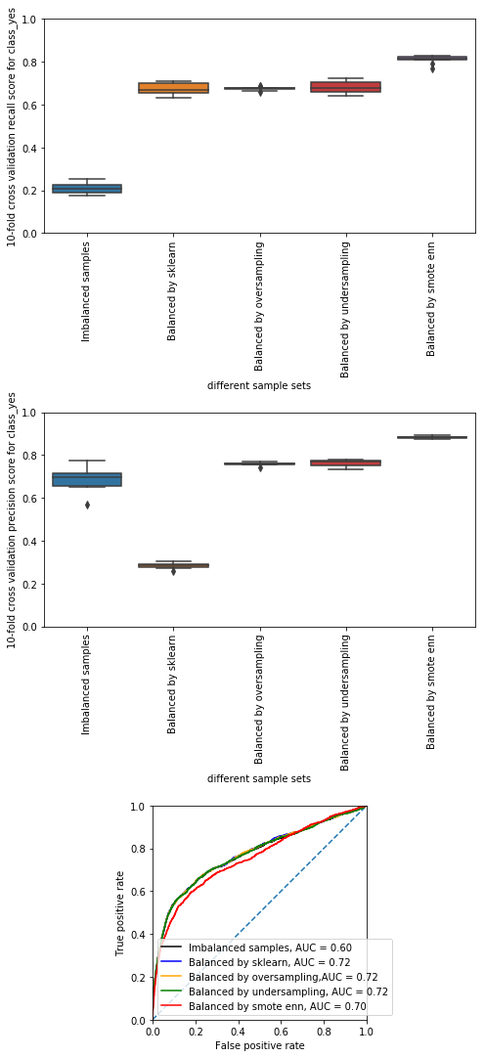
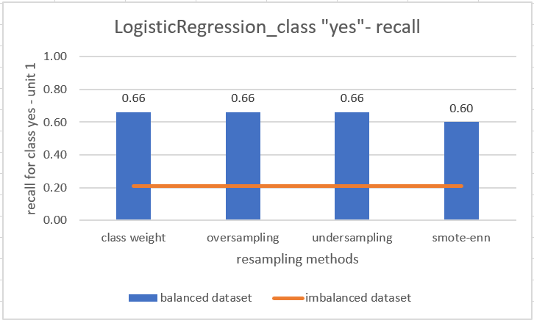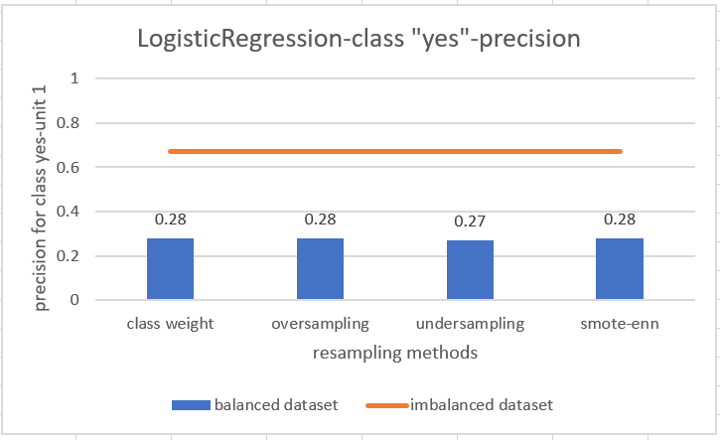
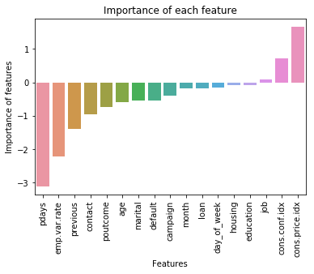
There is no obvious difference in performance when using logistic regression to evaluate the sklearn, oversampling and undersampling approaches: They all increase the recall and decreseas the precision in class “yes” to show up the trade-off, therefore they have the same auc score. Smote enn has a little lower auc score but it is a little better for cross validation. That means this approach well balances two classes: not emphasis too much on false negative.
However, the class_weight parameter in sklearn approch seems to have bad performance for precision during cross-validation. It could probably be explained by difference in the penalty ratio of error for different folds. We chose balanced class-weight by taking inversed proportion rate as penalty ratio of error. However, the penalty ratio for false positive probably lower than that in the fold, which cause the overfitting for precision.
The bottom right plot is the importance of features estimated by logistic regression on imbalanced dataset. The two most important features are “pdays” and “emp.var.rate”.

LinearSVC
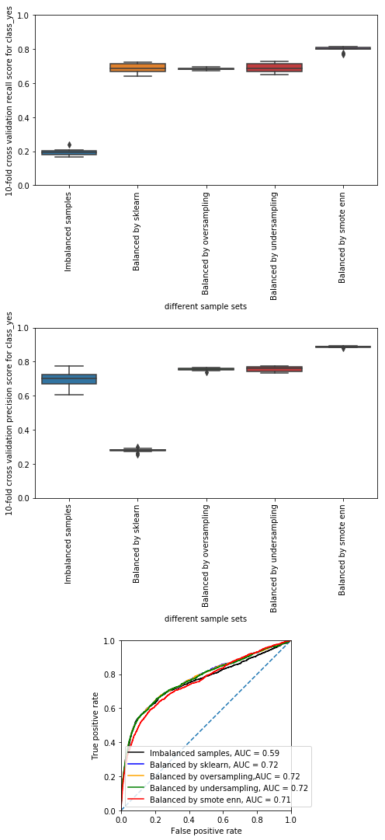
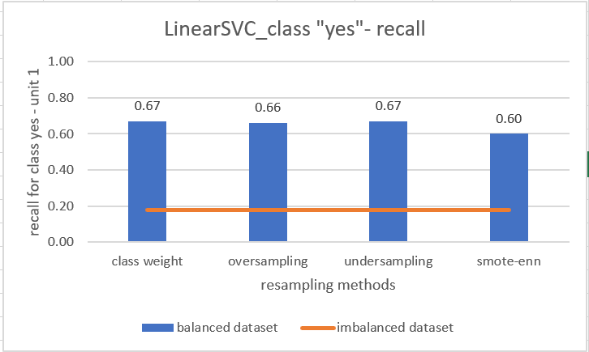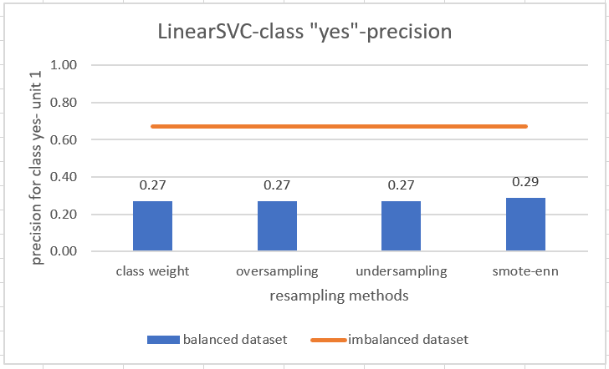
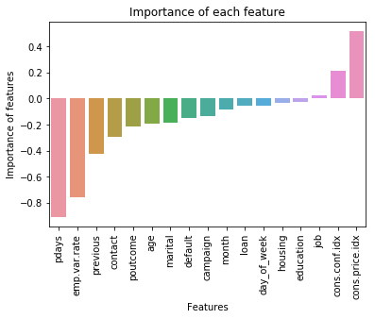

Similar to the logistic regression, linearSVC algorithm does not well distinguish the performance of resampling methods. It only shows a slightly better performance than logistic regression. One of the main differences is, that the SVC algorithm uses positive distance or negative distance to show the belonging of two classes at the sides of hyperplane, while logistic regression only shows probability.
The bottom right plot is the importance of features estimated by linearSVC on imbalanced dataset. The two most important features are “pdays” and “emp.var.rate”.

Multi-layer Perceptron neutral network
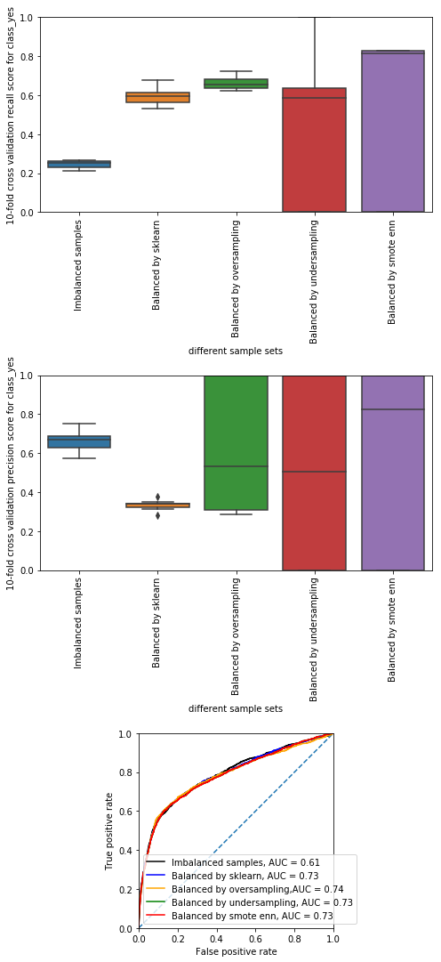
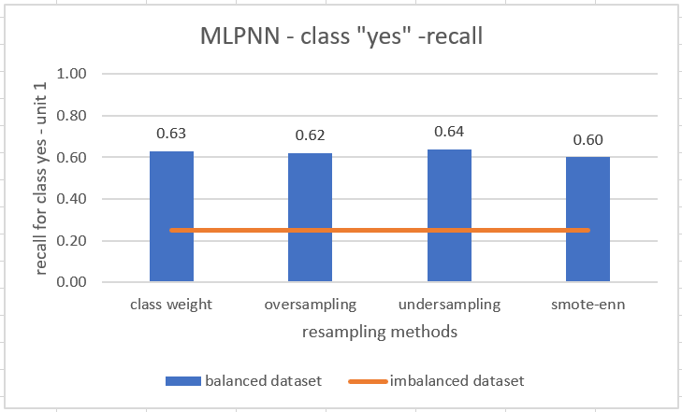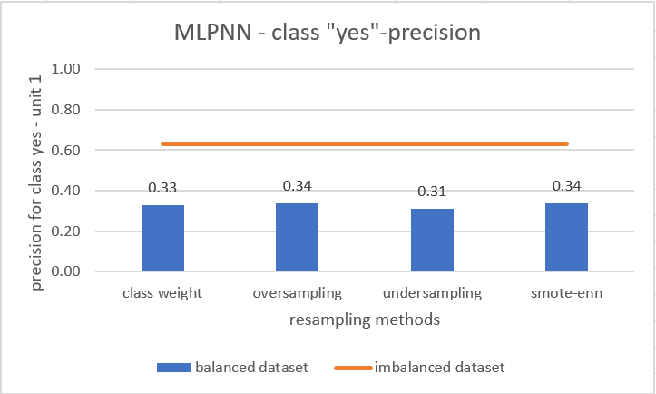

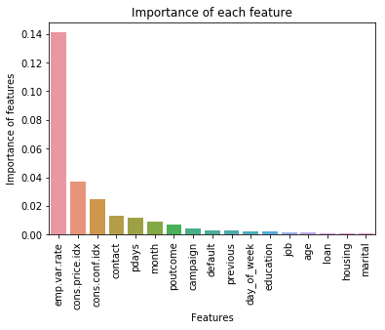

Undersampling and smote enn for MLPNN’s algorithm shows big variance of recall and precision for class no during cross validation. Oversampling also has high variance of precision for class yes in cross validation. That proves MLP classifier indeed has a bigger variance in its prediction than the other three machine learning algorithms.
In addition, MLPNN requires much longer processing time and does not show any outstanding prediction results, which indicates that complicated models do not always give the most satisfactory outcome.
The bottom right plot is the importance of features estimated by random forest on imbalanced dataset. The two most important features are “emp.var.rate” and “cons.price.idx”.

The cross-validation results and auc score for each algorithm and resampling methods are shown below.
Table 4. 10-fold Cross validation score mean of recall for class yes
 | imbanlanced | class_weight | oversampling | undersampling | smote-enn
RandomForest | 0.296 | 0.297 | 0.996 | 0.657 | 0.987
LogisticRegre | 0.210 | 0.674 | 0.675 | 0.683 | 0.812
LinearSVC | 0.194 | 0.688 | 0.686 | 0.690 | 0.800
MPLNN | 0.246 | 0.600 | 0.660 | 0.410 | 0.494

Table 5. 10-fold Cross validation score mean of precision for class yes
 | imbanlanced | class_weight | oversampling | undersampling | smote-enn
RandomForest | 0.509 | 0.439 | 0.923 | 0.742 | 0.982
LogisticRegre | 0.686 | 0.284 | 0.759 | 0.764 | 0.883
LinearSVC | 0.699 | 0.279 | 0.754 | 0.756 | 0.887
MPLNN | 0.664 | 0.333 | 0.627 | 0.501 | 0.565

Table 6. Auc score for each model’s performance
 | imbanlanced | class_weight | oversampling | undersampling | smote-enn
RandomForest | 0.629 | 0.619 | 0.655 | 0.721 | 0.722
LogisticRegre | 0.600 | 0.720 | 0.721 | 0.721 | 0.705
LinearSVC | 0.586 | 0.720 | 0.721 | 0.719 | 0.707
MPLNN | 0.615 | 0.734 | 0.736 | 0.732 | 0.727

In summary, LinearSVC has best performance considering processing time and performance indices. Using randomly undersampling, it can achieve the classification sensitivity (recall) of 0.67 and precision of 0.27 with an auc score of 0.72 on the minority class.
Thanks to decreasing of variance, we find all four resampling approach do well during cross validation in terms of recall for class yes. Oversampling leads to overestimation of minority class while undersampling leads to loss of information from the majority class (may be some important characteristics).
Smote enn outperforms the other three resampling approach during cross-validation, because it can reduce replication of some data from the minority class and some similar data from the majority class as well. However, this approach could produce some loss of important information from the majority class.
Another problem for oversampling is, we perform the cross validation after the oversampling. Similar examples (or exact replicas) may appear in both the training and test partitions. Therefore, the result of cross-validation seems more “efficient” because we are over-estimating the classification performance. This is known as the issue of “overoptimism”.

Cost-based model & f1 score
From the previous experiments, we can easily find out the trade-off concerns in the number of false positives compared to the number of false negatives. In real life, we can adjust the models where the cost of one error outweighs the cost of other types of errors to meet our needs.
Furthermore, oversampling and undersampling cause loss of variance in dataset, and it makes them “perform” well than they actually do. Therefore, it seems reasonable for them to have a performance below expectations on new data.
In addition, to get more satisfying results, we could change the model to implementation a cost-based classification rather than accuracy-targeted model. We can assign values to cost of false negative and false positive respectively. The discriminant could be the product of probability and the cost. If one is estimated greater than the other, we should choose to be the opposite.
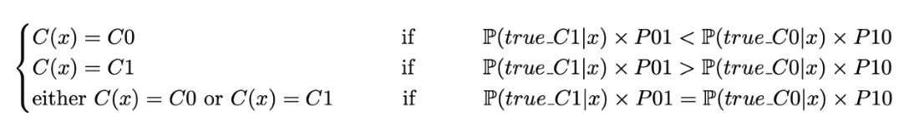
Here we do not know the true cost value ratio, but we can find a best ratio which allows us to have a best f1 score. It means a best balance of precision and recall based on the exist dataset. However, we do not know if the ratio of the majority versus the minority is the true ratio of their prior probability, to simplify, we test and discuss this model only on this dataset only by logistic regression algorithm.
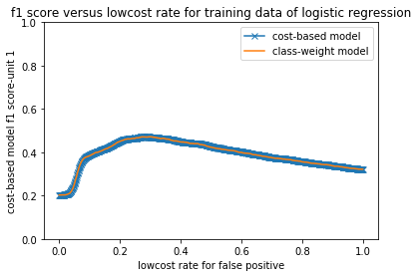
Figure 6. comparing between cost-based model with class-weight-set model
After the cross-validation for the cost-based model, we find out the best lowcost rate within [0, 1] for the model. And the curve is almost same as that of the best class_weight setting of sklearn model. The best lowcost rate is 0.472 for false positive and 1 is assigned for false negative, which also explained the overfitting problem about class_weight = “balanced” (We already know from previous discussion, the penalty weight for false positive versus that for false negative is smaller than 0.472 if we set balanced class weight, therefore the cross-validation of precision for class yes is very low).
Departure from this, we consider the method of adjusting class weight usually only has an effect on the cost of class errors. It will adjust a separating surface to decrease these accordingly. If the class weight is known, setting it through sklearn library is a good way to build appropriate model; while if the class weight is unknown, its better to use oversampling or undersampling or combination resampling approaches to train the model.
Then we can compare the feature importance figure of accuracy-target model and that of cost-based model, both are training directly on imbalanced dataset.
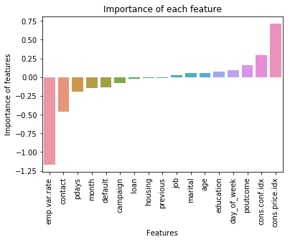
Figure 7. left: accuracy-target logistic regression model, right: cost-based logistic regression model
From this figure, we can easily find the effect of weight adjustment: it evenly distributes features with positive importance and that with negative importance, there fore the model tends to be balanced.

Resources
https://www.jeremyjordan.me/imbalanced-data/
https://arxiv.org/pdf/1608.06048.pdf
https://www.svds.com/learning-imbalanced-classes/
https://machinelearningmastery.com/roc-curves-and-precision-recall-curves-for-classification-in-python/
https://towardsdatascience.com/handling-imbalanced-datasets-in-machine-learning-7a0e84220f28
https://medium.com/greyatom/why-how-and-when-to-scale-your-features-4b30ab09db5e

